CONSOLIDATED WEB DEVELOPMENT ACTIVITY REPORT

Activity-Based Learning • Project Screenshots • Interface Documentation

Prepared from the supplied screenshots of the GitHub repository and three web development case studies.

Introduction
This report consolidates the supplied screenshots into one document for the Web Development Activity-Based Learning work. It records the repository structure and the visible interfaces of the TravelGo booking website, CineView movie review website, and AdventureX trekking website.

Project Overview

Case Study 1 — Bus and Train Ticket Booking Interface (TravelGo)
The screenshots show a journey search form with origin, destination, travel date, transport type, and passenger fields. Service cards display routes, departure times, available seats, and fares. A seat-selection section and fare summary are also visible.

Case Study 2 — Movie Review and Rating Website (CineView)
The CineView pages present popular films with poster images, genres, release years, cast details, short descriptions, user-facing ratings, and a critic reviews section.

Case Study 3 — Adventure and Trekking Website (AdventureX)
The AdventureX landing page introduces outdoor trips and trekking through a prominent heading, an Explore Trips link, and a Popular Adventures section with mountain landscape imagery.

Repository Evidence
The GitHub screenshot shows the public WD-Activity-Based-Learning repository. Visible files include HTML and CSS activity files, a README.md file, and a recent repository update. The README area is headed “Web Development Case Studies.”

Screenshot Documentation
The following figures are arranged in the order supplied. Each screenshot is preserved as visual evidence and scaled to fit the page while maintaining its aspect ratio.
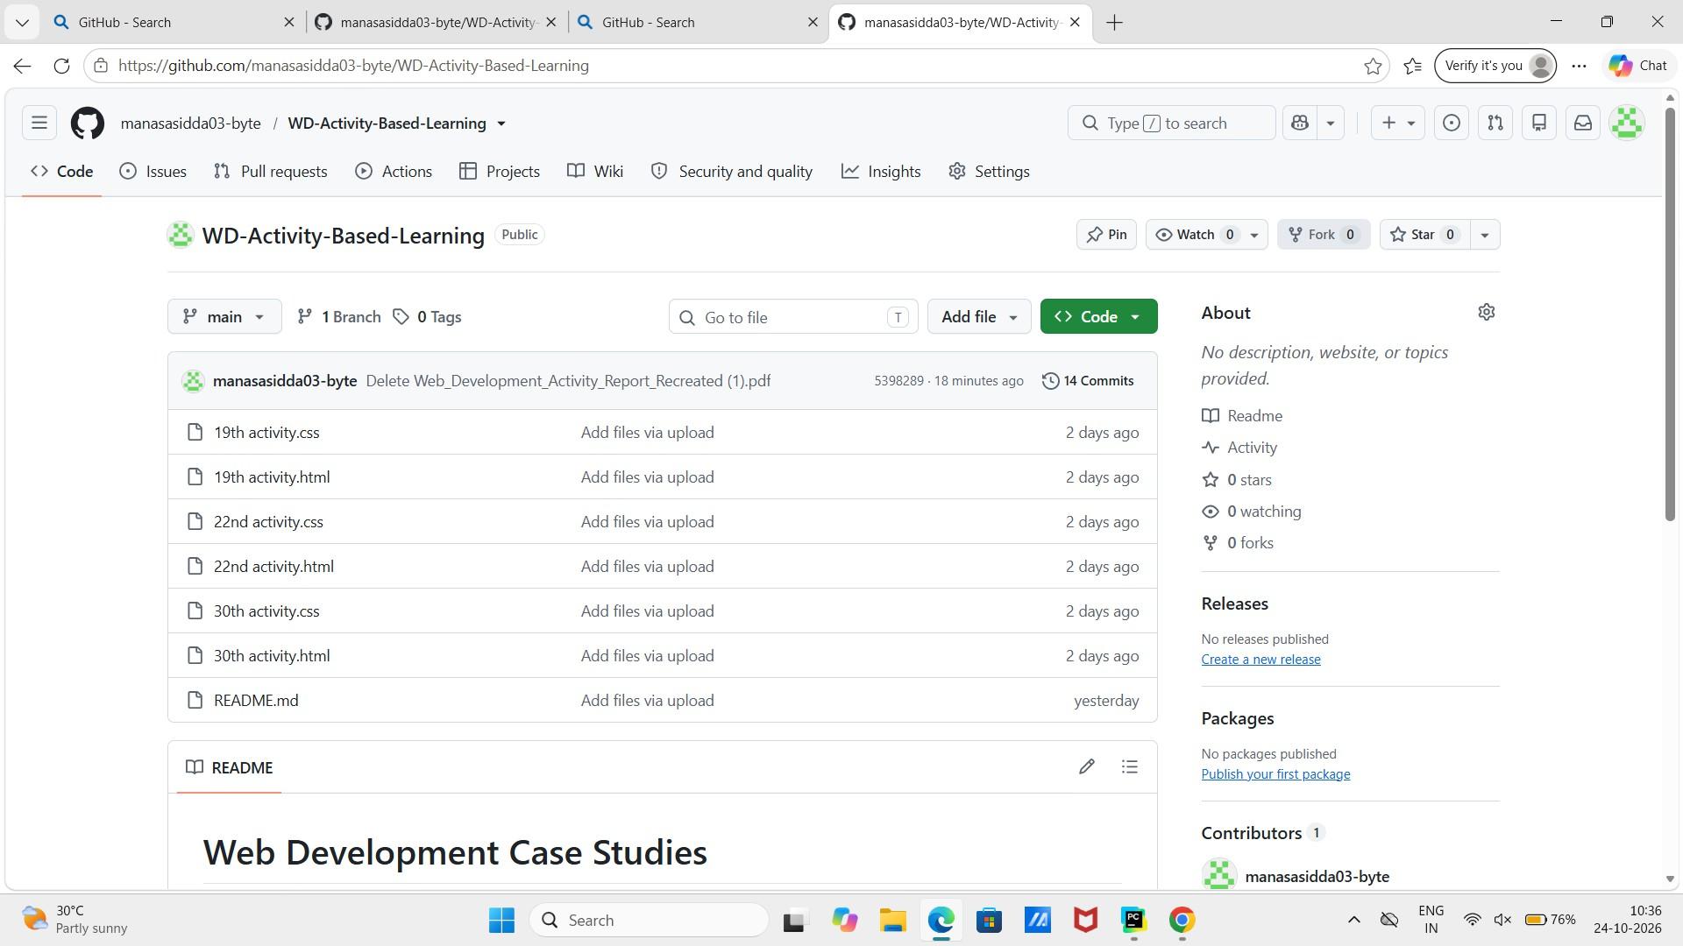
Figure 1. GitHub repository for WD-Activity-Based-Learning, showing the project files and README.

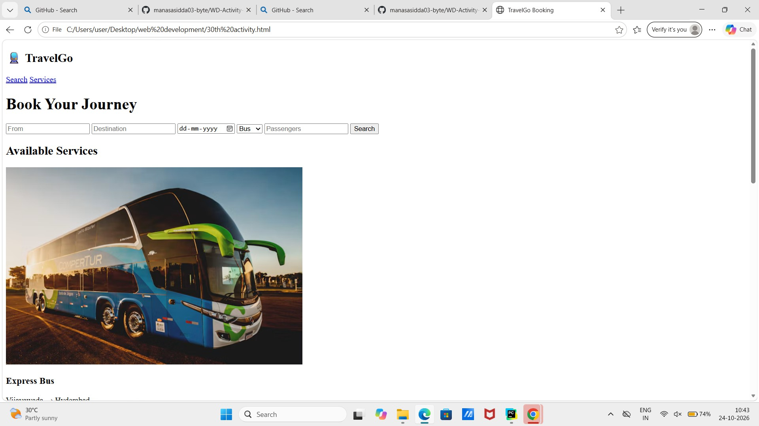
Figure 2. TravelGo booking interface: journey search form and available transport services.

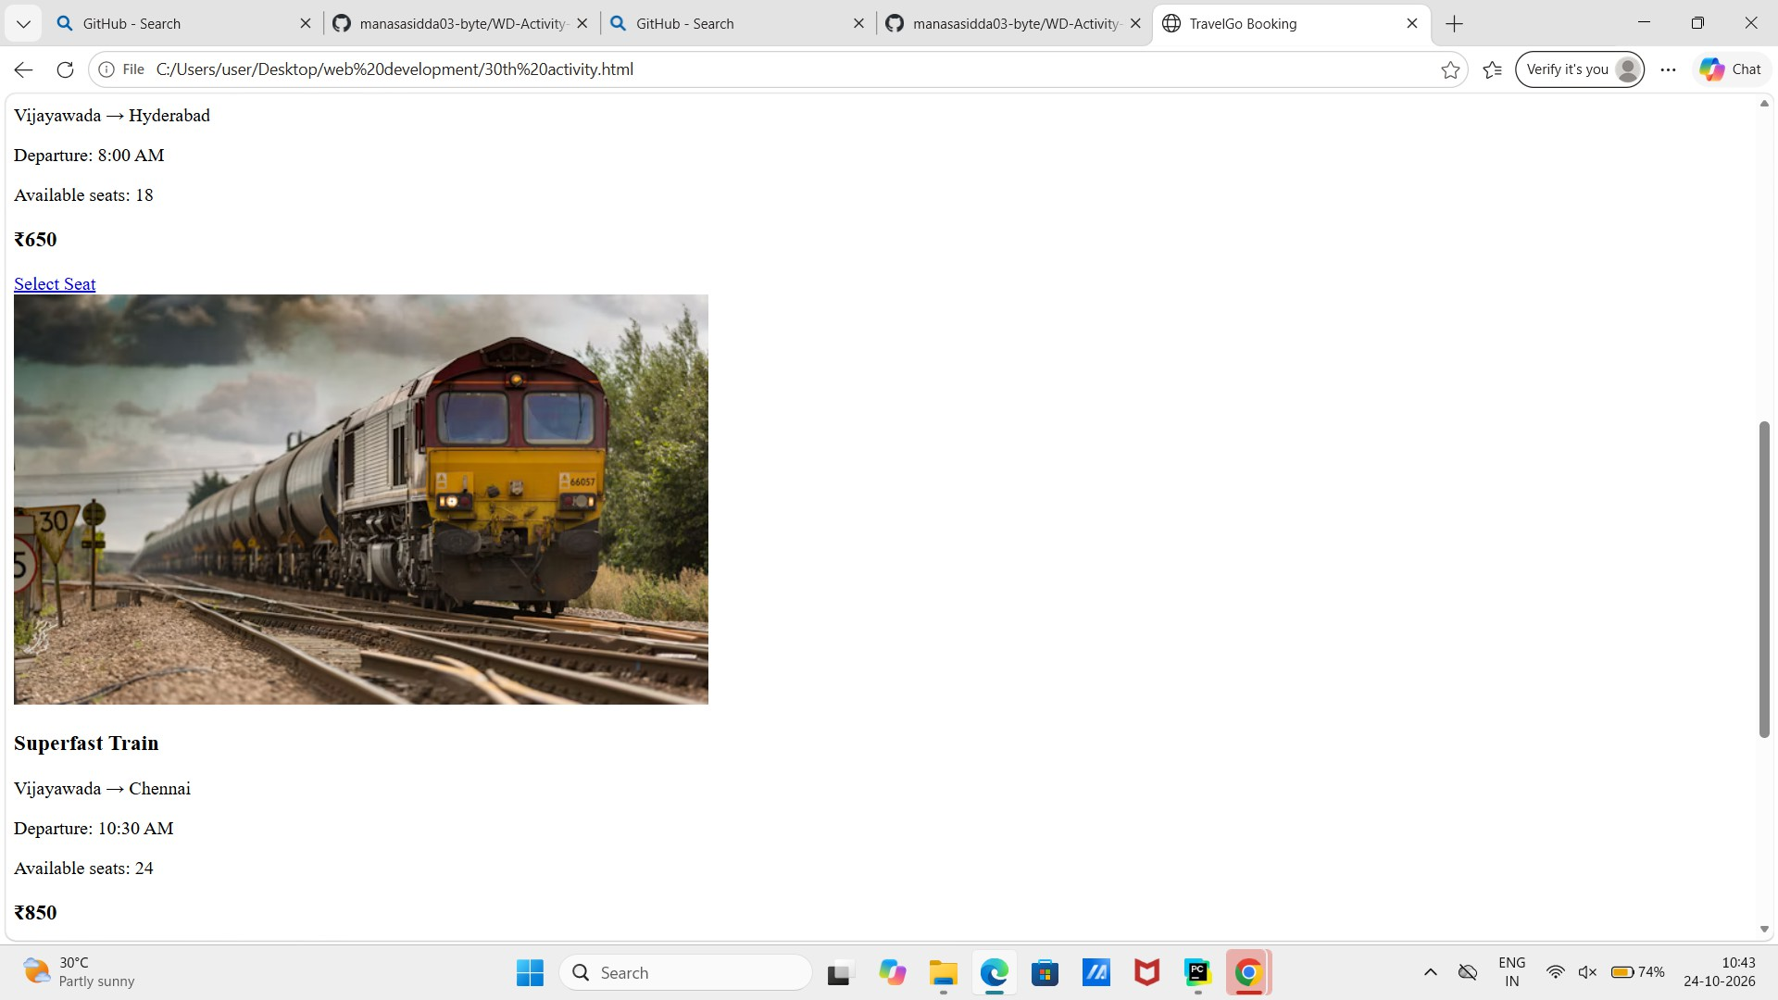
Figure 3. TravelGo service listings, including bus and train routes, departure times, seat availability, and fares.

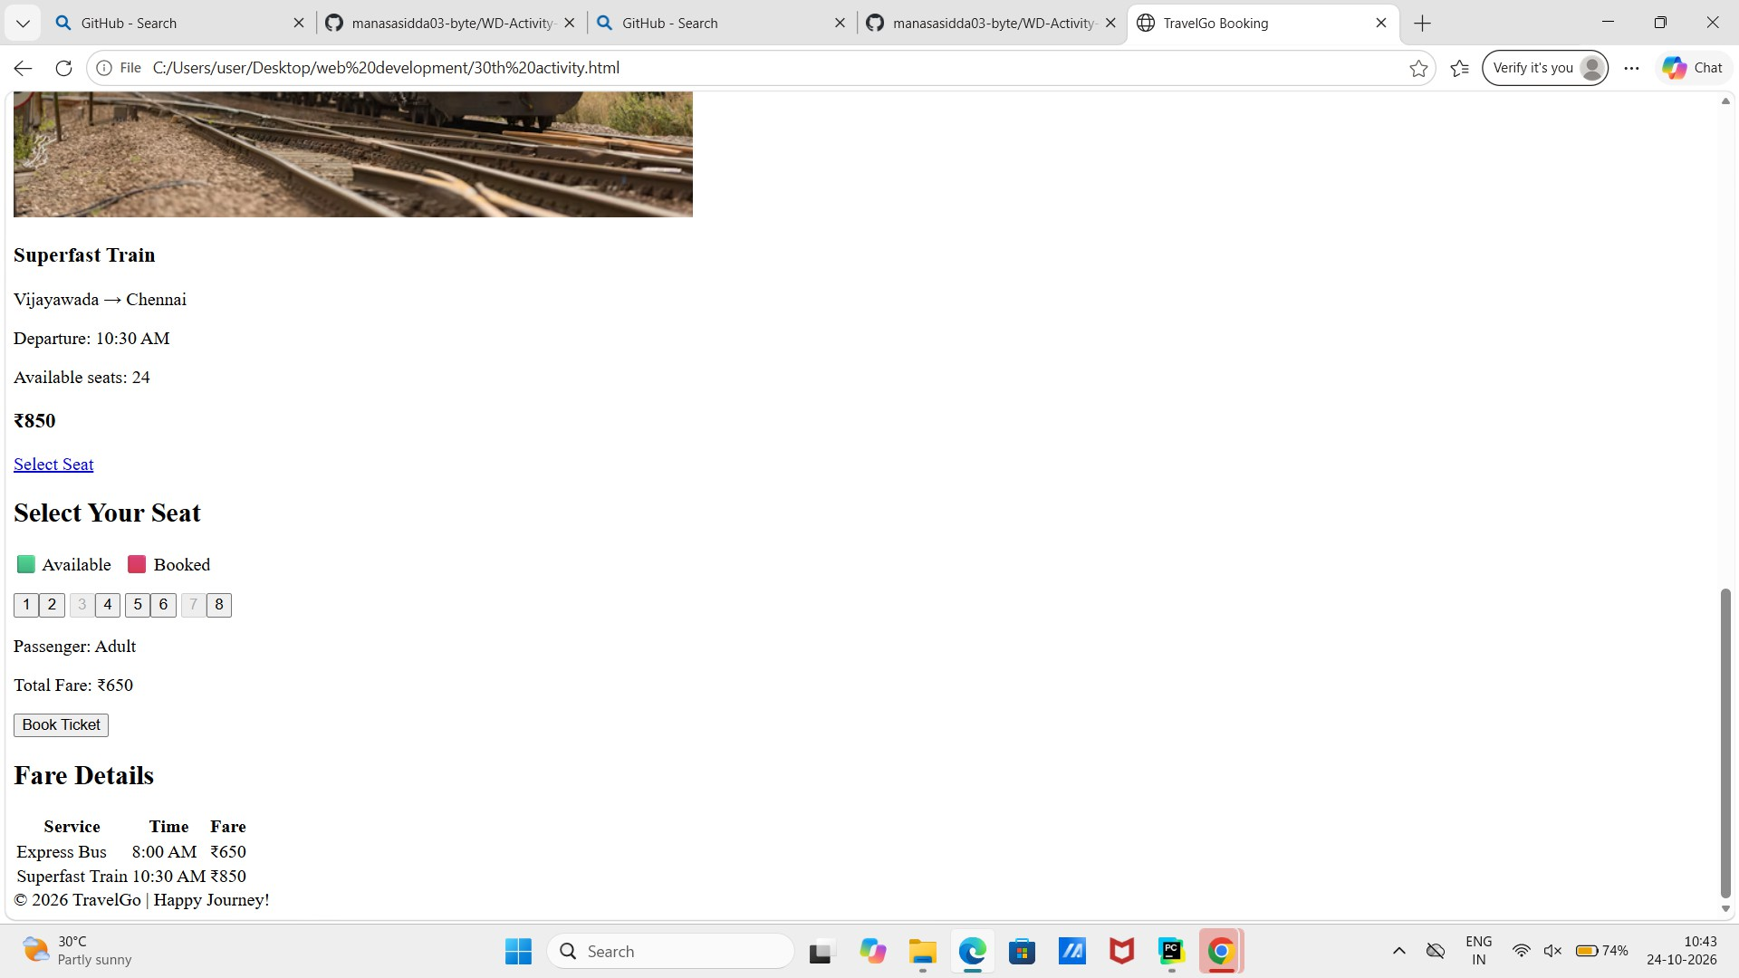
Figure 4. TravelGo seat selection interface and fare details.

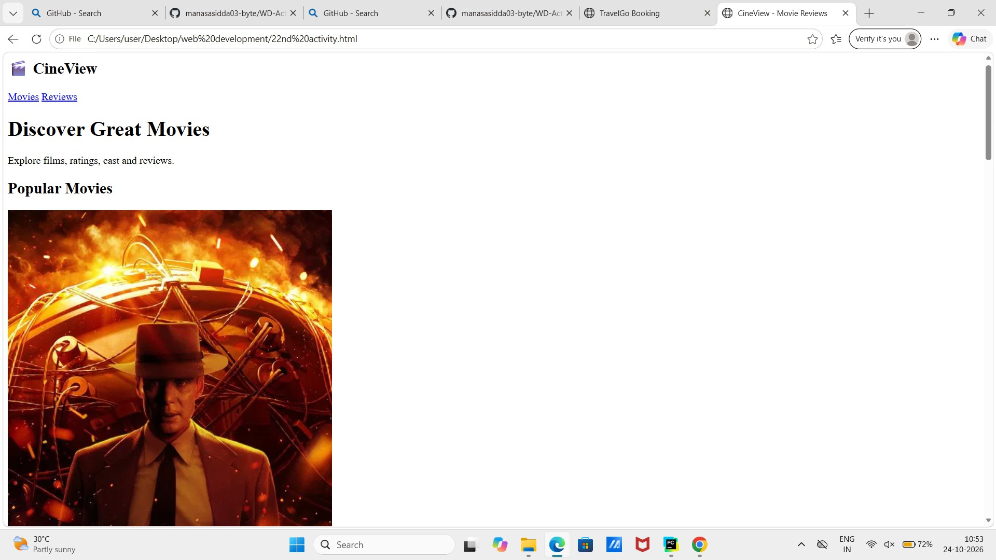
Figure 5. CineView movie review website landing page and popular movies section.

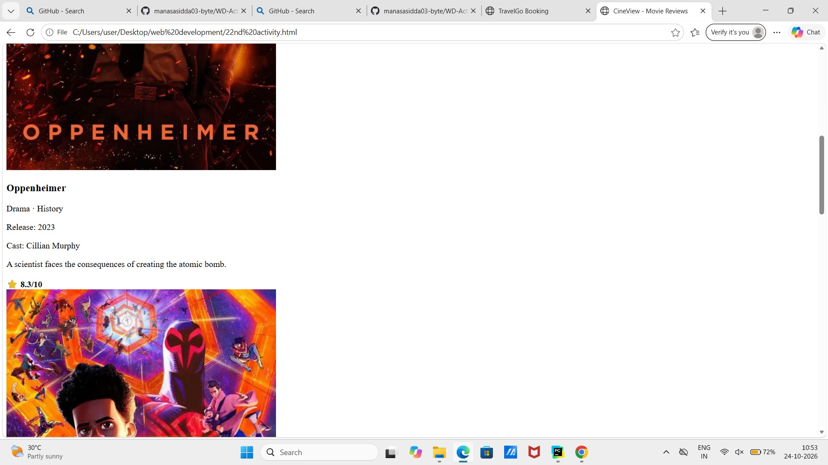
Figure 6. CineView movie details, genres, release year, cast, synopsis, and rating.

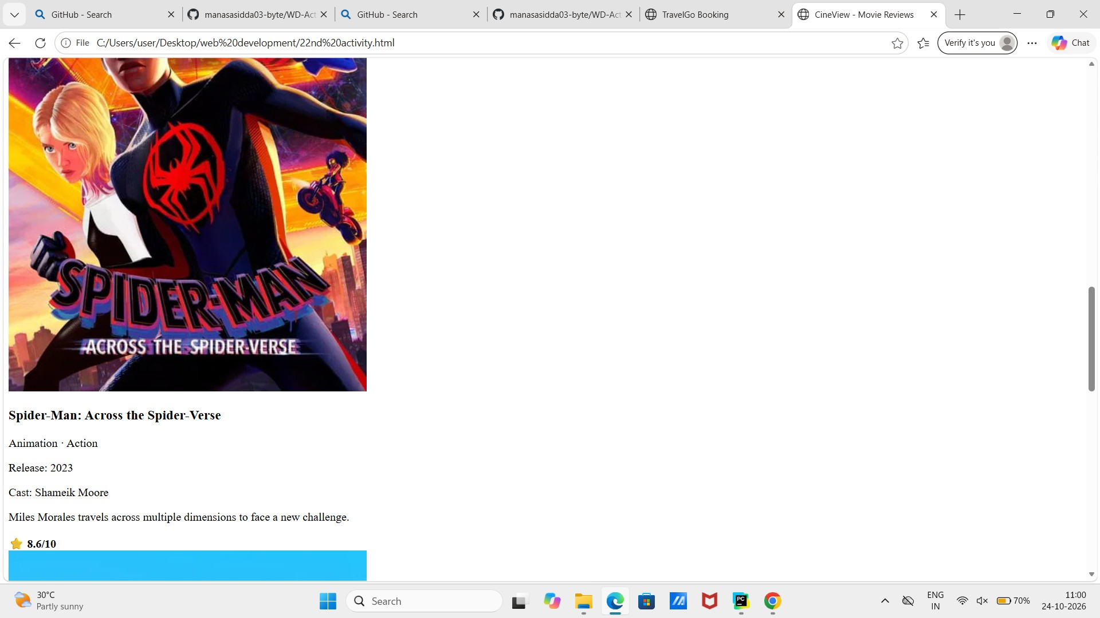
Figure 7. CineView movie cards and rating information for featured films.

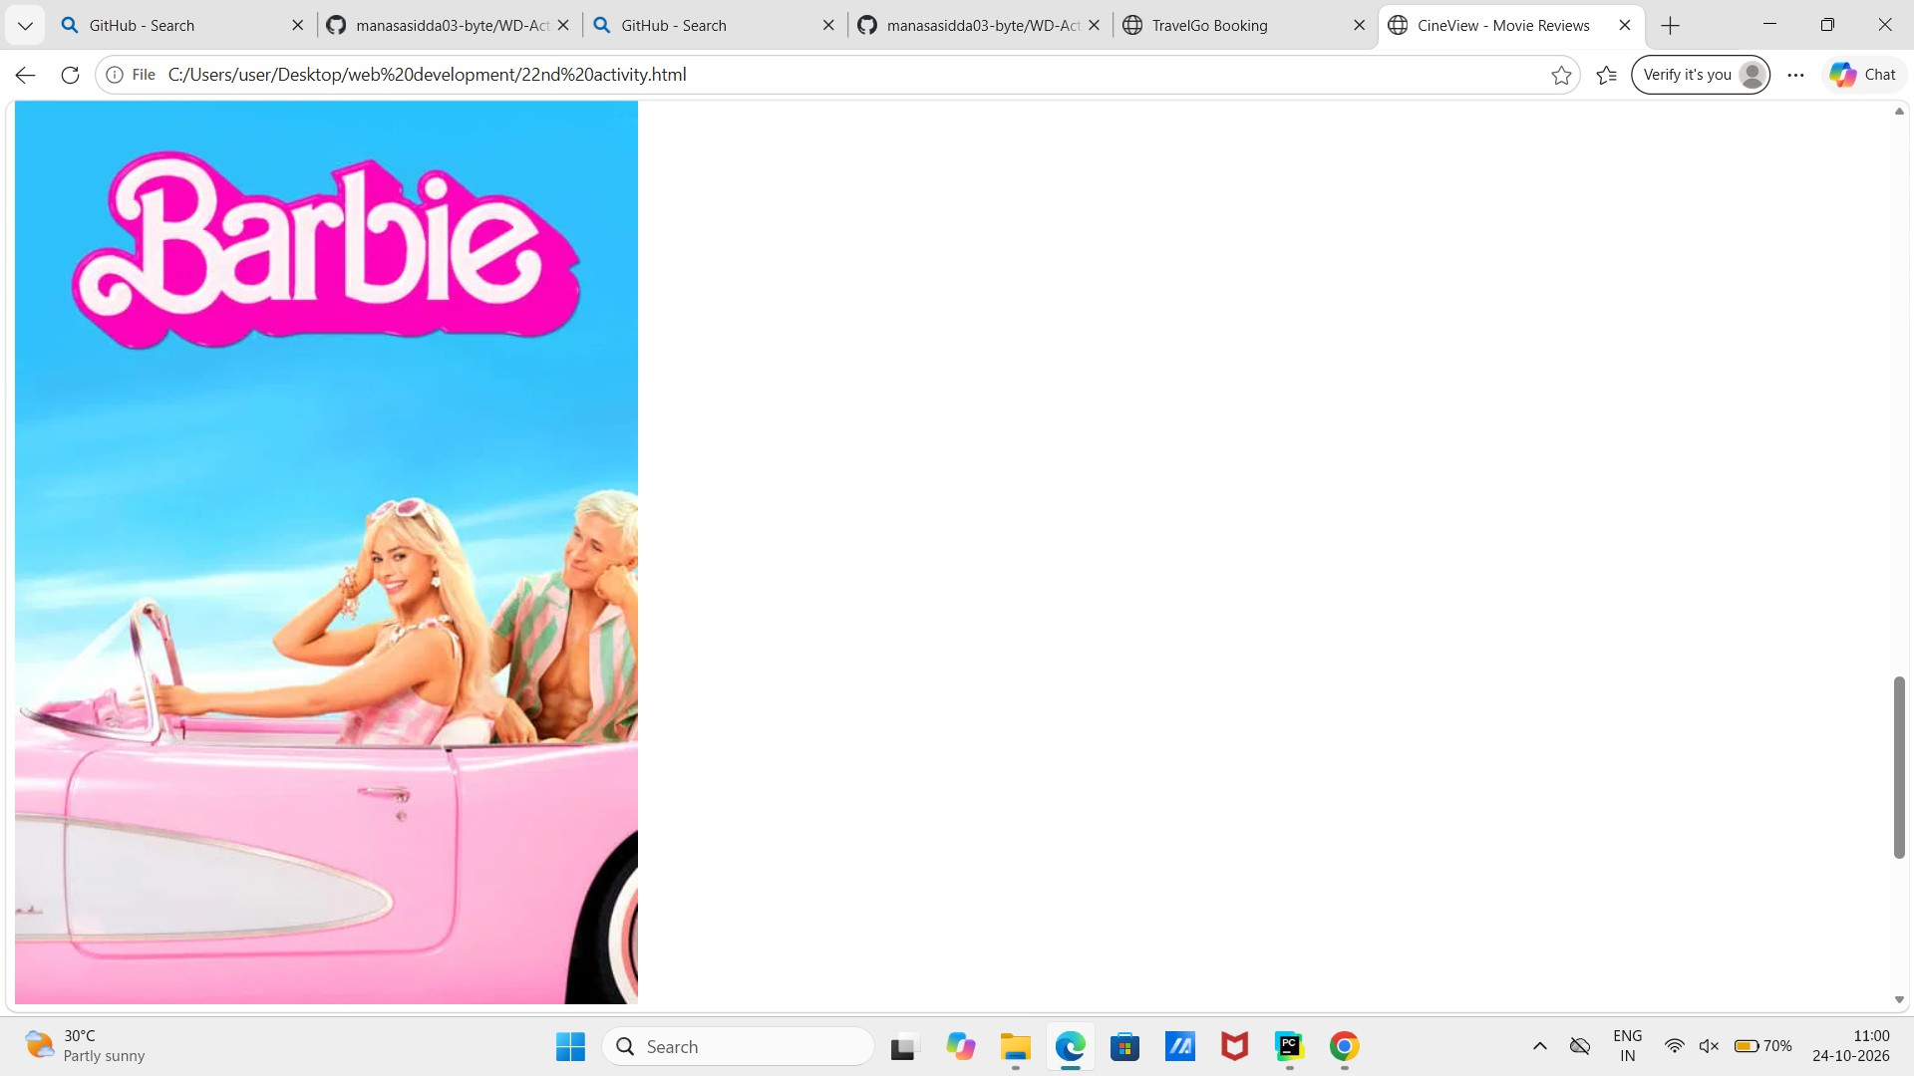
Figure 8. CineView movie details and rating presentation.

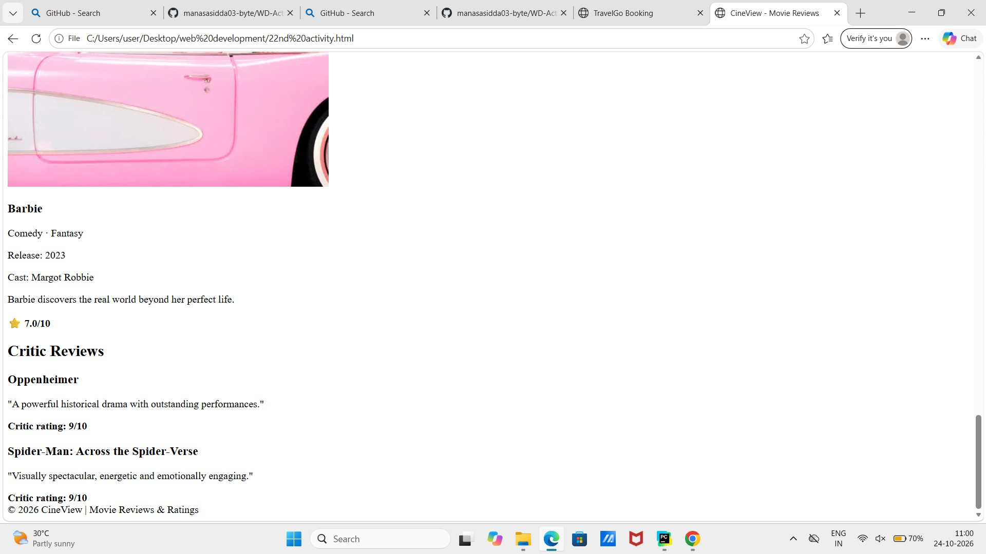
Figure 9. CineView critic reviews and ratings section.

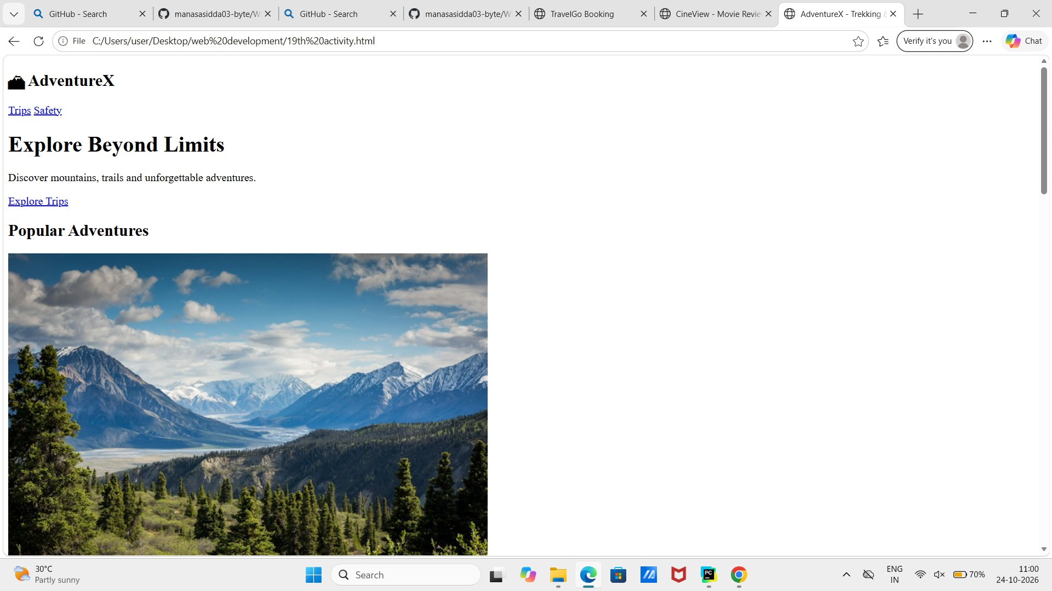
Figure 10. AdventureX trekking website landing page, featuring popular adventures and mountain scenery.

Additional Screenshots — AdventureX
These additional screenshots have been added to include the remaining AdventureX trekking page content in the consolidated report.
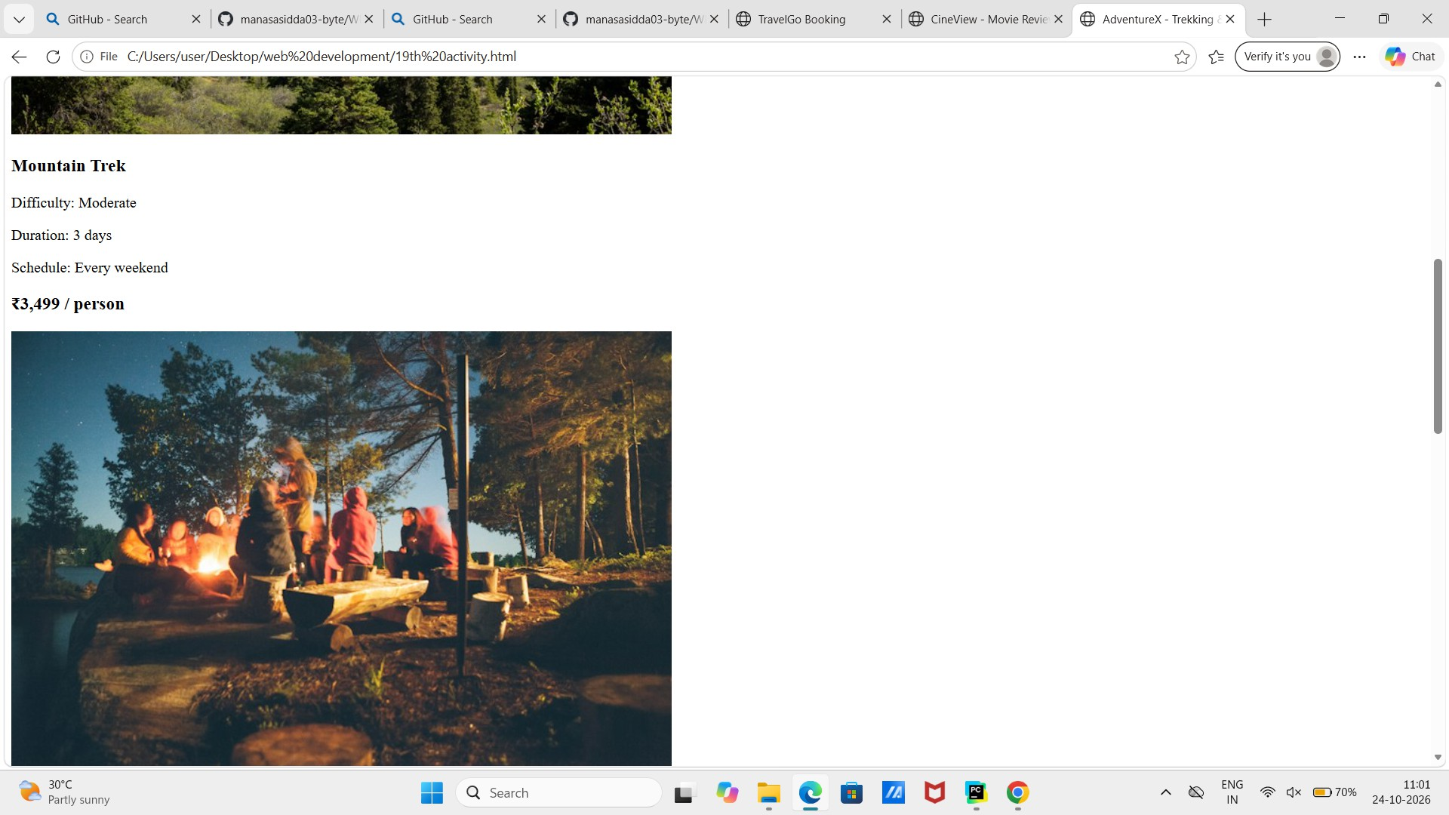
Figure 11. AdventureX — Mountain Trek details, including moderate difficulty, three-day duration, weekend schedule, and price.

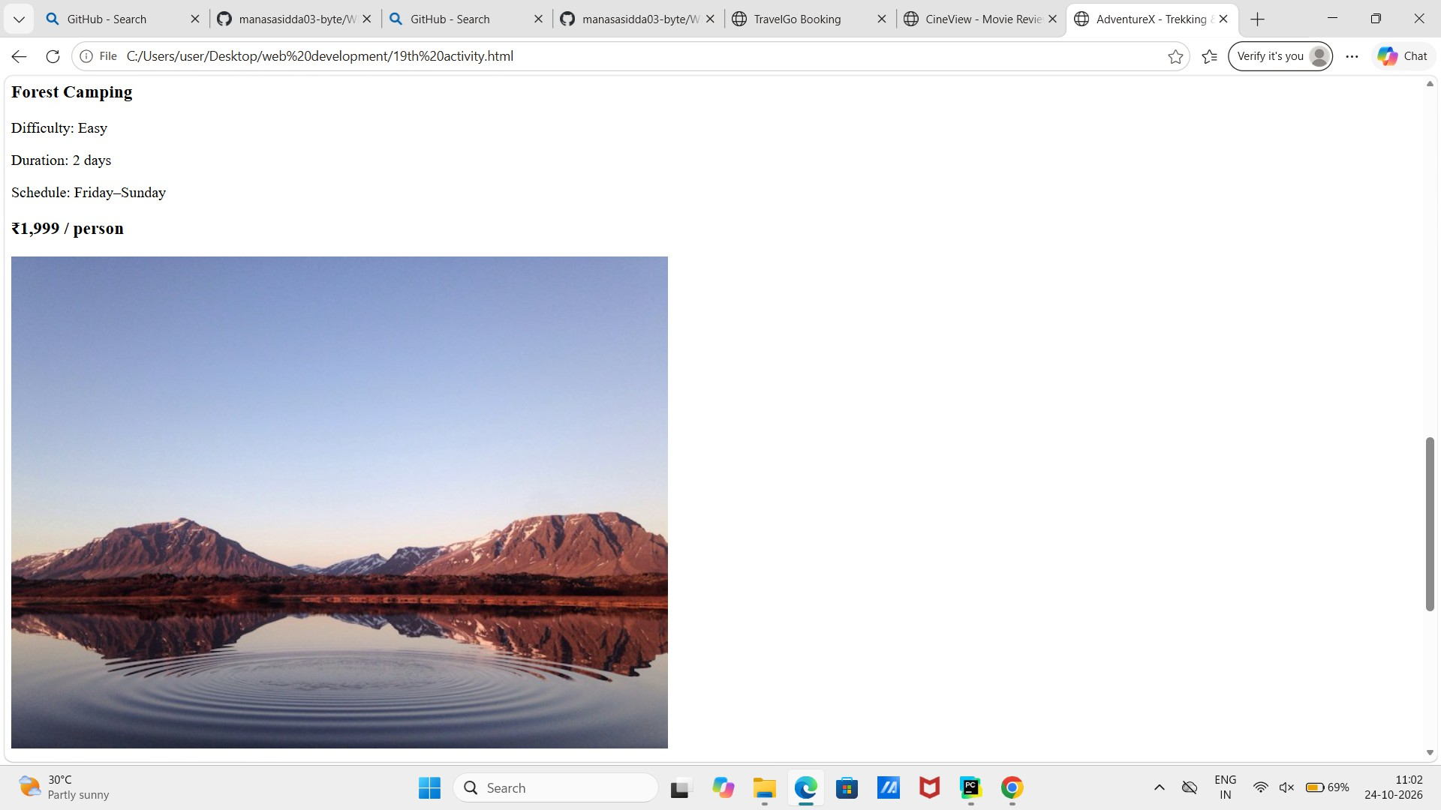
Figure 12. AdventureX — Forest Camping details, including easy difficulty, two-day duration, Friday–Sunday schedule, and price.

Conclusion
This report brings together the repository evidence and screenshots of three web development case studies: TravelGo for bus and train ticket booking, CineView for movie reviews and ratings, and AdventureX for trekking and outdoor adventures. The screenshots document the visible layouts, content, and key interface sections of each project. Together, they provide a consolidated visual record of the web development activities.

End of Report

