Phase 1: Initial Setup

1. Install EFCore packages

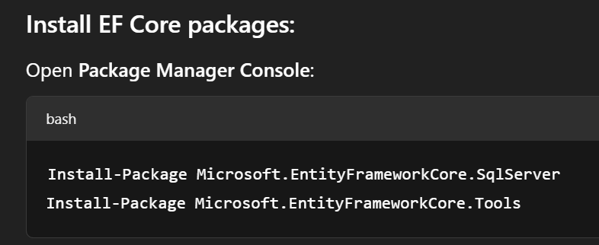

1. Create folder Data and add Database Context

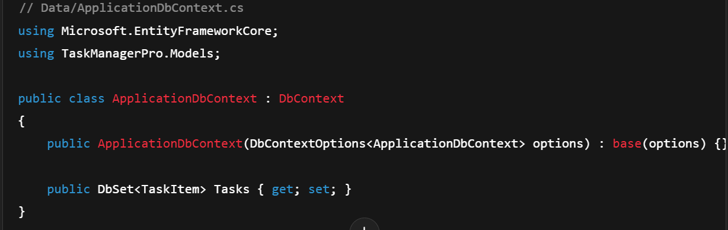

1. Add connection string in appsettings.json

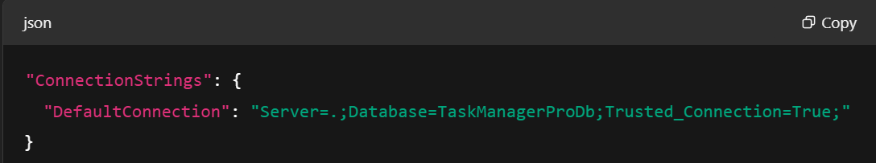

Register your DbContext in Program.cs

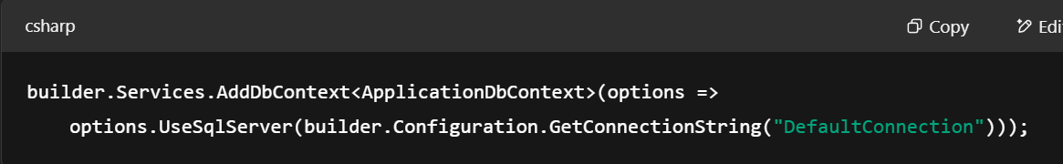

1. Add Migration and create Db

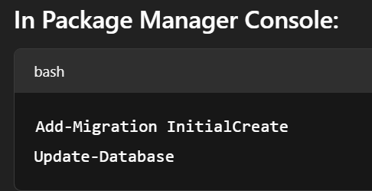

Phase 2: CRUD

1. Create TaskItem Model
2. Register TaskItem in ApplicationDbContext 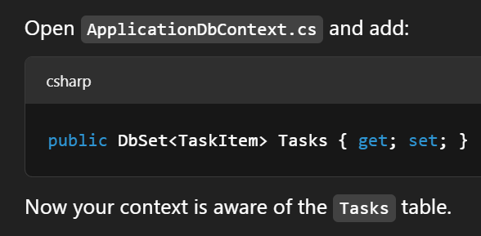
3. Add Migration for TaskItem Model

 

1. Add Controller and Views through scaffolding



Right-click the Controllers folder → Add → New Scaffolded Item

Choose ‘MVC Controller with views, using Entity Framework’

Pick your TaskItem model and ApplicationDbContext

Controllers and Views will be created.

Now, the website will have the basic CRUD functionalities.

Now, when we run the app, if you want it to open TaskItems/Index by default, instead of you manually typing it, set default routing in program.cs. Change default controller to TaskItems from Home Controller.