Training Module on HUMANET

BLR/P04/087/FS/I00

V000.a

 | Name | Role | Signature | Date
Author |  | Project Leader
Reviewer |  | Project Manager
Approver |  | Project Manager

BLUE CHIP COMPUTER CONSULTANTS PVT. LTD.

20/21, PATTALAMMA LAYOUT, SINGASANDRA,
HOSUR MAIN ROAD, BANGALORE - 560068. INDIA.
PH: 080 – 573 1603-5, FAX: 080 – 573 3156.

Table of Contents

1. Introduction 3
1.1. Purpose 3
1.2. Scope 3
1.3. Audience 3
1.4. Reference 3
2. Functional Overview 4
2.1. Major Functions 4
2.2. Functions Out of Scope 4
3. Functions 4
3.1. Common function 4
3.2. Other functions 4
3.3. Add Participants Screen 7
3.4. Add Need Participants Screen 8
3.5. Mark Attendance Screen 10
3.6. Calendar 12
3.7. Training Details List 13
3.8. Training Feedback 14
3.9. Training Feedback list Screen for HR 16
3.10. Training Action Plan Form 17
3.11. Training Type Master Entry Screen 19
4. Appendices 20
4.1. Appendix A - Acronyms and Abbreviations 20
4.2. Appendix B - Glossary of Terms 20
4.3. Amendment History 20

Introduction

Purpose

The purpose of this document is to describe the process flow of Training module, which shall be integrated with HUMANET.

Scope

This module will enable HR department to announce the various training programs and their schedules. And also it allows allotting some employees which will come from Appraisal Development plan as well as any other volunteers to the training program while creating the entry itself and it will send mails to the allotted people with training details.

The scheduled programs will be displayed in a calendar on respective dates. In calendar on clicking the particular training program link it will be redirect to the training details page.
The selected employees will also be intimated individually about the training program. And the user can see the employees list for the training program and their status as well as the past history of the training’s attended by the employees.

While creating the training program there is an option to select training effectiveness, feedback and action plan. If they are selected, before the training program schedule date all the participants will get homepage link to fill the initial ratings for improvement by attending training and after the training program is finished, all the attended participants will get homepage links for feedback, action plan and effectiveness where they can fill it and submit to appropriate superiors/HR. And superiors/HR will view it and they will enter their comments.

The training needs are identified by the appraisers during the appraisal period and the needs are classified into two types. One is mapping to existing training names and the other is identifying new needs. The HR can view the candidate’s training needs and can allot them schedule the existing training programs as well as can create new Training program if necessary.
Training cancellation can happen any date before the marking of attendance . Marking of a attendance indicates training has been conducted .

Audience

Sr. No. | Name of the Person | Role Played in Project
 | Bharathiraja | Project Manager

Reference

NA

Functional Overview

Major Functions

Inputs

- Training Schedule Entry
- Add Participants
- Add Need Participants
- Mark Attendance
- Training Feedback
- Training Action Plan

Functions Out of Scope

NA

Assumptions / Constraints / Dependencies (A /C /D)
Description of Assumptions / Constraints / Dependencies
Assumptions
Constraints
Dependencies

Functions

Common function

Sr. No. | Function Name | Purpose
 | Employee listing | Employee selection window to select employees. This by default has a search option too.

Other functions

Training Schedule Entry Screen

Purpose

This screen allows the authorized user to enter a new training schedule and also user can allot employees to attend the training by clicking on Add Participants link. And this will send mails to all the allotted employees with training details on saving the details.

User Interface

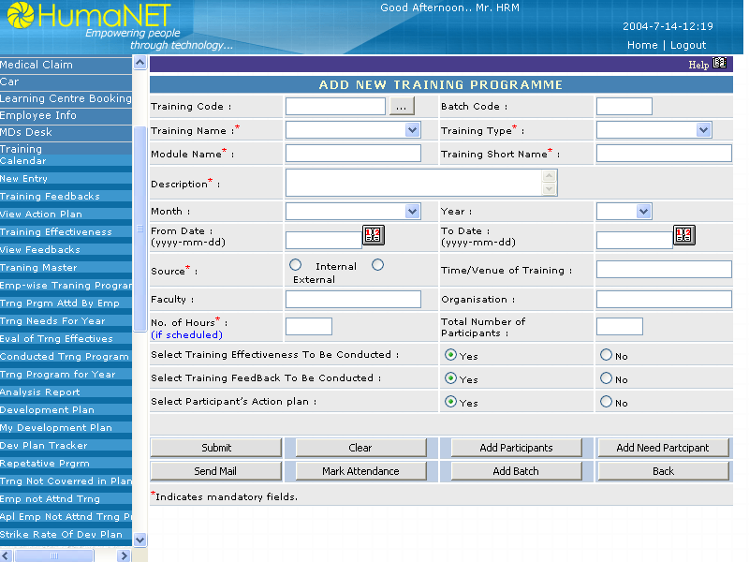

Input

Training Name, Training Description, Location, Date range, Source and organisation of the trainer, Trainer name, Number of hours, Organiser name, Training short name,Total number of participants,Effectiveness to be conducted, action plan to be conducted,Feebback to be conducted and the employees name to be attend.

Output

Sending mails to the allotted employees.

Processing

Validate the screen entries from corresponding table. When validated, allow the user to get into the application, else display error message. After saving entry sending mails to Organiser and the allotted employees with training details.

Submit Button :

On click of which entries are validated and saves the entry.

Click Button:

On click It will restore the values back when the screen was refreshed from the server.

Add Participants Button:

On Click the user will be directed to a listing of employee screen
And user can add the participants for a training programme.

Add Need Participants Button:

On Click the user will be directed to a listing of employee screen
Which will display the employees who are refered for a training programme based on the appraisal.

Mark Attendance Button:

On Click the user will be directed to a listing of employee screen
Which wii display the employees enrolled in the training programme .
The user can mark the attendance by selecting employees.

Send Mail Button:

On Click the user can send mails to the employees who have enrolled for the training programme.

Attributes

Sr No | Entity | Description | Type | Length
 | Training Code | Training Code for identifying the training uniqly | Char | 10
 | Training Type | Identifying the type of training | Char | 10
 | Training Name | Title of the training | Char | 50
 | Training Short Name | Short name for training to disply in calender | Char | 8
 | From Date | Start date of training | Date | 8
 | To Date | End date of training | Date | 8
 | Venue of Training | Location of the training to be held | Char | 50
 | Description | Brief desc. Of the training. | Char | 100
 | Source | Faculty source internal/external | Bit | 1
 | Trainer | Faculty name | Char | 50
 | Organisation | Trainers Organisation | Char | 50
 | Total No of Participants | TotalNo. of Participants | Numeric | 4
 | Cost of Training | Cost of Training | Numeric | 9
 | Cost of training per head | Display filed | Numeric | -
 | Effectiveness to be conducted | Effectiveness to be conducted | Bit | 0
 | Feedback to be conducted | Feedback to be conducted | Bit | 0
 | Action Plan to be conducted | Action plan to be conducted | Bit | 0

Add Participants Screen

Purpose

This screen allows the authorized user to allot employees for the entered training schedule and also this will provide a link for selecting employees to send mails in order to inform them with training details. This will have the search criteria also.

User Interface

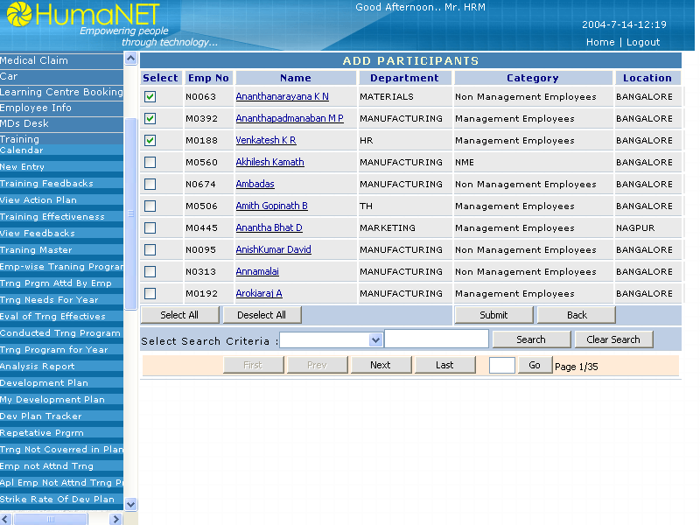

Input

Training Id and the employees name to be attend.

Output

Employees Added to the Training Program.

Processing

By giving the search criteria and clicking the search button it will display only those employees and the user can select the employees and on click of the save button it will be added those employees to the training program .

Save Button :

On click of which entries are validated and saves the entry.

Clear Search Button:

On click it will clear the search criteria.

Search Button:

On click it will display the employees based on the search criteria.

Select All Button:

On click it will select all the employees in the page.

UnSelect All Button:

On click it will unselect all the employees in the page.

Navigation Button:

On click user can navigte through pages.

Attributes

Sr No | Entity | Description | Type | Length
 | Training Code | Training Code for identifying the training uniqly | Char | 10
 | Department | Department name | Char | 20
 | Name | Name of the employee | Char | 25

Add Need Participants Screen

Purpose

This screen allows the authorized user to allots employees based on their appraisal for the entered training schedule

User Interface

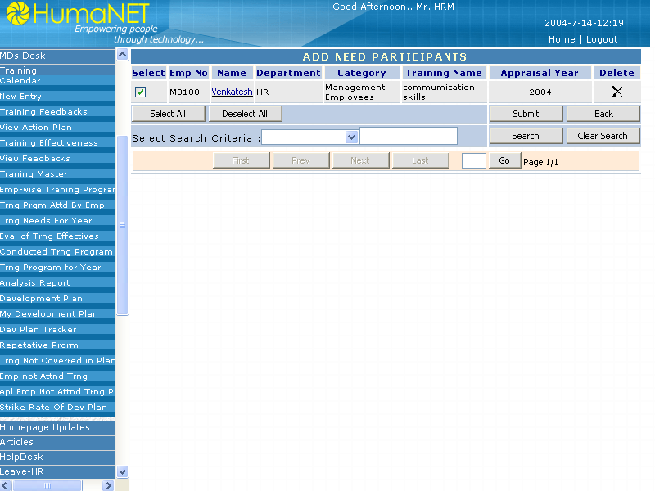

Input

Training Id and the employees name to be attend.

Output

Employees Adde to the Training Program

Processing

By giving the search criteria and clicking the search button it will display only those employees and the user can select the employees and on click of the save button it will be added those employees to the training program .

Save Button :

On click of which entries are validated and saves the entry.

Clear Search Button:

On click it will clear the search criteria.

Search Button:

On click it will display the employees based on the search criteria.

Select All Button:
On click it will select all the employees in the page.

UnSelect All Button:

On click it will UNselect all the employees in the page.

Navigation Button:

On click user can navigate through pages.

Attributes

Sr. No | Entity | Description | Type | Length
 | Training Codes | Training Code for identifying the training uniquely | Char | 10
 | Department | Department name | Char | 20
 | Name | Name of the employee | Char | 25

Mark Attendance Screen

Purpose

This screen allows the authorized user to mark the attendance of the employees who have attended a training program.

User Interface

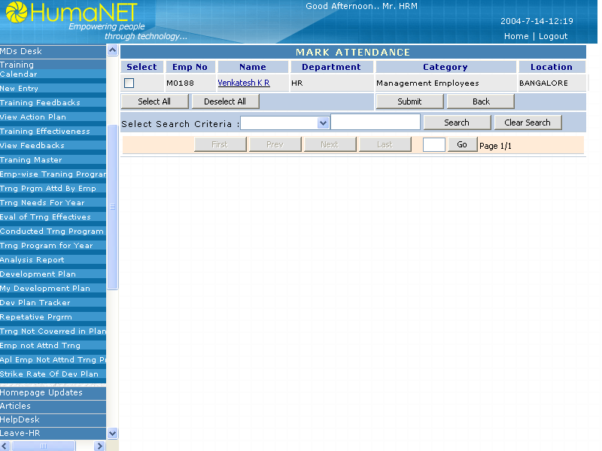

Input

Training Id and the employees name to be attend.

Output

Attendance marked.

Processing

By selecting the employees and on click of the save button the attendence of the employee will be marked.

Save Button :

On click of which entries are validated and saves the entry.

Clear Search Button:

On click it will clear the search criteria.

Search Button:

On click it will display the employees based on the search criteria.

Select All Button:

On click it will select all the employees in the page.

UnSelect All Button:

On click it will unselect all the employees in the page.

Navigation Button:

On click user can navigte through pages.

Attributes

Sr No | Entity | Description | Type | Lengh
1. | Training Code | Training Code for identifying the training uniqly | Char | 10
2. | Name | Name of the employee | Char | 25

Calendar

Purpose

This screen will show the calendar with training program links on respective dates. Default the calendar will show for the current months training details on respective dates. And user can view previous and next months training schedules by clicking on previous and next buttons on the top or directly on a particular month given below. The user can register him self for the training by clicking the links.

User Interface

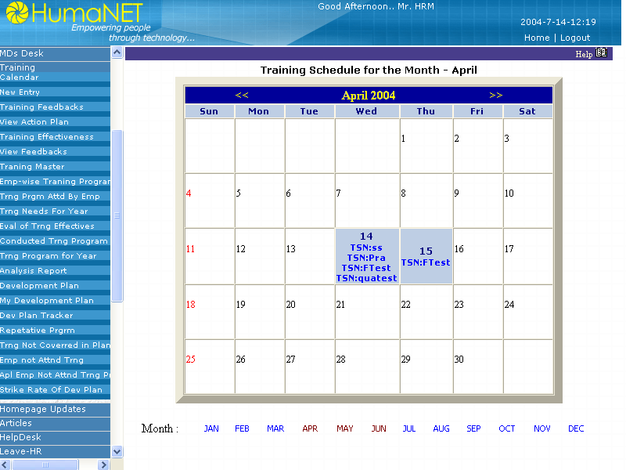

Input

Employee Name and current date

Output

Display the details of training program

Processing

Calendar

Default it will show the current month calendar with trainings on particular dates. On click on << button it will show the previous month calendar and on click on >> symbol it will show the next month calendar. It displays training short name, faculty name and no. of vacant seats with hyperlinks. On click of a particular training hyperlink, it will allow the user to register for the training if it is having vacant seats and if the date of the training is greater than current date.

Attribute

NA

Training Details List

Purpose

This screen will show the details of the training programs

User Interface

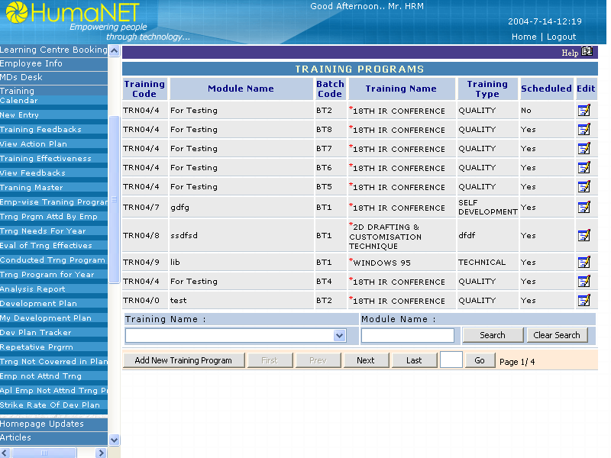

Input

Training Id.

Output

Displaying the details of the training program

Processing

It will take the training id and display the training details in report form.

Attributes

NA

Training Feedback

Purpose

This screen allows the user to enter his feedback on the training attended

User Interface
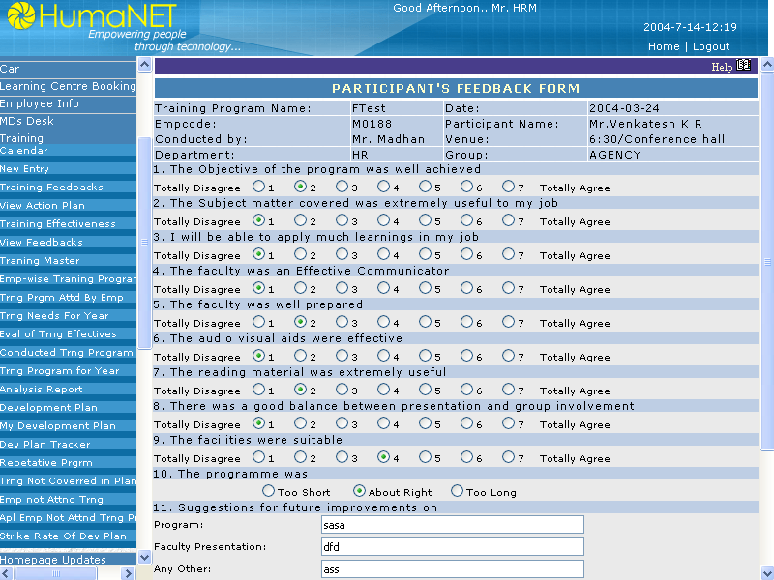

Input

Employee name, Training name, feedback details

Output

Saving the record and passing to HR.

Processing

After the training will get over the feedback link will be shown in homepage. Once the user filling the feedback form the link will not the shown in future. And also if the HR added her comments then the link will not be shown.Hr also can fill up the feed back of employees.

Submit Button : Validate the entered values and saves the record.

Attributes

Sr No | Entity | Description | Type | Length
1. | Training type id | Id for identifying the training type uniqly | Char | 10
2. | Employee id | Employee id | Char | 15
3. | Feedback Id | To identify the Feedback form for a particular training | Char | 3
4. | Feedback Question Id | To identify the question number | Char | 100
5. | Feedback Rating | To store the answer for the closed questions | Char | 2
6. | Feedback Description1 | To store the first answer for the open questions | Char | 100
7. | Feedback Description2 | To store the second answer for the open questions | Char | 100
8. | Feedback Description3 | To store the third answer for the open questions | Char | 100

Training Feedback list Screen for HR

Purpose

This screen allows the HR user to view the feedbacks and the average of all feedbacks rating as well as to add his/her comments.

User Interface

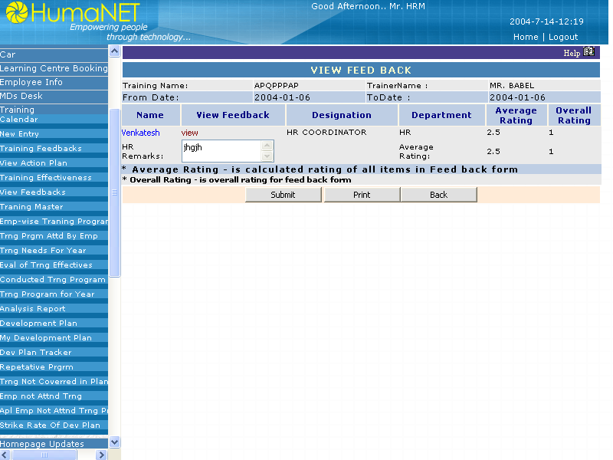

Input

Training id, HR employee id and HR comments.

Output

Saving the record and closing the feedback so that the feedback link will not appear on homepage.

Processing

From homepage HR can come to this page and on clicking the view link he/she can view each employees feedback. And it will display the average ratings of all feedbacks average and overal ratings. Here HR can add here comments and saving the record the feedbacks for that training will closes.

Submit Button :

Validate the entered values and saves the record.

Print Button:

On click it opens the same page in other window in the form of print view.

Attributes

Sr No | Entity | Description | Type | Length
1. | Training type id | Id for identifying the training type uniqly | Char | 10
2. | HR Employee id | Employee id | Char | 15
3. | Feedback Id | To identify the Feedback for a particular training | Char | 3
4. | Comments | To store the HR comments | Char | 100

Training Action Plan Form

Purpose

This screen allows the user to enter his action plan on the training attended.

User Interface

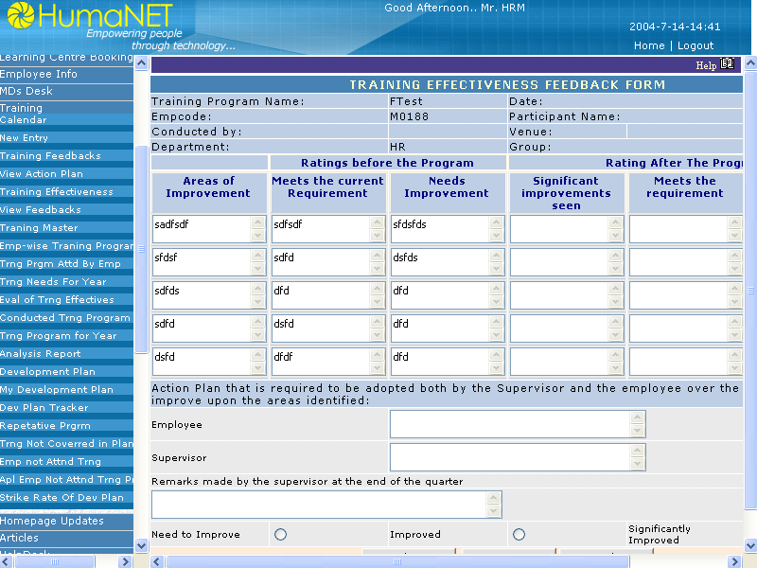

Input

Employee name, Training name, Action Plan details.

Output

Saving the record and passing to Immediate Reporting To

Processing

After the training will get over the action plan link will be shown in homepage. Once the user filling the action plan form the link will not be shown in future for him. The action plan will be submitted to the approvar of the user.

Submit Button :

Validate the entered values and saves the record.

Attributes

Sr No | Entity | Description | Type | Length
1. | Training type id | Id for identifying the training type uniqly | Char | 10
2. | Employee id | Employee id | Char | 15
3. | Action plan Id | To identify the Action plan form for a particular training | Char | 3
4. | Action plan S.NO | Serial no. for action plan | Numeric | 2
5. | Action Plan Col 1 | To store the Action plan description | Char | 100
6. | Action Plan Date | To store the action plan date | Date | 8
7. | Action Plan benefits | To store the benefits of action plan | Char | 100
8. | Comments | To store the needs for implementing the action plan | Char | 100

Training Effectiveness Feedback Form

Purpose

This screen allows the user to enter his feedback effectiveness on the training before and after attending the programme.

User Interface

Input

Employee code, Training name, Training effectiveness details.

Output

Saving the record and passing to Immediate Reporting To

Processing

Once an employee is added to a training programme, supervisor can enter the fields in training effectiveness page under the caption “Rating before the program”. These fields will be enabled only if there is at least 2 days remaining for the start date of the training program.
The fields under the caption “Rating after the program” will be disabled.
Once the training program is over and the attendance is marked, then supervisor can enter details in the fields under the caption “Rating after the program”.
Action plan that is required to be adopted both by the supervisor and the supervisor and the employee over the next quarter also filled by the supervisor and employee respectively.
Supervisor can enter the remarks and level of improvement at the end of the quarter.

Submit Button:

Validate the entered values and saves the record.

Attributes

Sr No | Entity | Description | Type | Length
1. | Training Program Name | Training program name. | Char | 50
2. | Date | Start date of the training program | Date time | 8
3. | Empcode | Employee code of the employee for identifying employee uniquely. | Char | 20
4. | Participant Name | Employee Name | Char | 50
5. | Conducted by | Name of person conducting the training program. | Char | 50
6. | Venue | Location of the training program | Char | 50
7. | Department | Department, which conducts the training program. | Char | 50
8. | Group | Group that conducts the training program. | Char | 50
9. | Areas of improvement | To store the areas of improvement. | Char | 2000
10. | Meets the current requirement | To store the details whether training meets the current requirement. | Char | 2000
11. | Needs Improvement. | To store details whether needs improvement. | Char | 2000
12. | Significant improvement seen. | To store the improvement seen after training program. | Char | 2000
13. | Meets the requirement | To store the details whether training meets the requirement. | Char | 2000
14. | Need improvement | To store whether employee needs improvement. | Char | 2000
15. | Action plan for employee | To store the action plan for the employee | Char | 2000
16. | Action for supervisor | To store the action plan for the supervisor. | Char | 2000
17. | Remarks made by the supervisor at the end of the quarter | To store the Remarks made by the supervisor at the end of the quarter | Char | 2000
18. | Options  1.Need to improve 2.Improved 3.Significantly improved. | Option buttons for saving the level of improvement at the end of the quarter. | Char | 50

Training Type Master Entry Screen

Purpose

This screen allows the admin user to enter new training types and to modify the existing training types

User Interface

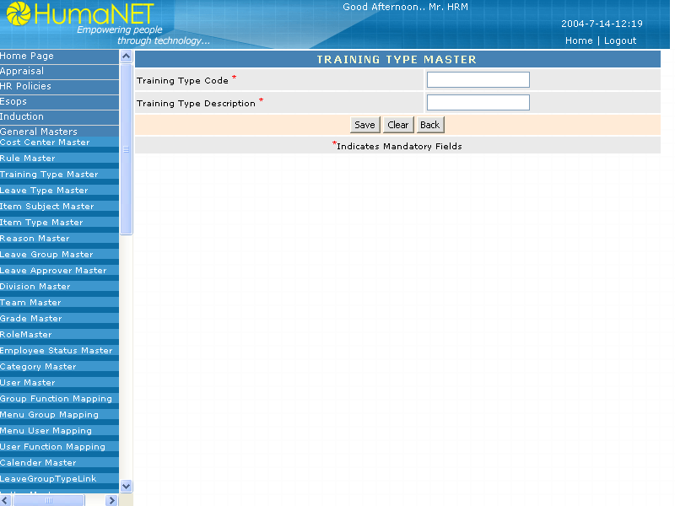

Input

Training type id and training type name

Output

Saving the record.

Processing

From search screen the user can come to this screen by clicking add new for adding a new training type or by clicking the existing training type id for modifying the training type.

Submit Button :

Validate the entered values and saves the record.

Cancel Button:

On click clear the entered values.

Attributes

Sr No | Entity | Description | Type | Length
1. | Training type id | Id for identifying the training type uniqly | Char | 10
2. | Training type name | Training type name | Char | 15

Appendices

Appendix A - Acronyms and Abbreviations

Acronyms and Abbreviations | Description
HUMANET | A product of Blue chip.
HR | Human Resource Personnel
URS | User Requirement Specification

Appendix B - Glossary of Terms

N.A

Amendment History

Date | Nature of amendment | Version | Pages affected | Author | RFC / CR No.

Note: Page numbers mentioned against each version are applicable to those versions only. For older versions of the document check in archive.

