Appraisal Module for HumaNet

BLR/P04/087/FS/I00

V000.a

 | Name | Role | Signature | Date
Author | Joam Mathew |  |  | 12/07/2004
Reviewer
Approver

BLUE CHIP COMPUTER CONSULTANTS PVT. LTD.

20/21, PATTALAMMA LAYOUT, SINGASANDRA,
HOSUR MAIN ROAD, BANGALORE - 560068. INDIA.
PH: 080 – 573 1603-5, FAX: 080 – 573 3156.

Table of Contents
1. Introduction 3
1.1. Purposes 3
1.2. Scope 3
1.3. Audience 3
1.4. Reference 3
2. Functional Overview 3
2.1. Major Functions 3
2.2. Functions Out of Scope 4
2.3. Assumptions / Constraints / Dependencies (A /C /D) 4
3. Functions 5
3.1. Common function 5
3.2. Event Log Screen 6
3.3. Set Date 9
3.4. Key Result Objectives 12
3.5. Objective Set Review 15
3.6. Objectives Vs Results 18
3.7. Self Appraisal 19

Introduction

Purposes

The purpose of this document is to define the Appraisal module functionality, which should be integrated with HUMANET. This document aims to capture all the details that are essential for the appraisals of the employees by their superiors.

Scope

The scope covers the entire Appraisal functionality as given below

- Capturing the important milestones (log-events) the employee has achieved.
- Setting of objectives by the employees.
- Submitting the objectives to the approver for approval.
- Approving of the objectives of his subordinates by the approvers.
- Setting the competency levels for the employees.
- Final Appraisal by the approvers.
- Releasing the appraisals for discussion with employees.
- Suggesting development plans for the employees
- Incorporating the development plans into training.

Audience

The intended audience for this document are

Audience | Responsibilities

Reference

Appraisal Module URS document

Functional Overview

Major Functions
This module is developed to capture the workflow, processes and transactions of the current Appraisal system in terms of competencies and objectives.
Through out the year supervisors log events for his/her subordinates into the system. Final Appraisal will start by setting the date for competency appraisal and this will initiate filling the final quarter objective comments and competency appraisal form and the employee also uses the set date for initiating setting the objectives for the next year. On setting the date mail will go to the employee and on homepage link will appear to fill the self-appraisal form.
Case I
After setting the date for Key Objectives. Each employee will set the objectives for the year and submits it to the supervisor, supervisor will review it and forwards to the above supervisors and finally it will come back to the employee for corrections and after corrections the supervisor will freeze/close it. Once it is freezed, objectives cannot be edited. Reviews will happen quarterly. For each quarter, intimation date prior to the quarter is set by the administrator of the system at the starting of the year. Based on the parameter (intimation date) days prior the end of the quarter, mail will go to the employees and on homepage link will appear to review the objectives. The employees will key the actual result in that quarter and he will submit it to the immediate supervisor. The immediate supervisor will write his comments and he will forward to the 2nd supervisor for review. Here supervisors will be ‘n’ level. Review form will be forwarded in hierarchical manner he cannot skip any supervisor in between but while any supervisor is sending it back he can send it to any level. Like this for all the 3 quarters review will happen. And in the final appraisal 4th quarter comments will be entered. At the end of the 4th quarter employee will enter comments, and significant achievements beyond objectives, overall ratings, and supervisor comments will be entered by the immediate supervisor (Appraiser).
Case II
Final appraisal will be initiated with set date competencies. On initiating, homepage link will appear to all employees where they can fill up 4th quarter comments for objectives and competencies form and once the employee fills self-appraisal form, he/she will submit it to his immediate supervisor (Appraiser). The appraiser will write his final comments for all the objectives as well as ratings to each objective and overall rating. And also fills ratings for competencies with comments to each competency and identified strengths and improvements will be entered in performance summary The immediate supervisor can send it back to the employee for corrections any number of times if it is not forwarded to the 2nd supervisor for review. Here supervisors will be ‘n’ level. Once the form moves from the immediate reporting-to Supervisor, then it cannot be send back to the Employee for any reason. Form will be forwarded in hierarchical manner he cannot skip any supervisor in between but while any supervisor is sending it back he can send it to any level. After reviews are finished form will be send to HR and in some cases HR will forward it to BUH (Discretion of HR) and after BUH review HR will release the appraisal for discussion between the employee and immediate supervisor. And intimation will go as mail to both the employees about the discussion date.
Before the discussion, immediate supervisor will fill the performance summary, which contains strengths and improvements. After the discussion immediate supervisor will move the necessary improvements to development plan. Some of the development plans methodology like Internal/External training will be mapped to a training need or a new training need.
After the appraisal development plan will initiate and immediate supervisor will fix some development plans for the employee and reviews will happen quarterly like in objectives.

Functions Out of Scope

N A

Assumptions / Constraints / Dependencies (A /C /D)

Description of Assumptions / Constraints / Dependencies
Assumptions | - Objective setting will occur yearly  - Objective reviews will occur quarterly  - Appraisals will occur yearly
Constraints | N A
Dependencies | - Employee related features depends Employee info module of HUMANET  - Approver mappings for employees and Requisition approvals depends on the mapping done on HUMANET

Functions

Common function

Sr. No. | Function Name | Purpose
 | Employee listing | Employee selection window to select employees. This by default has a search option too.
 | Common Dialog | Wherever popup screens are there for selection then common dialog will be used to populate the screen, which will be having search option also.
 | Objective Approvals | When an employee submits his objectives, the objectives details are sent to the mapped approver. The approver can verify the objectives.
 | Competency Approvals | When an employee submits his competencies, the competency details are sent to the mapped approver. The approver can verify the competencies.

Event Log Screen

Purpose

This screen allows the user to view the events of the selected subordinate employee and also allows the user to add new event for the employee.

User Interface

Log Events Listing
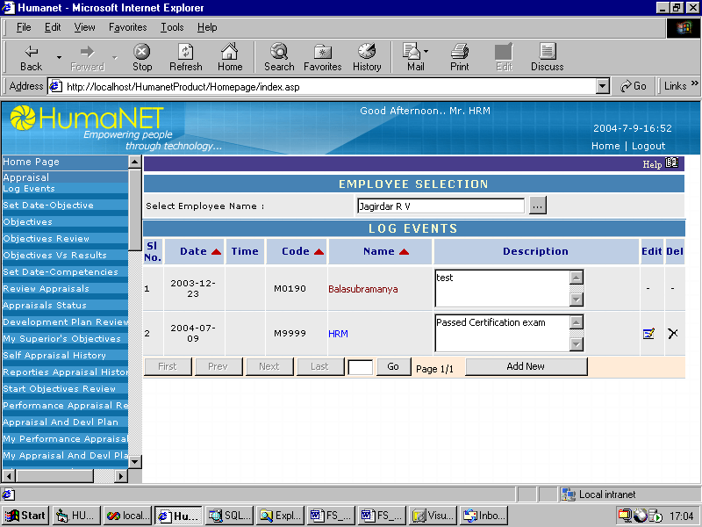
Add/Edit Screen for Log Events
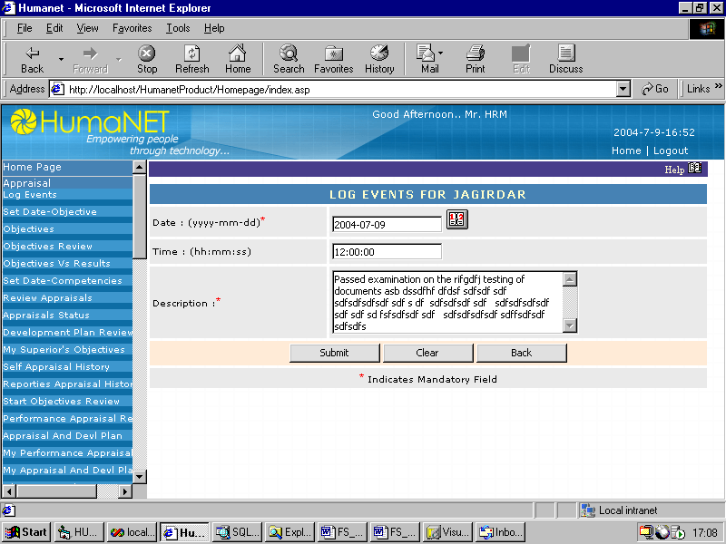

Input

For Listing Screen:
- Employee Id
- Supervisor id
For Add/Edit Screen:
- Employee Id
- Supervisor id
- Date
- Time
- Event description

Output

For Listing Screen:
List of the events for the employee
For Add/Edit Screen:
Saves the details to the database

Processing

Default it displays all the events specific to the selected employee with 10 records per page. And there are buttons to delete the existing event and edit button to edit the existing event and also add new button to add more events.
List Screen:
Select Employee:
On click of which will open a screen where the user can see all the subordinate employees and he can select any one among them. On select and submit it will show the events of the selected employee.
Add New Button:
On click of which will open a screen where the user will enter date, time and event description and saves to the database.
Edit Button:
On click of which will open a screen where the user will edit event description and saves to the database.
Delete Button:
On click user can delete a particular event from the list.
Navigation buttons:
Navigates through pages
Go Button:
Goes to a particular page of the resulted set.
Add/Edit Screen:
Submit Button:
Saves data to the database
Clear Button:
Resets the page to the loaded event
Back Button:
Takes the user to the grid screen.

Attributes

Sr. No | Display Field Name | Description | Data Type | Size
 | Log event date | Log event date | Date | 8
 | Log event time | Log event time | VarChar | 10
 | Log event description | Log event description | VarChar | 1000

Set Date

Purpose

This screen allows the authorized user to initiate the self-appraisal for competency to fill and also to initiate setting the objectives for the next year.

User Interface

Set Date Objectives
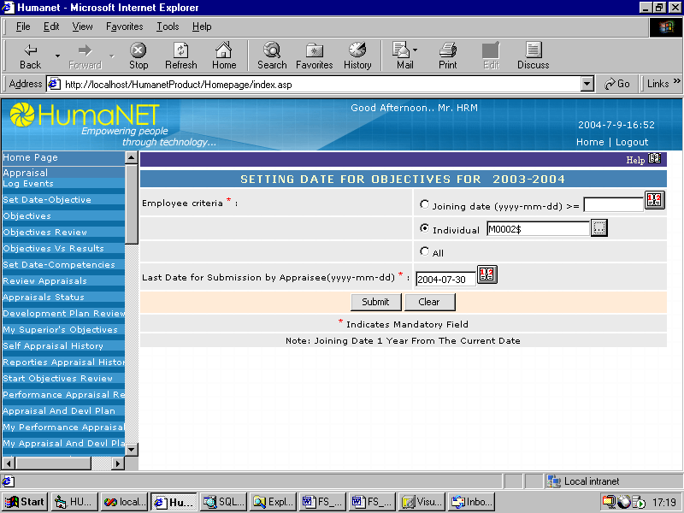

Set Date Competencies
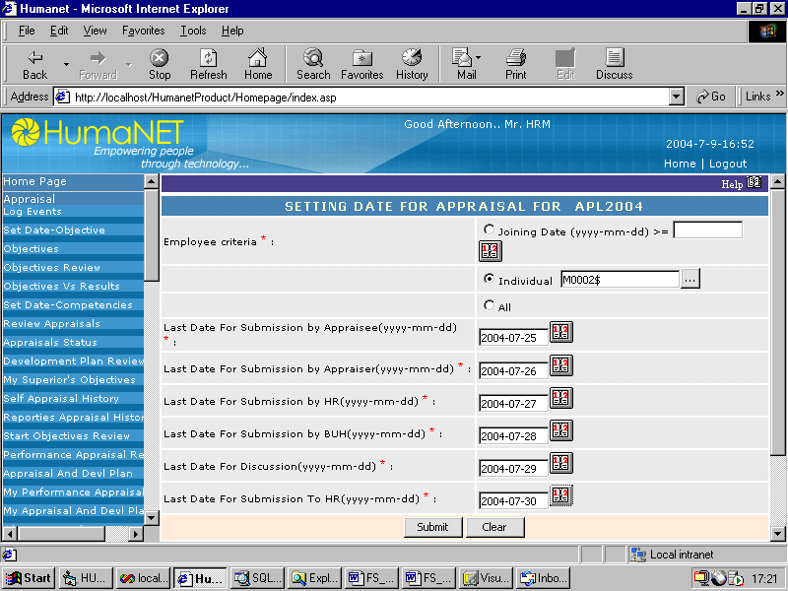

Status Report for set date
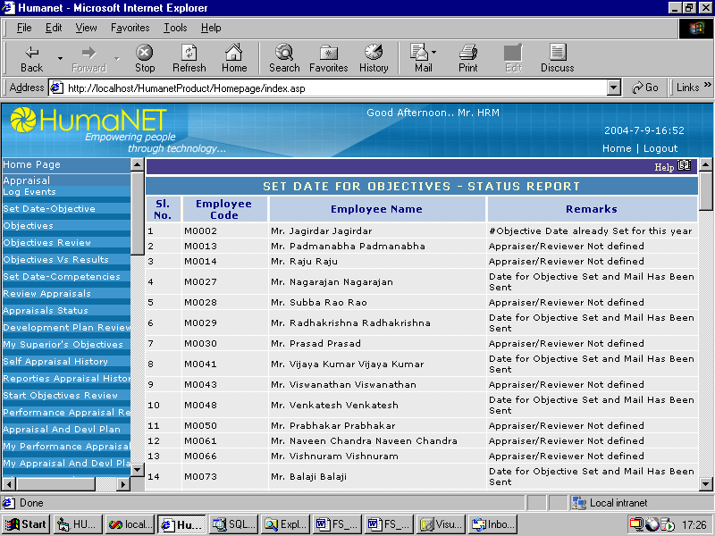

Input

Calendar Period and the module (objectives or competency appraisal)

Output

It will send mails to the selected employs to fill the objectives or competency appraisal also creates a link in the homepage of the employee.

Processing

User will select the employee criteria for appraisal and the last date of submission for various heads and submits the page.
On submit all the date parameters are saved to the database and mail will go to the selected employees in the criteria at the same time a link will be created in the homepage of the employee. The Status report lets the user know the successful and unsuccessful operations for the employees.
Submit button:
On submit all the date parameters are saved to the database and mail will go to the selected employees in the criteria as well as link in the homepage of the employee, and redirects to the result screen where the user knows the successful and unsuccessful operations.
Clear Button:
On click clears the screen.

Attributes

Sr. No | Display Field Name | Description | Data Type | Size
 | Employee code | Employee code | VarChar | 20
 | Last Date For Submission by Employee | Last Date For Submission by Employee | Date
 | Last Date For Submission by Appraiser | Last Date For Submission by Appraiser | Date
 | Last Date For Submission by HR | Last Date For Submission by HR | Date
 | Last Date For Submission by BUH | Last Date For Submission by BUH | Date
 | Last Date For Discussion | Last Date For Discussion | Date
 | Last Date For Submission To HR | Last Date For Submission To HR | Date

Key Result Objectives

Purpose

This screen allows the user to maintain his objectives. He can view, add, edit, and delete his objectives.

User Interface

Key Result Objectives Listing
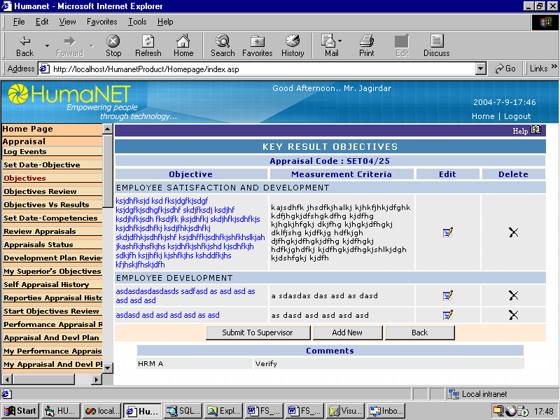
Key Result Objectives Add/Edit
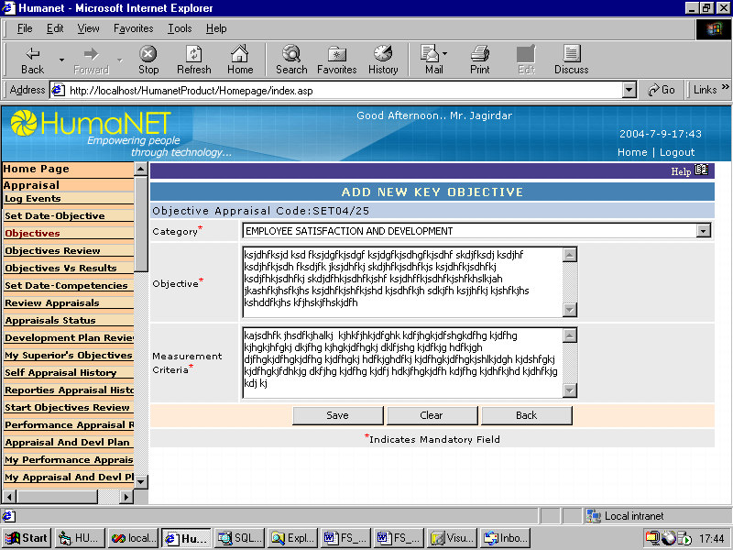

Input

For Add/Edit Screen:

- Category
- Objective
- Measurement Criteria

For Listing Screen:

- Employee code

Output

Listing Screen:
Displays the list of objectives, which the employee has set

Add/Edit Screen:
Sets the objectives for the employee.

Processing
By default it displays all the objectives of the logged in employee, and there are buttons to delete the existing objectives and edit button to edit the existing objectives and also add new button to add more objectives under different categories.
Add New Button:
On click of which will call a screen where the user will enter objective details and saves to the database.
Edit Button:
On click of which will call a screen where the user will edit objective details and saves to the database.
Delete Button:
On click user can delete a particular objective details from the list.
Submit to Supervisor:
On click the objectives form will be submitted to supervisor for review.

Attributes

Sr. No | Display Field Name | Description | Data Type | Size
 | Employee code | Employee code | VarChar | 20
 | Objective | Objective | VarChar | 1000
 | Measurement criteria | Measurement criteria | VarChar | 1000
 | Category | Category | VarChar | 10

Objective Set Review

Purpose
These screens are for the approvers to verify their subordinates’ objectives and approve them. If approved can be send to the senior approvers else sent back to employee itself for corrections.

User Interface

Listing Screen
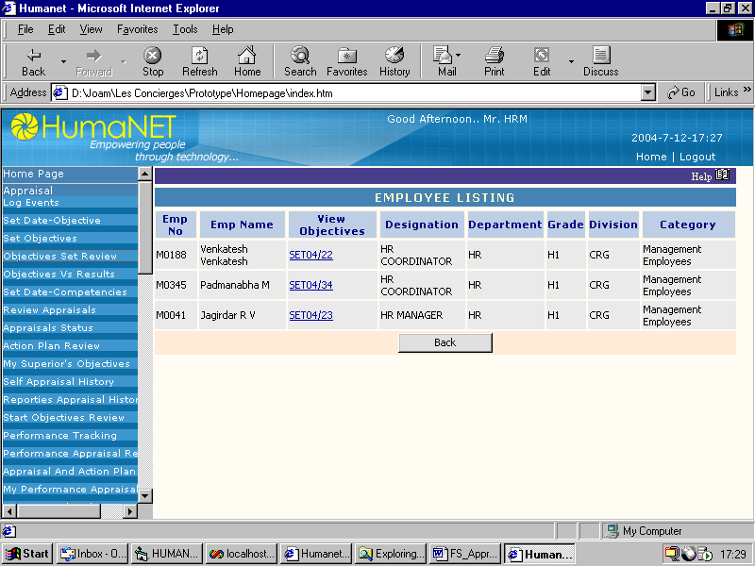
Approval Screen
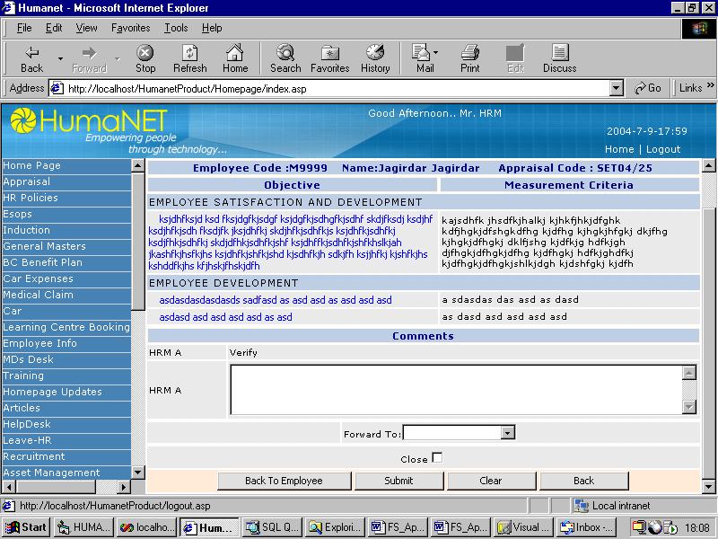

Input
Approval Screen:

- Comments
- Employee name

Output

Listing Screen:
Displays the list of objectives that are to be approved by the logged in employee.
Approval Screen:
Saves the details entered by the approver into the database.

Processing

These screens are for the approvers to approve the objectives set by their subordinates and send them to their higher approvers. If there is any corrections to be made then the objectives are send back to the employee. The approver is supposed to make his remarks before taking any action.

If send back to the employee then a link will be created in the homepage of the employee. If send to the higher approver a link will be created in the homepage of the approver. Corresponding mails will also be sent.
Listing Screen:
View Objectives Link:
On Click takes the user to the objectives approval screen for the corresponding employee.
Back Button:
On Click takes the user to the homepage.

Approval Screen:
Log Events Button:
On Click opens a window where the approver can view the important events about the employee.
Back to employee Button:
On click of this button the objectives will be send back to the employee for corrections.
Submit Button:
On click of this button the approvers’ comments will be saved and the objectives will be sent to approver selected. If the close checkbox is checked the objectives will be closed after the review.
Clear Button:
Clears the entries made by the user on the current screen.
Back Button:
Takes the user back to the listing screen for the objectives review.

Attributes

Sr. No | Display Field Name | Display Field Name | Data Type | Size
 | Employee code | Employee code | VarChar | 20
 | Objective | Objective | VarChar | 1000
 | Measurement criteria | Measurement criteria | VarChar | 1000
 | Category | Category | VarChar | 10

Objectives Vs Results

Purpose

This screen is for the employee to fill in the actual results he has achieved against his objectives.

User Interface

Input

Output

Processing

Attributes

Self Appraisal

Purpose

This screen is for the employee to fill in the actual competencies at the end of the year.

User Interface

Status display Screen
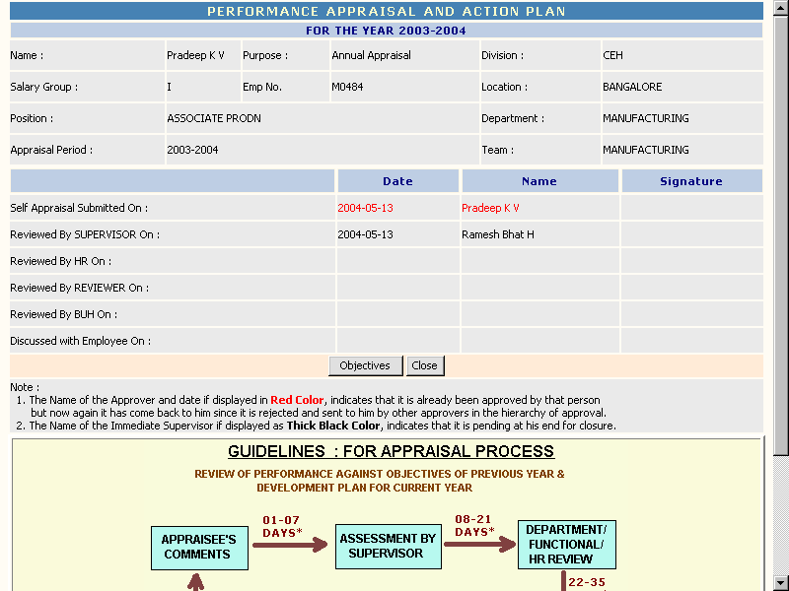
Key Result Objectives Screen
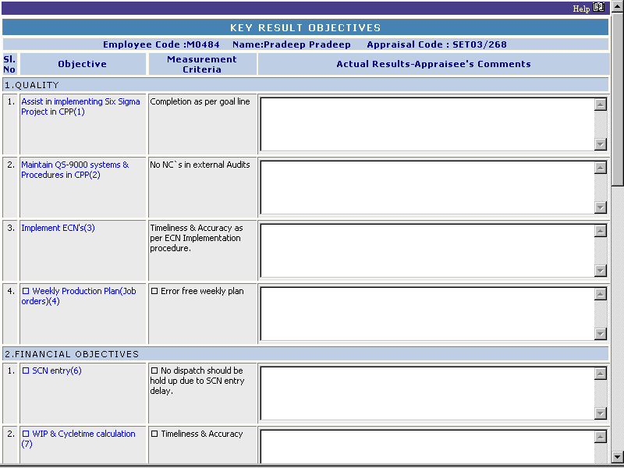
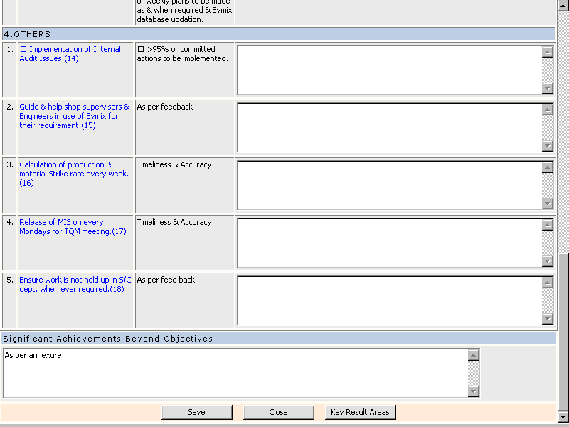

Self Appraisal (Key Result Areas)
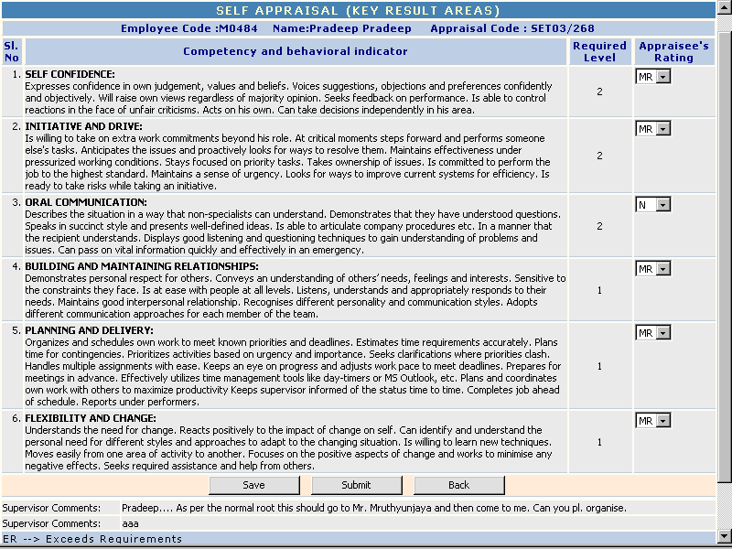

Input

For Key Result Objectives
- Actual Results for each objective

For Key Result Areas
- Ratings for each competency

Output

- Saves the details to the database and forwards the appraisals to the approver.

Processing

Status Display Screen:
Objectives Button:
On click takes the user to the key result objectives screen
Close Button:
On click closes the window.
Key Result Objectives Screen:
Objectives Link:
On click takes the user to the page where he can view the details, his comments, supervisor’s comments, and ratings of the previous quarters.
Save Button:
On click saves the details to the database.
Close Button:
On click closes the window
Key result areas Button:
On click takes the user to the key competencies screen
Key Result Areas Screen:
Save Button:
On click saves the details to the database
Submit Button:
On click saves the details and forwards the details to the supervisor for approval.
Back Button:
On click takes the user to the Key result objectives screen.

Attributes

Sr. No | Display Field Name | Display Field Name | Data Type | Size
 | Actual Results | Actual Results achieved by the employee during that quarter | VarChar | 500
 | Appraisee’s Rating | Employee’s rating of the competencies achieved during the year | VarChar | 10

Quarterly Key Objectives Comments

Purpose

This screen is for the employee and the approvers to view the employee’s and the supervisor’s comments on the selected objective for the current year.

User Interface

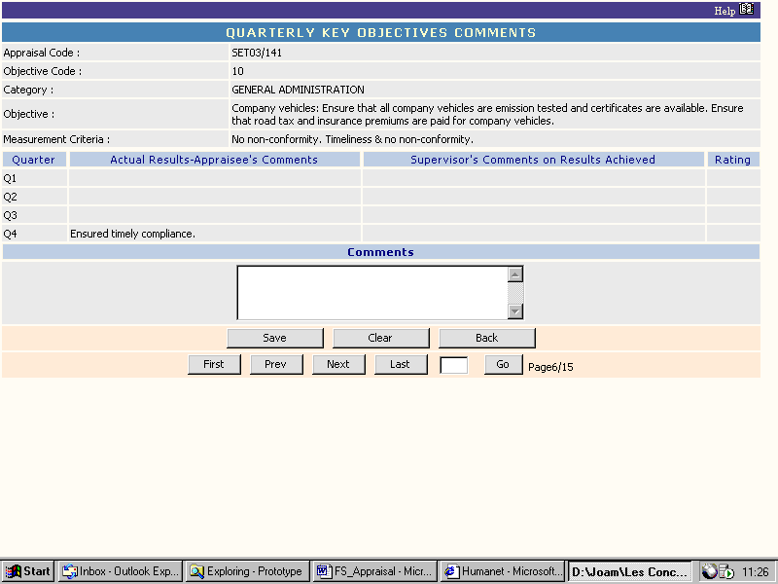

Input

- Comments

Output

Displays the comments of the previous quarters and saves the overall comments into the database.

Processing

Save Button:
Saves the data to the database
Clear Button:
Resets the page to the loaded event
Back Button:
Takes the user to the key result objectives screen.
Navigation buttons:
Navigates through the different objectives for the employee
Go Button:
Goes to a particular page of the objectives for the employee

Attributes

Sr. No | Display Field Name | Display Field Name | Data Type | Size
 | Comments | Overall comments for the appraisal year. | VarChar | 500

Review appraisals Listing

Purpose

This screen lists the appraisals that have been submitted to the approver for review.

Use Interface

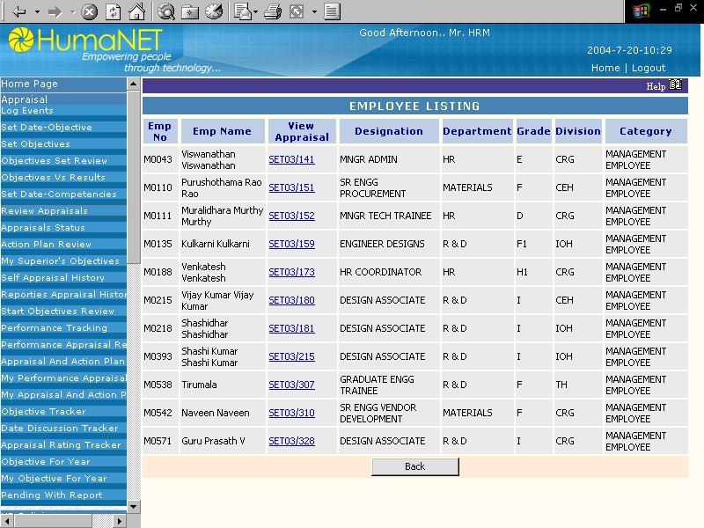

Input

N A

Output

Displays the list of appraisal that are pending for the approver

Processing

View Appraisal Link:
On click opens the key result objectives screen where the approver can enter the remarks about the employee.
Back Button:
On click takes the user to the homepage.

Attributes

N A

Appraisal Review

Purpose

These screens allow the approvers to enter the comments and ratings for the employees for last quarter objectives as well as the key competencies.

User Interface

Status display screen
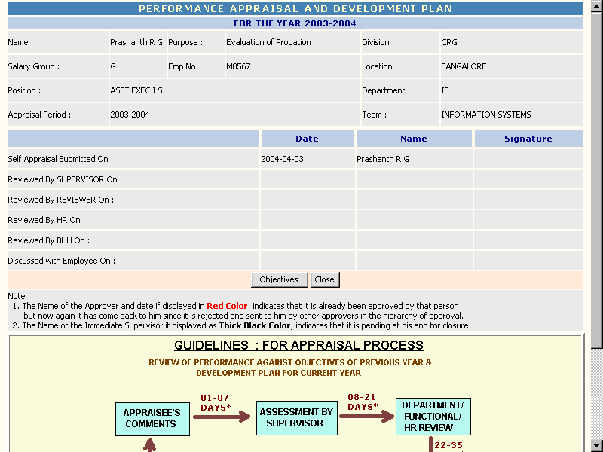
Key Result Objectives Screen
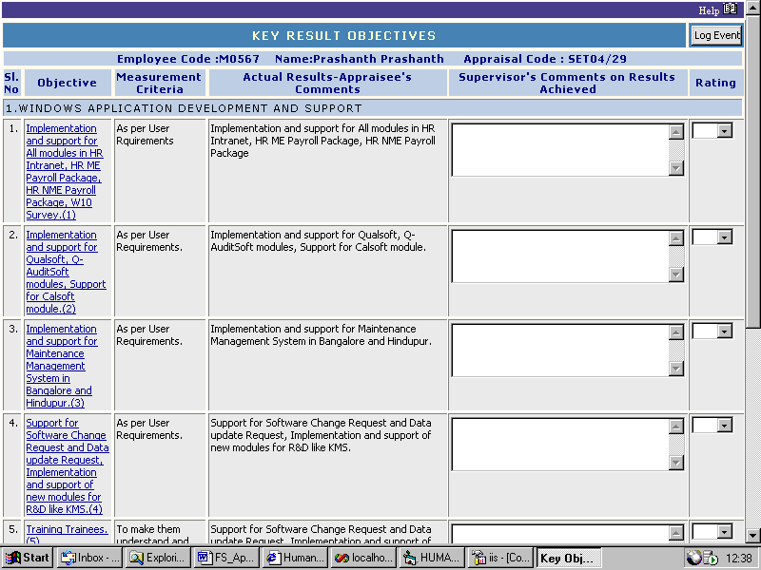

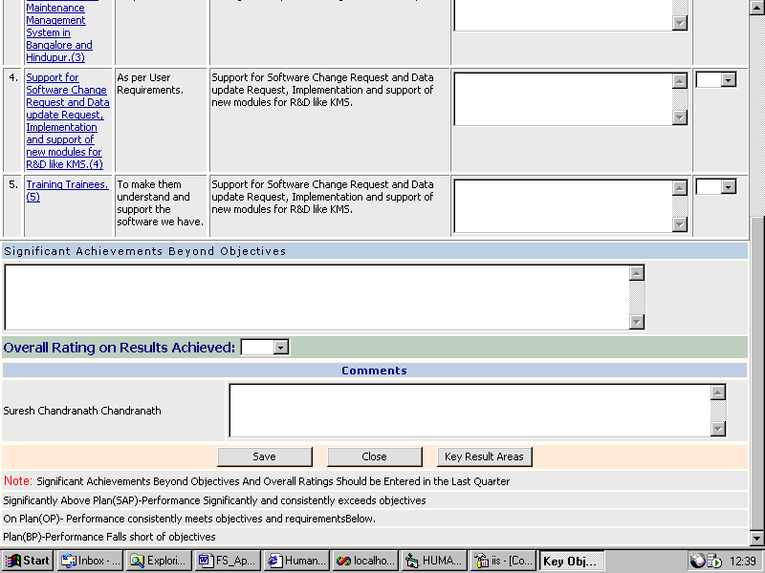
Key Result Areas Screen
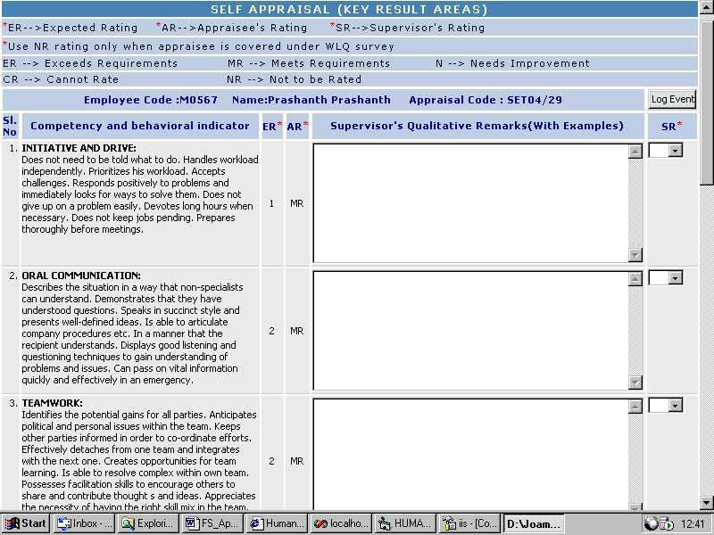

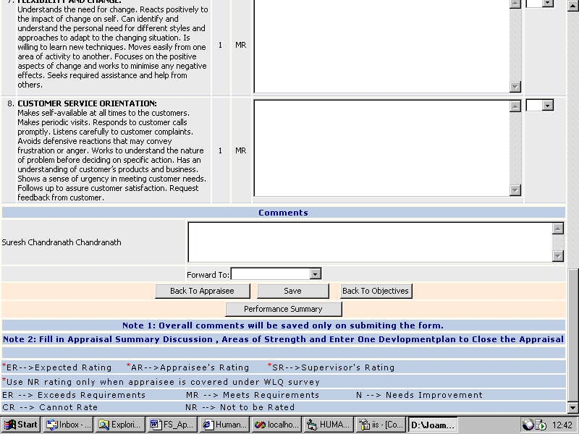

Input

For Key Result Objectives
- Supervisor’s comment for each objective
- Ratings
- Significant achievements beyond objectives
- Overall rating on results achieved
- Comments

For Key Result Areas
- Supervisor’s qualitative remarks for each result area.
- Ratings
- Comments
- Forward to

Output

Saves the details to the database and forwards the appraisals to the other approvers.

Processing

Status Display Screen:
Objectives Button:
On click takes the user to the key result objectives screen
Close Button:
On click closes the window.
Key Result Objectives Screen:
Objectives Link:
On click takes the user to the page where he can view the details, his comments, supervisor’s comments, and ratings of the previous quarters.
Save Button:
On click saves the details to the database.
Close Button:
On click closes the window
Key result areas Button:
On click takes the user to the key result areas screen
Key Result Areas Screen:
Log Events Button:
On Click opens a window where the approver can view the important milestones achieved by the employee
Back to appraisee Button:
On click sends the appraisal to the employee for corrections.

Save Button:
On click saves the details to the database
Performance Summary Button:
On click takes the user to the performance summary screen where the user can enter the performance summary details of the employee.
Back to objectives Button:
On click takes the user to the Key result objectives screen.

Attributes

Sr. No | Display Field Name | Display Field Name | Data Type | Size
 | Supervisor’s comments on results achieved | Supervisor’s comments on results achieved | VarChar | 500
 | Rating | Rating for objectives | VarChar | 10
 | Significant achievements beyond objectives | Significant achievements beyond objectives | VarChar | 500
 | Overall ratings on results achieved | Overall ratings on results achieved | VarChar | 10
 | Comments | Comments for Objective review | VarChar | 500
 | Supervisor’s qualitative remarks | Supervisor’s qualitative remarks | VarChar | 500
 | Supervisors Ratings | Rating for key result areas | VarChar | 10
 | Comments | Comments | VarChar | 500
 | Forward to | The approver to which the appraisal is to be forwarded. | VarChar | 20

Performance Summary

Purpose

This screen is for the supervisor to enter the performance details of the employee for the current year. The areas where the employee is strong and where the employee needs improvement can be recorded. The areas of development needed, can be incorporated into the development plan. The details of the discussion held with the employee can also be recorded.

User Interface

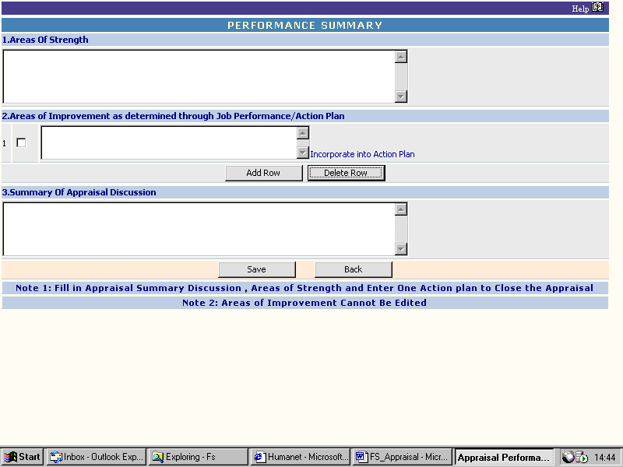

Input

- Areas of strength
- Areas of improvement
- Summary of appraisal discussion

Output

Saves the details into the database.

Processing

Incorporate into Action Plan link:
On click of this link the areas where the employee needs training will be incorporated into the development plans.
Add Row Button:
On click of this button an additional row will be inserted for entering the areas of development.
Delete Row Button:
On click of this button the rows selected will be deleted.
Save Button:
On click of this button the details will be saved into the database.
Back Button:
On click of this button the user will be taken back to the key result areas screen.

Attributes

Sr. No | Display Field Name | Display Field Name | Data Type | Size
 | Area of strength | Area of strength | VarChar | 500
 | Area of Improvement | Area of Improvement | VarChar | 500
 | Summary of appraisal discussion | Summary of appraisal discussion | VarChar | 500

Appraisal Status

Purpose

These screens are for the HR to know the status of the appraisal. The status of the appraisals can be

- Complete – If the appraisal cycle for the year is completed.
- Pending at approver – If the appraisal is pending with any of the approvers.
- Pending with self – If the employee has not submitted his self-appraisal form.

Reminders can be sent to the approvers or employees to finish off the appraisals.

User Interface

Criteria Screen
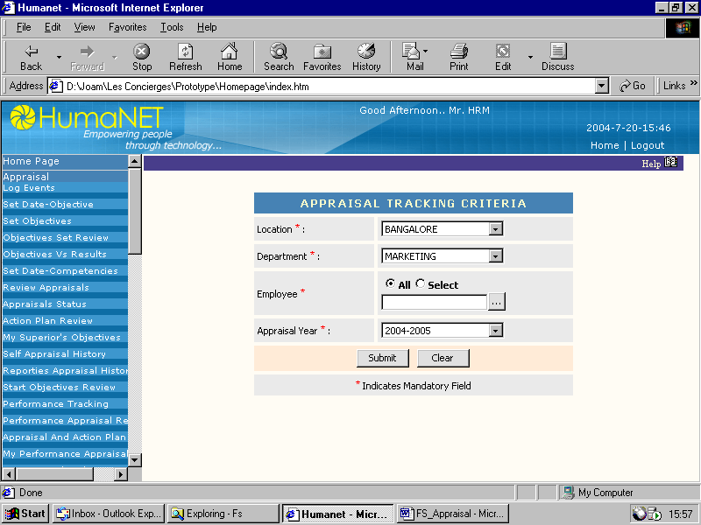
Listing Screen
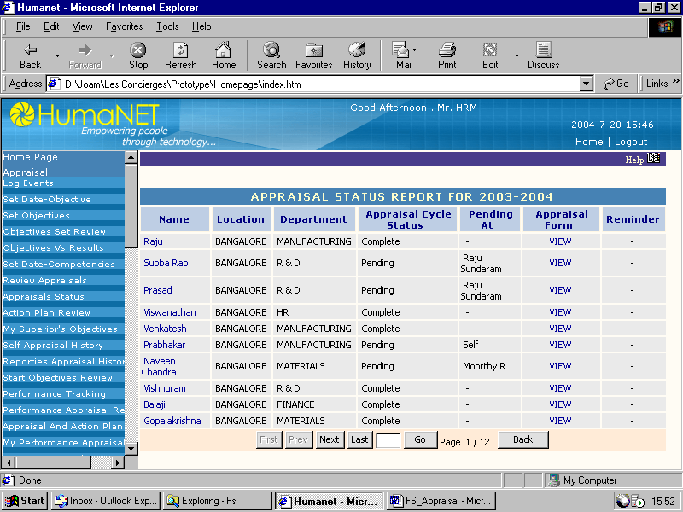

Appraisal View
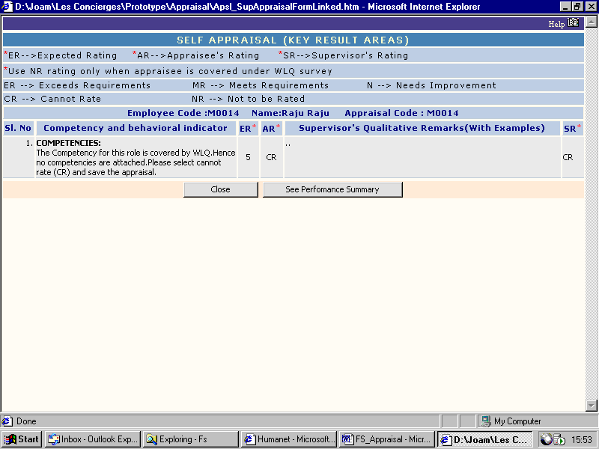
Performance Summary View
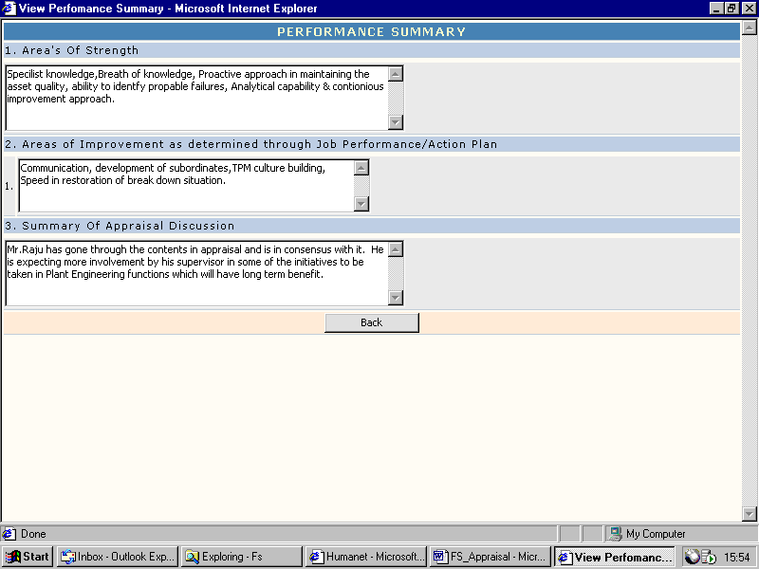

Input

For Criteria Screen
- Location
- Department
- Employee
- Appraisal Year

Output

Displays the appraisal status of the employees

Processing

For Criteria Screen:
Submit Button:
On Click takes the user to the Appraisals listing screen
Clear Button:
On click clears the fields and resets it to the original values
Appraisal Listing Screen:
Appraisal Form Link:
On click displays the appraisal details of the selected employee
Navigation Buttons:
Navigates through the list of appraisals
Back Button:
On click of this button takes the user to the criteria screen

Attributes

N A

