SVKM's NMIMS
Mukesh Patel School of Technology Management & Engineering
Statistical Natural Language Processing

Jupyter Notebook Lab Evaluator
Grading code and conceptual explanation, and flagging "correct output, wrong explanation" submissions

Project Report, Group 3
AI University Platform › Academic Services › Labs

Presented by Group 3
S016 · S017 · S020 · S025 · S026 · S027

October 2026

Contents
1. Summary
2. Problem and institutional context
3. Architecture
4. How it works
5. Stretch goal: correct output, wrong explanation
6. Scoring, weights and feedback
7. Dataset
8. Baseline vs improved, and results
9. Error analysis
10. Reusability and how to run it
11. Responsible AI, limitations and future work
12. Conclusion
References
Appendix A. Rubric for the customer segmentation lab
Appendix B. Feedback lines for all 18 submissions

1. Summary
The Lab Evaluator grades a student's Jupyter notebook on both its code and its written explanation, and flags notebooks whose code works but whose explanation describes the wrong algorithm. It takes a lab's rubric.json and one or more student .ipynb files. For each student it returns marks for code correctness, expected output, errors, documentation and conceptual explanation, a total out of 100 with a grade, a one-line note of where marks were lost, and the wrong-explanation flag.
No large language model is involved. The evaluator separates code from text, looks for rubric concepts and algorithm names using keyword lists, and compares the explanation with a model answer by similarity (a sentence-transformer model if one can be loaded, TF-IDF otherwise). It is about 200 lines of Python.
We tested it on 23 notebooks. Five are real student submissions from two course labs (text classification and K-Means). The other 18 are synthetic, generated at random across three more labs: SMS spam detection, customer segmentation and news-topic classification, with six kinds of submission per lab. On the real notebooks it flagged both misexplained submissions, raised no false flags, and ranked the strong, misexplained and broken notebooks the way we expected. On the synthetic set it caught all three misexplained submissions (recall 1.00), but it also flagged three correct explanations that happened to name an algorithm the student had rejected (precision 0.50). 15 of the 18 totals landed in the grade band we designed them for. Compared with a keyword-only baseline, the new explanation scorer dropped misexplained submissions from 56 to 9 out of 100 and kept strong ones at 95. It still under-scores explanations written in plain English. Over all 23 notebooks, flag recall was 1.00 and precision 0.63. The real set is small and nobody has marked it yet, so treat these numbers as a first look at how the method behaves.
The evaluator is one notebook, lab_evaluator.ipynb, that runs in Google Colab or local Jupyter. It writes reports/gradebook.csv, reports/results.json and a histogram of marks.

2. Problem and institutional context
Programming labs are submitted as .ipynb files that mix code, outputs, markdown explanations and comments, but most automated graders only check whether the code runs. A student can copy working code and write an explanation of a different algorithm, and still get full marks. Manual grading of both code and understanding is slow and inconsistent across teaching assistants. This project is Group 3's component of the course's AI University platform, under Academic Services → Labs.
User | What they get
Lab instructors and TAs | A first-pass mark per student, a one-line reason for every deduction, and a flag on suspicious explanations, so they review only the notebooks that need it
Students | Immediate, specific feedback, such as "explanation −17.7: describes a different algorithm than the code"
Other platform components | A gradebook row per student (a Python dictionary, CSV row or JSON record) that a dashboard or early-warning service can read

Objectives
- Separate a notebook into code, comments, markdown explanation, outputs and errors, and re-run it safely.
- Score five rubric components with rule-based checks a teacher can read.
- Measure conceptual understanding through concept coverage and similarity to a model answer.
- Detect a mismatch between the algorithm described in the text and the algorithm used in the code.
- Give evidence-based feedback without a generative model.
- Make a new lab need only a rubric.json.

Related work
Existing approaches either run unit tests only (nbgrader and course autograders) or send the notebook to an LLM. PyEvalAI (Wandel et al., 2025, arXiv 2502.18425) combines unit tests with a locally hosted LLM. Automatic short-answer grading compares student answers with a reference using lexical overlap or sentence embeddings such as Sentence-BERT (Reimers & Gurevych, 2019). We kept the unit tests, scored the explanation with simple NLP methods, and added a check that compares the algorithm the text describes with the one the code uses. Each deduction in the gradebook points to the check that caused it.

3. Architecture
The notebook is split into code and prose once. The code is executed, the algorithms named in the prose are compared with the ones used in the code, and the explanation is compared with the model answer. The results are then weighted into one gradebook row.
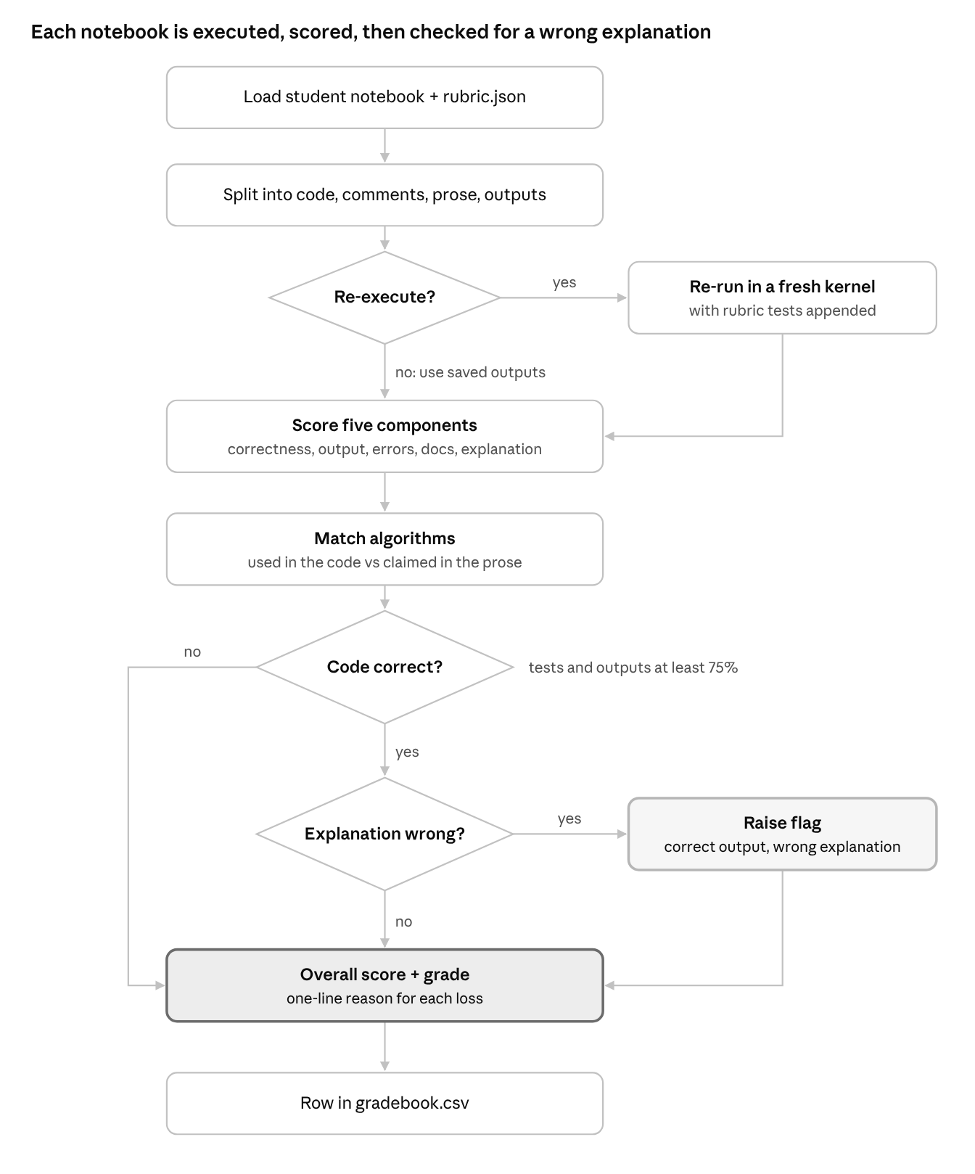
Figure 1. Grading flowchart for one notebook
Section 5 explains when a notebook is flagged. A flagged notebook keeps its marks (except the explanation penalty); the flag and the mismatch are added to its gradebook row.

4. How it works
The notebook has one section for each of these steps.
read_notebook() splits the cells into code, comments, markdown text (minus the lab title), printed outputs and errors, and counts cells the student never ran.
run_notebook() re-runs the notebook in a fresh kernel in a separate process, with the rubric's tests added as extra cells that print PASS or FAIL. So correctness comes from the student's own objects in memory, and saved outputs can't fake it.
The evaluator keeps a table of 15 common NLP/ML algorithms. It lists, for each one, its family, the words that show it is used in the code (e.g. CountVectorizer, AgglomerativeClustering, LinearSVC), and the words that show it is described in the text (e.g. "bag of words", "dendrogram", "support vector"). Algorithms in the same family are alternatives: you use bag of words or TF-IDF; you cluster with K-Means or hierarchically.
similarity() compares the student's explanation with the rubric's model answer, using the all-MiniLM-L6-v2 sentence-transformer if it loads and TF-IDF cosine similarity otherwise.
Each of the five checks returns a score from 0 to 1 and a one-line reason when marks are lost.
Check | Marks | How it is scored
Code correctness | 35 | Share of rubric tests passed; without tests, share of code cells that ran without error
Expected output | 15 | Share of expected results found in the printed output (text, or a number within a range)
Errors | 15 | 1 minus 0.3 per runtime error and 0.1 per cell never run
Documentation | 15 | Average of three checks: 150+ words of explanation, 0.15+ comments per code line, docstrings on every function
Conceptual explanation | 20 | 60% share of rubric concepts mentioned + 40% similarity to the model answer; halved if under 30 words; cut to a fifth if it describes a different algorithm than the code

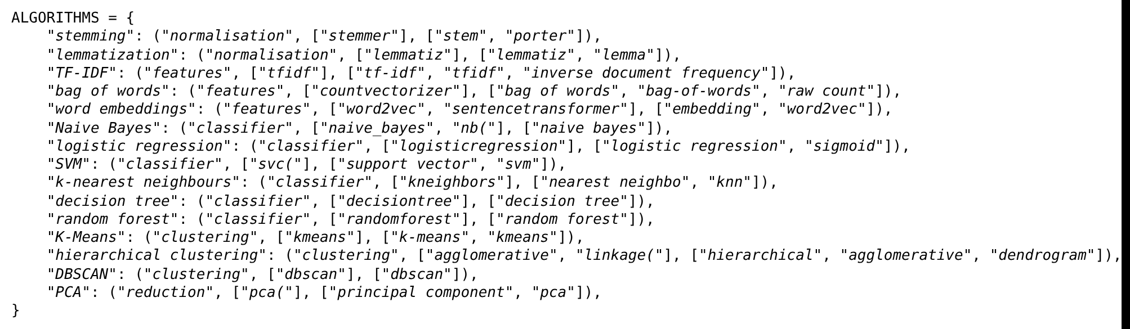
Figure 2. Screenshot of the algorithm table in lab_evaluator.ipynb (Section 5)
The explanation check combines concept coverage and similarity, then applies the two penalties.
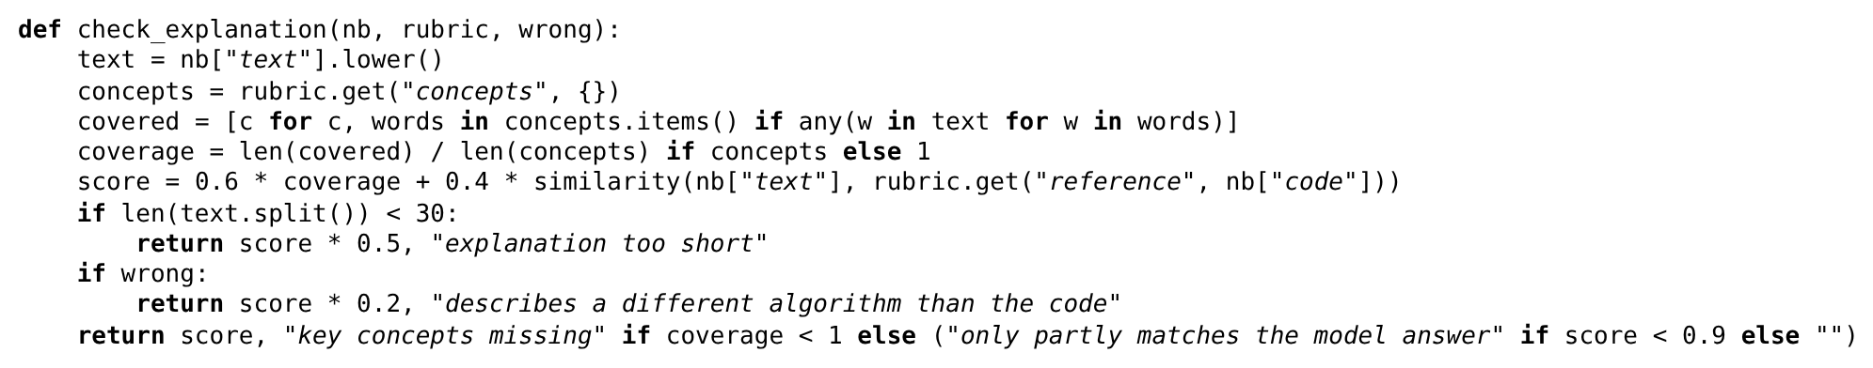
Figure 3. Screenshot of check_explanation() from lab_evaluator.ipynb (Section 7)

5. Stretch goal: correct output, wrong explanation
A notebook is flagged when its code is judged correct and its prose misdescribes the algorithm. Correct means at least 75% of rubric tests pass and, when the lab defines expected outputs, at least 75% of those are found.
The explanation counts as wrong when the text describes an algorithm that the code does not use, while the code uses a different algorithm from the same family. Example from the evaluation set: CS-02's text says "K-Means picks three random centroids" while the code calls AgglomerativeClustering.
If the code itself is wrong, the notebook isn't flagged. In that case the code is the problem. Short or missing explanations are not flagged here; they lose marks under documentation and explanation instead.
The gradebook's last column names every mismatch, for example "says bag of words, code uses TF-IDF, says Naive Bayes, code uses SVM" (NT-02).
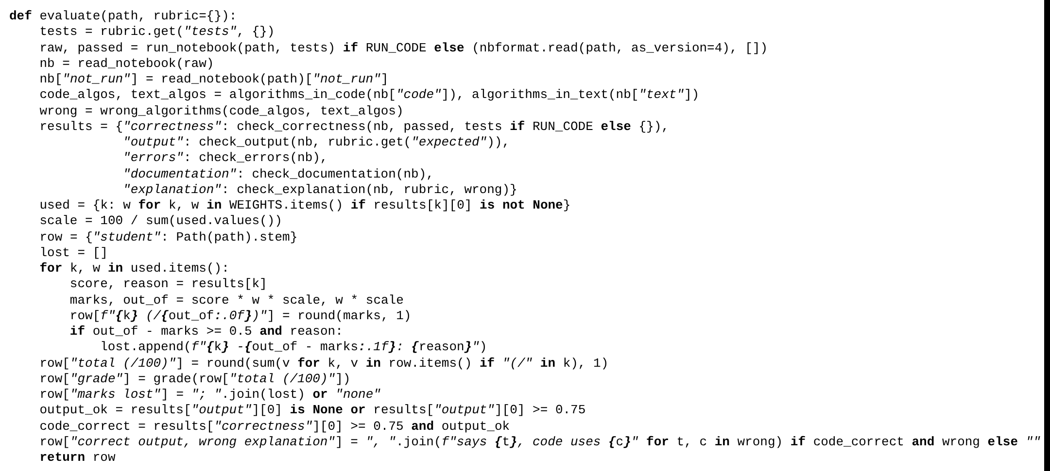
Figure 4. Screenshot of evaluate(): the five checks are combined, weighted, and the flag is set only when the code is correct

6. Scoring, weights and feedback
The overall score is a weighted average of five component scores, scaled to 100. Code correctness carries the most weight because working code is still the lab's main goal.
Component | Default weight
Code correctness | 35%
Conceptual explanation | 20%
Expected output | 15%
Documentation quality | 15%
Errors | 15%

The weights are set in one line at the top of the notebook (WEIGHTS). When a lab has no check of some kind, that check is skipped and the remaining marks are scaled up to 100. Grades are A from 90, B from 80, C from 70, D from 60, and F below 60.
Feedback is a single line per student saying where marks were lost, put together from what each check measured. No language model writes it. Losses under half a mark are not listed. For example, SP-03 gets:
"correctness -11.7: 1 of 3 tests failed; output -15.0: 2 expected result(s) missing; errors -15.0: 3 runtime error(s), cells not run; documentation -3.9: too little written explanation; explanation -14.2: key concepts missing"
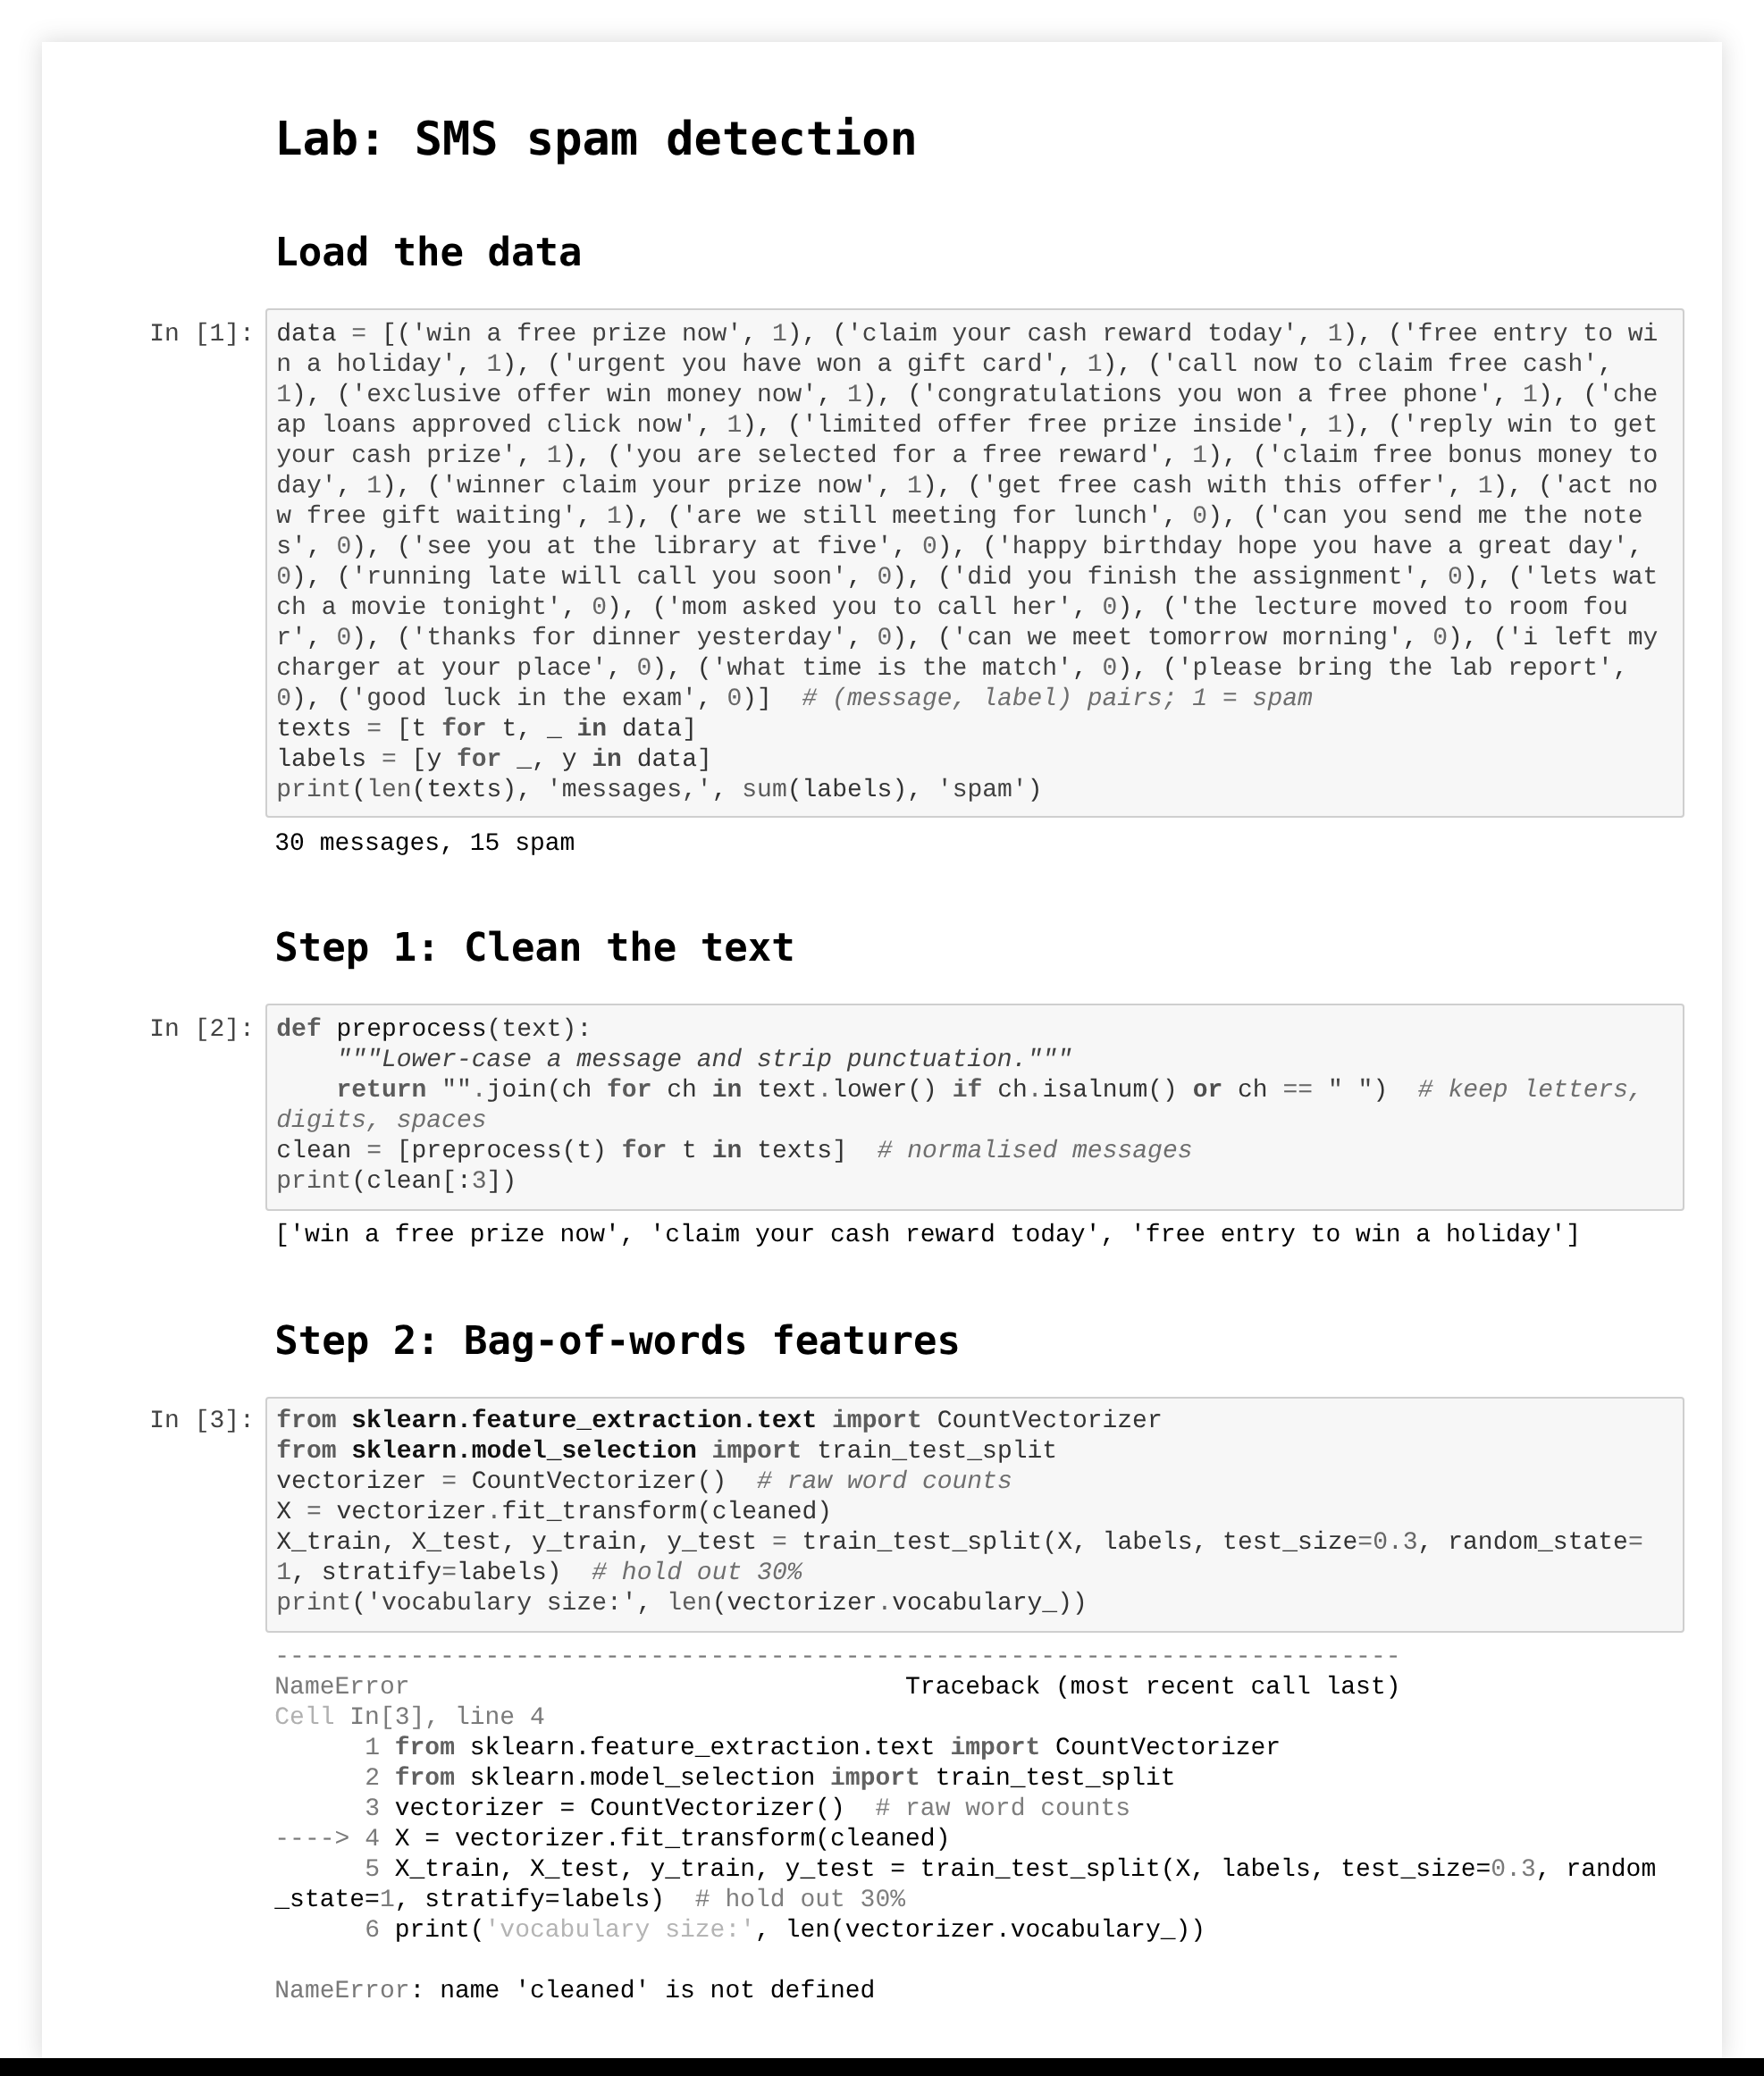
Figure 5. Screenshot of submission SP-03: a typo (cleaned instead of clean) causes NameErrors in later cells.
All of this goes into reports/gradebook.csv: one row per student with marks for each check, the total, the grade, the "marks lost" line and the wrong-explanation flag. The notebook also prints the mark distribution and saves a histogram as reports/mark_distribution.png.

7. Dataset
The evaluator was tested on a mix of real and synthetic notebooks: 23 in total.

Real notebooks
Five real student notebooks from two course labs, identified by roll number. Ground truth (whether the explanation matches the code) was established by reading each notebook.
Lab | Notebook | Code uses | Explanation describes | Misdescribes algorithm
Text classification (24 movie reviews) | S016 | Porter stemming, TF-IDF, Multinomial Naive Bayes | The same pipeline | No
Text classification | S017 | Porter stemming, TF-IDF, Multinomial Naive Bayes | Lemmatisation, bag of words, logistic regression | Yes
Text classification | S020 | Same pipeline with typos (clean_txt, accuracy_scor) and a bag-of-words vectoriser; last cell not run | One line: "model works, accuracy is printed." | No
K-Means clustering (300 2-D points) | S025 | K-Means | Agglomerative hierarchical clustering | Yes
K-Means clustering | S026 | K-Means | K-Means | No

Synthetic notebooks
To test labs and failure patterns the real set does not cover, we generated 18 random synthetic submissions across three further labs, each with a known ground truth. Submission IDs are anonymous codes (SP-, CS-, NT-). Every synthetic notebook was executed before saving, so it carries outputs and errors exactly as a student would submit it.
Lab | Data | Method in the code | Rubric tests | Expected outputs
SMS spam detection (SP) | 30 short messages, 15 spam | Bag of words (CountVectorizer) + logistic regression | Model type, vectoriser type, detects obvious spam | Accuracy ≥ 0.75; new message predicted spam
Customer segmentation (CS) | 150 synthetic customers (age, spend score) | Standard scaling + agglomerative clustering (Ward) | Model type, 3 clusters, features scaled | Silhouette ≥ 0.5; "3 clusters" printed
News topics (NT) | 24 headlines, 3 topics | TF-IDF + linear SVM, 4-fold cross-validation | Vectoriser type, model type, 3 classes | Mean accuracy ≥ 0.6; sport headline classified

Each lab has the same six submission types, so results can be compared across labs:
Suffix | Designed as | Misdescribes algorithm | Expected band
-01 | Strong: correct code, full explanation | No | A
-02 | Correct code; explanation describes a different algorithm | Yes | B–C
-03 | Typo causing runtime errors, last cell never run, one-line explanation | No | F
-04 | Correct code; one-sentence explanation | No | B–C
-05 | Correct code and explanation, plus one sentence naming a rejected alternative | No | A
-06 | Correct code; explanation paraphrased in plain words | No | A–B

The -02 submissions describe lemmatisation + TF-IDF + Naive Bayes (SP), K-Means (CS), and bag of words + Naive Bayes (NT). The -05 submissions add sentences such as "We did not use Naive Bayes" or "Unlike K-Means, this method does not need random starting centroids". The expected bands are our design targets. No teacher marked these.
Each synthetic lab has a rubric.json with a model answer, six concepts with the words that count as mentioning them, two expected results and three tests. There is no train/test split because the evaluator has no trained parameters; the weights and thresholds were set by hand and were not changed for this evaluation.
One problem was found in the test set itself and fixed: the first version of the news lab asked the model to classify a headline that shared no words with the training data, so even the strong submission lost output marks. The headline was replaced and all notebooks were regenerated and re-graded. In future, each rubric should be run against a reference solution before use.
The real set is small (five notebooks, two labs) and has no teacher marks, and the synthetic set was written by the same team as the evaluator. The next step is a larger set of real, anonymised submissions with teacher marks.

8. Baseline vs improved, and results

Real notebooks
ID | Corr. /35 | Out. /15 | Err. /15 | Doc. /15 | Expl. /20 | Total | Grade | Flag (mismatch named) | Conf.
S016 | 35.0 | 15.0 | 15.0 | 13.9 | 20.0 | 98.9 | A | No | 0.9
S017 | 35.0 | 15.0 | 15.0 | 12.9 | 3.3 | 81.2 | B | says lemmatization, code uses stemming, says logistic regression, code uses Naive Bayes, says bag of words, code uses TF-IDF | 0.6
S020 | 23.3 | 0.0 | 4.5 | 5.2 | 0.3 | 33.3 | F | No | 0.9
S025 | 35.0 | 15.0 | 15.0 | 11.4 | 1.6 | 78.0 | C | says hierarchical clustering, code uses K-Means | 0.7
S026 | 35.0 | 15.0 | 15.0 | 11.7 | 20.0 | 96.7 | A | No | 0.9

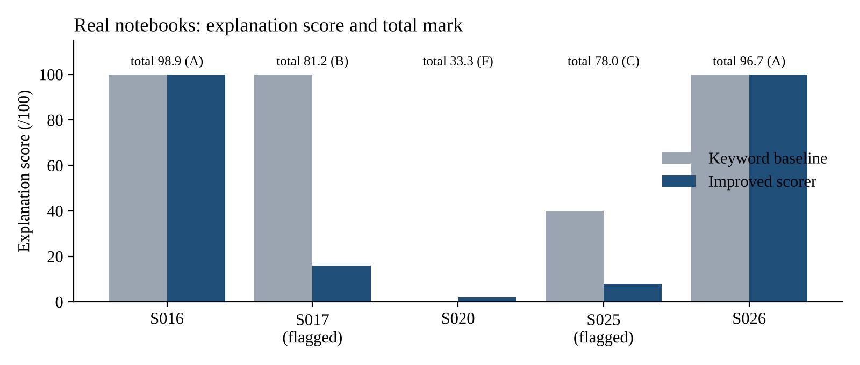
Figure 6. Real notebooks: keyword baseline vs improved explanation score, with total marks
Both misexplained submissions were flagged and every mismatch was named (S017 has three: lemmatisation vs stemming, bag of words vs TF-IDF, logistic regression vs Naive Bayes). There were no false flags. The keyword baseline gave S017 full explanation marks because its step headings still use the right words; the improved scorer dropped it to 16. S020's typos were caught by the rubric tests and the error check, giving an F.
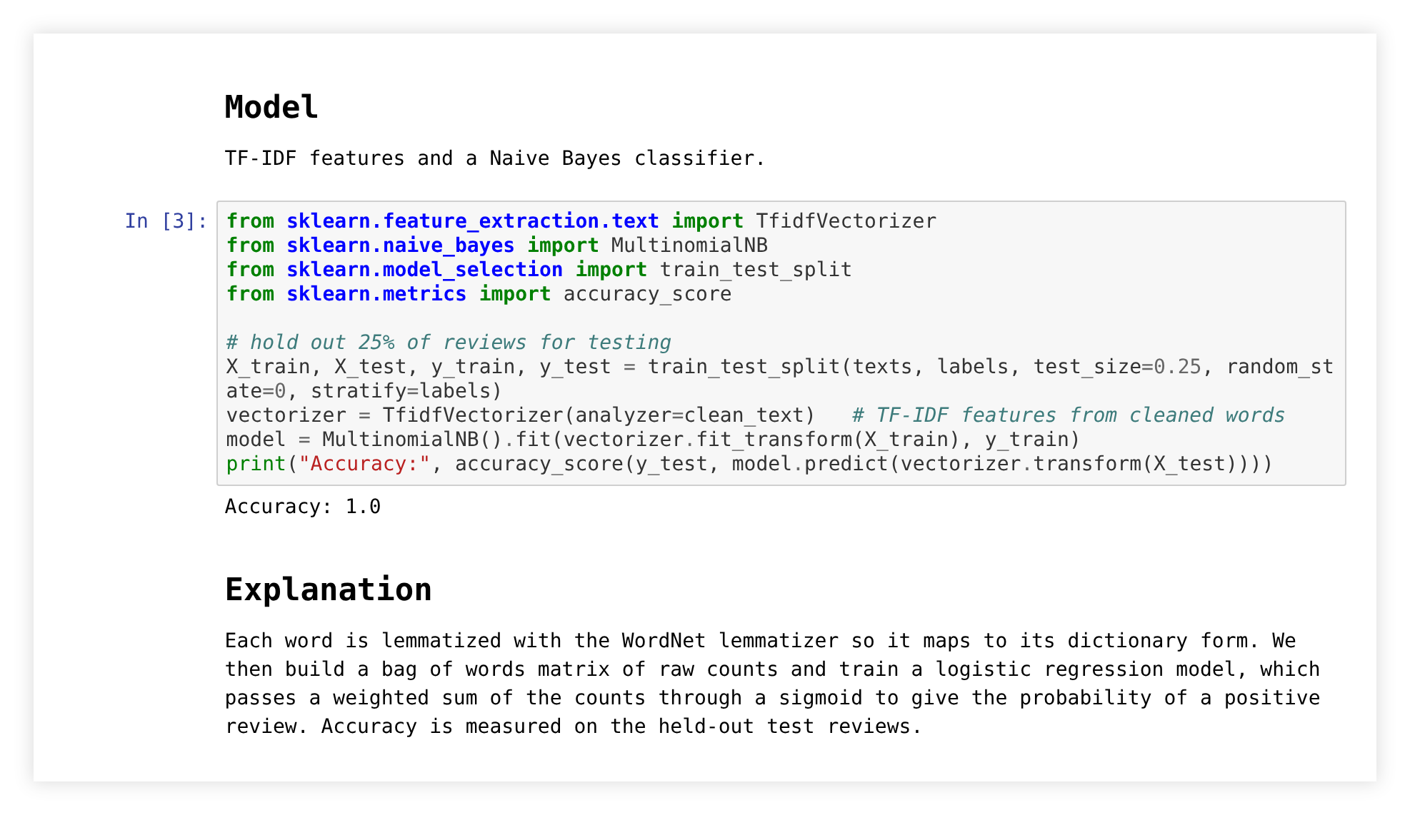
Figure 7. Screenshot of real notebook S017: TF-IDF and Naive Bayes in the code, lemmatisation, bag of words and logistic regression in the explanation

Synthetic notebooks
ID | Corr. /35 | Out. /15 | Err. /15 | Doc. /15 | Expl. /20 | Total | Grade | Flagged | Conf.
SP-01 | 35.0 | 15.0 | 15.0 | 15.0 | 19.8 | 99.8 | A | No | 0.9
SP-02 | 35.0 | 15.0 | 15.0 | 13.9 | 2.3 | 81.2 | B | Yes | 0.6
SP-03 | 23.3 | 0.0 | 0.0 | 11.1 | 5.8 | 40.2 | F | No | 0.9
SP-04 | 35.0 | 15.0 | 15.0 | 11.3 | 5.5 | 81.8 | B | No | 0.8
SP-05 | 35.0 | 15.0 | 15.0 | 15.0 | 3.9 | 83.9 | B | Yes | 0.7
SP-06 | 35.0 | 15.0 | 15.0 | 14.6 | 7.1 | 86.7 | B | No | 0.9
CS-01 | 35.0 | 15.0 | 15.0 | 15.0 | 17.7 | 97.7 | A | No | 0.9
CS-02 | 35.0 | 15.0 | 15.0 | 13.1 | 1.3 | 79.4 | C | Yes | 0.6
CS-03 | 23.3 | 0.0 | 0.0 | 11.0 | 2.8 | 37.1 | F | No | 0.9
CS-04 | 35.0 | 15.0 | 15.0 | 11.2 | 2.8 | 79.0 | C | No | 0.8
CS-05 | 35.0 | 15.0 | 15.0 | 15.0 | 3.5 | 83.5 | B | Yes | 0.7
CS-06 | 35.0 | 15.0 | 15.0 | 13.8 | 6.6 | 85.4 | B | No | 0.9
NT-01 | 35.0 | 15.0 | 15.0 | 14.3 | 19.6 | 98.9 | A | No | 0.9
NT-02 | 35.0 | 15.0 | 15.0 | 12.7 | 2.1 | 79.8 | C | Yes | 0.6
NT-03 | 23.3 | 0.0 | 4.5 | 10.9 | 2.9 | 41.6 | F | No | 0.9
NT-04 | 35.0 | 15.0 | 15.0 | 11.1 | 5.4 | 81.5 | B | No | 0.8
NT-05 | 35.0 | 15.0 | 15.0 | 14.8 | 3.8 | 83.6 | B | Yes | 0.7
NT-06 | 35.0 | 15.0 | 15.0 | 13.5 | 6.3 | 84.8 | B | No | 0.9

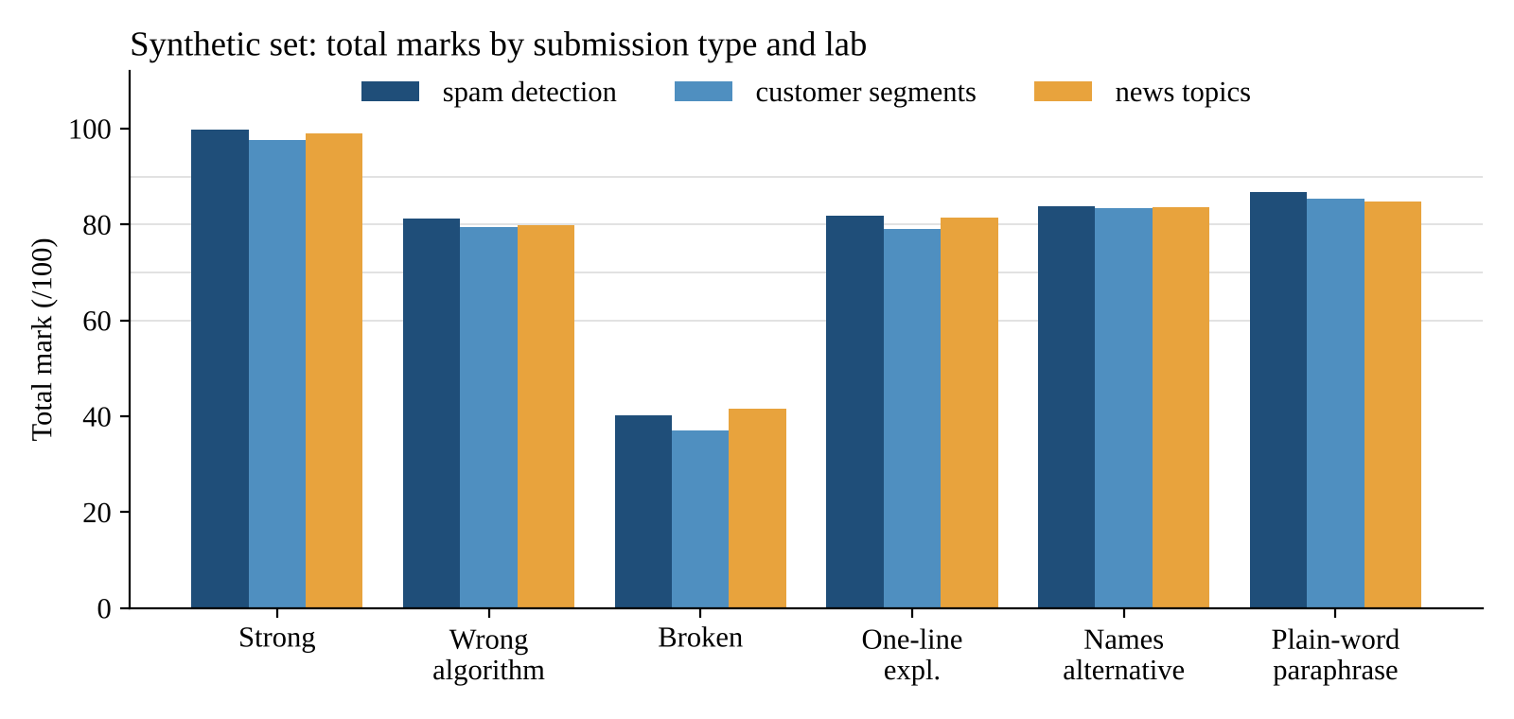
Figure 8. Total marks by submission type and lab
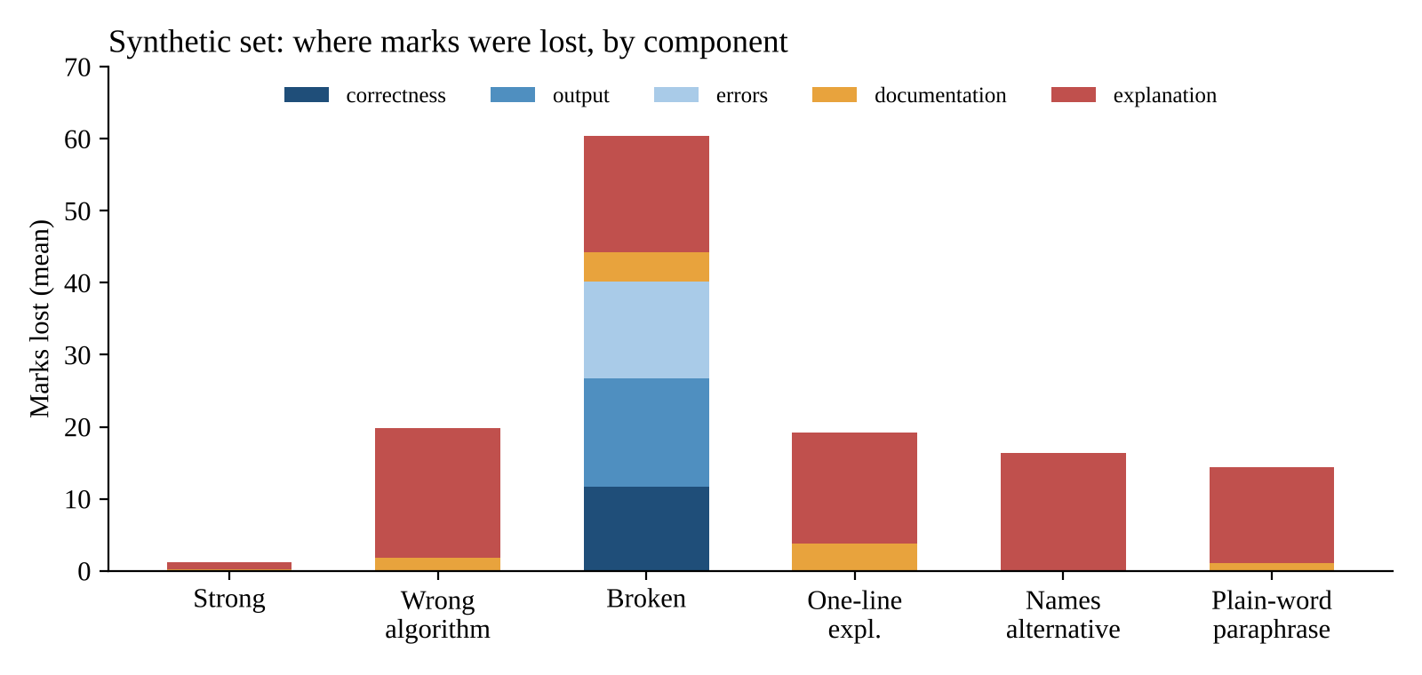
Figure 9. Mean marks lost per component, by submission type
In Figure 9, for submissions with working code, almost all lost marks come from the explanation, with a smaller documentation penalty for short write-ups. Broken submissions lose marks across every component.
Code-side checks behaved consistently: every submission with working code earned full correctness, output and error marks, and the three broken submissions scored 37–42 (F). Strong submissions scored 97.7–99.8 (A) in all three labs without any lab-specific tuning. The spread above F comes almost entirely from the explanation check.
15 of 18 totals fell inside the band expected by design. All three misses are the -05 submissions, which should earn an A but scored 83.5–83.9 (B) because of a false flag. Grade distribution: 3 A, 9 B, 3 C, 0 D, 3 F; mean 78.1, median 82.6.
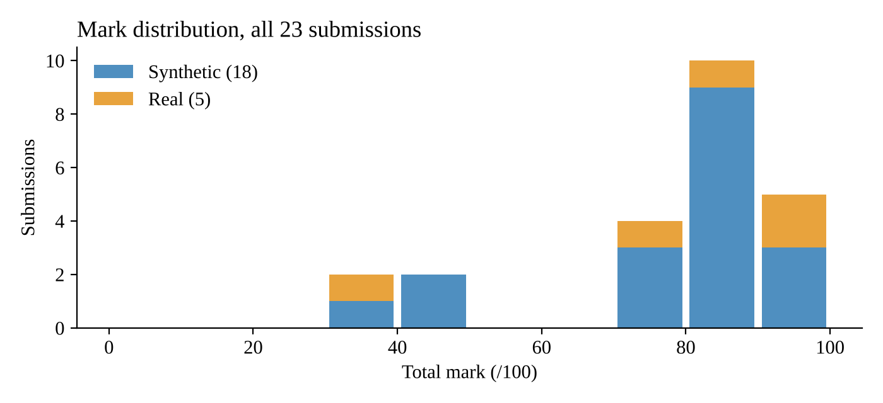
Figure 10. Mark distribution across all 18 submissions

Explanation scorer: baseline vs improved
The baseline scores an explanation by the share of rubric concepts whose keywords appear. The improved scorer adds semantic similarity, the algorithm cross-check and the contradiction penalty.
Submission type | Baseline (mean /100) | Improved (mean /100)
Strong (-01) | 100 | 95
Wrong algorithm (-02) | 56 | 9
Broken, one-line (-03) | 28 | 19
One-sentence (-04) | 28 | 23
Names an alternative (-05) | 100 | 19
Plain-word paraphrase (-06) | 39 | 34

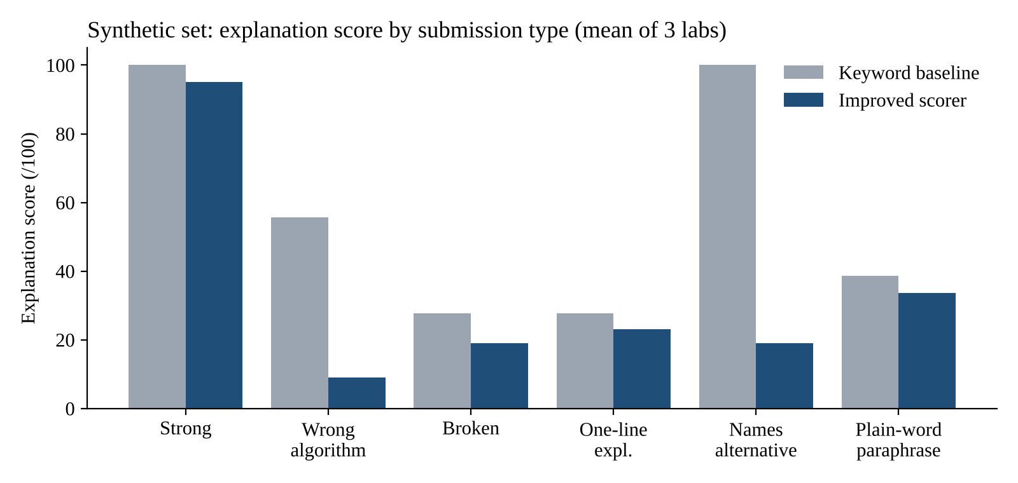
Figure 11. Explanation scores under the keyword baseline and the improved scorer
The baseline cannot tell correct explanations from misdescribed ones, because a wrong explanation can still contain several rubric keywords (SP-02 and NT-02 scored 67 on the baseline). It also wrongly penalises the -05 submissions, which drop from 100 to 19, and neither scorer gives much credit to explanations written in plain words.

Wrong-explanation flag
 | Should flag | Should not flag
Flagged | 5 (S017, S025, SP-02, CS-02, NT-02) | 3 (SP-05, CS-05, NT-05)
Not flagged | 0 | 15

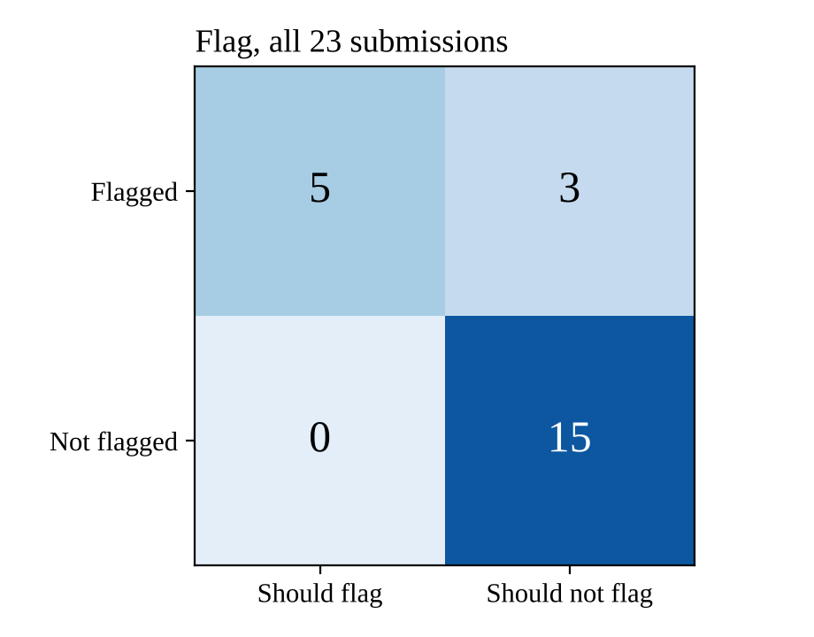
Figure 12. Confusion matrix for the wrong-explanation flag
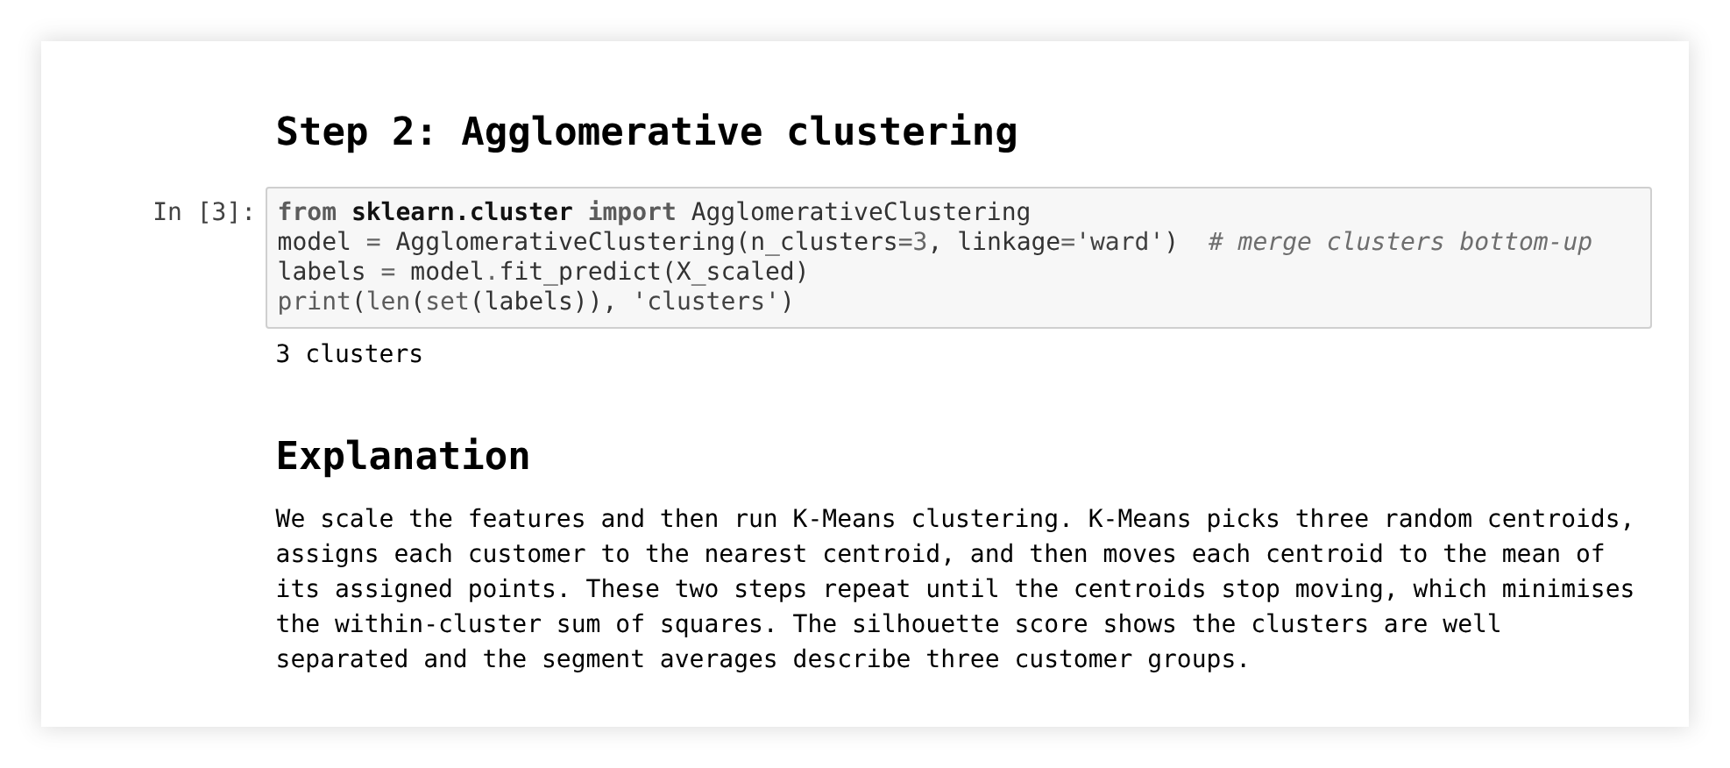
Figure 13. Screenshot of submission CS-02: the code uses AgglomerativeClustering, the explanation describes K-Means. The evaluator flags it as "says K-Means, code uses hierarchical clustering".
Across all 23 notebooks: precision 0.63, recall 1.00 (real set: 2 of 2 found, no false flags; synthetic set: 3 of 3 found, 3 false flags). Every true mismatch was caught and named correctly, including several mismatches in one notebook. Every false flag came from a sentence naming an algorithm the student did not use.

Confidence and agreement with teachers
In the synthetic set, the three true flags received confidence 0.6 and would be sent to a teacher under the "below 0.7" rule. The three false flags received exactly 0.7, so they would not. If every flagged notebook went to a teacher regardless of confidence, the false flags would also be reviewed.
The grading metrics (MAE, RMSE, Pearson correlation and the share within ±10 marks of the teacher) are implemented in Section 12 of the notebook. They have not been measured because there are no teacher marks; they run as soon as a human_scores.csv file is added. All results used the offline TF-IDF similarity backend; Sentence-BERT is used automatically where it can be downloaded, including in Colab, but has not yet been measured on this set.

9. Error analysis
The evaluator matches fixed words and has no sense of meaning, and that explains its mistakes. All the cases below happened in the evaluation set.
Case | Where | What happens | Fix
Rejected alternative read as a claim | SP-05, CS-05, NT-05: "We did not use Naive Bayes", "Unlike K-Means…" | Flagged as describing that algorithm; ≈ −16 marks | Skip mentions in clauses with "not", "unlike", "instead of", "compared to"; later, a dependency parser
Headings counted as explanation | SP-03/04, CS-03/04 | The under-30-words rule never fires; marked "key concepts missing" instead | Score only the cell under an "Explanation" heading
Paraphrase without technical words | SP-06, CS-06, NT-06: "the two nearest groups are joined again and again" | Concepts not recognised; ≈ −13 marks | Sentence-BERT similarity per concept
Length counted twice | All -03 and -04 | Short write-ups lose ≈ 4 documentation marks on top of the explanation penalty | Judge explanation quality in one place
Unchecked rubric expectation | News lab, first version | Strong work lost output marks | Validate rubrics on a reference solution

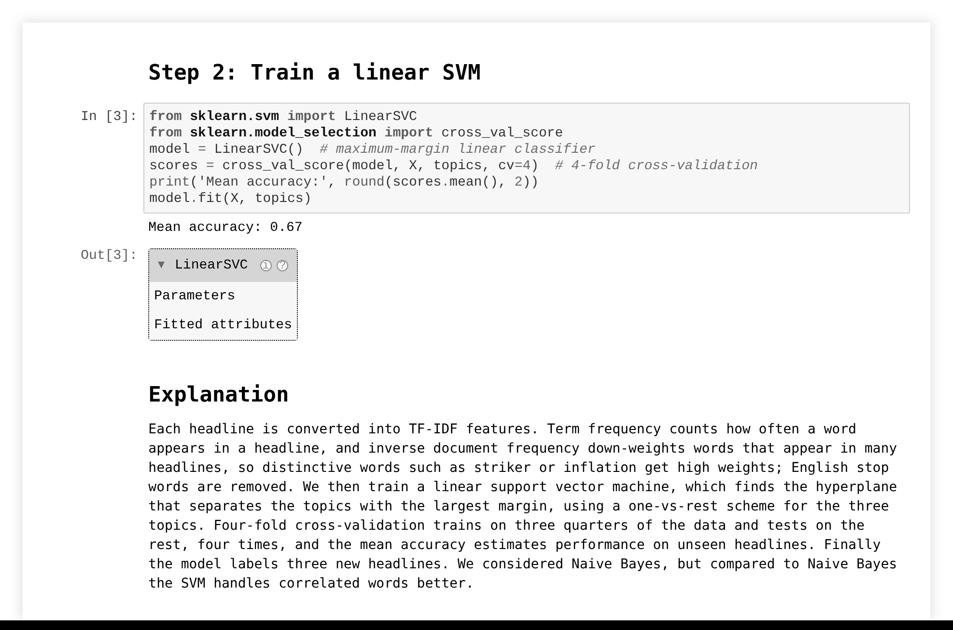
Figure 14. Screenshot of submission NT-05: a correct explanation that mentions Naive Bayes as a rejected alternative is falsely flagged.
Every wrong explanation was flagged, in all three labs. Broken code received an F in every lab. The rubric tests looked at object types and behaviour and ignored variable names, so no correct submission lost correctness marks.
Explanation scores under-rate students who write in simpler English or use non-standard terms (the -06 submissions lost about 13 marks for correct explanations).

10. Reusability and how to run it
The three evaluation labs were added by writing one rubric.json each, with no change to the evaluator; a new technique needs one line in the algorithm table.
Running it in Google Colab
- Upload lab_evaluator.ipynb to Colab and choose Runtime → Run all. Missing packages install automatically.
- When Section 9 asks, pick the lab's rubric.json and that lab's student notebooks. Locally, set RUBRIC and NOTEBOOKS to the file paths instead, e.g. samples/synthetic/spam_detection/rubric.json and samples/synthetic/spam_detection/*.ipynb.
- The gradebook is saved as reports/gradebook.csv and reports/results.json, with the mark histogram as reports/mark_distribution.png.
A rubric has four optional parts: reference (a model answer), concepts (each idea with the words that count as mentioning it), expected (text the output should contain, or a number captured by a pattern within a range) and tests (named one-line Python asserts).
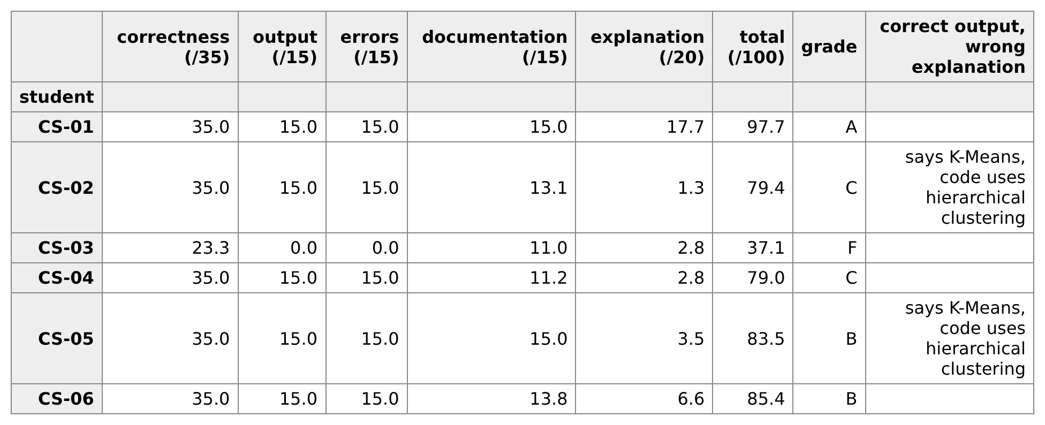
Figure 15. Screenshot of the gradebook produced for the customer segmentation lab
Other parts of the platform can call evaluate(path, rubric), which grades one notebook and returns its gradebook row. The file results.json holds one record per student with a confidence score. Example:
{
"input_id": "CS-02",
"result": {
"marks": {"correctness": 35.0, "output": 15.0, "errors": 15.0,
"documentation": 13.1, "explanation": 1.3},
"total": 79.4, "grade": "C",
"marks_lost": "documentation -1.9: too little written explanation; explanation -18.7: describes a different algorithm than the code",
"wrong_explanation": "says K-Means, code uses hierarchical clustering",
"confidence": 0.6
}
}
Confidence starts at 1 and drops by 0.1 when only TF-IDF similarity is available, by 0.2 when the rubric has no tests, by 0.2 when the notebook is flagged, and by 0.1 when the total is within 2 marks of a grade boundary. A student dashboard could read these fields as they are.

11. Responsible AI, limitations and future work
Concern | How it is handled
Privacy | Everything runs locally; no notebook content is sent to an outside service. Name files by anonymous ID or roll number.
Security | Student code is run in a separate process. Use Colab or a container, or set RUN_CODE = False to grade saved outputs only.
Bias | Plain-English explanations scored about 13 marks lower than technical ones with the same meaning, which would disadvantage students less fluent in course terms.
Hallucination | No generative model is used; every reason in the gradebook comes from a check that actually failed.
Explainability | Every deduction has a one-line reason, flags name the exact mismatch, and the code is short enough to read end to end.
Human oversight | It is a first-pass grader. Flagged notebooks and disputed marks go to a teacher, and agreement with teacher marks should be measured before marks count toward grades.

Current limitations
- The real set has only five notebooks from two labs and no teacher marks; synthetic expected bands are design targets.
- Weights and thresholds were set by hand.
- Only the TF-IDF similarity backend was measured.
- Algorithms are recognised through library calls and fixed phrases, so negation, comparison and paraphrase break the detector.
Future work
- Collect 30 or more anonymised real lab notebooks with teacher marks, then report MAE, RMSE and correlation
- Ignore algorithm mentions in negated or comparative clauses before flagging
- Score only the designated Explanation cell
- Measure the Sentence-BERT backend and add per-concept semantic matching
- Send every flagged notebook to a teacher regardless of confidence
- Tune the component weights against teacher marks instead of setting them by hand
- Detect hand-written algorithms from code structure
- Package the evaluator as a Python module and API (POST /evaluate-notebook)

12. Conclusion
The evaluator caught working code paired with an explanation of a different algorithm in both such notebooks in the real set and all three in the synthetic set, and each new lab needed only a rubric. It matches words, though, and that is its main weakness. A student who mentions an algorithm they chose not to use, or who explains the method without the usual terms, can lose marks unfairly. Teacher review of flagged notebooks limits the damage for now. Handling negation, scoring only the explanation cell and testing Sentence-BERT on teacher-marked notebooks are what we would do next.

References
- Rousseeuw, P. J. (1987). Silhouettes: a graphical aid to the interpretation and validation of cluster analysis. Journal of Computational and Applied Mathematics 20, 53–65.
- Wandel, N. et al. (2025). PyEvalAI: AI-assisted evaluation of Jupyter notebooks for immediate personalized feedback. arXiv:2502.18425.
- Reimers, N. & Gurevych, I. (2019). Sentence-BERT: Sentence embeddings using Siamese BERT-networks. EMNLP-IJCNLP.
- Project Jupyter. nbgrader documentation. https://nbgrader.readthedocs.io
- Pedregosa, F. et al. (2011). Scikit-learn: Machine learning in Python. JMLR 12, 2825–2830.

Appendix A. Rubric for the customer segmentation lab
The rubric used for the customer segmentation lab, as stored in samples/synthetic/customer_segments/rubric.json. The other two labs follow the same format.
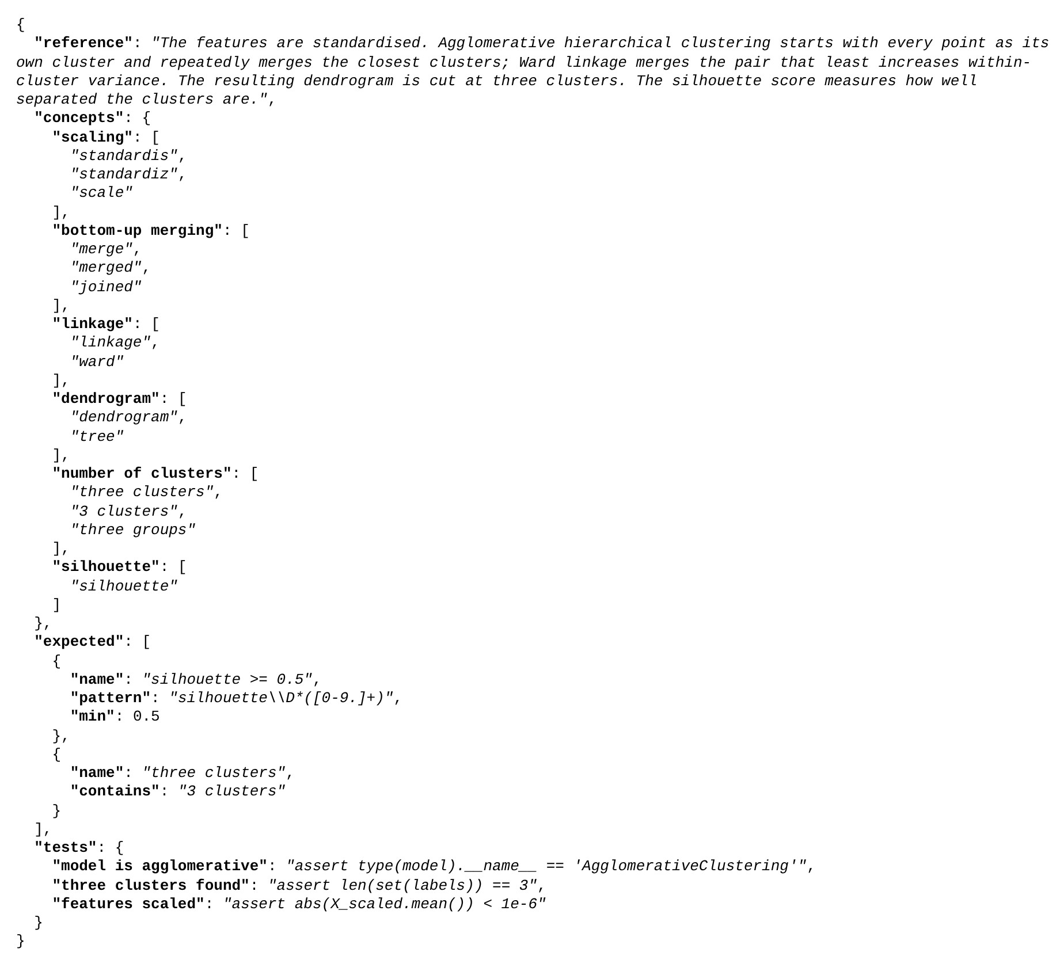
Figure 16. rubric.json for the customer segmentation lab

Appendix B. Feedback lines for all 18 submissions
ID | Marks lost
SP-01 | none
SP-02 | documentation -1.1: too little written explanation; explanation -17.7: describes a different algorithm than the code
SP-03 | correctness -11.7: 1 of 3 tests failed; output -15.0: 2 expected result(s) missing; errors -15.0: 3 runtime error(s), cells not run; documentation -3.9: too little written explanation; explanation -14.2: key concepts missing
SP-04 | documentation -3.7: too little written explanation; explanation -14.5: key concepts missing
SP-05 | explanation -16.1: describes a different algorithm than the code
SP-06 | explanation -12.9: key concepts missing
CS-01 | explanation -2.3: only partly matches the model answer
CS-02 | documentation -1.9: too little written explanation; explanation -18.7: describes a different algorithm than the code
CS-03 | correctness -11.7: 1 of 3 tests failed; output -15.0: 2 expected result(s) missing; errors -15.0: 3 runtime error(s), cells not run; documentation -4.0: too little written explanation; explanation -17.2: key concepts missing
CS-04 | documentation -3.8: too little written explanation; explanation -17.2: key concepts missing
CS-05 | explanation -16.5: describes a different algorithm than the code
CS-06 | documentation -1.2: too little written explanation; explanation -13.4: key concepts missing
NT-01 | none
NT-02 | documentation -2.3: too little written explanation; explanation -17.9: describes a different algorithm than the code
NT-03 | correctness -11.7: 1 of 3 tests failed; output -15.0: 2 expected result(s) missing; errors -10.5: 2 runtime error(s), cells not run; documentation -4.1: too little written explanation; explanation -17.1: explanation too short
NT-04 | documentation -3.9: too little written explanation; explanation -14.6: key concepts missing
NT-05 | explanation -16.2: describes a different algorithm than the code
NT-06 | documentation -1.5: too little written explanation; explanation -13.7: key concepts missing

