Credit Card Default Prediction using PyCaret
A Low-Code AutoML Project — MLOps

Group 8
Syed Fazal Mehdi — S011
Manas Dabhade — S025
Deven Bhole — S027

MBA Tech (Data Science), SVKM's NMIMS Mukesh Patel School of Technology Management & Engineering, Mumbai
October 2026

1. Abstract
This project applies PyCaret, an open-source low-code machine learning library, to predict whether a credit card customer will default on next month's payment. Using the UCI 'Default of Credit Card Clients' dataset (24,000 customers, 23 features), PyCaret's setup() function built a single preprocessing pipeline (one-hot encoding, normalisation and SMOTE oversampling), compare_models() benchmarked ten algorithms with 5-fold cross-validation, and the best model, a Gradient Boosting Classifier, reached a cross-validated AUC of 0.783 and 81.1% accuracy on a hold-out test set. The finalised pipeline was saved and served through a Streamlit web application that scores single customers or batches from a CSV file. The whole project runs locally in Visual Studio Code.

2. Problem Statement
Credit card issuers lose money when customers fail to repay. Identifying risky customers one month in advance lets a bank reduce credit limits, contact the customer or adjust provisioning before the loss happens.
Objective: build a classification model that, given a customer's credit limit, demographics and the last six months of billing and repayment history, predicts the probability that the customer defaults next month — and deliver it as a working, reusable tool.
Challenges:
- Class imbalance: only about 22% of customers default, so accuracy alone is misleading.
- Many candidate algorithms; manually coding, tuning and comparing them is slow.
- Preprocessing must be identical at training and prediction time to avoid leakage and errors.

3. Dataset
Source: Yeh, I-C. & Lien, C-H. (2009), 'Default of Credit Card Clients', UCI Machine Learning Repository (https://archive.ics.uci.edu/dataset/350/default+of+credit+card+clients). Data from a Taiwanese bank, April–September 2005. The 24,000-row version distributed with PyCaret (pycaret.datasets.get_data('credit')) was used.
Column(s) | Description
LIMIT_BAL | Credit limit (NT$)
SEX, EDUCATION, MARRIAGE, AGE | Demographics (first three categorical)
PAY_1 … PAY_6 | Repayment status per month (-2/-1 paid duly, 0 revolving, 1–8 months delayed)
BILL_AMT1 … BILL_AMT6 | Bill statement amount per month
PAY_AMT1 … PAY_AMT6 | Amount paid per month
default (target) | 1 = defaulted next month, 0 = did not

There are no missing values. 5% of rows (1,200 customers) were held back before modelling to simulate genuinely new customers.

4. About PyCaret
PyCaret is a low-code Python wrapper around scikit-learn, LightGBM, XGBoost, imbalanced-learn and other libraries. A few function calls replace hundreds of lines of code for preprocessing, cross-validation, model comparison, hyperparameter tuning, plotting and deployment. Version 3.3.2 was used; it supports Python 3.9–3.11.
Function | Purpose
setup() | Initialises the experiment and builds the preprocessing pipeline
compare_models() | Trains and cross-validates all candidate models, returns a leaderboard
tune_model() | Hyperparameter search on a chosen metric
plot_model() | AUC, confusion matrix, feature importance and other plots
predict_model() | Scores the hold-out set or new data
finalize_model() / save_model() | Refits on all data and saves pipeline + model as a .pkl

5. System Architecture
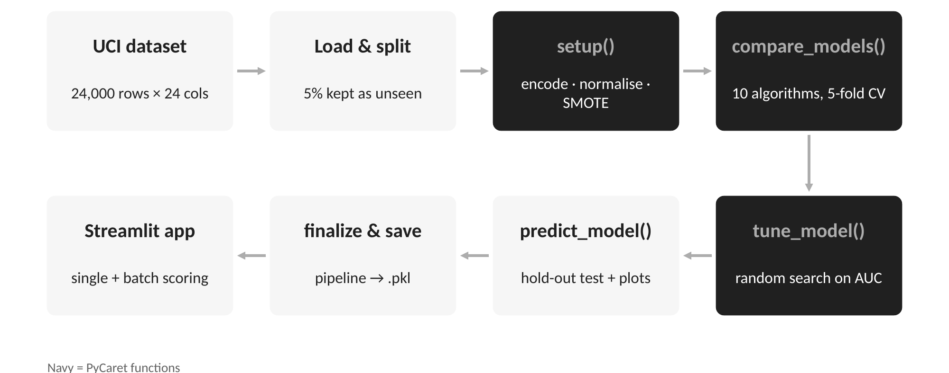
- Ingestion: CSV loaded with pandas; 5% held out as unseen data.
- Preparation (setup): 80/20 train–test split, one-hot encoding of SEX/EDUCATION/MARRIAGE, z-score normalisation, SMOTE on training folds only.
- Modelling: 10 algorithms compared with stratified 5-fold CV, sorted by AUC; best model tuned with random search.
- Evaluation: hold-out metrics and plots saved to outputs/.
- Deployment: finalised pipeline saved as credit_default_model.pkl and loaded by a Streamlit app.

6. Implementation
Environment: Visual Studio Code with the Python extension, Python 3.11 virtual environment, pycaret==3.3.2 and streamlit. Project layout:
- train.py — the full PyCaret training pipeline
- app.py — Streamlit demo
- data/credit.csv — dataset
- outputs/ — leaderboard, metrics, plots and saved model
- requirements.txt, README.md — setup and run instructions
Core code:
setup(data=data, target="default",
categorical_features=["SEX", "EDUCATION", "MARRIAGE"],
normalize=True, fix_imbalance=True,
train_size=0.8, fold=5, session_id=42)
top3 = compare_models(n_select=3, sort="AUC")
tuned = tune_model(top3[0], optimize="AUC", n_iter=10, choose_better=True)
predict_model(tuned) # hold-out evaluation
final = finalize_model(tuned)
save_model(final, "outputs/credit_default_model")
Steps to run in VS Code: (1) open the folder; (2) python -m venv .venv and activate it; (3) pip install -r requirements.txt; (4) select the .venv interpreter; (5) python train.py (about 3–6 minutes); (6) streamlit run app.py and open http://localhost:8501.

7. Results
Table: 5-fold cross-validated leaderboard (sorted by AUC)
Model | Accuracy | AUC | Recall | Precision | F1
Gradient Boosting Classifier | 0.8212 | 0.7834 | 0.3984 | 0.6622 | 0.4973
Light Gradient Boosting Machine | 0.8206 | 0.7807 | 0.3888 | 0.6646 | 0.4904
Ada Boost Classifier | 0.8165 | 0.7683 | 0.4078 | 0.6358 | 0.4965
Random Forest Classifier | 0.8112 | 0.7614 | 0.4068 | 0.6130 | 0.4888
Extra Trees Classifier | 0.8043 | 0.7506 | 0.3863 | 0.5908 | 0.4670
Logistic Regression | 0.6938 | 0.7309 | 0.6430 | 0.3867 | 0.4827
Ridge Classifier | 0.7062 | 0.7281 | 0.6342 | 0.3989 | 0.4895
Naive Bayes | 0.2911 | 0.7259 | 0.9667 | 0.2343 | 0.3772
K Neighbors Classifier | 0.7378 | 0.7069 | 0.5075 | 0.4246 | 0.4623
Decision Tree Classifier | 0.7186 | 0.6098 | 0.4130 | 0.3778 | 0.3946

Gradient Boosting ranked first. Random-search tuning did not improve on the default hyperparameters, so PyCaret's choose_better option kept the original model. On the 20% hold-out test set it scored accuracy 0.811, AUC 0.759, recall 0.372, precision 0.624 and F1 0.466. After finalising on all training data, it predicted the 1,200 unseen customers with 82.7% accuracy.
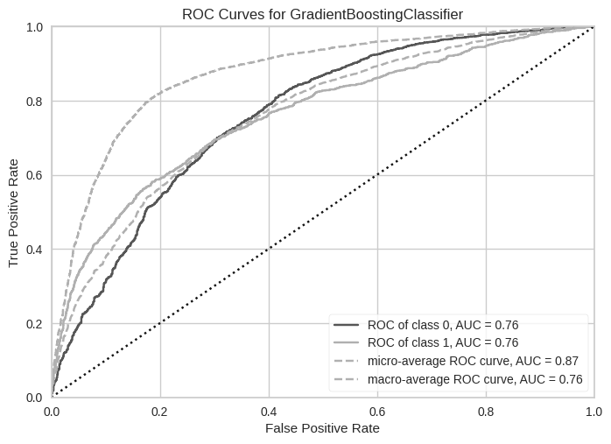
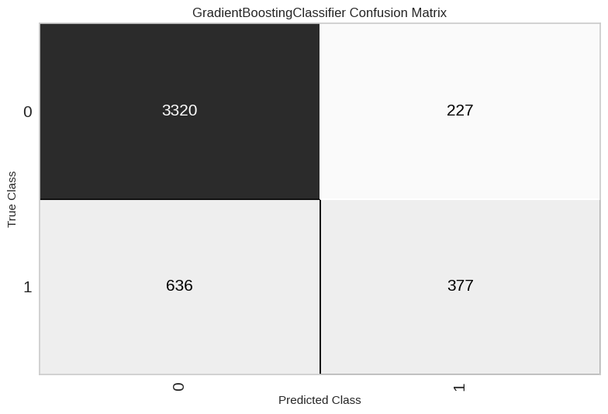
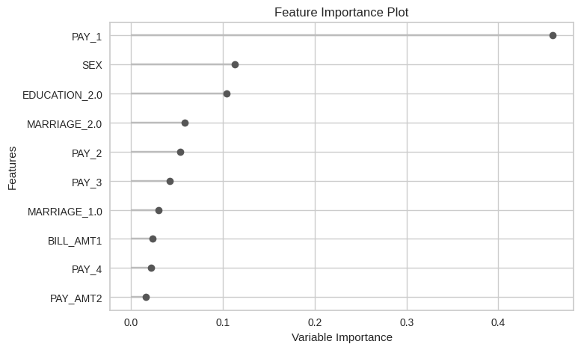
Interpretation:
- PAY_1 (most recent repayment status) is by far the strongest predictor: a customer already behind on payments is likely to default again.
- Ensemble boosting models (GBC, LightGBM, AdaBoost) outperform linear models and single trees.
- Recall of about 0.40 means the default 0.5 threshold catches 4 in 10 defaulters. A bank that values catching defaulters more than avoiding false alarms should lower the threshold or use cost-sensitive optimisation.

8. Comparison: PyCaret vs Traditional Notebook (Google Colab style)
To measure what PyCaret adds, the same experiment was rebuilt the traditional way in a Jupyter notebook written for Google Colab (traditional/Traditional_sklearn_Colab.ipynb). It uses scikit-learn, imbalanced-learn and LightGBM directly. To keep the comparison fair, both versions use the same 5% unseen hold-back, a stratified 80/20 split, the same 10 algorithms, 5-fold cross-validation, one-hot encoding plus standard scaling, SMOTE inside each fold, and 10 iterations of random-search tuning on AUC. Both ran on the same 2-vCPU machine, which matches the CPU count of Google Colab's free tier.
Table: Traditional notebook leaderboard (5-fold CV, sorted by AUC)
Model | Accuracy | AUC | Recall | Precision | F1
Gradient Boosting | 0.8016 | 0.7731 | 0.5120 | 0.5586 | 0.5341
LightGBM | 0.8120 | 0.7701 | 0.4377 | 0.6061 | 0.5082
Random Forest | 0.8022 | 0.7612 | 0.4816 | 0.5642 | 0.5196
AdaBoost | 0.7693 | 0.7587 | 0.5522 | 0.4832 | 0.5153
Extra Trees | 0.7969 | 0.7426 | 0.4419 | 0.5534 | 0.4914
Logistic Regression | 0.6736 | 0.7328 | 0.6621 | 0.3692 | 0.4740
Naive Bayes | 0.2953 | 0.7307 | 0.9632 | 0.2350 | 0.3778
Ridge | 0.6830 | 0.7299 | 0.6534 | 0.3768 | 0.4780
KNN | 0.6644 | 0.6933 | 0.6258 | 0.3551 | 0.4530
Decision Tree | 0.7004 | 0.6128 | 0.4547 | 0.3614 | 0.4027

Table: Head-to-head comparison
Aspect | PyCaret | Traditional notebook
Best model | Gradient Boosting | Gradient Boosting
CV AUC (best model) | 0.7834 | 0.7731 (tuned 0.7771)
Hold-out accuracy | 0.8107 | 0.7820
Hold-out AUC | 0.7589 | 0.7490
Hold-out recall | 0.3722 | 0.5054
Hold-out precision | 0.6242 | 0.5095
Hold-out F1 | 0.4663 | 0.5074
Accuracy on 1,200 unseen customers | 0.8270 | 0.7850
End-to-end runtime | 5.8 min | 10.6 min
Core modelling code | ~12 lines, 1 import | ~65 lines, 13 imported libraries/classes
Whole script length | 70 lines | 89 lines
Did tuning help? | No; choose_better kept the default model | Yes, slightly (+0.004 CV AUC)

Notable changes and insights:
- Development effort: PyCaret needed six function calls. The notebook needed a hand-built ColumnTransformer, an imblearn Pipeline, a cross-validation loop, a hyperparameter grid and metric code. That is about five times more modelling code, and more places for bugs such as fitting the scaler before the split.
- Runtime: PyCaret finished in about 45% less time. Most of the notebook's extra time went to tuning Gradient Boosting over a wider hand-written grid (up to 300 trees, depth 6). PyCaret's built-in search space is narrower and quicker.
- Model quality: both approaches picked Gradient Boosting and ranked the models almost the same way. PyCaret was slightly ahead: about 0.01 higher AUC and about 3 percentage points higher hold-out accuracy.
- Precision vs recall: the notebook's model caught more defaulters (recall 0.51 vs 0.37) but raised more false alarms (precision 0.51 vs 0.62). Small implementation details, such as fold shuffling, encoder settings and the tuned hyperparameters, moved the decision boundary. For a bank that cares most about catching defaulters, the notebook's model may actually be preferable.
- Transparency and control: the notebook makes every choice explicit and easy to change. PyCaret hides defaults that must be inspected (e.g. via get_config()) to know exactly what ran.
- Extras for free: PyCaret automatically produced the leaderboard, Kappa/MCC, diagnostic plots, a choose_better safety check, and a single deployable pipeline file. Each of these needs extra code in the notebook.
- Verdict: PyCaret is better for rapid prototyping, benchmarking and teaching. A traditional notebook is better when fine-grained control, custom preprocessing or full auditability is required. A practical workflow is to explore with PyCaret, then reimplement the chosen model explicitly for production.
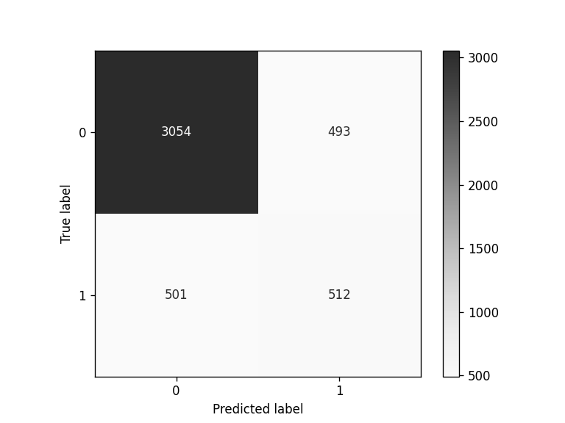
Figure: Confusion matrix of the traditional notebook's model on the hold-out set.

9. Working Demo
The Streamlit app (app.py) loads the saved pipeline and offers two modes: Single customer (form input returning a default probability and a Low/Medium/High risk label) and Batch CSV (upload a file such as outputs/unseen_sample.csv to rank every customer by risk and download the results). Because the saved .pkl contains the full preprocessing pipeline, raw inputs can be passed in directly.
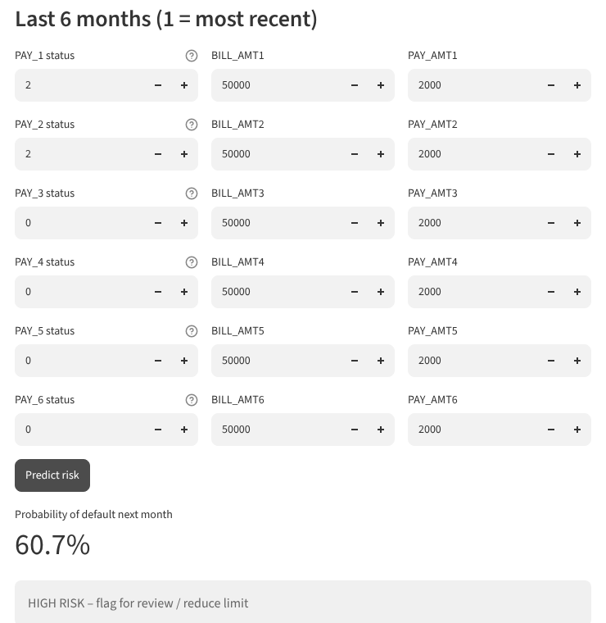
Figure: a customer two months behind on the last two payments is scored at 60.7% default probability (High risk).

10. Learnings
- AutoML accelerates experimentation: ten algorithms benchmarked in minutes with one call.
- Pipelines prevent data leakage: preprocessing and SMOTE are fit inside each CV fold and saved with the model.
- Metric choice matters on imbalanced data: AUC, recall and F1 are more informative than accuracy.
- Hyperparameter tuning is not guaranteed to help; validating against the baseline is essential.
- Low-code vs code-first: PyCaret cut the modelling code by about 5x and the runtime by about 45% compared with a traditional scikit-learn notebook, at the cost of some transparency.
- Reproducibility needs care: fixed session_id, pinned library versions and a supported Python version (3.9–3.11).
- A saved model plus a light UI (Streamlit) turns an experiment into a usable product — a core MLOps idea.

11. Conclusion and Future Scope
PyCaret let the team build, compare, evaluate and deploy a credit-default classifier end to end with very little code. The Gradient Boosting model reached a cross-validated AUC of 0.78. Compared with an equivalent traditional notebook, PyCaret matched or beat its accuracy with far less code and time, and the Streamlit demo shows how the model would be used in practice.
Future scope:
- Optimise the decision threshold using business costs of false negatives vs false positives.
- Track experiments with MLflow (PyCaret supports log_experiment=True).
- Add SHAP explanations with interpret_model() for regulatory transparency.
- Containerise with Docker and expose a REST API with PyCaret's create_api().
- Monitor data drift on new customer data and retrain periodically.

12. Team Contribution
Member | Contribution
Syed Fazal Mehdi (S011) | Problem definition, dataset research, exploratory analysis
Manas Dabhade (S025) | PyCaret pipeline (setup, model comparison, tuning, evaluation)
Deven Bhole (S027) | Streamlit demo, report and presentation

(Edit this table to reflect the actual division of work.)

13. References
- Yeh, I-C. & Lien, C-H. (2009). The comparisons of data mining techniques for the predictive accuracy of probability of default of credit card clients. Expert Systems with Applications, 36(2), 2473–2480.
- UCI Machine Learning Repository: Default of Credit Card Clients. https://archive.ics.uci.edu/dataset/350/default+of+credit+card+clients
- PyCaret documentation. https://pycaret.org/docs/getting-started/installation/
- Streamlit documentation. https://docs.streamlit.io
- scikit-learn and imbalanced-learn documentation. https://scikit-learn.org, https://imbalanced-learn.org

