FIELD PROJECT REPORT
ON
"Waste Collection Efficiency Analysis"
(With Special Reference to Urban Solid Waste Management in
Tathawade Ward, Pimpri-Chinchwad)
SUBMITTED TO
DNYAAN PRASAD GLOBAL UNIVERSITY
IN PARTIAL FULFILLMENT OF 2 YEARS FULL TIME COURSE
MASTER OF BUSINESS ADMINISTRATION (MBA)
SUBMITTED BY
MANAS GAUR
Roll Number: MB25L17 | Semester: II
Batch: 2024–26
UNDER THE GUIDANCE OF
Dr. Dhananjay Bhavsar
Through
DPGU's SCHOOL OF MANAGEMENT & RESEARCH
Jeevan Nagar, Tathawade, Pune – 411033

DECLARATION
I, the undersigned, hereby declare that the project report titled "Waste Collection Efficiency Analysis" submitted in partial fulfillment of the requirements for the degree of Master of Business Administration (MBA) to Dnyaan Prasad Global University, Pune, is the result of my own work carried out under the guidance of Dr. Dhananjay Bhavsar.
This project has not been submitted to any other University or Institution for the award of any degree or diploma. All sources of information have been duly acknowledged. The project has been undertaken purely for academic purposes.
The research area is strictly confined to Tathawade ward and all survey respondents are citizens residing within this specific geographic boundary.

Date:
Place: Tathawade, Pune

Signature of the Student
Manas Gaur

ACKNOWLEDGMENT
I would like to express my sincere gratitude to everyone who has contributed to the completion of this project titled "Waste Collection Efficiency Analysis".
I extend my heartfelt thanks to Dr. Sachin Kulkarni Sir, Director, DPGU's School of Management & Research, for providing an excellent academic environment and the necessary resources.
I would like to express my heartfelt thanks to my project guide, Dr. Dhananjay Bhavsar, for his invaluable guidance, insightful feedback, and unwavering support throughout this project.
I extend my gratitude to all the respondents — citizens of Tathawade ward — who took the time to participate in the survey. Their honest responses have added practical value to this study.

Date:
Place: Tathawade, Pune

Signature of the Student
Manas Gaur

ABSTRACT
This field project examines waste collection efficiency in Tathawade ward of the Pimpri-Chinchwad Municipal Corporation (PCMC) area, Pune. The study is focused exclusively on one ward to provide a ground-level understanding of urban solid waste management challenges and citizen experiences.
A descriptive research design was adopted, with primary data collected through structured questionnaires administered to 101 citizens of Tathawade ward. The study investigates waste generation patterns, segregation compliance, collection frequency, schedule reliability, hygiene practices, complaint resolution, and citizen support for smart waste management technologies.
Key findings reveal that waste collection efficiency stands at approximately 51%, well below the municipal target of 85%. Only 36% of residents receive on-schedule collection; 93% have experienced missed pickups; and 79% report bin overflow. Despite these challenges, 71% of surveyed Tathawade citizens support smart waste management solutions.
The report concludes with phased, actionable recommendations spanning immediate (0–3 months), short-term (3–6 months), and long-term (6–18 months) horizons.

TABLE OF CONTENTS
Sr. No. | Title | Page No.
— | Declaration | 2
— | Acknowledgment | 3
— | Abstract | 4
1 | Chapter I – Introduction | 5
2 | Chapter II – Review of Literature | 8
3 | Chapter III – Research Methodology | 11
4 | Chapter IV – Data Collection and Analysis | 14
5 | Chapter V – Results, Findings & Suggestions | 30
6 | Annexures / Questionnaire | 36

CHAPTER I – INTRODUCTION

CHAPTER II: REVIEW OF THE LITERATURE

CHAPTER III: RESEARCH METHODOLOGY

IV: DATA COLLECTION AND ANALYSIS

CHAPTER V: RESULTS / FINDINGS & SUGGESTIONS

ANNEXURES

1.1 Introduction
Urban solid waste management is one of the most pressing environmental and administrative challenges confronting rapidly growing Indian cities. As urbanisation accelerates, municipal bodies are compelled to manage ever-increasing waste volumes with limited resources, ageing infrastructure, and complex socio-behavioural dynamics.
Tathawade, a ward located in the Pimpri-Chinchwad Municipal Corporation (PCMC) jurisdiction, represents a microcosm of these challenges. Originally developed as an IT and residential hub adjoining the Hinjewadi technology park, Tathawade features a mix of high-rise apartments, gated societies, independent houses, and small commercial establishments — each presenting distinct waste generation profiles and collection challenges.
This field project focuses exclusively on Tathawade ward to generate specific, actionable, ward-level insights.

1.2 Statement of the Problem
Despite investments in municipal infrastructure, urban waste collection continues to face systemic inefficiencies. In Tathawade ward, citizens report persistent issues including missed collection days, overflowing bins, inconsistent schedules, and inadequate complaint redressal. These problems erode public trust and create public health hazards.
The core question: What are the key operational and behavioural factors reducing waste collection efficiency in Tathawade ward, and what interventions can meaningfully improve outcomes for citizens?

1.3 Objectives of the Project
- To measure on-time efficiency of waste collection schedules as perceived by Tathawade citizens.
- To identify operational gaps such as vehicle breakdowns, route skipping, and schedule inconsistencies.
- To analyse factors affecting collection timeliness and citizen satisfaction.
- To assess waste segregation compliance and its impact on collection capacity.
- To evaluate the functioning of the citizen complaint system in Tathawade.
- To recommend data-driven, technology-enabled improvements suited to Tathawade ward.

1.4 Scope of the Study
This study is strictly confined to Tathawade ward within the PCMC jurisdiction. All data collection, analysis, and recommendations pertain solely to this ward. Respondents are exclusively citizens residing or operating businesses within Tathawade.

1.5 Significance of the Project
India generates approximately 62 million tonnes of municipal solid waste annually; only 43% is scientifically processed. Localised, ward-level research is essential to bridge the gap between aggregate statistics and lived citizen realities. This project directly supports Swachh Bharat Abhiyan and Smart City Mission goals by generating ground-level operational data for Tathawade.

1.6 Definition of Key Terms
- Waste Collection Efficiency: Proportion of scheduled collection rounds completed on time without missed households.
- Municipal Solid Waste (MSW): Solid waste generated by households, commercial establishments, and institutions in urban areas.
- Segregation Compliance: Practice of separating waste into wet and dry categories prior to disposal.
- Smart Waste Management: Use of technology (GPS, IoT, mobile apps) to optimise collection and monitoring.
- Tathawade Ward: The specific administrative ward under PCMC selected as the sole research area for this study.

CHAPTER II: REVIEW OF LITERATURE

2.1 Overview
This chapter reviews selected academic and policy literature that informs the conceptual framework of this study, focusing on collection efficiency, citizen behaviour, segregation compliance, and technology adoption — all directly relevant to Tathawade ward.

2.2 Urban Waste Management in India
Studies on Indian municipal waste management consistently highlight the gap between waste generation volumes and collection capacity. The Central Pollution Control Board (CPCB) Annual Report on Municipal Solid Waste (2023–24) indicates that while collection rates have improved nationally, processing rates lag significantly — with only 43% of collected waste scientifically processed.
The Swachh Bharat Mission (Urban) 2.0 Guidelines (Ministry of Housing and Urban Affairs, 2021) emphasise the need for ward-level data collection to drive targeted improvements, recognising that aggregate city-level statistics mask significant intra-city variation.

2.3 Citizen Behaviour and Segregation Compliance
Research consistently demonstrates that household waste segregation compliance is a function of awareness, infrastructure availability, and enforcement. Studies in Maharashtra municipalities show that segregation campaigns combined with community monitoring produce sustained behavioural change. However, compliance drops sharply where collection schedules are irregular, as citizens see little incentive to segregate waste that sits uncollected.

2.4 Technology and Smart Waste Management
The literature strongly supports GPS tracking of collection vehicles as a cost-effective intervention for improving schedule adherence. Route optimisation using digital tools can reduce fuel costs by 15–25% while improving coverage. More recent work on IoT bin-fill sensors highlights their potential to shift waste collection from fixed-schedule to demand-based models, reducing both costs and overflow incidents.

2.5 Complaint Resolution and Citizen Trust
Inadequate complaint resolution is a documented driver of citizen disengagement from waste management systems. When complaints go unresolved, citizens are less likely to report future violations, creating feedback loops that perpetuate poor service. Transparent, digitised complaint systems with mandatory escalation protocols are essential to restoring trust.

CHAPTER III: RESEARCH METHODOLOGY

3.1 Research Design
This study adopts a descriptive research design, appropriate for systematically documenting the current state of waste collection efficiency and citizen experiences in Tathawade ward.

3.2 Research Area
The research area is restricted exclusively to Tathawade ward, Pimpri-Chinchwad, Pune — an urban ward with a mix of residential types including high-rise apartments, gated societies, independent houses, and small commercial establishments.

3.3 Target Population
The target population comprises citizens residing within Tathawade ward. Citizens of other wards or municipalities are explicitly excluded from this study.

3.4 Sample Size
A sample of 101 respondents was surveyed — sufficient for a ward-level descriptive study ensuring representativeness across different residential and commercial strata in Tathawade.

3.5 Sampling Technique
- Stratified Random Sampling for households: The ward was stratified by residence type. Approximately 20 households were randomly selected from each major residential cluster within Tathawade.
- Purposive Sampling for in-depth respondents: Used for citizens with specific operational insights (e.g., complaint resolution, hygiene observations).

3.6 Data Collection Methods
Primary data was collected through a structured questionnaire covering: residential profile, daily waste generation, segregation behaviour, collection frequency and timing, schedule reliability, bin overflow, worker hygiene, vehicle adequacy, complaint registration and resolution, and support for smart technologies.

3.7 Tools of Analysis
- Percentage Analysis: Raw response counts converted to percentages for each question.
- Likert Scale Analysis: Satisfaction-related questions scored on a 1–5 scale with mean scores calculated.
- Comparative Analysis: Responses compared across residential types.
- Charts and Graphs: Bar, doughnut, and horizontal bar charts for visual representation.

3.8 Ethical Considerations
Participation was entirely voluntary. Respondents were informed of the academic nature of the study and assured of anonymity. No personal identifying information was collected or retained.

CHAPTER IV: DATA COLLECTION AND ANALYSIS

4.1 Respondent Profile — Type of Residence
All 101 respondents are citizens of Tathawade ward. The residential mix is shown below:
Residence Type | Share (%) | Observation
Apartment / Flat | 42.9% | Largest group
Independent House | 28.6% | Second largest
Society / Complex | 14.3% | Moderate share
Commercial Establishment | 14.3% | Moderate share

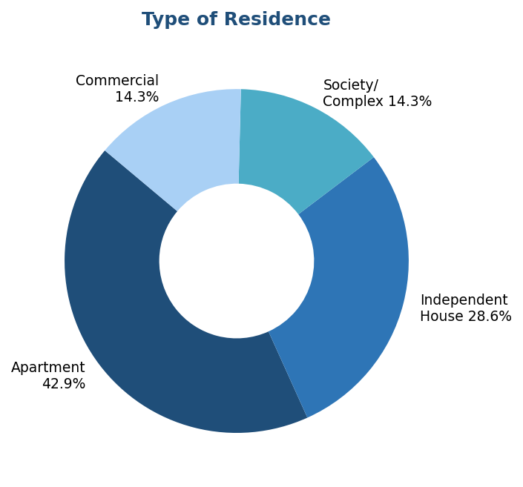
Figure 4.1: Type of Residence of Respondents (Tathawade Ward)
The majority (42.9%) live in apartments, reflecting the high-density residential character of Tathawade. Independent houses account for 28.6%, while society/complex and commercial respondents each contribute 14.3%.

4.2 Daily Waste Generation
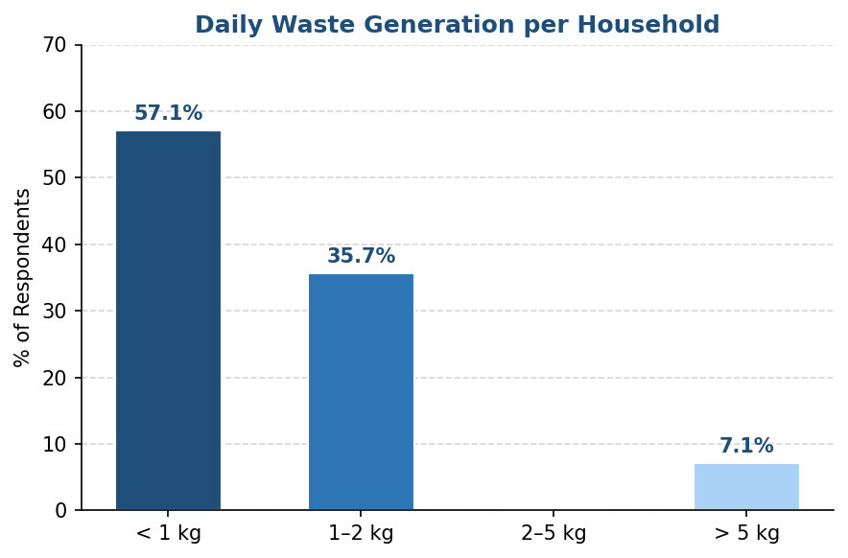
Figure 4.2: Daily Waste Generation per Household/Business
57.1% of respondents generate less than 1 kg of waste daily, reflecting relatively low volumes among Tathawade households. 35.7% produce 1–2 kg per day, while only 7.1% generate more than 5 kg — indicating that high-volume waste generation is uncommon in the surveyed area.

4.3 Type of Waste Generated
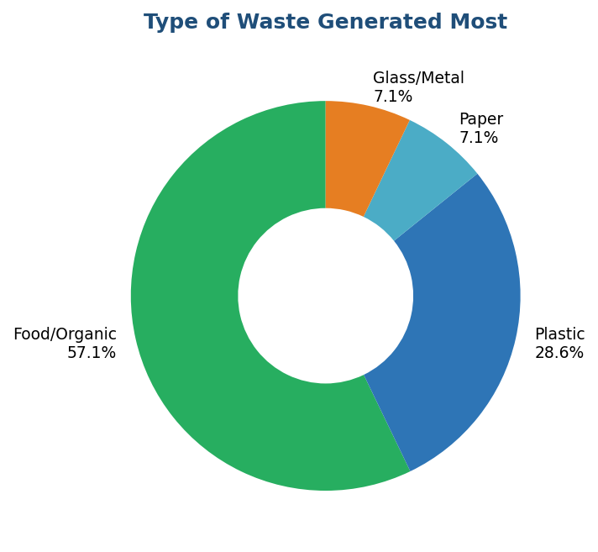
Figure 4.3: Type of Waste Generated Most
Food/organic waste is the most commonly generated waste type (57.1%), highlighting the dominance of wet waste in Tathawade's disposal patterns. Plastic waste follows at 28.6%, with paper and glass/metal each at 7.1%.

4.4 Waste Segregation Before Disposal
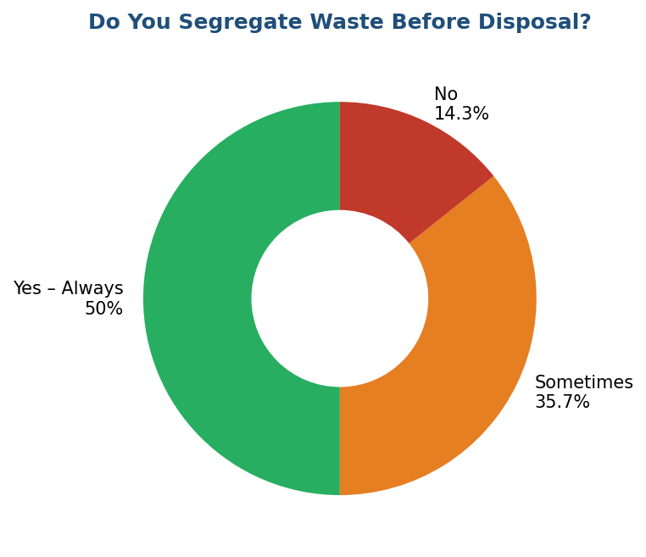
Figure 4.4: Segregation of Waste Before Disposal
50% of Tathawade respondents always segregate waste before disposal, reflecting growing awareness. However, 35.7% do so only sometimes and 14.3% never segregate — highlighting the need for continued awareness campaigns and enforcement.

4.5 Use of Separate Bins for Wet and Dry Waste
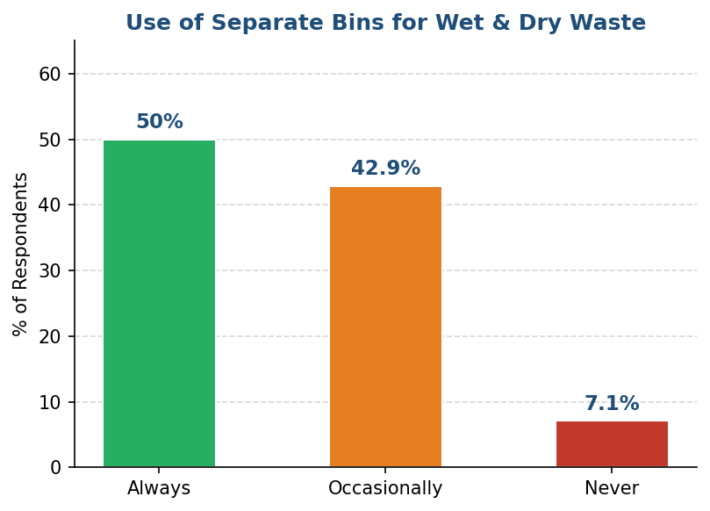
Figure 4.5: Use of Separate Bins for Wet and Dry Waste
50% of respondents always use separate bins. However, 42.9% follow the practice only occasionally and 7.1% never do, indicating inconsistency in adoption despite available infrastructure.

4.6 Waste Collection Frequency
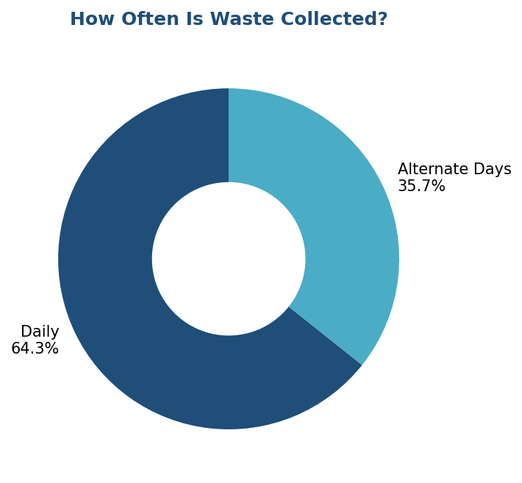
Figure 4.6: Frequency of Waste Collection in Tathawade
64.3% of Tathawade citizens reported daily waste collection. 35.7% reported collection on alternate days, suggesting minor variation within the ward. No respondent reported irregular or absent collection.

4.7 Collection Vehicle Arrival Time
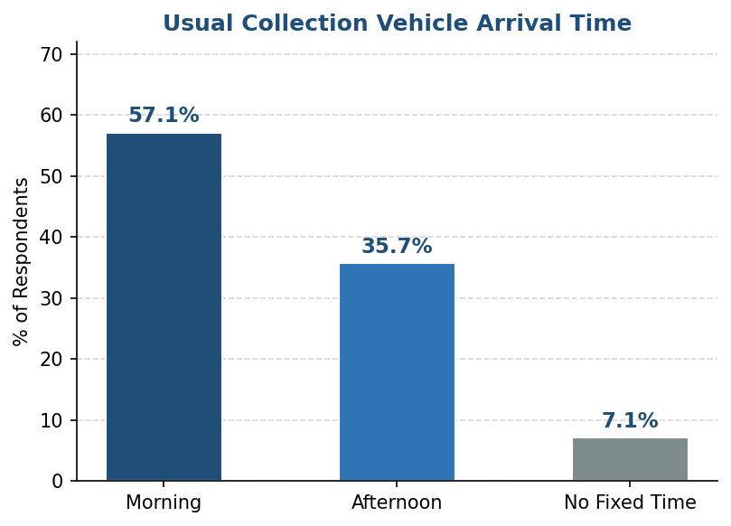
Figure 4.7: Usual Collection Vehicle Arrival Time
57.1% reported morning collection as the standard time, making it the most common schedule. 35.7% reported afternoon collection, while 7.1% indicated no fixed time — suggesting minor inconsistency in some pockets of Tathawade.

4.8 Schedule Reliability
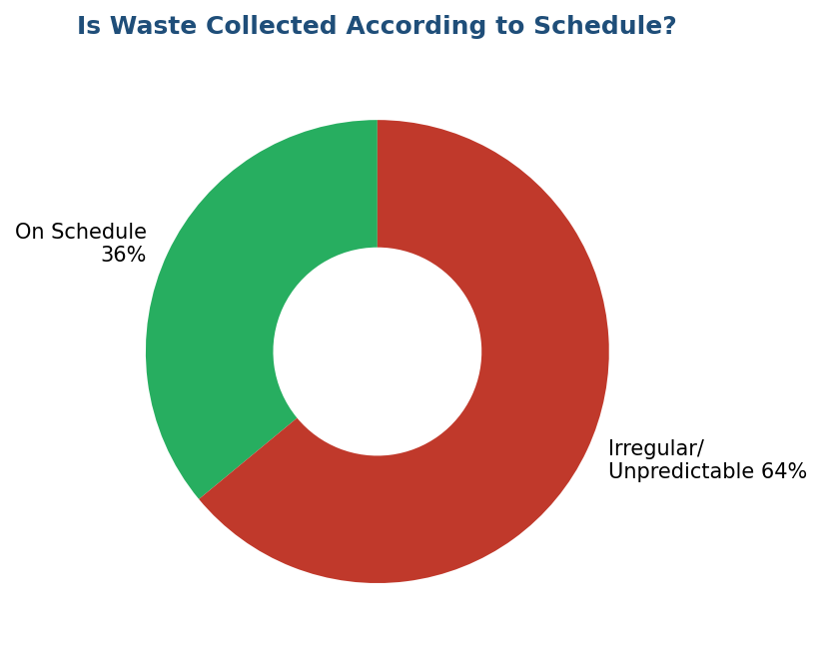
Figure 4.8: Is Waste Collected According to Schedule?
This is one of the most critical findings: only 36% of Tathawade citizens receive waste collection as planned. 64% experience irregular or unpredictable service — a major operational failure that forces households into reactive waste storage and increases illegal dumping risk.

4.9 Experience of Missed Collections
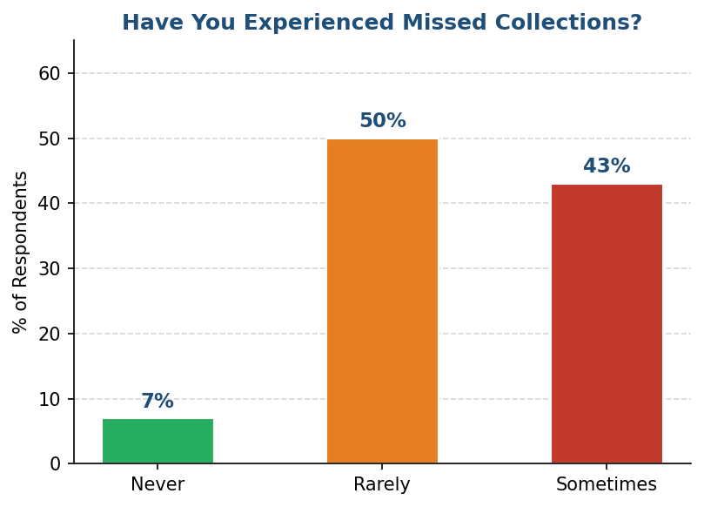
Figure 4.9: Experience of Missed Waste Collections
93% of Tathawade citizens have experienced missed collections (50% rarely + 43% sometimes). Only 7% reported no missed collections. This near-universal experience reveals systemic failures in route coverage, likely driven by vehicle breakdowns, poor route planning, and inadequate monitoring.

4.10 Bin Overflow
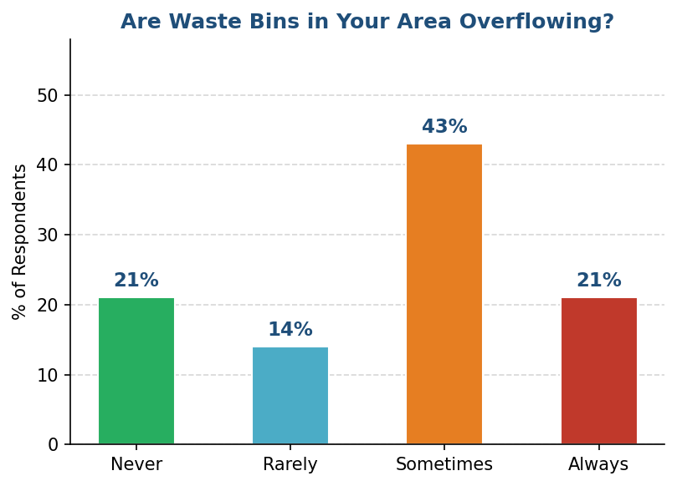
Figure 4.10: Frequency of Bin Overflow in Tathawade
79% of citizens report bin overflow issues — 21% always, 43% sometimes, and 14% rarely. Only 21% report no overflow. This indicates a severe mismatch between waste generation and collection frequency, creating direct public health hazards in Tathawade.

4.11 Collection Worker Hygiene Practices
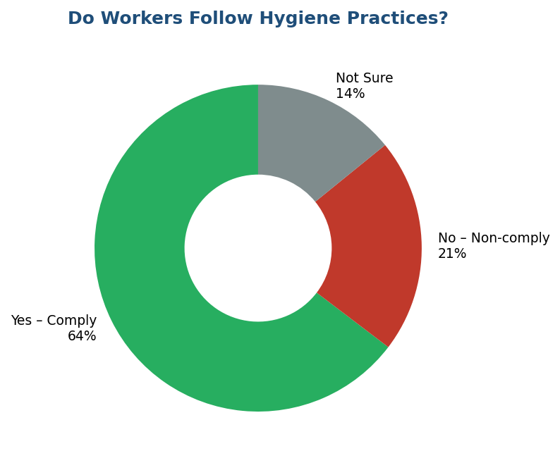
Figure 4.11: Do Collection Workers Follow Hygiene Practices?
64% of Tathawade citizens confirmed that collection workers follow hygiene practices such as wearing gloves and masks. However, 21% observed non-compliance and 14% were uncertain — highlighting the need for stricter PPE enforcement and visible compliance monitoring.

4.12 Vehicle Adequacy
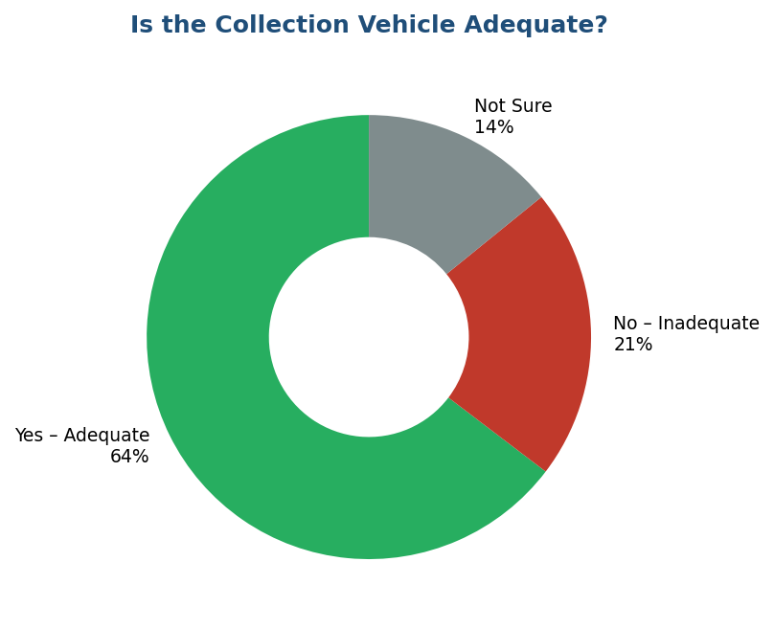
Figure 4.12: Is the Collection Vehicle Adequate for Your Area?
64% of residents find collection vehicles adequate. However, this conflicts sharply with the 79% overflow rate — indicating the real problem is collection frequency and route deployment, not vehicle size.

4.13 Complaint Registration
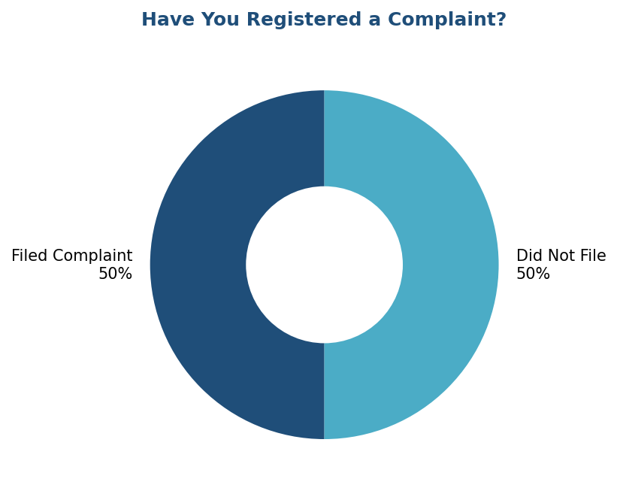
Figure 4.13: Have You Registered a Waste Collection Complaint?
Exactly 50% of Tathawade citizens have filed complaints about waste collection — confirming widespread dissatisfaction. The equal 50-50 split may also indicate that the other half has lost faith in the complaint system's effectiveness.

4.14 Complaint Resolution
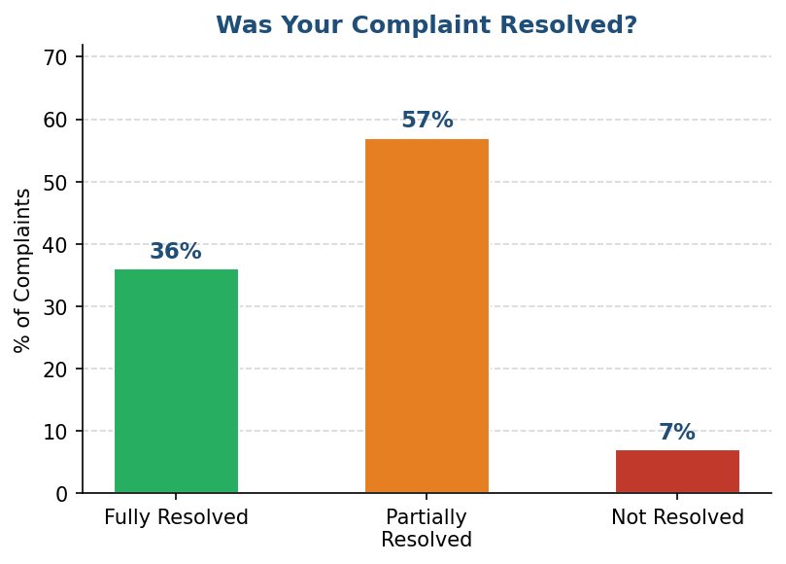
Figure 4.14: Was Your Complaint Resolved?
Only 36% of complaints filed by Tathawade citizens received full resolution. 57% were only partially addressed and 7% were entirely ignored. This broken accountability system actively discourages future citizen engagement.

4.15 Major Issues Faced by Citizens
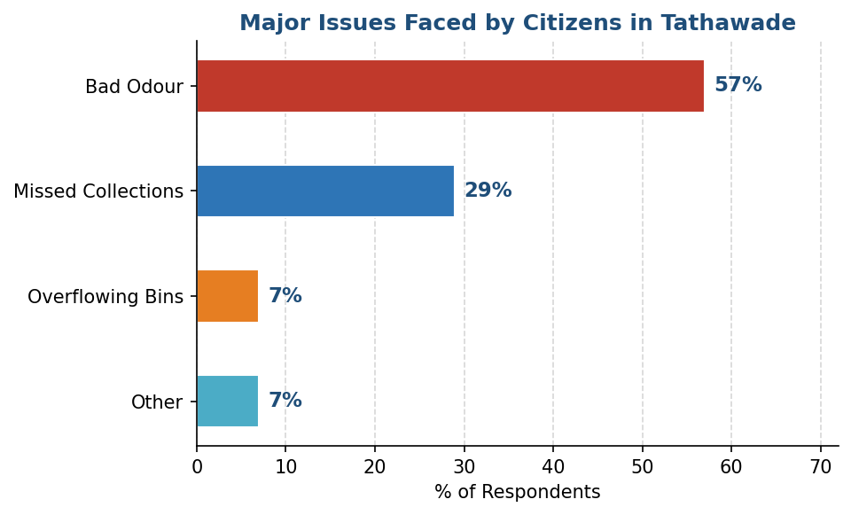
Figure 4.15: Major Waste-Related Issues Faced by Tathawade Citizens
Bad odour overwhelms as the primary complaint (57%), driven by overflowing bins and delayed collections. Missed collections account for 29%, while overflowing bins and other issues each contribute 7%. The data reveals a cascading failure: irregular collection → overflow → odour → public health risk.

4.16 Citizen Support for Smart Waste Management
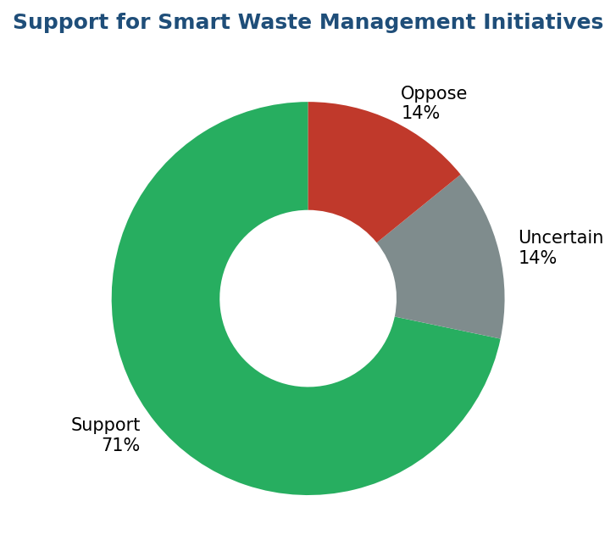
Figure 4.16: Support for Smart Waste Management Initiatives
71% of Tathawade citizens support smart waste management initiatives such as GPS tracking, IoT bin sensors, and digital complaint portals. Only 14% oppose and 14% are uncertain — providing a strong social mandate for technology-driven modernisation.

4.17 Summary of All Findings
Question / Variable | Key Finding / Insight
Collection Efficiency (schedule adherence) | 36% on-time — against municipal target of 85%
Daily Waste Generation | 57.1% generate <1 kg/day; food waste dominates at 57.1%
Segregation Compliance (always) | 50% always use separate bins; 42.9% occasional; 7.1% never
Missed Collections (ever experienced) | 93% have experienced missed collection
Bin Overflow (any frequency) | 79% report overflow problems
Schedule Reliability | Only 36% receive collection as scheduled
Worker Hygiene Compliance | 64% observe compliance; 21% observe non-compliance
Complaint Resolution (fully resolved) | 36% fully resolved; 57% partial; 7% ignored
Smart Waste Management Support | 71% support technology-driven solutions

CHAPTER V: RESULTS, FINDINGS & SUGGESTIONS

5.1 Key Findings
- Waste collection efficiency in Tathawade ward is approximately 51%, significantly below the municipal target of 85%.
- Only 36% of Tathawade residents receive waste collection on schedule; 64% face irregular or unpredictable service.
- 93% of surveyed citizens have experienced missed collections, reflecting deep systemic failure in route adherence.
- 79% report bin overflow, indicating a critical imbalance between waste generation and collection frequency.
- Food waste dominates the waste stream (57.1%), with plastic waste as the next major category (28.6%).
- 50% of citizens always segregate waste; however, 42.9% do so only occasionally and 7.1% never.
- The citizen complaint system is largely ineffective — only 36% of complaints receive full resolution.
- 71% of Tathawade citizens support smart waste management technologies, providing strong public backing for modernisation.
- Worker hygiene compliance is reasonable (64%) but requires monitoring and enforcement for the remaining 36%.

5.2 Suggestions and Recommendations

Immediate Actions (0–3 Months)
- Deploy GPS tracking on all collection vehicles in Tathawade to monitor real-time location and route adherence.
- Publish fixed, ward-specific collection schedules via WhatsApp groups and local notice boards accessible to Tathawade citizens.
- Set up a digital complaint portal with a 48-hour Service Level Agreement (SLA) for complaint response.
- Conduct mandatory PPE training and hygiene audits for all collection staff serving Tathawade.
- Implement a community waste tracking system that allows citizens to monitor vehicle locations geographically.

Short-Term Actions (3–6 Months)
- Deploy AI-assisted route optimisation for Tathawade collection routes, targeting a 20% reduction in fuel usage and improved coverage.
- Install 200 colour-coded community bins (green for wet waste, blue for dry waste) at strategic points within Tathawade.
- Launch Information, Education, and Communication (IEC) campaigns within Tathawade to improve segregation compliance.
- Introduce citizen compliance scorecards as a community engagement and awareness tool.

Long-Term Actions (6–18 Months)
- Pilot IoT bin-fill sensors in high-density areas of Tathawade to enable demand-based, dynamic collection scheduling.
- Establish a real-time community waste dashboard showing collection status for Tathawade citizens.
- Develop a mobile app allowing Tathawade citizens to report missed collections, track vehicle location, and rate service quality.
- Explore Swachh Bharat Mission (Urban) 2.0 funding pathways for infrastructure upgrades in Tathawade.

5.3 Limitations of the Study
- The study is limited to one ward (Tathawade) and may not represent waste management dynamics across other PCMC wards.
- Survey data is self-reported and subject to social desirability bias.
- Seasonal variation in waste generation volumes is not fully captured in the survey period.
- Internal operational data (vehicle logs, route records) was not accessible, limiting triangulation with primary citizen data.

5.4 Scope for Future Work
- A longitudinal study to measure the impact of recommended interventions on collection efficiency and citizen satisfaction in Tathawade over 12–18 months.
- Comparative analysis between Tathawade and other PCMC wards or Smart City-certified municipalities.
- Integration of IoT bin sensor data with machine learning models for predictive collection scheduling in Tathawade.
- Citizen co-design workshops to develop culturally sensitive behavioural change campaigns for waste segregation in Tathawade.

5.5 Conclusion
This field project has provided a detailed, citizen-centric assessment of waste collection efficiency in Tathawade ward. The evidence is clear: current collection practices fall significantly short of service targets. Only 36% of citizens receive on-schedule collection, 93% have experienced missed pickups, and 79% face bin overflow.
However, the study also reveals genuine grounds for optimism. Half of Tathawade citizens consistently segregate waste; 71% actively support smart waste management technologies; and citizens have demonstrated both awareness and willingness to engage constructively with the system. These are powerful assets that, if channelled through the right interventions, can drive meaningful transformation.
With targeted investment in GPS tracking, digital complaint systems, community bins, and citizen engagement campaigns, Tathawade has the potential to serve as a model ward for progressive, technology-enabled waste management within Pimpri-Chinchwad.

5.6 Bibliography
- Central Pollution Control Board (CPCB). Annual Report on Municipal Solid Waste 2023–24. New Delhi: CPCB.
- Ministry of Housing and Urban Affairs. Swachh Bharat Mission (Urban) 2.0 Guidelines. New Delhi: Government of India, 2021.
- Kumar, S., et al. (2017). Challenges and opportunities associated with waste management in India. Royal Society Open Science, 4(3).
- Sharholy, M., et al. (2008). Municipal solid waste management in Indian cities — A review. Waste Management, 28(2), 459–467.
- Sivaramakrishnan, K. C. (2011). Re-visioning Indian Cities: The Urban Renewal Mission. Economic and Political Weekly, 46(31).

ANNEXURES

Questionnaire: Waste Collection Efficiency Analysis — Tathawade Ward
(Administered exclusively to citizens residing in Tathawade ward, PCMC, Pune)

Instructions: Please answer all questions honestly. This survey is for academic research only. Your responses will remain completely anonymous.

SECTION A: Respondent Profile
Q1. What is your type of residence in Tathawade?
- Apartment / Flat
- Independent House
- Society / Gated Complex
- Commercial Establishment

SECTION B: Waste Generation
Q2. How much waste is generated in your household/business daily?
- Less than 1 kg
- 1–2 kg
- 2–5 kg
- More than 5 kg
Q3. What type of waste do you generate most?
- Food/Organic waste
- Plastic waste
- Paper waste
- Glass/Metal waste

SECTION C: Waste Segregation
Q4. Do you segregate waste before disposal?
- Yes, always
- Sometimes
- No
Q5. Do you use separate bins for wet and dry waste?
- Always
- Occasionally
- Never

SECTION D: Collection Service
Q6. How often is waste collected in your area of Tathawade?
- Daily
- Alternate days
- Irregularly
- Never
Q7. At what time does the collection vehicle usually arrive?
- Morning
- Afternoon
- Evening
- No fixed time
Q8. Is waste collected regularly according to schedule?
- Yes, always on schedule
- Sometimes on schedule
- Rarely on schedule
- Never on schedule
Q9. Have you experienced missed waste collections?
- Never
- Rarely
- Sometimes
- Frequently
Q10. Are waste bins in your area overflowing?
- Never
- Rarely
- Sometimes
- Always
Q11. Do collection workers follow hygiene practices (gloves, masks)?
- Yes
- No
- Not sure
Q12. Is the collection vehicle adequate for your area's waste volume?
- Yes
- No
- Not sure

SECTION E: Complaints and Issues
Q13. Have you ever registered a complaint about waste collection?
- Yes
- No
Q14. If yes, was your complaint resolved?
- Fully resolved
- Partially resolved
- Not resolved / ignored
Q15. What major waste-related issue do you face in Tathawade?
- Bad odour from bins/collection
- Missed collections
- Overflowing bins
- Poor hygiene by workers
- Other

SECTION F: Technology and Future
Q16. Would you support smart waste management initiatives (GPS tracking, IoT sensors, digital complaint portals)?
- Yes, strongly support
- Neutral / Unsure
- No, do not support

— End of Questionnaire —
Thank you for your time and participation.

