DBMS LAB

1. Introduction to SQL

Structured Query Language)[[5]](https://en.wikipedia.org/wiki/SQL#cite_note-chamberlin2001-5) is a [domain-specific language](https://en.wikipedia.org/wiki/Domain-specific_language) used in programming and designed for managing data held in a [relational database management system](https://en.wikipedia.org/wiki/Relational_database_management_system) (RDBMS), or for stream processing in a [relational data stream management system](https://en.wikipedia.org/wiki/Relational_data_stream_management_system) (RDSMS). It is particularly useful in handling [structured data](https://en.wikipedia.org/wiki/Data_model), i.e. data incorporating relations among entities and variables. SQL offers two main advantages over older read–write [APIs](https://en.wikipedia.org/wiki/API) such as [ISAM](https://en.wikipedia.org/wiki/ISAM) or [VSAM](https://en.wikipedia.org/wiki/VSAM). Firstly, it introduced the concept of accessing many records with one single command. Secondly, it eliminates the need to specify how to reach a record, e.g. with or without an [index](https://en.wikipedia.org/wiki/Database_index).

1. Features of SQL

* High Performance  
  SQL provides high-performance programming capability for highly transactional, heavy workload, and high usage [database systems](https://intellipaat.com/blog/what-is-database/). SQL programming gives various ways to describe the data more analytically.
* High Availability  
  SQL is compatible with databases like MS Access, Microsoft SQL Server, MySQL, Oracle Database, SAP HANA, SAP Adaptive Server, etc. All of these [relational database management systems](https://intellipaat.com/blog/tutorial/sql-tutorial/rdbms/) support SQL and it is easy to create an application extension for procedural programming and various other [SQL functions](https://intellipaat.com/blog/tutorial/sql-tutorial/sql-functions/) which are additional features thus converting SQL into a powerful tool.
* Scalability and Flexibility  
  [SQL](https://intellipaat.com/blog/tutorial/sql-tutorial/introduction-to-sql/) provides Scalability and Flexibility. It is very easy to create new tables and previously created or not used tables can be dropped or deleted in a database.
* Robust Transactional Support  
  SQL programming can handle large records and manage numerous transactions.
* Management Ease  
  SQL is used in almost every Relational Database Management System. “[Select](https://intellipaat.com/blog/tutorial/sql-tutorial/select-statement/)“, “Create”, “Insert”, “Drop”, “Update”, and “[Delete](https://intellipaat.com/blog/tutorial/sql-tutorial/delete-query/)” are the standard and common SQL commands that help us to manage large amounts of data from a database very quickly and efficiently.
* Open Source  
  SQL is an open-source programming language for building relational database management system

1. Different software available for SQL

| [ManageEngine](https://guru99.link/recommends-sqlmgmt-tools) |  |  |
| --- | --- | --- |
| [Aqua Data Studio](https://bit.ly/3oe8nJ9) |  |  |
| [SolarWinds Database Performance Analyzer](https://www.solarwinds.com/database-performance-analyzer/registration?a_aid=BIZ-PAP-GURU99&a_bid=5942e254&CMP=BIZ-PAP-GURU99-SQL-MANAGEMENT-TOOLS-ANALYZER) |  |  |
| [DbSchema](https://shop.dbschema.com/affiliate.php?ACCOUNT=250126330556&AFFILIATE=120043&PATH=https://dbschema.com/%3FAFFILIATE%3D120043&AFFSRC=top-20-sql-management-tools) |  |  |
| [DBVisualizer](https://bit.ly/3qTMZdt) |  |  |
| [Devart](https://secure.2checkout.com/affiliate.php?ACCOUNT=DEVARTFG&AFFILIATE=120043&PATH=https%3A%2F%2Fwww.devart.com%2Fdbforge%2Fmysql%2F%3FAFFILIATE%3D120043&AFFSRC=top-20-sql-management-tools) |  |  |
| [SQL Sentry](https://www.solarwinds.com/sql-sentry?a_aid=BIZ-PAP-GURU99&a_bid=ade0cfff&CMP=BIZ-PAP-GURU99-SQL-MANAGEMENT-SQL-SENTRY) |  |  |
| [Paessler PRTG MySQL Monitoring](http://track.webgains.com/click.html?wglinkid=2081375&wgprogramid=264775&wgcampaignid=1451605&clickref=top-20-sql-management-tools&wgtarget=https://www.paessler.com/mysql_monitoring) |  |  |
| [SysTools](https://shop.systoolsgroup.com/affiliate.php?ACCOUNT=SYSTOOBY&AFFILIATE=120043&PATH=https%3A%2F%2Fwww.systoolsgroup.com%2Fsql-password-recovery.html%3FAFFILIATE%3D120043&AFFSRC=top-20-sql-management-tools) |  |  |
| [EMS SQL Manager](https://bit.ly/3bOXAOg) |  |  |
| [Microsoft SQL Server Management Studio Express](https://guru99.live/t0Lfnd) |  |  |
| [FlySpeed](https://secure.2checkout.com/affiliate.php?ACCOUNT=ACVDBSO&AFFILIATE=120043&PATH=https%3A%2F%2Fwww.activedbsoft.com%2F%3FAFFILIATE%3D120043&AFFSRC=top-20-sql-management-tools) |  |  |

1. Data types in SQL

Data types mainly classified into three categories for every database.

* String Data types

| CHAR(Size) |  |
| --- | --- |
| VARCHAR(Size) |  |
| BINARY(Size) |  |
| VARBINARY(Size) |  |
| TEXT(Size) |  |
| TINYTEXT |  |
| MEDIUMTEXT |  |
| LONGTEXT |  |
| ENUM(val1, val2, val3,...) |  |
| SET( val1,val2,val3,....) |  |
| BLOB(size) |  |

* Numeric Data types

| BIT(Size) |  |
| --- | --- |
| INT(size) |  |
| INTEGER(size) |  |
| FLOAT(size, d) |  |
| FLOAT(p) |  |
| DOUBLE(size, d) |  |
| DECIMAL(size, d) |  |
| DEC(size, d) |  |
| BOOL |  |

* Date and time Data types

| DATE |  |
| --- | --- |
| DATETIME(fsp) |  |
| TIMESTAMP(fsp) |  |
| TIME(fsp) |  |
| YEAR |  |

1. Components of SQL

## Data Manipulation Language

The Data Manipulation Language (DML) contains the subset of SQL commands used most frequently — those that simply manipulate the contents of a database in some form. The four most common DML commands retrieve information from a database (the SELECT) command, add new information to a database (the INSERT command), modify information currently stored in a database (the UPDATE command), and remove information from a database (the DELETE command).

## Data Definition Language

The Data Definition Language (DDL) contains commands that are less frequently used. DDL commands modify the actual structure of a database, rather than the database’s contents. Examples of commonly used DDL commands include those used to generate a [new database table](https://www.thoughtco.com/creating-databases-and-tables-in-sql-1019781) (CREATE TABLE), modify the structure of a database table (ALTER TABLE), and delete a database table (DROP TABLE).

## Data Control Language

The [Data Control Language](https://www.lifewire.com/data-control-language-dcl-1019477) (DCL) is used to [manage user access to databases](https://www.thoughtco.com/access-controls-in-sql-1019700). It consists of two commands: the GRANT command, used to add database permissions for a user, and the REVOKE command, used to remove existing permissions. These two commands form the core of the relational database security model.

6. SQL commands

1. Show database:- Show all the databases present in the system.

Syntax: show databases;

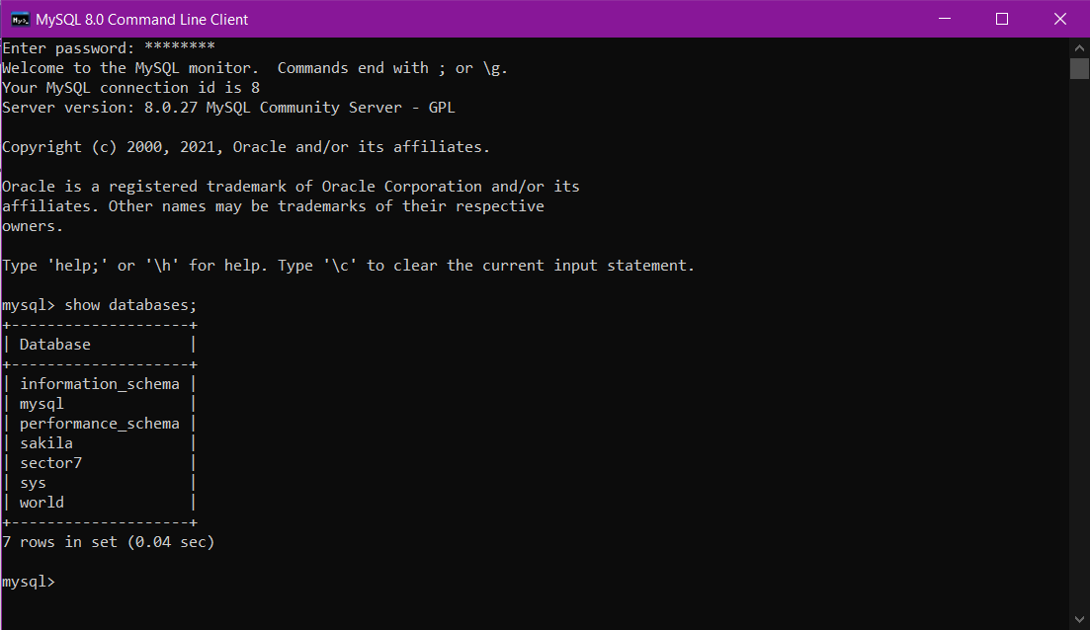

2. Create database: Helps to create a database in the system.

Syntax: Create database name_database;



3. Use: Help us to choose the database on which we have to work on.

Syntax: Use database_name;

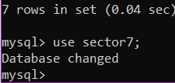

4. Create table: Creates a table in the database.

Syntax: Create table table_name (column_name datatype);

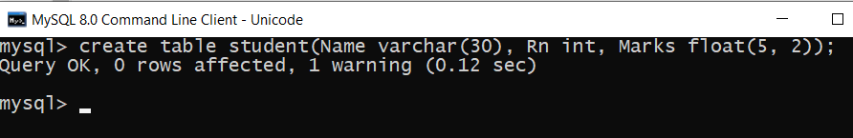

* 1. Describe: Describe the current database in the form of metadata.

Syntax: describe table_name;

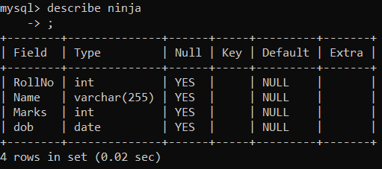

* 1. Insert Values to tables:

1. TO ADD SINGLE ELEMENT:

Insert into table_name values(-------Data---------);

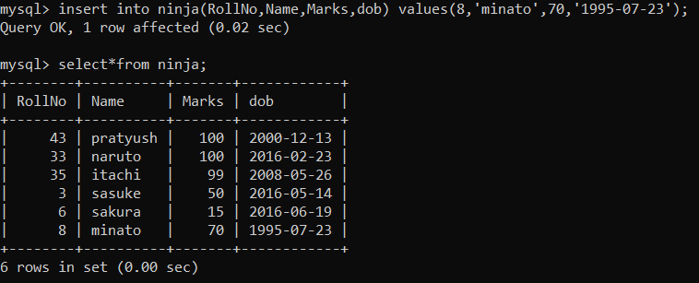

1. TO ADD MULTIPLR VALUES TOGETHER:

Insert into table_name values(tuple1),(tuple2);

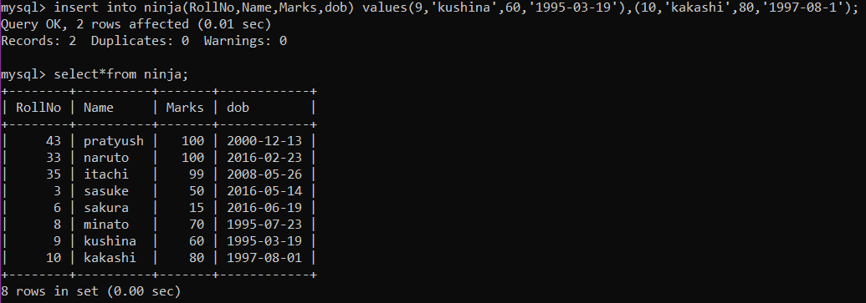

1. TO INSERT NULL VALUES:

Insert into table_name values (----data---, null);

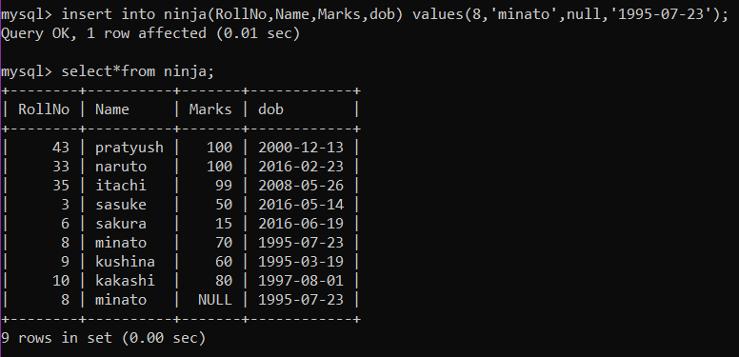

* 1. Apply ‘Where’ conditions

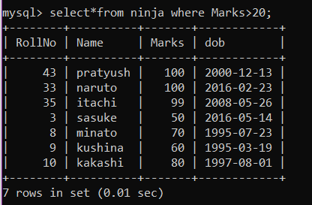

* 1. Alter
     + 1. Make column as a primary key

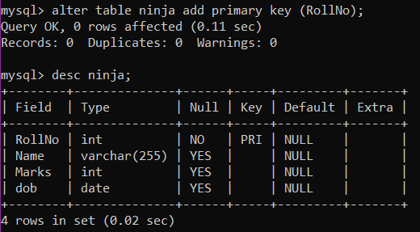

* + - 1. Add column in table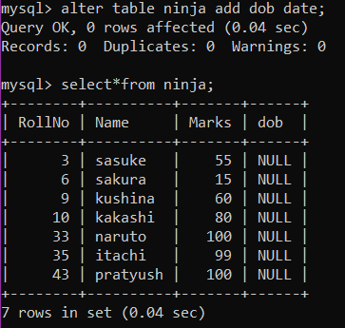
      2. Drop any column from table

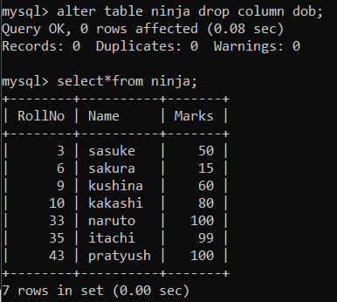

* 1. Delete record from table

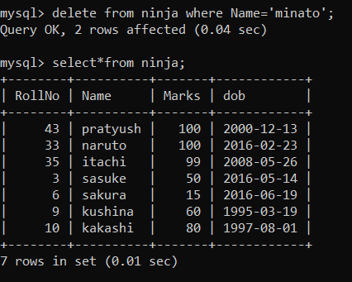

* 1. Update record in table

