AUTHOR: MANASHA PAVITHRA J
ROLL NO: NC.AI.U4AID24027
AI-POWERED HUMAN POSE ESTIMATION & MOTION ANALYSIS SYSTEM

1. Executive Summary & Project Overview
This project implements an end-to-end Computer Vision system for real-time human pose estimation, kinematic body landmark detection, ergonomic posture evaluation, and autonomous pose classification using OpenCV and MediaPipe. The system localizes 33 key 2D/3D skeletal keypoints (head, shoulders, elbows, wrists, hips, knees, ankles) to evaluate biomechanical postures in sports, ergonomics, dance analytics, and healthcare fitness monitoring.

2. System Methodology & Pipeline
System Pipeline Steps:
- Video / Image Acquisition: Read high-resolution input visual feeds using OpenCV VideoCapture.
- Color Space Transformation: Convert raw BGR frames to RGB format required by neural inferencing engines.
- Neural Landmark Inferencing: Execute MediaPipe Pose Landmarker for 33 full-body 3D landmark localization.
- Joint Geometry Calculation: Compute joint angle vectors, torso inclination, and anatomical line alignments.
- Feature Classification: Apply heuristic thresholding for ergonomic slouch detection and yoga posture recognition.
- Real-time Visual Overlay: Render annotated skeletal wireframes and metric overlays onto frame outputs.

3. Core Pose Estimation Module
import cv2
import mediapipe as mp

class PoseEstimationPipeline:
def __init__(self, model_complexity=1):
self.mp_pose = mp.solutions.pose
self.mp_drawing = mp.solutions.drawing_utils
self.pose = self.mp_pose.Pose(
static_image_mode=False,
model_complexity=model_complexity,
min_detection_confidence=0.5,
min_tracking_confidence=0.5
)

def process_frame(self, frame):
rgb_frame = cv2.cvtColor(frame, cv2.COLOR_BGR2RGB)
results = self.pose.process(rgb_frame)
if results.pose_landmarks:
self.mp_drawing.draw_landmarks(
frame,
results.pose_landmarks,
self.mp_pose.POSE_CONNECTIONS
)
return frame, results

if __name__ == "__main__":
pipeline = PoseEstimationPipeline()
cap = cv2.VideoCapture("input_feed.mp4")
while cap.isOpened():
ret, frame = cap.read()
if not ret: break
annotated, _ = pipeline.process_frame(frame)
cv2.imshow("Pose Estimation Engine", annotated)
if cv2.waitKey(1) & 0xFF == 27: break
cap.release()
cv2.destroyAllWindows()
Output:
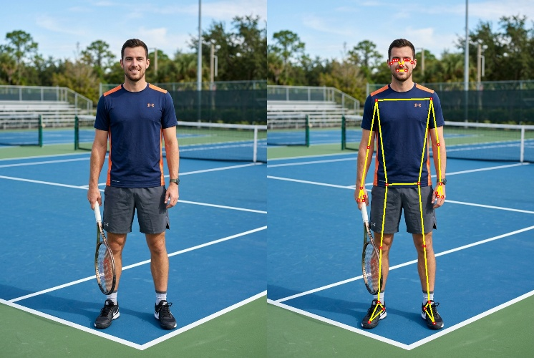

4. Ergonomic Sitting Posture Analysis Module
System Description: Evaluates workstation ergonomic health by measuring relative spatial coordinates of the ear, shoulder, and hip landmarks to detect forward neck slouching and spinal curvature.
import cv2
import numpy as np
import mediapipe as mp
import math

class ErgonomicPostureAnalyzer:
@staticmethod
def calculate_angle(a, b, c):
radians = math.atan2(c[1]-b[1], c[0]-b[0]) - math.atan2(a[1]-b[1], a[0]-b[0])
angle = abs(radians * 180.0 / math.pi)
return 360.0 - angle if angle > 180.0 else angle

def analyze(self, frame, landmarks, w, h):
ear = (int(landmarks[7].x * w), int(landmarks[7].y * h))
shoulder = (int(landmarks[11].x * w), int(landmarks[11].y * h))
hip = (int(landmarks[23].x * w), int(landmarks[23].y * h))

neck_angle = self.calculate_angle((shoulder[0], shoulder[1]-100), shoulder, ear)
torso_angle = self.calculate_angle((hip[0], hip[1]-100), hip, shoulder)

is_slouched = neck_angle > 35 or torso_angle > 25
status_text = "IMPROPER / SLOUCHED POSTURE!" if is_slouched else "PROPER POSTURE"
color = (0, 0, 255) if is_slouched else (0, 255, 0)

cv2.putText(frame, f"Status: {status_text}", (30, 50), cv2.FONT_HERSHEY_SIMPLEX, 0.9, color, 2)
return frame
Output:
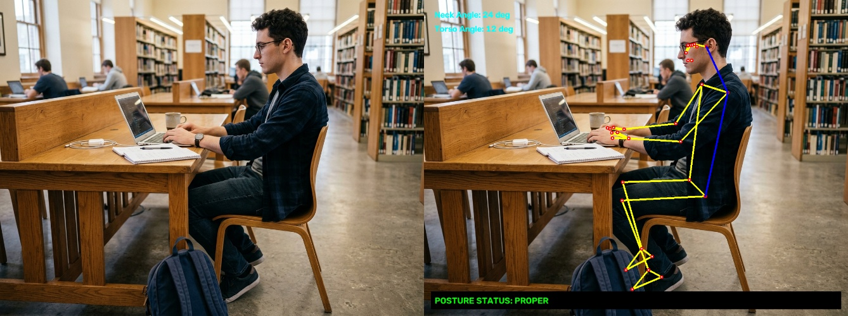
System Description: Extracts joint trajectories and spatial motion vectors across dynamic performance movements for dance training analytics.

5. Kinematic Dance Movement Tracking Module
import cv2
import mediapipe as mp

class DanceKinematicsTracker:
def __init__(self):
self.mp_pose = mp.solutions.pose
self.mp_drawing = mp.solutions.drawing_utils

def render_kinematics(self, frame, landmarks, w, h):
coords = [(int(lm.x * w), int(lm.y * h)) for lm in landmarks.landmark]
self.mp_drawing.draw_landmarks(frame, landmarks, self.mp_pose.POSE_CONNECTIONS)
# Log key joint vectors (left wrist, right wrist, ankles)
cv2.putText(frame, f"Wrist L: {coords[15]}", (30, 40), cv2.FONT_HERSHEY_SIMPLEX, 0.6, (0,255,255), 2)
return frame
Output:
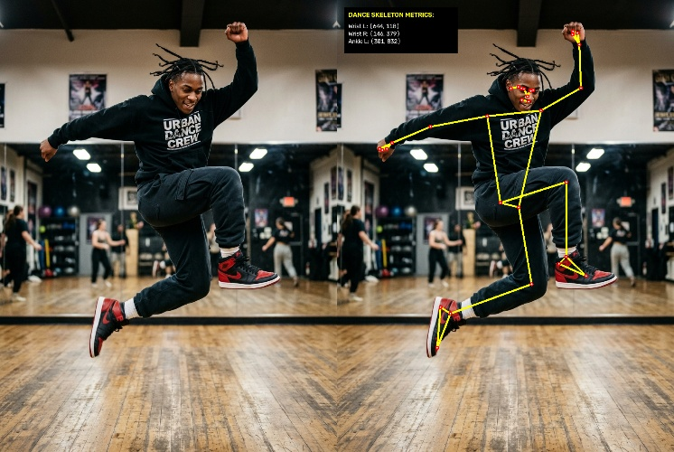

6. Autonomous Yoga Pose Classifier Module
System Description: Classifies yoga poses (Tree Pose, Warrior Pose, T-Pose) based on vector angle geometry across lower limb flexions and upper limb horizontal extensions.
import cv2
import numpy as np
import mediapipe as mp
import math

class YogaPoseClassifier:
@staticmethod
def calculate_angle(a, b, c):
radians = math.atan2(c[1]-b[1], c[0]-b[0]) - math.atan2(a[1]-b[1], a[0]-b[0])
angle = abs(radians * 180.0 / math.pi)
return 360.0 - angle if angle > 180.0 else angle

def classify(self, landmarks, w, h):
lm = landmarks.landmark
l_hip, r_hip = (int(lm[23].x*w), int(lm[23].y*h)), (int(lm[24].x*w), int(lm[24].y*h))
l_knee, r_knee = (int(lm[25].x*w), int(lm[25].y*h)), (int(lm[26].x*w), int(lm[26].y*h))
l_ank, r_ank = (int(lm[27].x*w), int(lm[27].y*h)), (int(lm[28].x*w), int(lm[28].y*h))

l_knee_angle = self.calculate_angle(l_hip, l_knee, l_ank)
r_knee_angle = self.calculate_angle(r_hip, r_knee, r_ank)

if l_knee_angle < 140 or r_knee_angle < 140:
return "Tree Pose (Vrksasana)"
elif abs(l_ank[0] - r_ank[0]) > 0.3 * w:
return "Warrior Pose (Virabhadrasana)"
return "T Pose"
Output:
