Katie Davenport
CS 6650: Scalable Distributed Systems
Homework 8: Welcome to the Data Layer

Step I: My SQL Integration for Relational Data
Deliverable 1: Working MySQL Implementation
The implementation of the RDS integration is provided in Github directory: /hw8/infra/terraform . The following steps were required to extend Terraform with RDS integration.
- Add and configure a “rds” module with the three standard files: main.tf, outputs.tf, and variables.tf.
- Added the “rds” module to the main.tf file in the root directory.
- Update the main.tf file in the “ecs” directory to wire the database to the container.
- Update the “ecs” block in the root main.tf file.

Select screenshots are provided below:

New “rds” directory
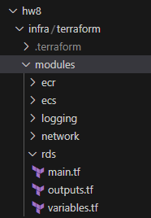
Some of the configurations in the new “rds” module files
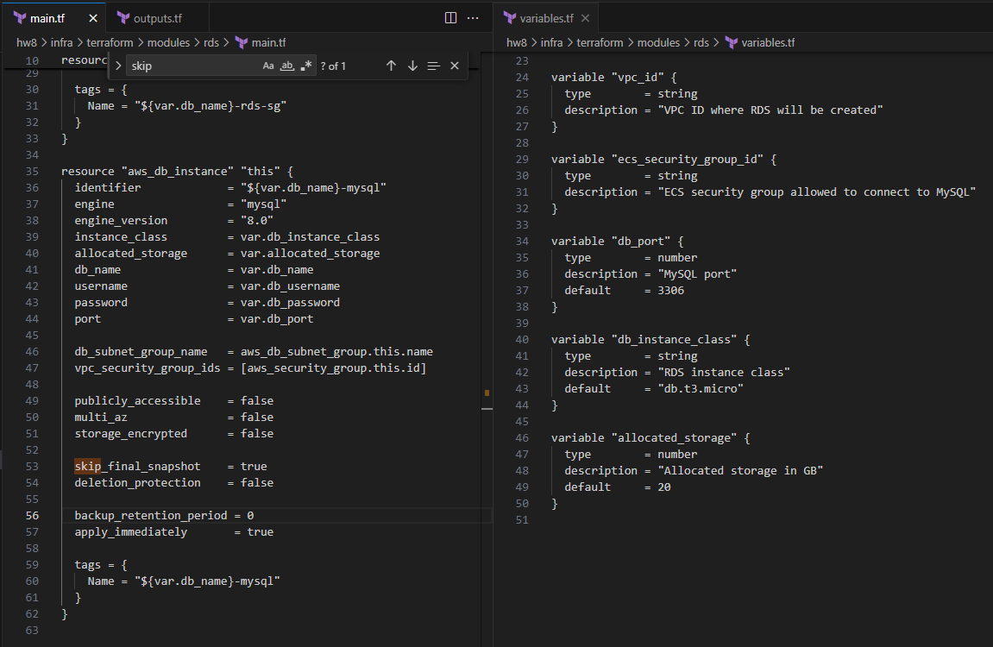

Wire the “rds” module in the main.tf file in the root directory
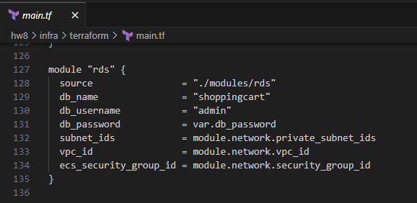

Wire the database to the container in the main.tf to file in the “ecs” directory.
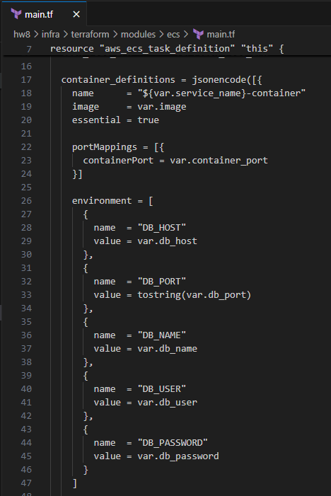

Update the ecs block on main.tf
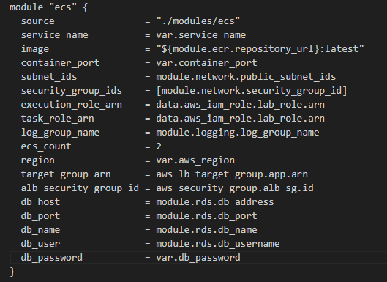

The implementation of the shopping cart API with persistent storage is provided in GitHub directory: hw8/src . Below are screenshots showing successful calls to the new endpoints:

POST /shopping-carts
GET /shopping-carts/{id}
POST /shopping-carts/{id}/items

Create a new cart
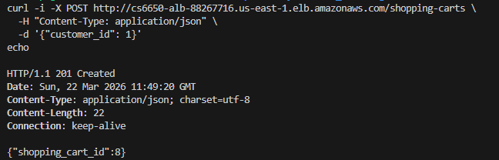

Add an item to a cart
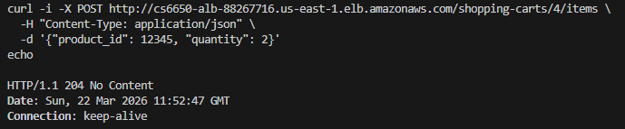

Add another product to a cart
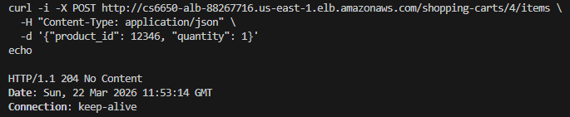

Add the same product to the cart again
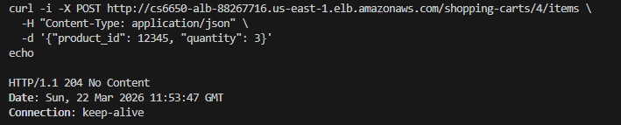

Get the cart (note: prior posts for product 12345 resulted in a total quantity of 10.
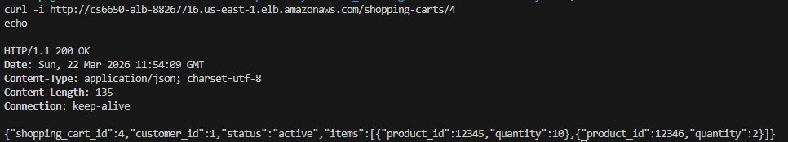

Invalid product
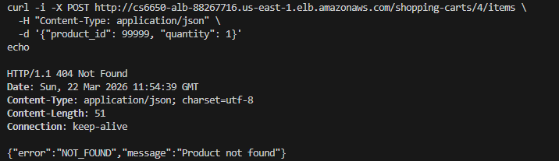

The database schema design is provided in GitHub directory: hw8/src/go/db.go . It is also described in more detail below.

Deliverable 2: Performance Testing Results
Below are performance testing results for Locust and from AWS (RDS, ECS, and ALB).

Locust statistics:
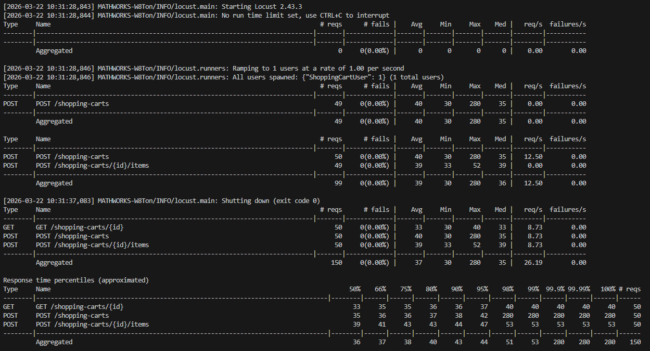

AWS: RDS statistics
Average CPU Utilization
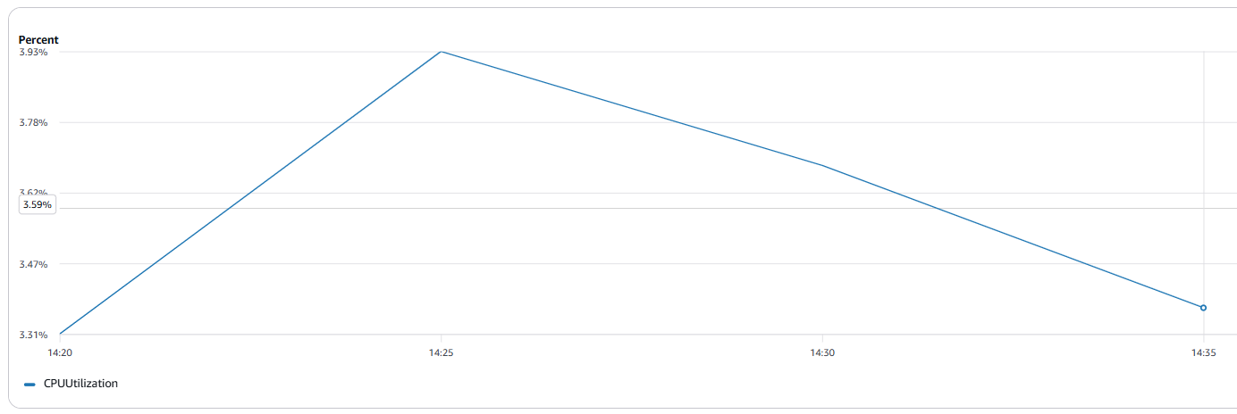

Database Connections: Sum
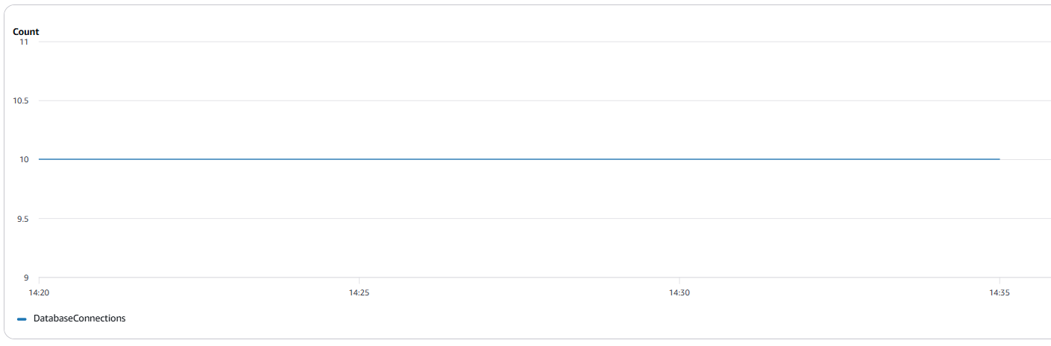

ReadIOPS: Average 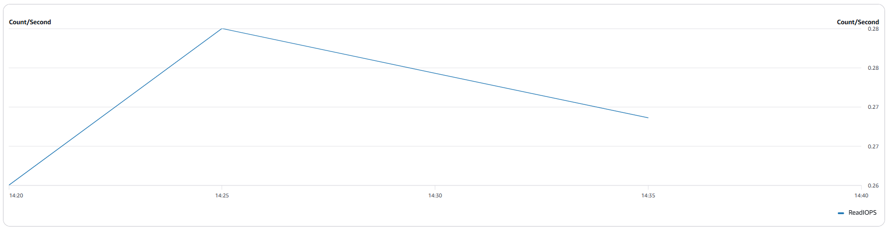

WriteIOPS: Average
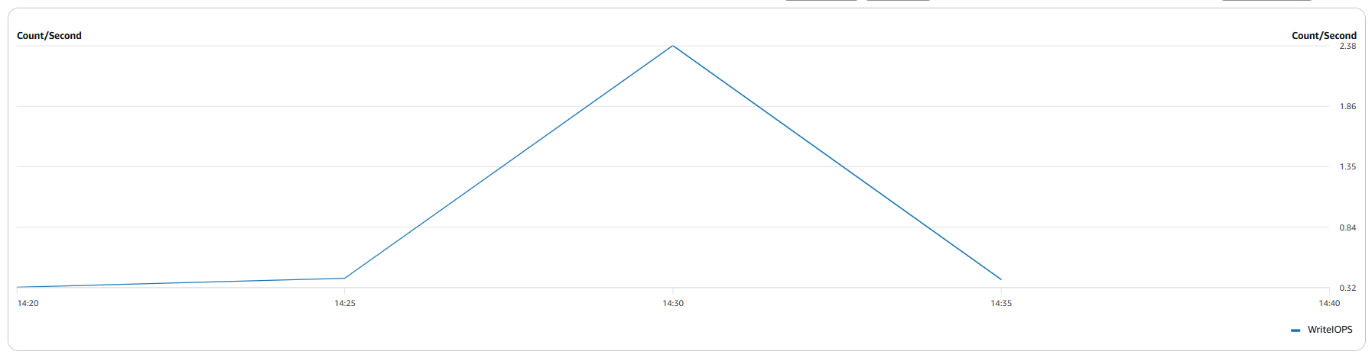

Read Latency: Average
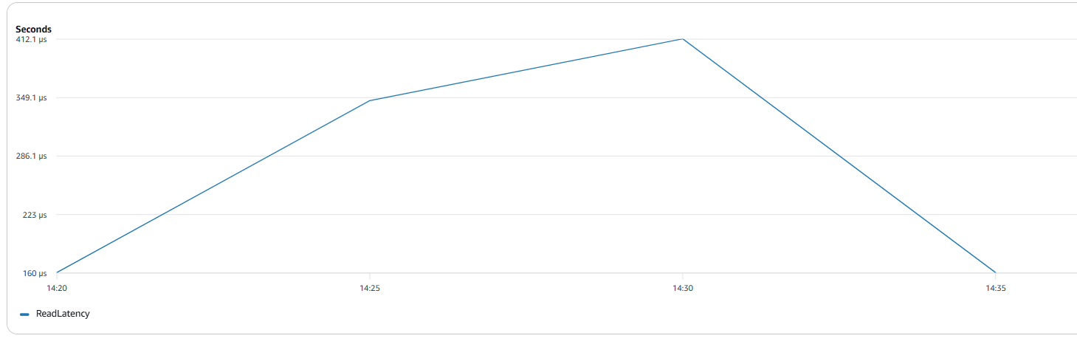

Write Latency: Average
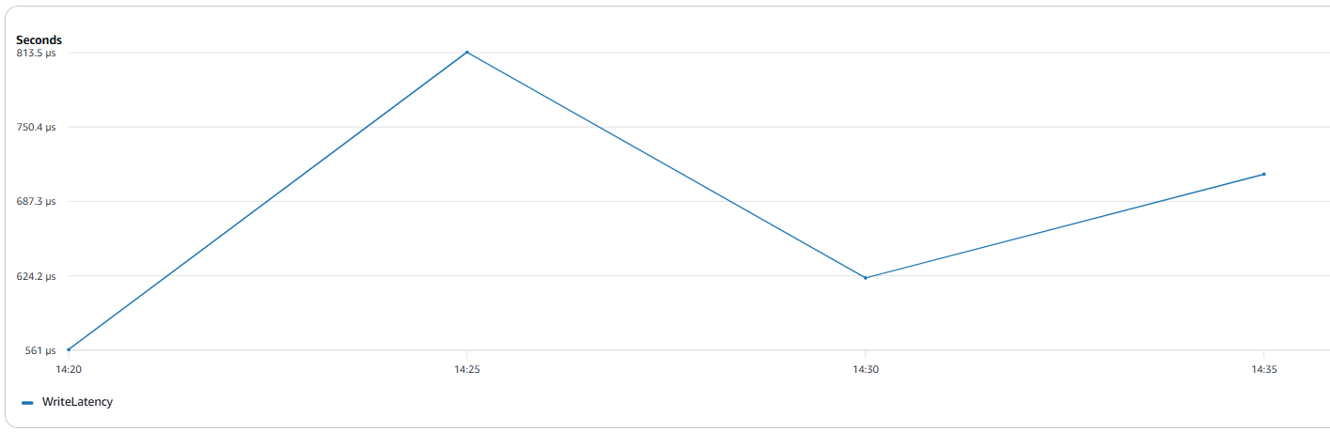

AWS: ECS statistics
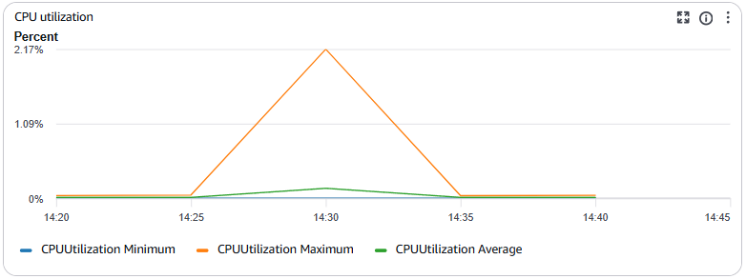
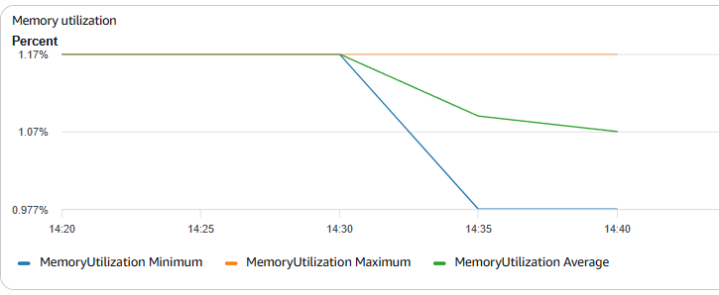

AWS: ALB statistics
RequestCount
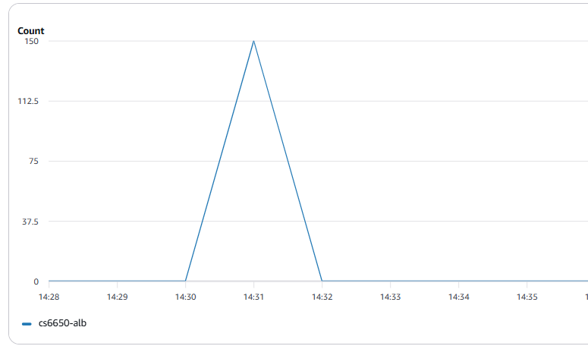

Target Response Time
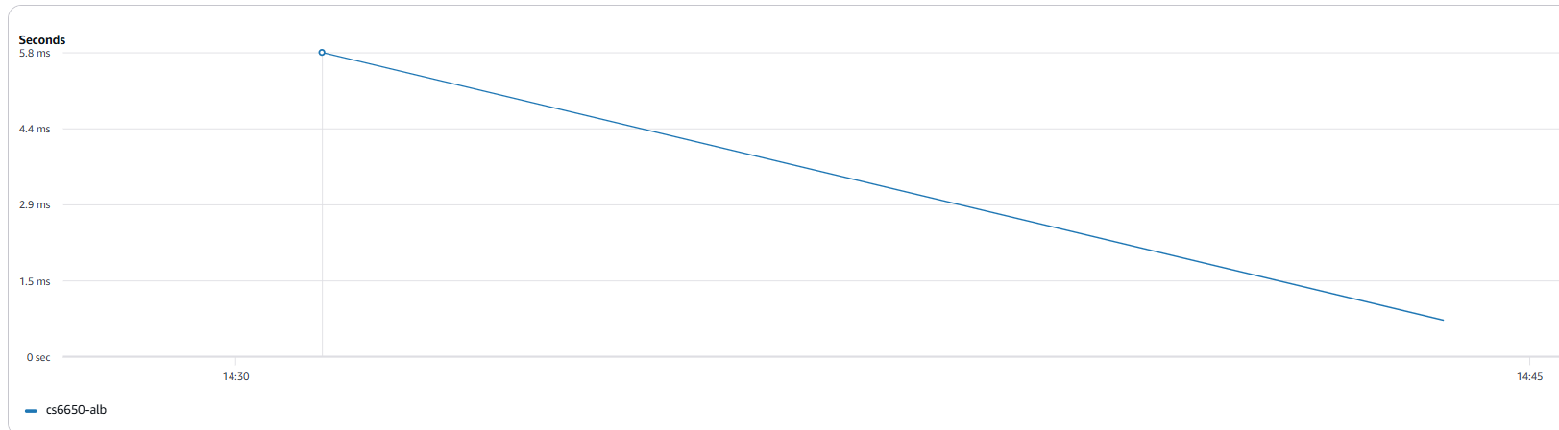

Deliverable 3: Implementation Notes

Database schema design decisions and rationale

The database schema shown below includes three tables: products, shopping_carts, and shopping_cart_items. Note that the submitted code includes an additional orders table should we want to add the /shopping-carts/{shoppingCartId}/checkout endpoint, which responds with an order id.

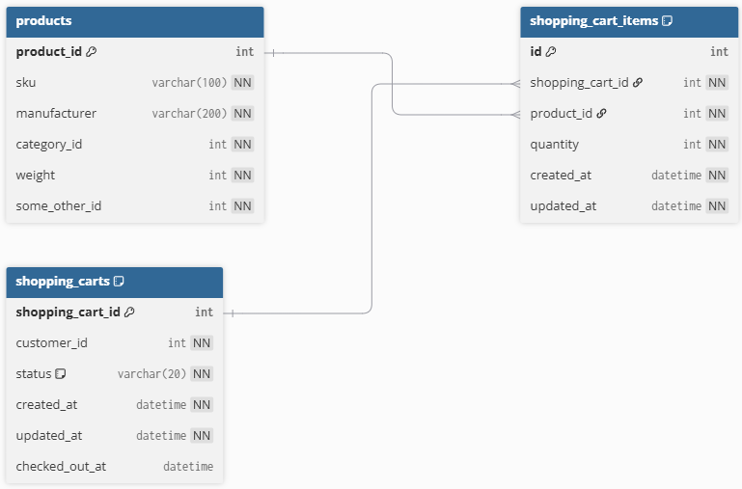

The products table stores data about products and matches the Product schema provided in the OpenAPI Specification. The shopping_carts table stores data about a shopping cart. It includes the customer_id, which is a required field in the request body for the /shopping-carts endpoint, as well as a status field to indicate if the cart has been checked out. The shopping_cart_items table stores data about the items in a shopping cart. Each item includes a product and a quantity for that product. Both the shopping_carts and shopping_cart_items tables include created_at and updated_at fields to reflect the state of the cart and its items.

Each table has a primary key: product_id for products, shopping_cart_id for shopping_carts, and id for shopping_cart_items. The shopping_cart_items table has two foreign key constraints. The first is to the shopping_carts table, representing a one-to-many relationship between a cart and its items. This constraint includes “ON DELETE CASCADE,” meaning that if a shopping cart is deleted, all related shopping cart items are also deleted. The second foreign key is to the products table, where each shopping cart item references a single product. In addition, the shopping_cart_items table includes a unique constraint on the combination of shopping_cart_id and product_id to ensure that a product appears only once per cart.

There are two indices for shopping_carts: customer_id and the combination of customer_id and updated_at. These support efficient retrieval of carts for a given customer. There are also indices on shopping_cart_items for shopping_cart_id and product_id, which improve the efficiency of operations that add or retrieve items within a cart.

One challenge I faced with the SQL implementation is that schema changes require careful planning and coordination. For example, I initially included an orders table, but later realized it was not required for the three endpoints in this assignment. While it is possible to modify the schema, doing so can require migrations and updates to related code, which adds complexity compared to more flexible in-memory data structures.

Comparison to Week 5

Our week 5 homework implementation used in-memory storage. Below is a comparison of load testing data for that and this homework. The homework 5 data is from “Test 4” with 4 works, 50 users, and the FastHttpUser for 3 minutes. This was the most similar test.

Locust Statistics
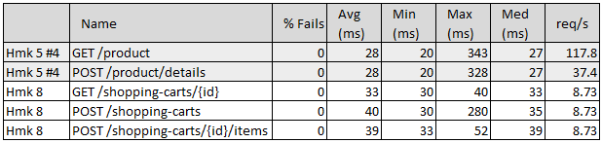

AWS Metrics
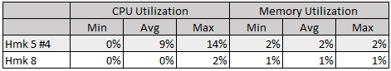

The MySQL-based implementation shows slightly higher latency than the in-memory implementation while maintaining zero failures. However, system resource utilization (CPU and memory) is significantly lower in Homework 8 due to the much smaller and sequential workload. Overall, the results highlight the expected tradeoff: in-memory storage provides faster responses under load, while the database-backed system introduces modest latency overhead in exchange for persistence and data integrity.

Connection pool and database performance analysis

The data indicates that connection pooling was efficient. Despite processing 150 requests, the RDS instance maintained a low and stable number of connections (10), indicating that connections were reused rather than frequently created and destroyed. Additional signs of effective connection pooling include low CPU utilization (3.9%) and I/O activity, along with relatively consistent latency. There was only one single higher-latency outlier, likely caused by the initial connection / warm-up.

