CS6650 — Distributed Music Streaming: Experiment Report
Team: Ananyaa Mylsamy · Manasha Sekar

System Overview
We built two Go microservices deployed on AWS ECS Fargate to simulate the core challenge of music streaming at scale: delivering fixed-size audio chunks to thousands of concurrent streams without rebuffering.
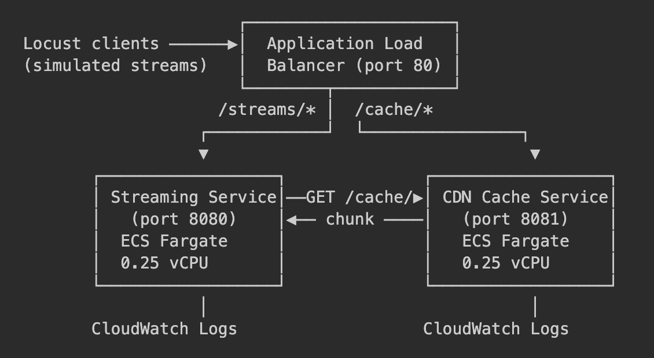
Architecture
Service | Role
Streaming Service | Manages active streams in-memory (sync.Map). On each chunk request, tries CDN first (500ms timeout); falls back to local CPU generation if CDN fails. Implements circuit breaker (5 failures → open 30s) and adaptive quality switching.
CDN Cache Service | Pre-populates 100 songs × 300 chunks in-memory at startup. Serves chunks at low latency when the circuit is closed.
Audio is modelled as byte arrays: high-quality chunks (320kbps) cost ~500k CPU iterations; low-quality (128kbps) cost ~50k , a 10× difference that drives all three experiments.

Experiment 1 — Single-Instance Capacity Under Load

Purpose & Tradeoff
Find the maximum concurrent streams a single 0.25 vCPU Fargate instance can serve before p99 chunk delivery latency exceeds 500ms (the rebuffering threshold). The tradeoff is concurrency vs. latency: more users means more goroutines competing for CPU, which drives up per-chunk generation time.

Limitations
Single instance only; CDN circuit breaker trips at ~300 users in every run (forcing local fallback), so results reflect local CPU generation throughout — CDN hit performance is not measured here.

Results (AWS — Fargate, Single Instance, 0.25 vCPU)
Three runs at 300, 400, and 500 concurrent users (fixed 320kbps, adaptive=false, 3–5 min each):
Users | Median (ms) | p95 (ms) | p99 (ms) | RPS | CDN Circuit
300 | 150 | 290 | 370 | 1,283 | Open
400 | 220 | 410 | 480 | 1,447 | Open
500 | 260 | 480 | 610 | 1,433 | Open
p99 crosses 500ms at 500 users. RPS plateaus at 400->500 users, confirming CPU saturation.
500-user run — Statistics and Charts:
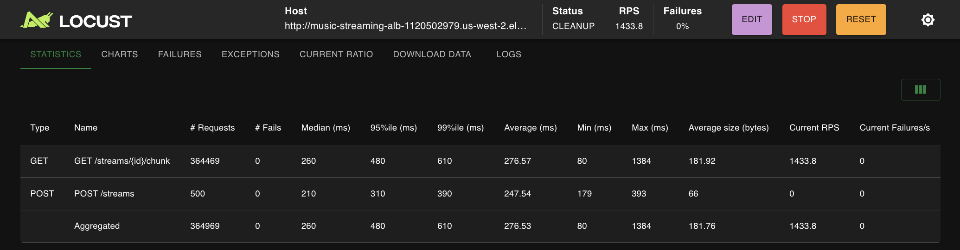  500 users’ stats | 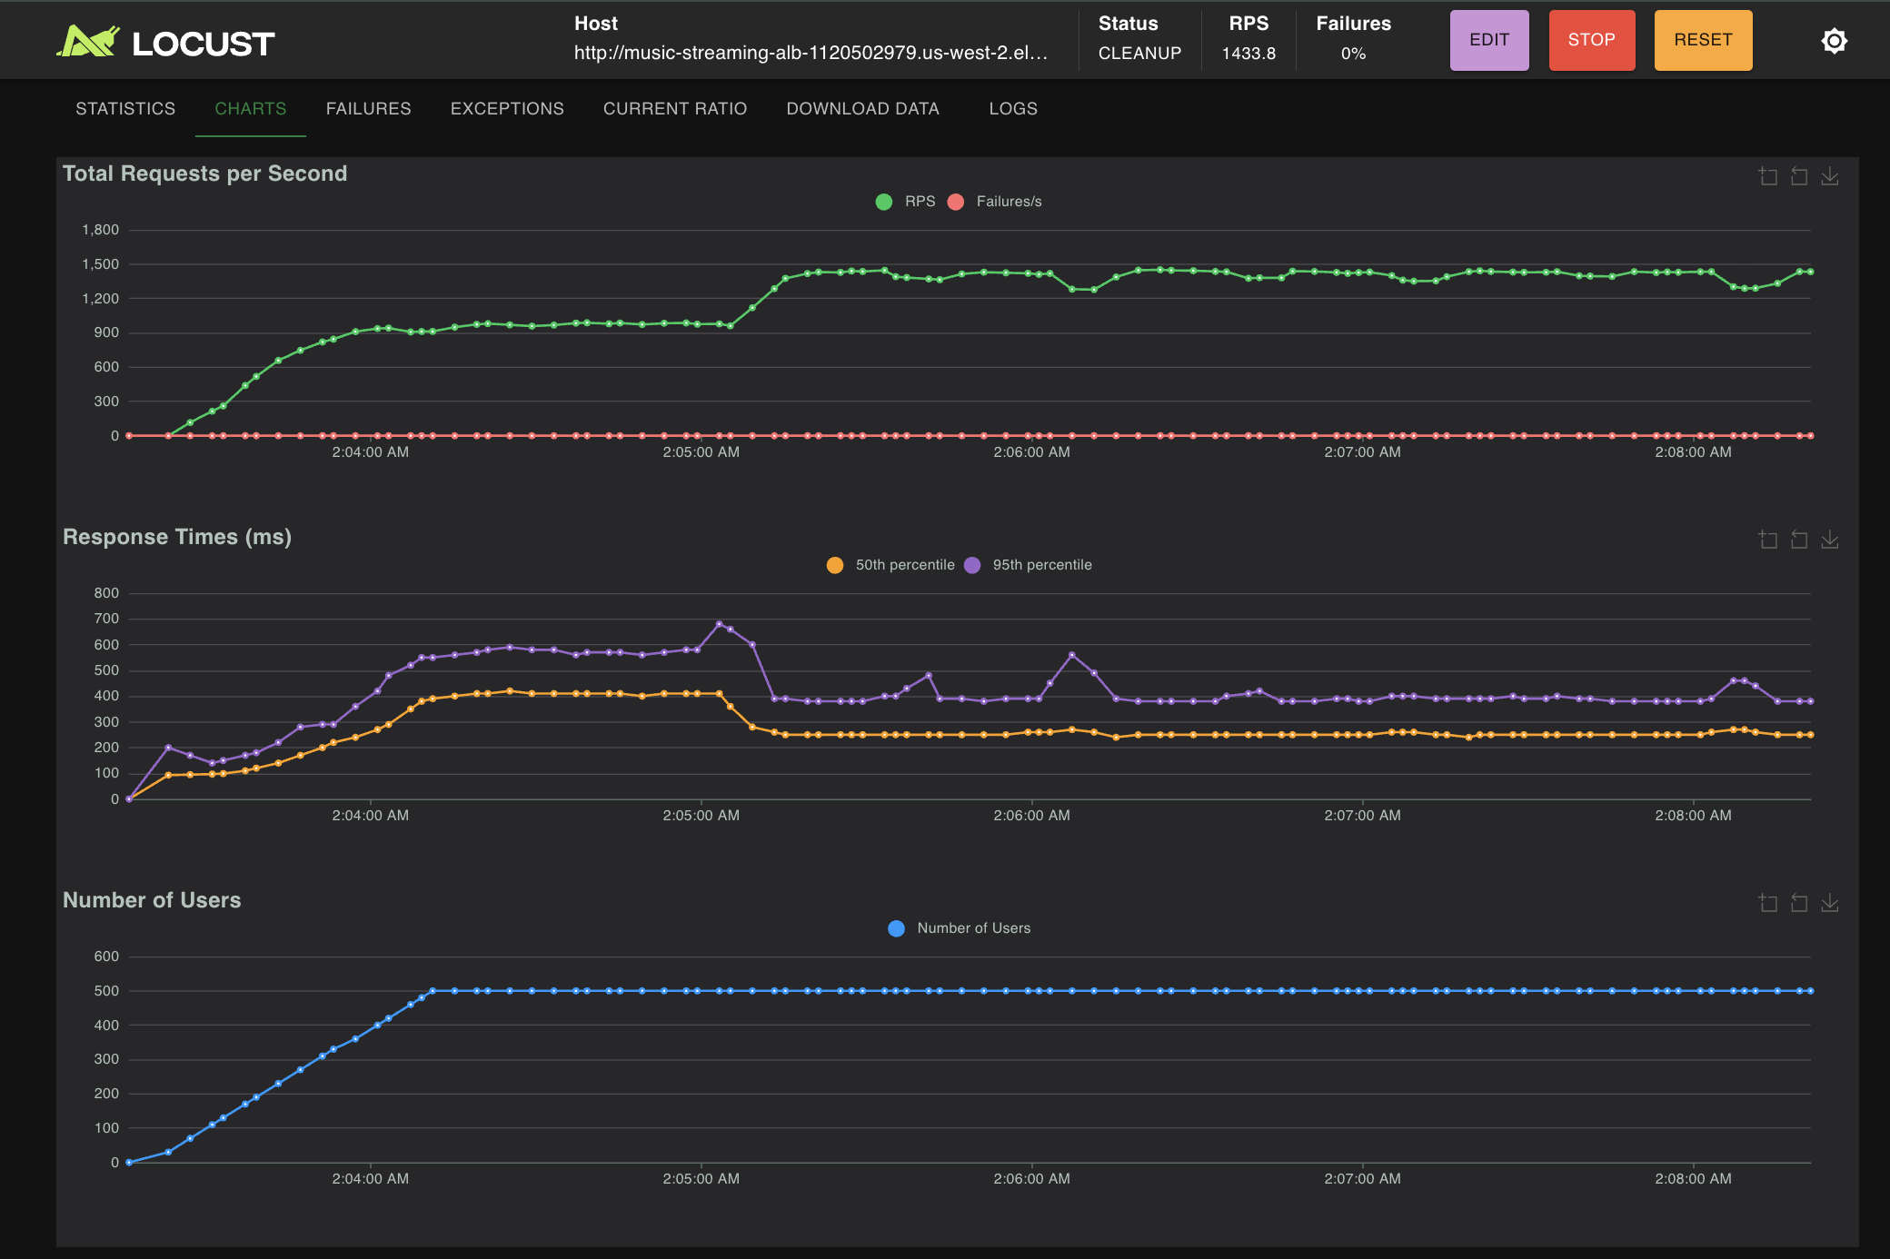  500 user’s charts

Analysis
The CDN circuit breaker opened in every run — at 300+ concurrent streams, CDN calls timed out consistently, forcing all chunks to be generated locally. This means the bottleneck is CPU, not network: each chunk costs ~500k CPU iterations, and with 500 goroutines competing on 0.25 vCPU, scheduling pressure drives p99 above threshold. The RPS plateau at 1,433 between 400 and 500 users confirms the CPU ceiling was reached. Crucially, the circuit breaker prevented cascading failures: HTTP error rate was 0% across all runs — the service degraded gracefully rather than crashing.
Conclusion: Single-instance capacity is ~400–500 concurrent streams on 0.25 vCPU. The CDN is the first bottleneck, not the streaming logic.
Limitations of analysis: The 500ms threshold is a simulation approximation. Real rebuffering depends on client buffer size and pre-fetch strategy, not purely p99 latency.

Experiment 2 — Adaptive Bitrate Switching Under CPU Saturation

Purpose & Tradeoff
Test whether adaptive quality switching (320kbps → 128kbps when delivery latency > 300ms) reduces rebuffering under CPU pressure. The tradeoff is audio quality vs. streaming continuity: dropping to 128kbps is less noticeable to a listener than a buffer stall. All runs use songs outside the CDN cache (exp2_track_*) to force local generation throughout, keeping CPU saturated — the exact worst-case scenario adaptive mode is designed for.

Limitations
Isolated runs only (all-adaptive vs. all-fixed). Mixed loads were also tested but masked the adaptive benefit, since CPU savings from adaptive streams were immediately absorbed by co-located fixed streams. Results do not reflect real-world mixed traffic.

Results
Both runs: 400 users, 7-minute duration, CDN circuit open throughout.
Adaptive stats and charts:  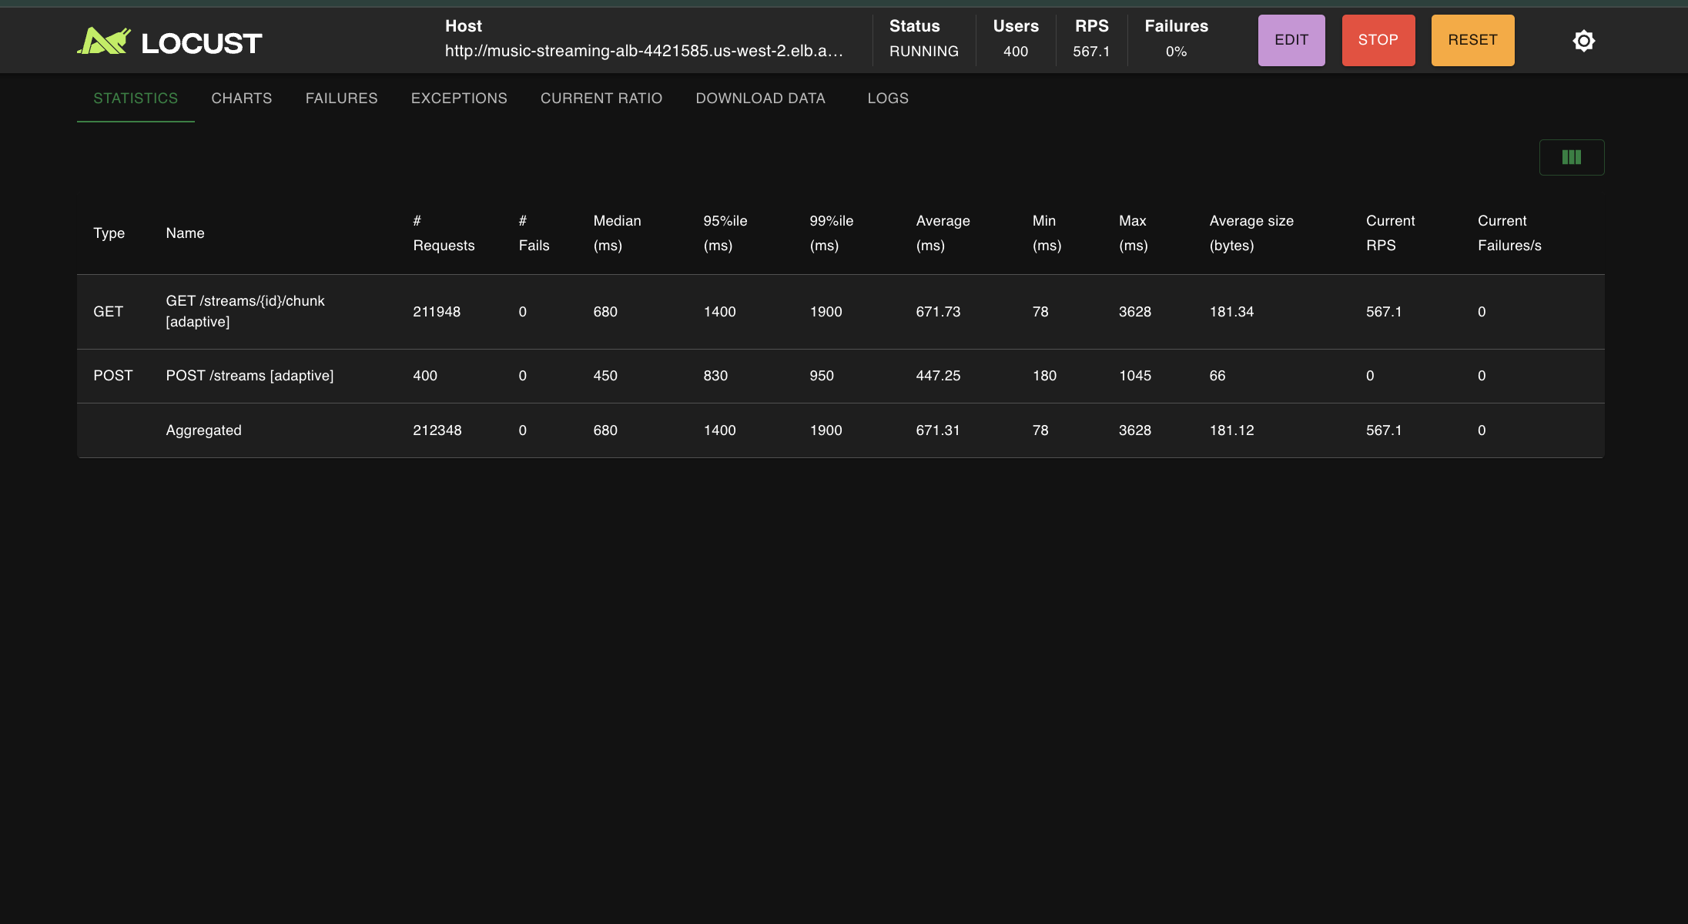 | 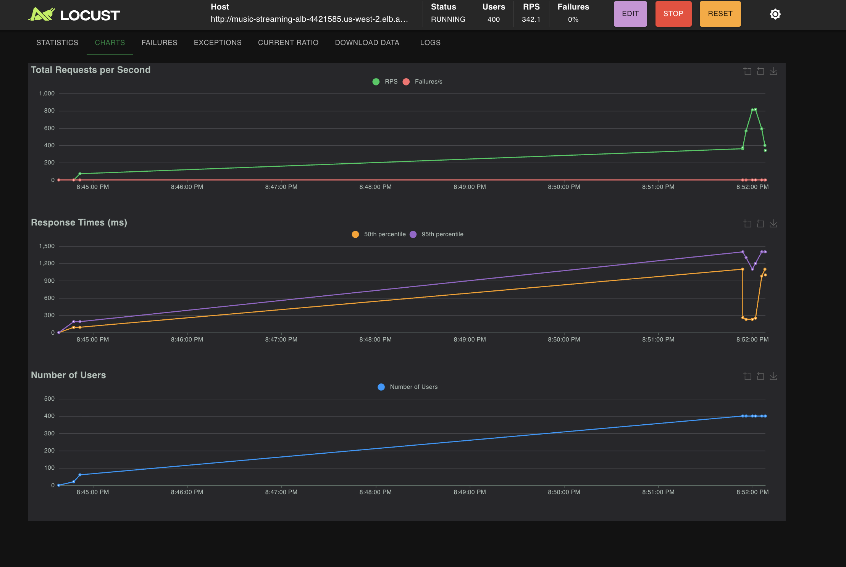
Fixed stats and charts:  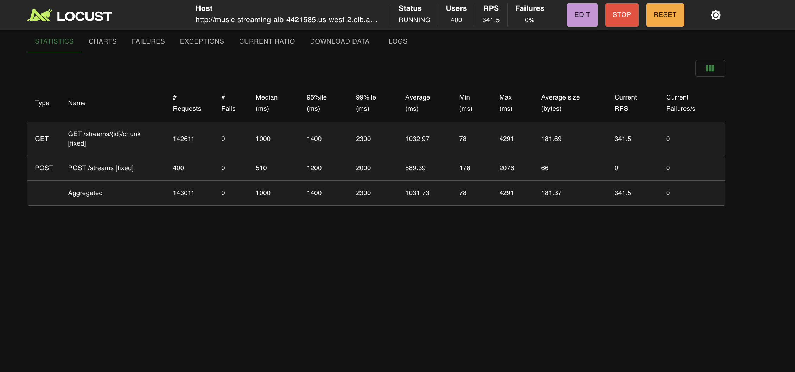 | 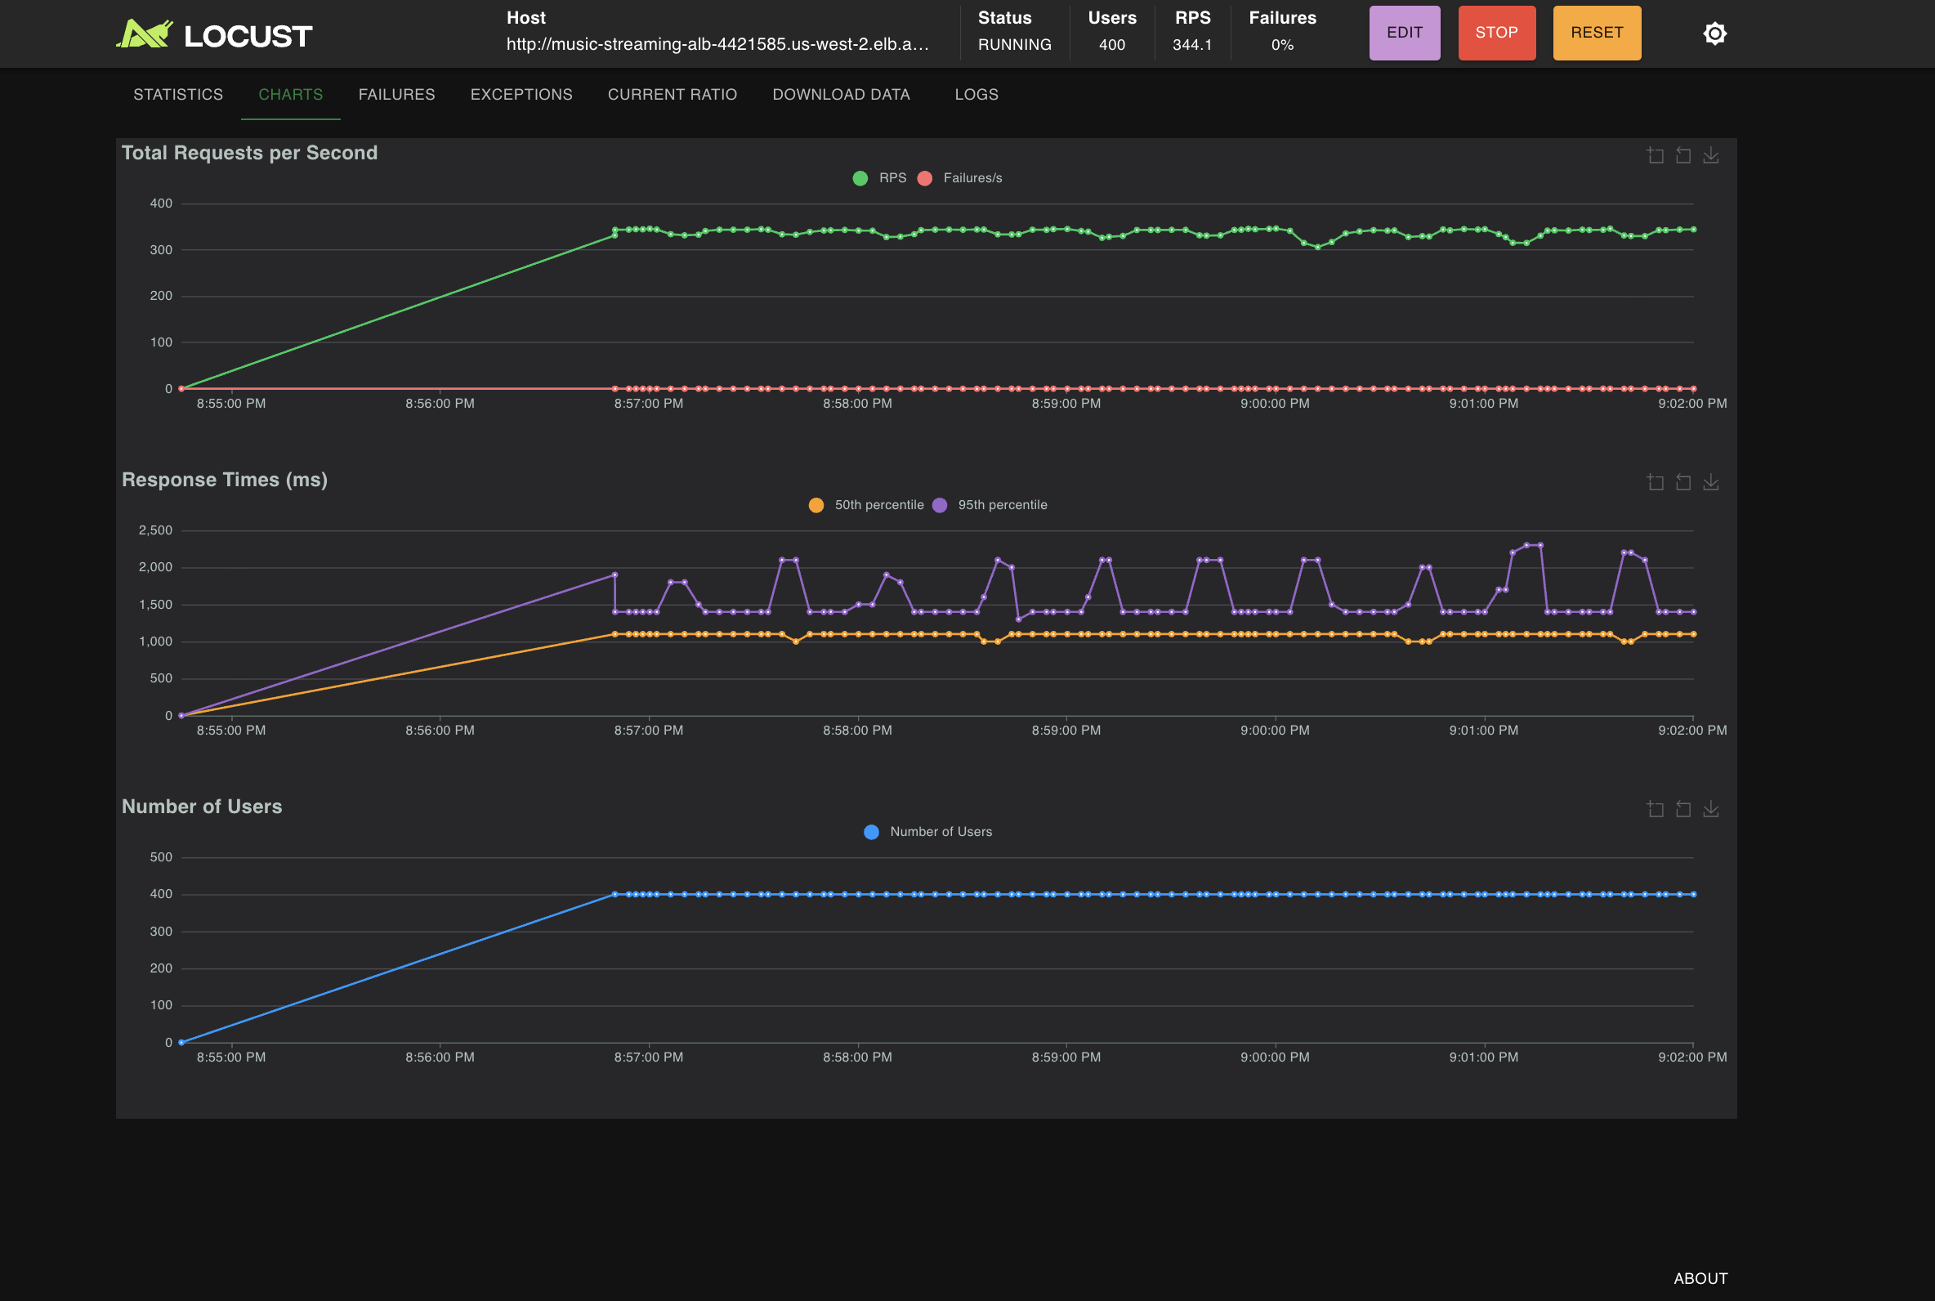
Metric | Adaptive | Fixed | Δ
Median latency | 680 ms | 1,000 ms | 32% faster
p95 latency | 1,400 ms | 1,400 ms | same
p99 latency | 1,900 ms | 2,300 ms | 17% faster
Throughput (RPS) | 567.1 | 341.5 | +66% more
Quality switches | ~6,382 (~16/stream) | 0 | —
Latency comparison (adaptive left, fixed right):
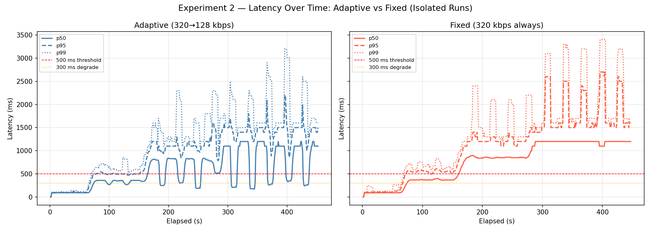

Analysis
Adaptive mode delivered 32% lower median latency and 66% higher throughput on identical hardware. The mechanism is direct: each quality switch cuts the CPU cost of that stream’s next chunk from 500k to 50k iterations, freeing CPU for other streams. The latency comparison chart shows adaptive streams oscillating around a lower p50 baseline while fixed streams plateau at a persistently higher level. Rebuffer event counts were similar (~670% per stream in both modes), which is expected: both modes cross the 300ms threshold under saturation. The adaptive advantage is that chunks arrive sooner after a stall, the next chunk is 10× cheaper to generate.
Conclusion: Adaptive bitrate meaningfully improves throughput and median latency under CPU saturation. It does not eliminate rebuffering — it reduces recovery time after each stall.
Limitations of analysis: Quality switch threshold (300ms) and quality levels (320/128kbps) are fixed parameters. A tunable threshold or multi-level ladder (320->192->128) might yield better results.

Experiment 3 — Horizontal Scaling

Purpose & Tradeoff
Test whether horizontal scaling produces near-linear capacity gains and whether it matters which tiers are scaled. Part A adds streaming instances (1→2→4) while keeping CDN fixed, predicting sub-linear gains as the single CDN becomes a bottleneck. Part B co-scales both tiers (1+1→2+2→4+4), predicting near-linear gains by distributing CDN load. The tradeoff is infrastructure cost vs. capacity quality: Part B is twice as expensive but hypothesises the circuit breaker stays closed and chunks are served via the fast cache path.

Limitations
In-memory stream state requires ALB sticky sessions in both parts true round-robin load balancing is not achievable without shared state (e.g., Redis). CDN instances pre-populate independently; each holds a full 100×300 chunk cache so memory cost scales linearly with instance count. Neither part was tested above 1,000 concurrent users, leaving the upper capacity ceiling unmeasured.

Part A — Scale Streaming Only
All runs: 1,000 concurrent users, fixed 320kbps, 7-minute duration. ALB sticky sessions (lb_cookie) required — without them, 33% of chunk requests failed with 404 because stream state is in-memory per instance.
Streaming Instances | p50 (ms) | p95 (ms) | p99 (ms) | RPS | Scaling factor
1 | 2,700 | 4,600 | 7,400 | 339.2 | 1×
2 | 1,500 | 2,600 | 3,200 | 552.6 | 1.6×
4 | 580 | 1,100 | 1,400 | 1,186.7 | 3.5×

Part A — Analysis
The CDN circuit breaker opened in all three runs — the single CDN instance is always the bottleneck, regardless of how many streaming instances are added. Yet latency and throughput improved significantly: p50 dropped from 2,700ms to 580ms (78% improvement) and RPS nearly tripled (3.5×). The improvement comes from CPU scheduling, not CDN: with fewer streams per instance (1000 → 500 → 250), each goroutine gets more CPU time for local chunk generation. The gains are sub-linear on latency but near-linear on RPS — this is the correct behaviour, since lower per-chunk latency allows users to cycle through chunks faster, generating more requests per second.
The sticky sessions discovery was an important operational finding: in-memory stream state does not survive cross-instance routing, so ALB affinity is a hard requirement for this architecture.
Conclusion: Scaling streaming instances alone produces real but sub-linear latency gains and near-linear throughput gains. The CDN remains a shared bottleneck. Part B is expected to demonstrate whether CDN scaling closes the gap toward true linear scaling.
Limitations of analysis: All Part A runs share a single CDN, we cannot yet separate the CDN bottleneck contribution from the CPU scheduling improvement. Part B results will clarify this.

Part B — Scale Both Tiers Together
Purpose: Scale both the streaming and CDN tiers together (1+1 → 2+2 → 4+4) to test whether distributing CDN load prevents circuit breaker saturation and yields near-linear capacity gains compared to Part A.
Tradeoff: Infrastructure cost vs. capacity quality. Scaling both tiers doubles the cost vs. Part A, but the hypothesis is that CDN load is distributed (1/N per CDN instance), keeping CDN calls below the 500ms timeout so the circuit breaker stays closed and chunks are served from the fast cache path rather than generated locally.
Limitations: Part B was not run with a 1+1 baseline reset, so Run 2 (2+2) is compared against Part A's 2+1 results. CDN instances pre-populate independently each holds a full copy of the 100×300 chunk cache, so no inter-CDN coordination is needed, but memory cost doubles/quadruples. ALB sticky sessions remain required for stream state affinity.

Run 3 — 4+4 (Streaming + CDN)
Statistics:  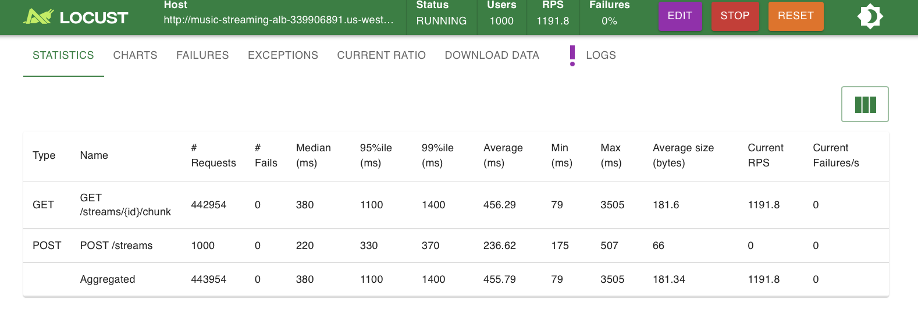 | Charts:  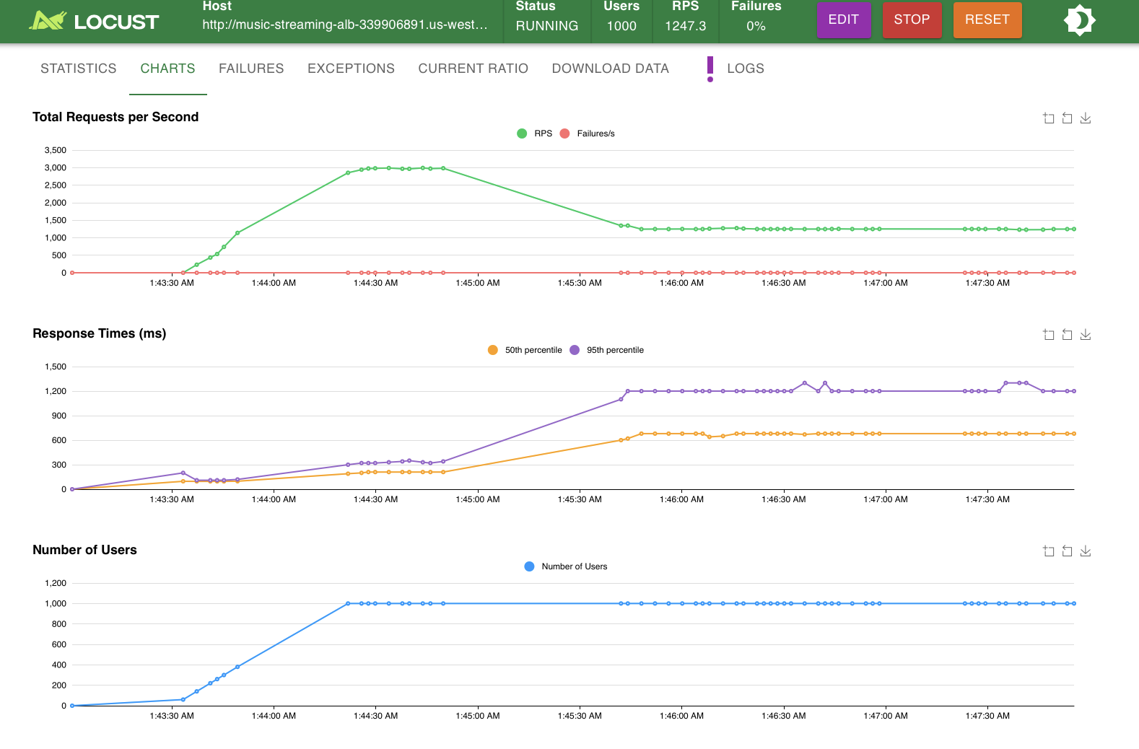
What happened:
At 4+4, each CDN instance handled ~250 users' chunk requests, well below the timeout threshold. The circuit breaker stayed closed throughout, meaning chunks were served from the CDN cache (fast path, ~79ms min) rather than generated locally (500k CPU iterations). Median latency dropped to 380ms- below the 500ms rebuffer threshold — the first run across all experiments where the system operated within capacity at 1,000 users.

Part B — Analysis & Conclusions
Config | p50 (ms) | p95 (ms) | RPS | Circuit Breaker
1+1 (baseline) | 2,700 | 4,600 | 339 | Open (always)
2+2 | 1,100 | 2,400 | 560 | Partial
4+4 (Run 3) | 380 | 1,100 | 1,192 | Closed
4+4 (Runs 4–5) | 510 | 1,100 | 1,237 | Closed
Scaling both tiers produced a qualitatively different outcome from Part A. In Part A the CDN circuit breaker opened in every run, forcing all chunks to local CPU generation. In Part B at 4+4, the circuit breaker stayed closed — each CDN instance handled a fraction of the total load, serving chunks from in-memory cache instead. The median latency (380ms) dropped below the 500ms rebuffer threshold for the first time across all experiments.
Conclusion: Near-linear scaling requires both tiers to scale together. Co-scaling the CDN distributes cache load proportionally, keeps the circuit breaker closed, and delivers chunks via the fast path. At 4+4, the system handles 1,000 concurrent streams at median 380ms with 3.5× the throughput of a single instance within the rebuffer threshold.
Limitations: 4+4 was not tested at 2,000 users, so the upper ceiling is unknown. A stateless redesign (Redis-backed stream state) would remove the sticky sessions requirement and enable true round-robin load balancing.

Project Conclusion
This project simulated the core delivery challenge of music streaming at scale — serving fixed-size audio chunks to thousands of concurrent streams without rebuffering — using two Go microservices on AWS ECS Fargate. Three experiments measured the three main levers of streaming performance: single-instance capacity, quality adaptation, and horizontal scale-out.
Experiment | Key Question | Finding
1 — Single Instance | Breaking point on 0.25 vCPU? | ~400–500 users; CDN trips first, CPU saturates second; 0% HTTP errors throughout
2 — Adaptive Bitrate | Does quality switching help? | +32% lower latency, +66% throughput on same hardware; recovery faster, stall frequency unchanged
3 — Horizontal Scaling | Near-linear gains? | Part A: 3.5× RPS, CDN always bottleneck. Part B (4+4): p50 drops below 500ms threshold — both tiers must scale together

The three experiments together reveal a consistent theme: the CDN circuit breaker is the architectural pivot point. It is the first bottleneck (Exp 1), the mechanism that makes CPU pressure the binding constraint (Exp 2), and the component whose saturation limits horizontal scaling gains (Exp 3 Part A). Keeping the circuit closed — by reducing per-stream CPU cost via adaptive mode, or by distributing CDN load via co-scaling is the key to serving more concurrent streams within latency budget.

