RALLY INTELLIGENCE REPORT
PM Modi Mega Rally Kolkata
Phase: Pre 7D

Generated: 13 March 2026, 03:41 UTC
Mindgen Pvt Ltd | Confidential

Executive Summary
This report analyses public mood and digital engagement surrounding PM Modi Mega Rally Kolkata. A total of 20 mentions were monitored across 7 platforms during the pre 7d phase. The overall Rally Mood Score stands at 53.5/100, indicating a neutral reception. Sentiment distribution shows 20.0% positive, 10.0% negative, and 70.0% neutral. The leader favourability score is 0.0/100. Bot suspicion affects 0.0% of analysed content. The polarization index stands at 0.0, and 0 potential misinformation items were flagged.
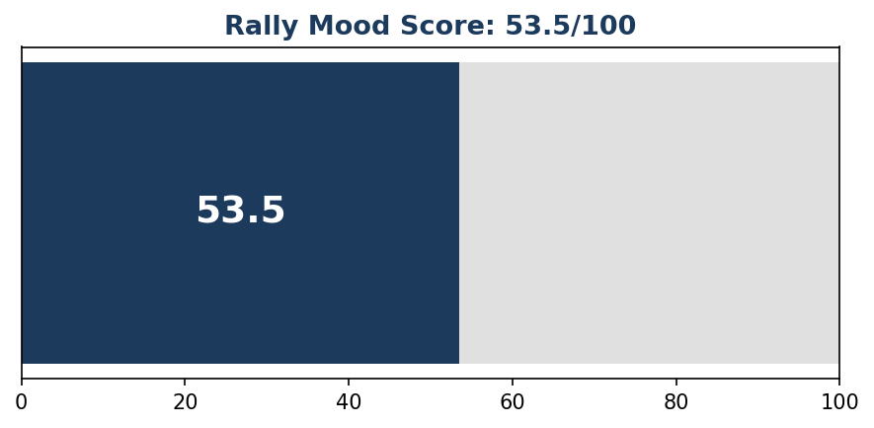

Key Findings
1. Total digital mentions reached 20 across all monitored platforms.
2. Positive sentiment (20.0%) outweighs negative sentiment (10.0%).
3. Rally Mood Score: 53.5/100.
4. Leader favourability stands at 0.0/100.
5. Share of voice for BJP: 25.0%.
6. Opposition counter-narrative intensity: 0.0%.
7. Bot-suspected content: 0.0% of total volume.
8. Polarization index: 0.0 (higher = more divisive).
9. Top platform by volume: twitter.
10. Misinformation flags: 0 items flagged for review.

Public Mood Snapshot
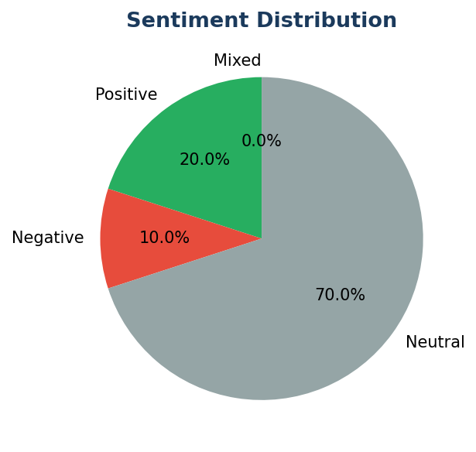

Sentiment Breakdown
Sentiment | Percentage
Positive | 20.0%
Negative | 10.0%
Neutral | 70.0%
Mixed | 0.0%

Platform Performance
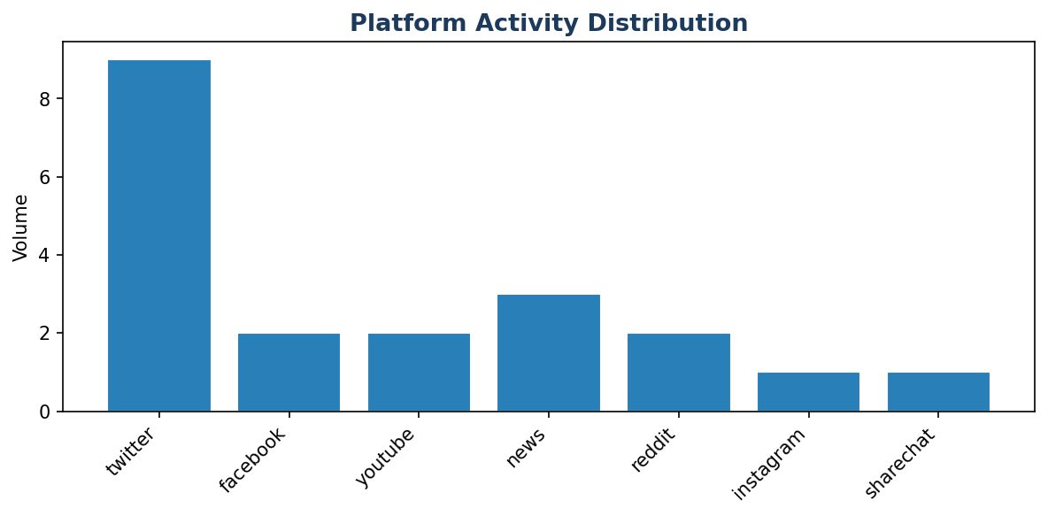
Platform | Volume
twitter | 9
news | 3
facebook | 2
youtube | 2
reddit | 2
instagram | 1
sharechat | 1

Top Keywords and Hashtags
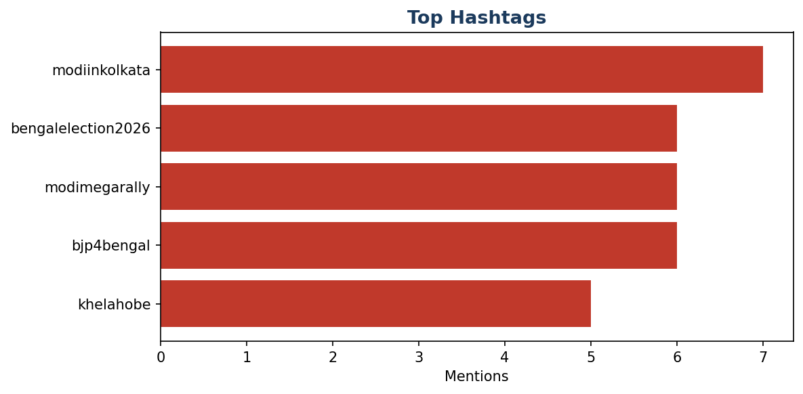

Top Keywords
Keyword | Count
rally | 8
bengal | 7
modi | 6
bjp | 4
will | 3
kolkata | 2
massive | 2
modiinkolkata | 2
issues | 2
brigade | 2
promises | 2
development | 2
speech | 2
jobs | 2
crowd | 2
looks | 1
like | 1
going | 1
all | 1
out | 1

Top Influencers and Amplifiers
Name | Followers | Posts | Total Engagement
DemoUser11 | 52,918 | 1 | 2,089
DemoUser8 | 2,561 | 1 | 2,011
DemoUser1 | 38,242 | 1 | 2,001
DemoUser9 | 87,033 | 1 | 1,811
DemoUser6 | 32,757 | 1 | 1,736
DemoUser19 | 68,351 | 1 | 1,494
DemoUser16 | 11,726 | 1 | 1,492
DemoUser10 | 4,590 | 1 | 1,369
DemoUser7 | 34,727 | 1 | 1,334
DemoUser12 | 43,925 | 1 | 1,321
DemoUser5 | 47,538 | 1 | 1,257
DemoUser13 | 80,298 | 1 | 995
DemoUser2 | 70,025 | 1 | 897
DemoUser4 | 99,899 | 1 | 752
DemoUser17 | 46,588 | 1 | 676

Risk Assessment
Risk | Severity | Detail
No Critical Risks | LOW | No significant risks identified in this phase

Methodology
This report was generated using the Rally Intelligence Engine (RIE), an AI-powered public mood analysis platform. The methodology employs a 5-layer hybrid NLP stack: (1) Rules-based keyword matching, (2) Domain-specific political lexicon scoring, (3) Transformer-based classification using multilingual models (MuRIL, XLM-RoBERTa), (4) Large Language Model interpretation (Claude/GPT-4o) for nuanced cases, and (5) Human analyst review for flagged content.
Data was collected from 7 platforms. Languages processed include English, Hindi, Bengali, Hinglish, and Romanised Bengali. Bot detection used heuristic scoring based on account age, posting patterns, and network behaviour. All metrics are computed from 20 classified documents.

Limitations
- Digital sentiment does not equal voting intention.
- Bot detection is heuristic-based and may have false positives/negatives.
- Sarcasm detection accuracy in Bengali is approximately 70-75%.
- Rural and offline sentiment is not captured.
- Platform API restrictions may limit data completeness.

