<https://docs.databricks.com/getting-started/quick-start.html>

**Get started as a Databricks Data Science & Engineering user**

June 11, 2021

This tutorial gets you going with Databricks Data Science & Engineering: you create a cluster and a notebook, create a table from a dataset, query the table, and display the query results.

Tip

As a supplement to this article, check out the Quickstart Tutorial notebook, available on your Databricks Data Science & Engineering landing page, for a 5-minute hands-on introduction to Databricks. Simply log in to Databricks and click **Explore the Quickstart Tutorial**. If you don’t see the tutorial, select Data Science & Engineering from the persona switcher in the sidebar.

**Requirements**

You are logged into Databricks, and you’re in the Data Science & Engineering workspace. See [Sign up for a free Databricks trial](https://docs.databricks.com/getting-started/try-databricks.html).

**Step 1: Orient yourself to the Databricks Data Science & Engineering UI**

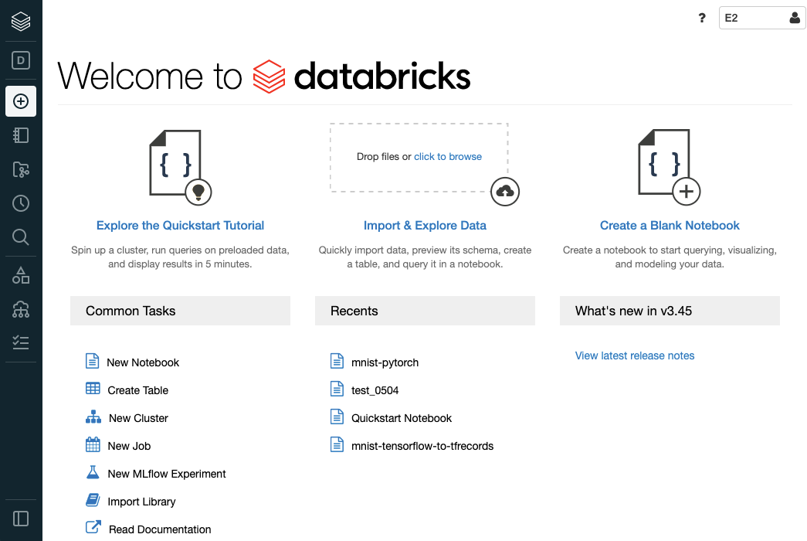

From the sidebar at the left and the **Common Tasks** list on the landing page, you access fundamental Databricks Data Science & Engineering entities: the Workspace, clusters, tables, notebooks, jobs, and libraries. The Workspace is the special root folder that stores your Databricks assets, such as notebooks and libraries, and the data that you import.

**Use the sidebar**

You can access all of your Databricks assets using the left sidebar. The sidebar’s contents depend on the selected persona: **Data Science & Engineering**, **Machine Learning**, or **Databricks SQL**.

* By default, the sidebar appears in a collapsed state and only the icons are visible. Move your cursor over the sidebar to expand to the full view.
* To change the persona, click the icon immediately below the Databricks logo, and select a persona from the menu.



* To pin a persona so that it appears next time you log in, click pin personanext to the persona. Click it again to remove the pin.
* Use **Menu options** at the bottom of the sidebar to set the sidebar mode to Auto (default behavior), Expand, or Collapse.
* When you open a machine learning-related page, the persona automatically switches to **Machine Learning**.