Full Stack Development with MERN Project Documentation

1. Introduction
Title
LinkLance – A Full Stack Freelance Marketplace Platform
Team Member
- Manasi Badgujar – Full Stack Developer
  - Backend API Development (Node.js, Express, MongoDB)
  - Frontend Development (React, Tailwind CSS)
  - Authentication, Role-Based Access Control, Chat Integration
  - Database Design and System Integration

2. Project Overview
Purpose
LinkLance is a full-stack freelancing platform designed to connect clients who post projects with freelancers who apply and work on them. The system manages the complete lifecycle of a project—from posting and bidding to approval, submission, and completion—while enabling real-time communication through an integrated chat system.
The primary goal of the project is to demonstrate real-world MERN stack development, including secure authentication, role-based dashboards, REST APIs, and real-time features using Socket.IO.
Key Features
- Multi-role system: Admin, Client, Freelancer
- Secure authentication using JWT
- Project posting, bidding, and approval workflow
- Freelancer project submission with URL upload
- Client approval & project completion flow
- Real-time chat using Socket.IO
- Admin panel for user & project moderation
- Responsive UI with Tailwind CSS
- Light/Dark mode support

3. System Architecture
Frontend Architecture
- Built using React (Vite) for fast development and optimized builds
- Component-based structure with reusable UI components
- Context API for global state management (Authentication & Theme)
- Tailwind CSS for responsive, utility-first styling
- Role-based routing using protected routes
Key Concepts Used
- React Hooks (useState, useEffect, useContext)
- Conditional rendering based on user roles
- REST API integration via Axios
- Socket.IO client for real-time messaging

Backend Architecture
- Developed using Node.js with Express.js
- RESTful API design for modularity and scalability
- Middleware-based authentication and authorization
- Role-based access control using custom middleware
- Centralized error handling
Key Components
- Controllers: Handle business logic
- Routes: API endpoint definitions
- Middleware: Auth, role checks, admin protection
- Socket server for chat functionality

Database Architecture
- MongoDB used as the primary database
- Mongoose ODM for schema definition and validation
Core Collections
- User – Stores client, freelancer, and admin details
- Project – Stores project lifecycle data
- Application – Freelancer bids and project applications
- Chat – Messages exchanged per project
Relationships are maintained using MongoDB ObjectIds to ensure data consistency.

4. Setup Instructions
Prerequisites
- Node.js (v18+ recommended)
- MongoDB (Local or MongoDB Atlas)
- npm or yarn
- Git

Installation Steps
1. Clone the Repository
git clone https://github.com/your-username/codefinder.git
cd codefinder
2. Backend Setup
cd server
npm install

Create a .env file:
PORT=6001
MONGO_URI=your_mongodb_connection_string
JWT_SECRET=your_secret_key

3. Frontend Setup
cd client
npm install

5. Folder Structure
Client (Frontend)
client/
├── src/
│ ├── components/
│ ├── context/
│ ├── pages/
│ │ ├── admin/
│ │ ├── client/
│ │ ├── freelancer/
│ │ └── chat/
│ ├── utils/
│ ├── App.jsx
│ └── main.jsx

Server (Backend)
server/
├── controllers/
├── middleware/
├── models/
├── routes/
├── socket.js
├── index.js
└── config/

6. Running the Application
Start Backend
cd server
npm start
Runs on: http://localhost:6001
Start Frontend
cd client
npm run dev
Runs on: http://localhost:5173

7. API Documentation
Authentication
Method | Endpoint | Description
POST | /api/auth/register | Register new user
POST | /api/auth/login | Login & receive JWT

Projects
Method | Endpoint | Description
POST | /api/projects | Create project (Client)
GET | /api/projects/open | View open projects
PUT | /api/projects/:id/approve | Approve freelancer
PUT | /api/projects/:id/complete | Mark project completed

Applications
Method | Endpoint | Description
POST | /api/applications | Apply to project
GET | /api/applications/my | Freelancer applications

Chat
Method | Endpoint | Description
GET | /api/chats/:projectId | Fetch project chat
Socket | sendMessage | Send real-time message

8. Authentication & Authorization
- JWT-based authentication
- Token stored in localStorage
- Middleware validates token on every protected route
- Role-based middleware restricts access:
  - Admin-only routes
  - Client-only project creation
  - Freelancer-only applications

9. User Interface
The UI is fully responsive and supports light and dark modes.
Key Screens below :
- Login & Registration
- Client Dashboard
- Freelancer Dashboard
- Admin Panel
- Real-time Chat Interface

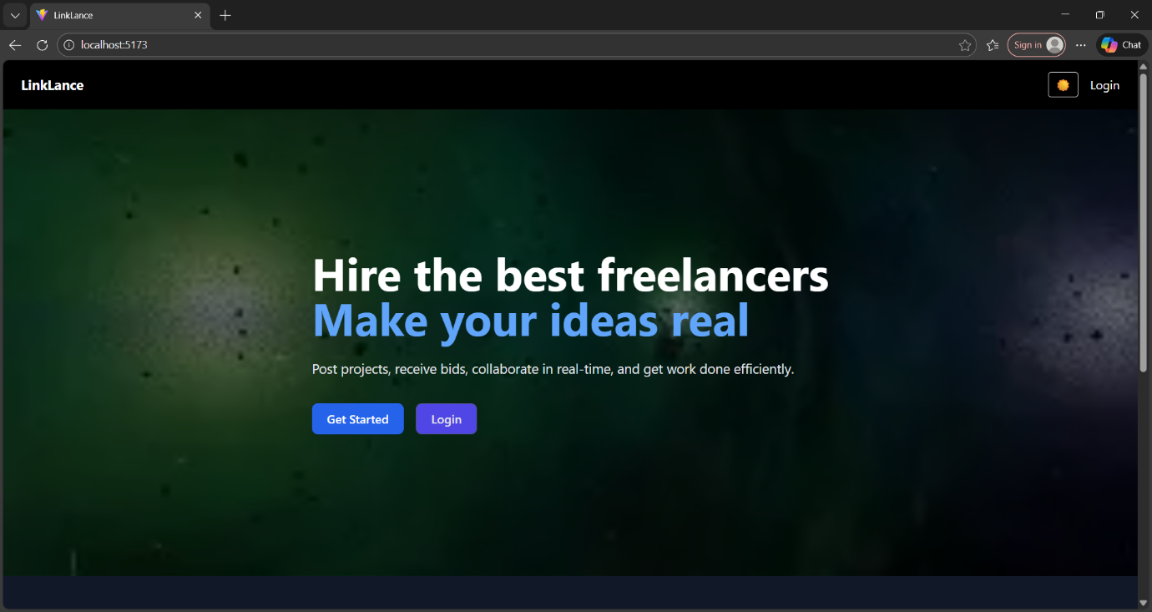
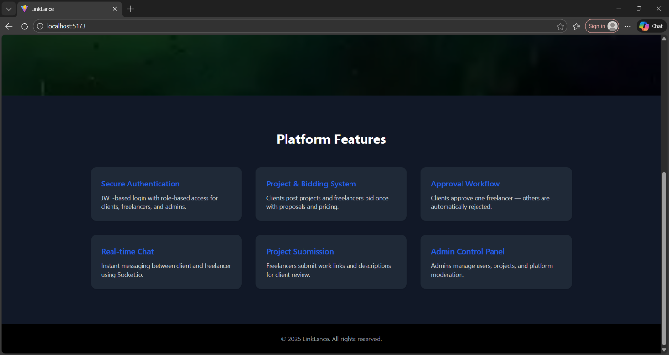
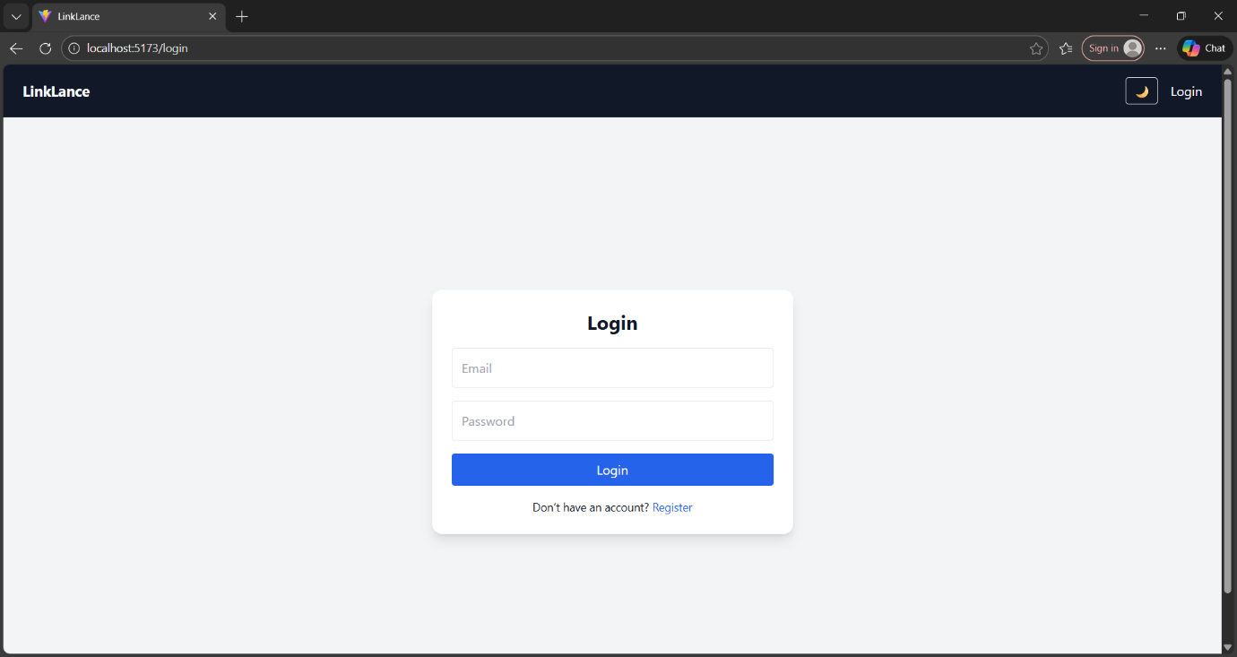
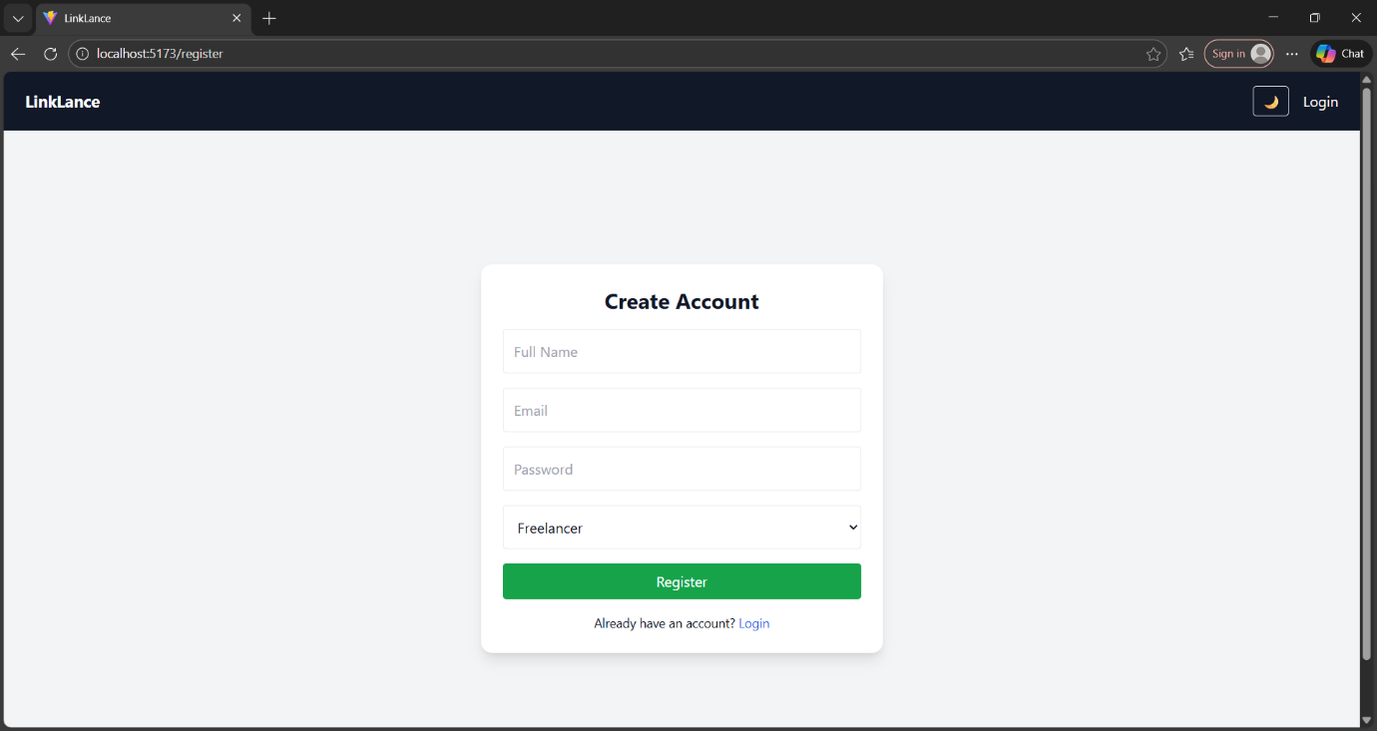
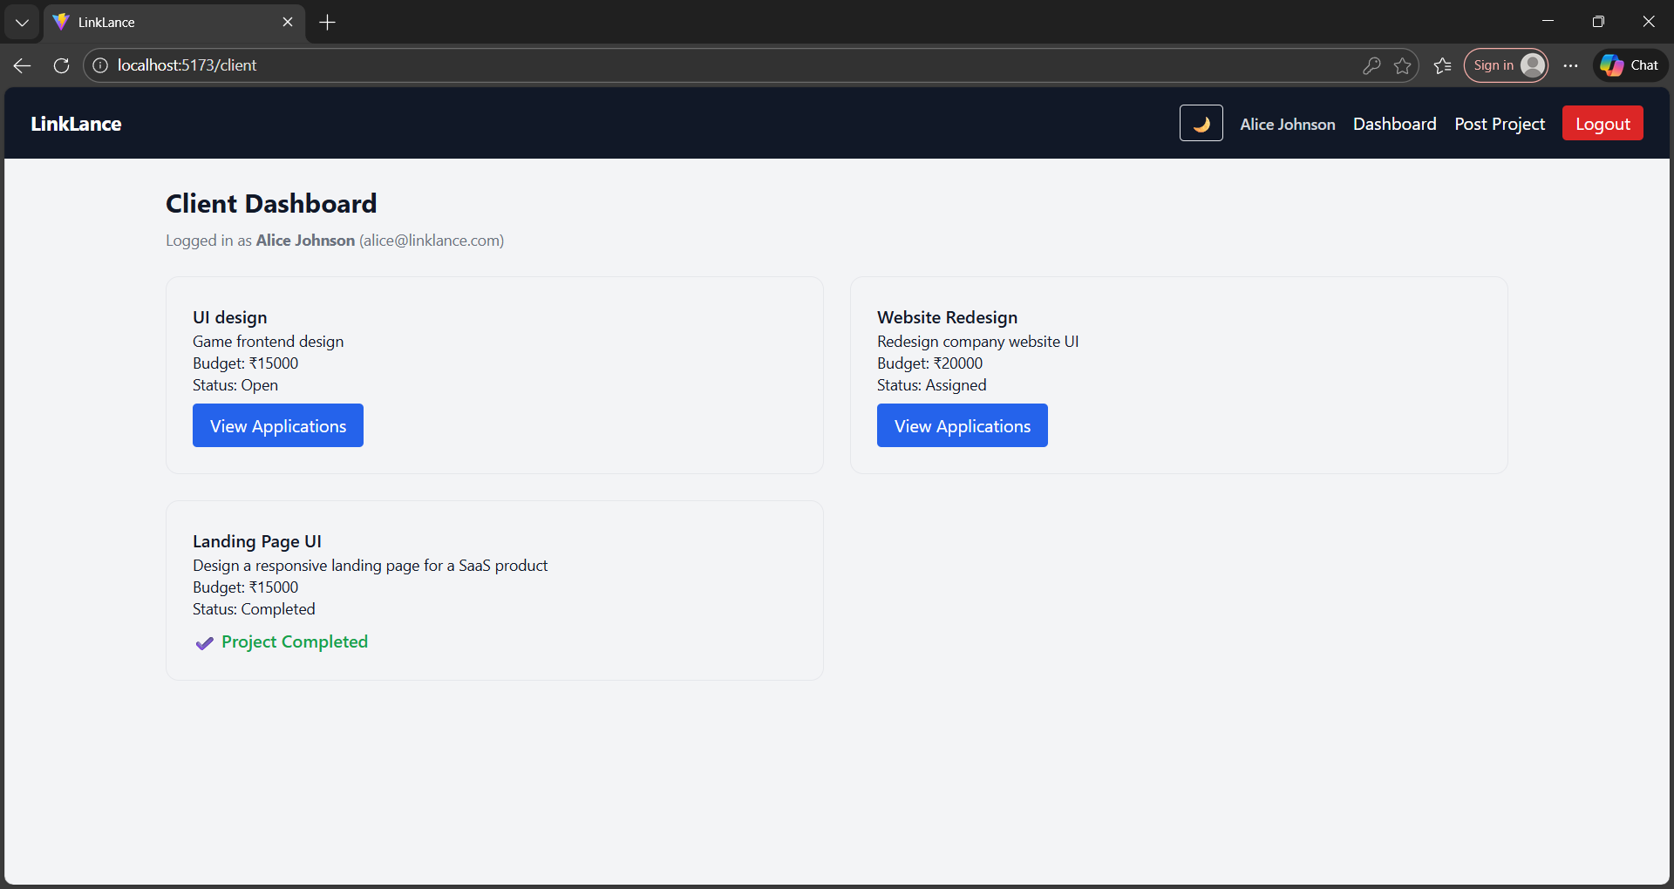
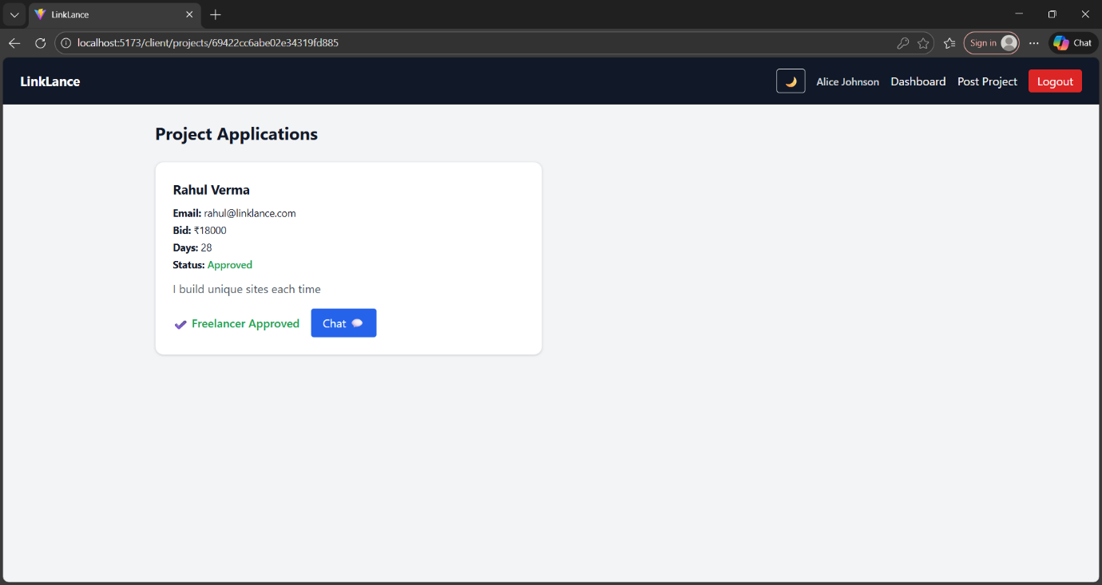
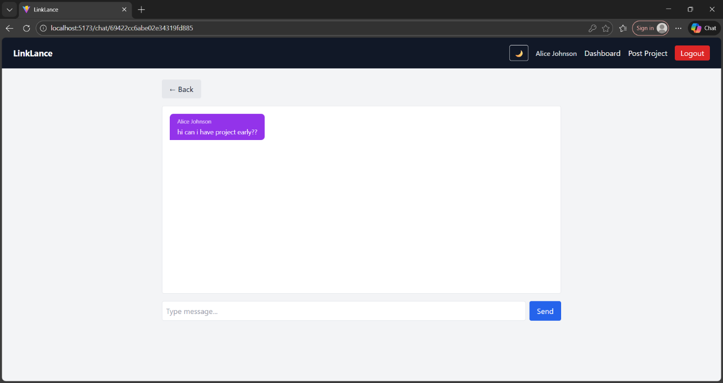
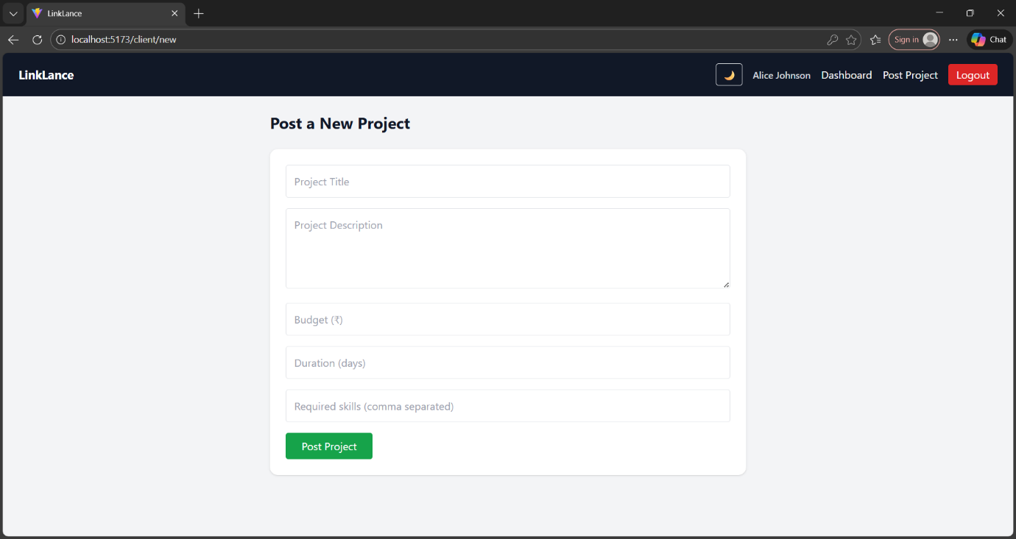
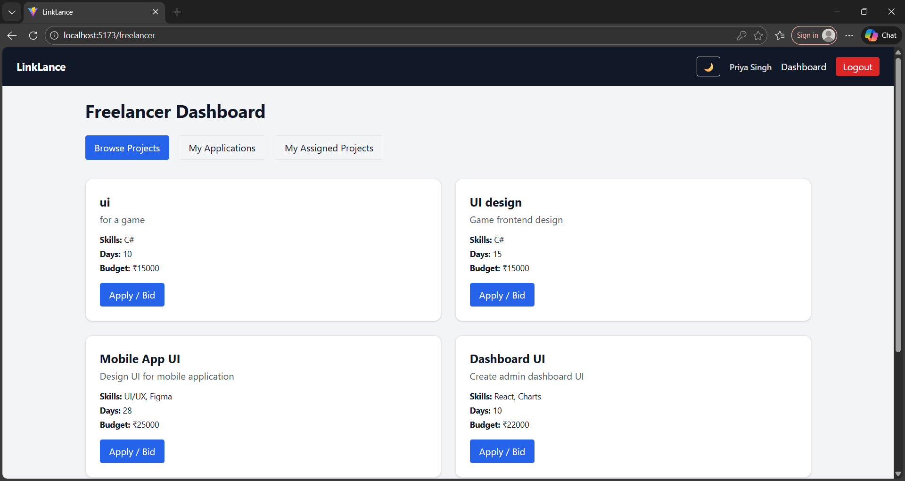
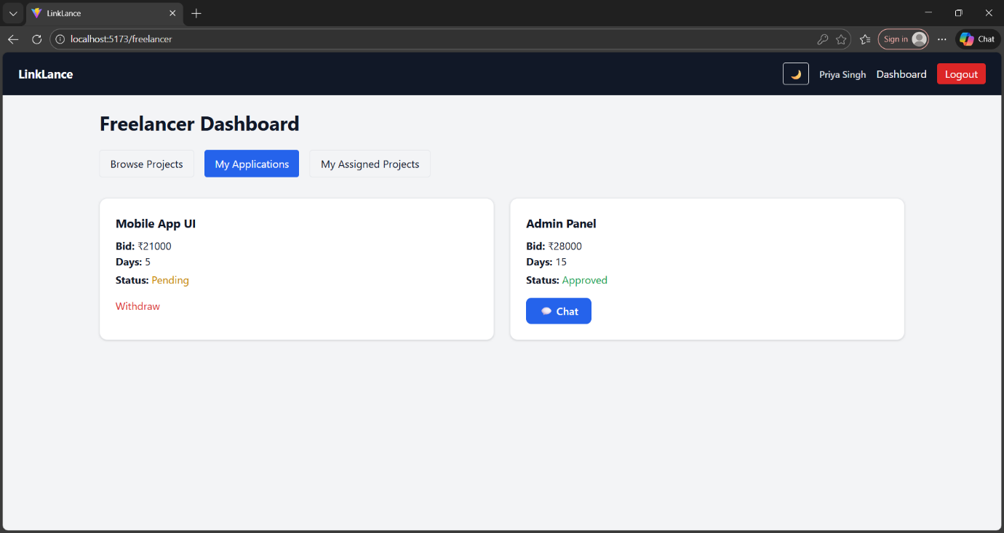
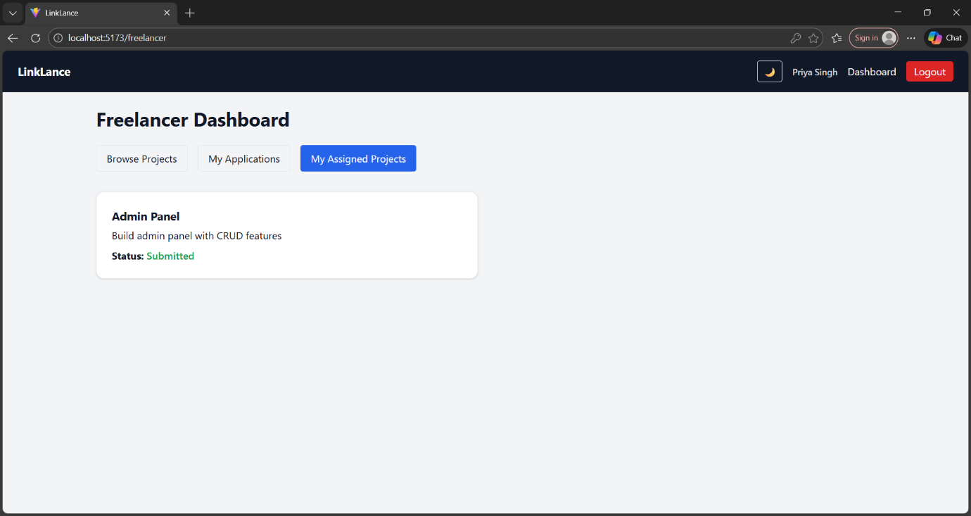

10. Testing Strategy
- Manual testing using Thunder Client for APIs
- Browser-based testing for UI flows
- Role-based scenario testing
- Real-time chat tested using multiple sessions

11. Demo video link:
https://drive.google.com/file/d/17_V7IoTNxm_YuBTOaQpD7xd-e92UD_Z_/view?usp=drive_link
12. Known Issues
- No email notifications yet
- No chat history pagination
- No automated testing framework implemented

13. Future Enhancements
- Payment gateway integration
- AI suggestions and filtering
- Email & in-app notifications
- File uploads in chat
- Project milestones & escrow system
- Advanced admin analytics dashboard
- Automated test coverage (Jest / Cypress)

Conclusion
LinkLance demonstrates a complete real-world MERN stack application with modern UI, secure authentication, role-based workflows, and real-time communication. The project reflects industry-level architecture and serves as a strong foundation for future enhancements or deployment.

