Software Requirements Specification (SRS)
Bank Management System — Phase 1
Team E11
Meghna Sanjeev PES1UG24CS269
Mrinmayi Raman PES1UG24CS278
Advika Raj PES1UG24CS906
Manasi Vipin PES1UG24CS260

1. Introduction

1.1 Purpose
This document specifies the functional, non-functional and security requirements for a small console-based Bank Management System. It is the updated Phase-1 submission and retains the original project scope while adding the security and verification detail required by the updated deliverables.

1.2 Scope
The system supports a bank employee in creating, searching, updating and closing customer accounts, and supports a customer in depositing money, withdrawing money, checking balance and viewing a mini-statement. Account and transaction information is stored using local file handling. The project is intentionally kept simple and does not include real banking integration, online payments, networking, or an external database.

1.3 Definitions and Abbreviations
Term | Meaning
FR | Functional Requirement
NFR | Non-Functional Requirement
SEC | Security Requirement
RTM | Requirements Traceability Matrix
PIN | Personal Identification Number

2. Overall Description

2.1 Product Perspective
The product is a standalone C/C++ console application. It uses a small set of modules for the console interface, authentication, account management, transaction management and file storage. No external service is required.

2.2 Product Functions
- Employee login and administrative account management.
- Customer authentication using account number and PIN.
- Create account with customer details and initial deposit.
- Deposit and withdraw money with balance validation.
- Check balance and view recent transactions.
- Search, update and close accounts.
- Persist account and transaction information in local files.
- Display clear error messages for invalid operations.

2.3 User Classes
Actor | Responsibilities
Bank Employee | Login; create, search, update and close customer accounts.
Customer | Authenticate; deposit; withdraw; check balance; view mini-statement.

2.4 Constraints
- C/C++ console implementation.
- Local file handling instead of a database.
- No real financial transactions or external banking interfaces.
- Simple menu-driven interaction.

2.5 Assumptions
- Users provide valid basic input formats unless an error case is being tested.
- One local installation is used at a time.
- The project is an academic simulation and uses sample data only.

3. Specific Requirements

3.1 Functional Requirements
ID | Requirement
FR-1 | The system shall allow an authenticated bank employee to create a customer account by entering name, address, contact number and initial deposit amount.
FR-2 | The system shall generate a unique account number for each newly created account.
FR-3 | The system shall allow an authenticated customer to deposit a positive amount into an existing account.
FR-4 | The system shall allow an authenticated customer to withdraw a positive amount only when sufficient balance is available.
FR-5 | The system shall display the current balance for an authenticated customer.
FR-6 | The system shall display a mini-statement containing recent transactions for an authenticated customer.
FR-7 | The system shall allow an authenticated employee to search for an account using its account number.
FR-8 | The system shall allow an authenticated employee to update customer account details.
FR-9 | The system shall allow an authenticated employee to close an existing account.
FR-10 | The system shall authenticate an employee using a username and password before administrative operations.
FR-11 | The system shall authenticate a customer using an account number and PIN before self-service transactions.
FR-12 | The system shall display an appropriate error message when an operation fails because of invalid input, invalid credentials, insufficient balance, duplicate account data, or a non-existent account.
FR-13 | The system shall store account and transaction data in local files so that data remains available after the program is restarted.

3.2 Non-Functional Requirements
ID | Category | Measurable Requirement
NFR-1 | Performance | For normal local use, deposit, withdrawal and balance enquiry shall complete within 2 seconds.
NFR-2 | Usability | The system shall use a numbered, menu-driven console interface with clear prompts and messages.
NFR-3 | Reliability | Invalid input shall be rejected without changing the affected account balance or stored account record.
NFR-4 | Maintainability | Each major feature shall be implemented in a separate function/module so that individual features can be modified independently.
NFR-5 | Portability | The program shall compile using a standard C/C++ compiler on the target development OS without requiring an external service.
NFR-6 | Data persistence | A successful account or transaction update shall remain available after closing and restarting the program.

3.3 Security Objectives
- SO-1: Ensure that only authenticated employees can perform administrative account operations.
- SO-2: Ensure that only an authenticated customer can access that customer's self-service banking operations.

3.4 Security Requirements
ID | Security Requirement
SEC-1 | Employee authentication shall be required before create, search, update or close account operations.
SEC-2 | Customer authentication shall require a valid account number and PIN before deposit, withdrawal, balance or mini-statement operations.
SEC-3 | Failed authentication shall deny access and display a clear error message without performing the requested operation.
SEC-4 | The system shall validate transaction amounts so that zero or negative deposits/withdrawals are not accepted.

4. External Interface Requirements

4.1 User Interface
The interface is a console menu. The program presents numbered choices, accepts keyboard input and displays success or error messages. No graphical UI is required.

4.2 Data Interface
Persistent data is accessed through local files. The exact file format may be chosen during implementation; it only needs to support reliable reading and writing of account and transaction records.

4.3 Software Interfaces
No external API, REST service, cloud service or database is required. The architecture uses internal C/C++ module interfaces only.

5. Use Case Model
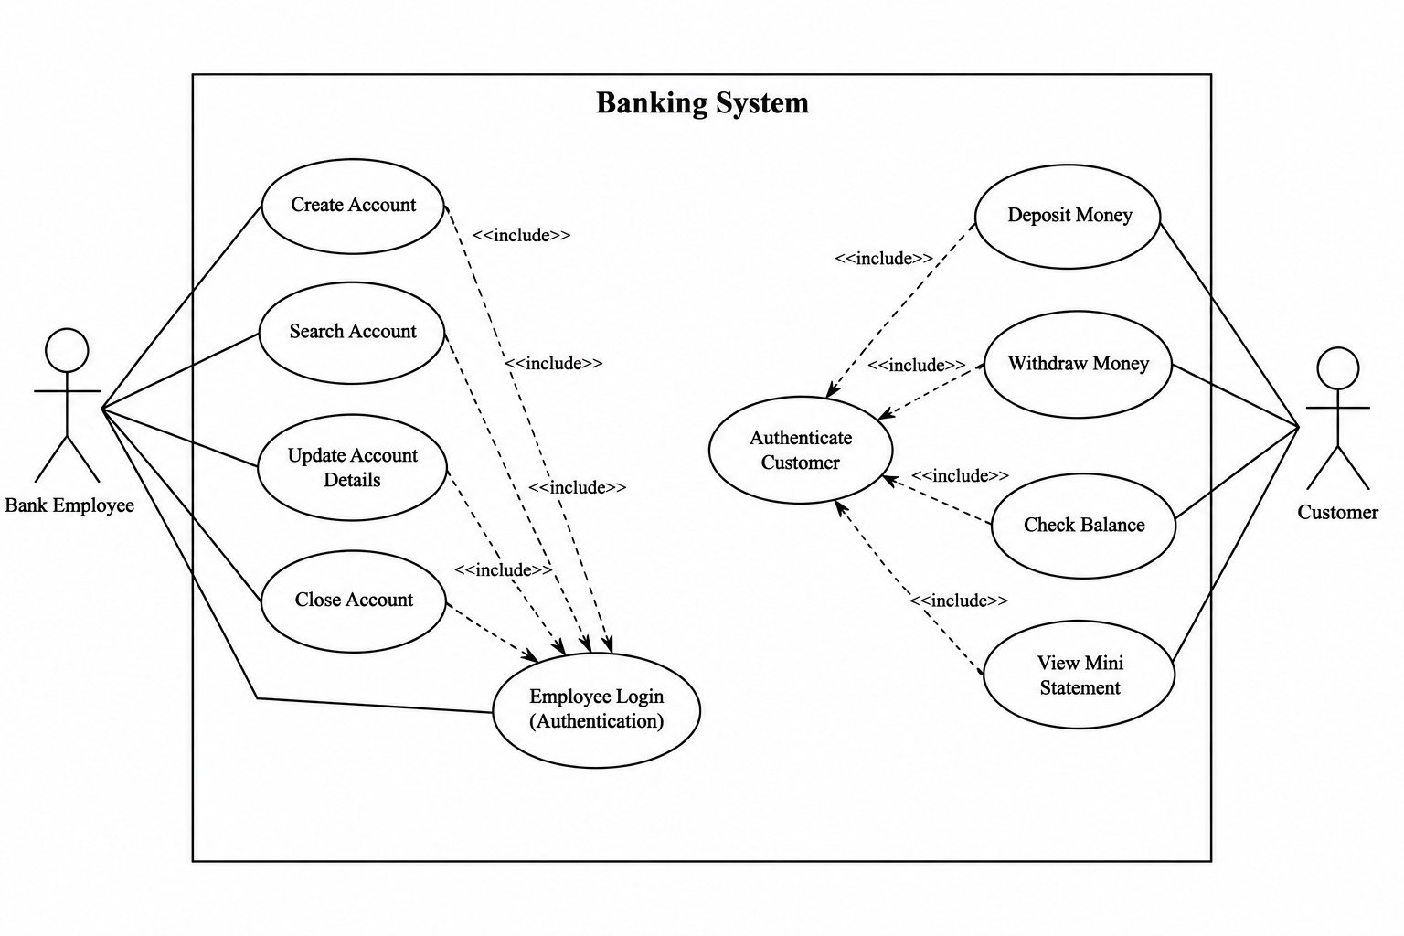
Figure 1. Use case diagram

5.1 Use Case Summary
Actor | Use Cases
Bank Employee | Employee Login; Create Account; Search Account; Update Account Details; Close Account
Customer | Authenticate Customer; Deposit Money; Withdraw Money; Check Balance; View Mini Statement

6. Requirements Traceability Matrix
Req ID | Requirement Summary | Use Case | Verification | Priority
FR-1 | Create account | Create Account | TC-01, TC-02 | High
FR-2 | Unique account number | Create Account | TC-01 | High
FR-3 | Deposit | Deposit Money | TC-03, TC-04 | High
FR-4 | Withdrawal with balance check | Withdraw Money | TC-05, TC-06 | High
FR-5 | Check balance | Check Balance | TC-07 | High
FR-6 | Mini-statement | View Mini Statement | TC-08 | Medium
FR-7 | Search account | Search Account | TC-09 | Medium
FR-8 | Update account | Update Account Details | TC-10 | Medium
FR-9 | Close account | Close Account | TC-11 | Medium
FR-10 | Employee authentication | Employee Login | TC-12 | High
FR-11 | Customer authentication | Authenticate Customer | TC-13 | High
FR-12 | Error handling | All use cases | TC-04, TC-06, TC-14 | Medium
FR-13 | Persistent storage | All data operations | TC-15 | High
NFR-1 | ≤2 s local transaction response | All transactions | TC-16 | Medium
NFR-2 | Simple console UI | All use cases | TC-17 | Medium
NFR-3 | Invalid input does not alter records | All input validation | TC-14 | High
NFR-4 | Modular implementation | Code structure | Code review | Low
NFR-5 | Compile on target OS | Build | Build check | Low
NFR-6 | Persistence across restart | All data operations | TC-15 | High
SEC-1 | Employee access control | Employee Login | TC-12 | High
SEC-2 | Customer access control | Authenticate Customer | TC-13 | High
SEC-3 | Failed login denies operation | Authentication | TC-12, TC-13 | High
SEC-4 | Positive transaction amounts | Deposit/Withdraw | TC-04, TC-06 | High

