SRS — Pharmacy Expiry & Re-order Dispatch Engine

1. Introduction

1.1 Purpose
This SRS specifies the requirements for the Pharmacy Expiry & Re-order Dispatch Engine (Problem Statement #15). It is written for the course instructor, developers and testers, and is the baseline for design, implementation and testing.

1.2 Scope
The system helps hospital pharmacy staff manage medicine stock by batch. It will:
- Track every medicine batch with its quantity and expiry date.
- Enforce First Expired First Out (FEFO) when medicines are dispensed.
- Generate FEFO ordered picking lists.
- Detect low stock against a safety threshold and automatically raise and dispatch purchase orders to suppliers.
- Keep an immutable audit trail of all stock and order events.
Out of scope: billing, patient records, prescription validation and supplier payment.

1.3 Definitions and Acronyms
Term | Meaning
FEFO | First-Expired-First-Out: the batch with the nearest expiry date is used first
Batch | A received lot of one medicine, with its own batch ID, quantity and expiry date
Safety threshold | Minimum stock level for a medicine; at or below it, a re-order is triggered
PO | Purchase Order sent to an Inventory Supplier
FR / NFR | Functional / Non-Functional Requirement
UC | Use Case
RTM | Requirements Traceability Matrix

1.4 References
- PES University, Lab 1 Problem Statement #15: Pharmacy Expiry & Re-order Dispatch Engine
- 01_Requirements_Engineering/Requirements_Table.docx (FR, NFR and RTM)
- UseCase_Diagram.pdf and UseCase_Flow.docx (Lab 1 deliverables)
- 02_Architectural_Diagram/Architecture_Diagram.png
- IEEE Std 830-1998, Recommended Practice for Software Requirements Specifications

2. Overall Description

2.1 Product Perspective
The engine is a new, standalone web application used inside a hospital pharmacy. It replaces manual stock registers and manual re-ordering. Its only external interface is the supplier side: suppliers receive purchase orders and update their status.

2.2 Product Functions
- Register medicine batches (batch ID, medicine name, quantity, expiry date).
- Dispense medicine in FEFO order across one or more batches.
- Generate a FEFO-ordered picking list for a medicine.
- Monitor stock against safety thresholds on a schedule.
- Generate and dispatch purchase orders when stock is low.
- Let suppliers acknowledge and update purchase-order status.
- Record an immutable audit log of all of the above.

2.3 User Classes and Actors
Actor | Type | Responsibilities
Pharmacy Clerk | Primary, human | Registers batches, dispenses medicine, generates FEFO picking lists
Inventory Supplier | Primary, human / external | Receives purchase orders, acknowledges them and updates their status
System Scheduler | Primary, time-based | Triggers periodic stock-level monitoring
The problem statement names only the Pharmacy Clerk and Inventory Supplier. The System Scheduler is added as a time-based actor because stock monitoring (UC-05) runs automatically, without a human starting it.

2.4 Operating Environment
- Web application accessed through a modern browser (Chrome, Edge, Firefox) on pharmacy desktops.
- Server side application with a relational database.
- Supplier communication over HTTPS/TLS.

2.5 Design and Implementation Constraints
- The audit log must be append-only; existing records cannot be edited or deleted.
- Audit records must be retained for at least 3 years.
- Supplier communication must be encrypted (TLS).

2.6 Assumptions and Dependencies
- Each medicine has a safety threshold configured before monitoring starts.
- Expiry dates entered at batch registration are correct.
- Suppliers have access to the Supplier Portal, or an endpoint that can receive purchase orders.
- Users are authenticated before using any function.

3. Specific Requirements
The system has 5 functional and 2 non-functional requirements. Full rationale for each is in the Requirements Table (folder 01).

3.1 Functional Requirements
ID | Requirement | Priority | Acceptance Criteria
FR-001 | The system shall enforce FEFO picking order by prioritizing medicine batches with the nearest expiry date during sales checkout. | High | Pass: the oldest valid (unexpired) batch is selected first. Fail: a newer batch is assigned while an older unexpired batch exists.
FR-002 | The system shall allow a Pharmacy Clerk to register a new medicine batch by recording batch ID, medicine name, quantity received and expiry date. | High | Pass: the new batch appears in inventory with all four fields stored correctly and is included in FEFO ranking. Fail: missing or incorrect expiry date, or batch excluded from FEFO ranking.
FR-003 | The system shall generate a FEFO-ordered dispensing/picking list for a given medicine, showing all in-stock batches sorted by ascending expiry date. | Medium | Pass: for a medicine with 3+ batches, the list is strictly in ascending expiry order. Fail: a batch is omitted or out of order.
FR-004 | The system shall detect when a medicine's available stock falls at or below its configured safety threshold and flag it for re-order processing. | High | Pass: within 1 minute of a stock update reaching the threshold, the medicine is on the Low Stock list. Fail: not flagged, or flagged while above threshold.
FR-005 | The system shall allow an Inventory Supplier to update a dispatched PO's status (Acknowledged / Fulfilled / Rejected) and update the expected-incoming-stock record. | Medium | Pass: marking a PO Fulfilled adds the quantity to expected stock and the status changes visibly. Fail: status not reflected, or stock changed without a status change.

3.2 Non-Functional Requirements
ID | Type | Requirement | Priority | Acceptance Criteria
NFR-001 | Performance & Security | The system shall automatically generate and dispatch supplier purchase order requests when item stock dips below the safety threshold. | High | Pass: under simulated peak load, the PO is generated and dispatched within 2 seconds of a breach, over TLS. Fail: latency above 2 seconds, or payload sent unencrypted.
NFR-002 | Data Integrity & Compliance | The system shall maintain an immutable audit log of every batch registration, dispensing transaction and purchase-order event, retained for at least 3 years. | Medium | Pass: an audit query for a transaction 1 to 3 years old returns a complete, unaltered record (actor, timestamp, action). Fail: a record is missing, editable, or purged early.

3.3 External Interface Requirements
- User interfaces: a Pharmacy Clerk web UI (batch registration, dispensing, picking list) and a Supplier Portal (view and update POs).
- Software interfaces: a relational database for inventory, purchase orders and the audit log.
- Communication interfaces: purchase orders are dispatched to suppliers over HTTPS/TLS.

4. Use-Case Model
The system has 3 actors and 8 use cases, with three «include» relationships and one «extend» relationship.
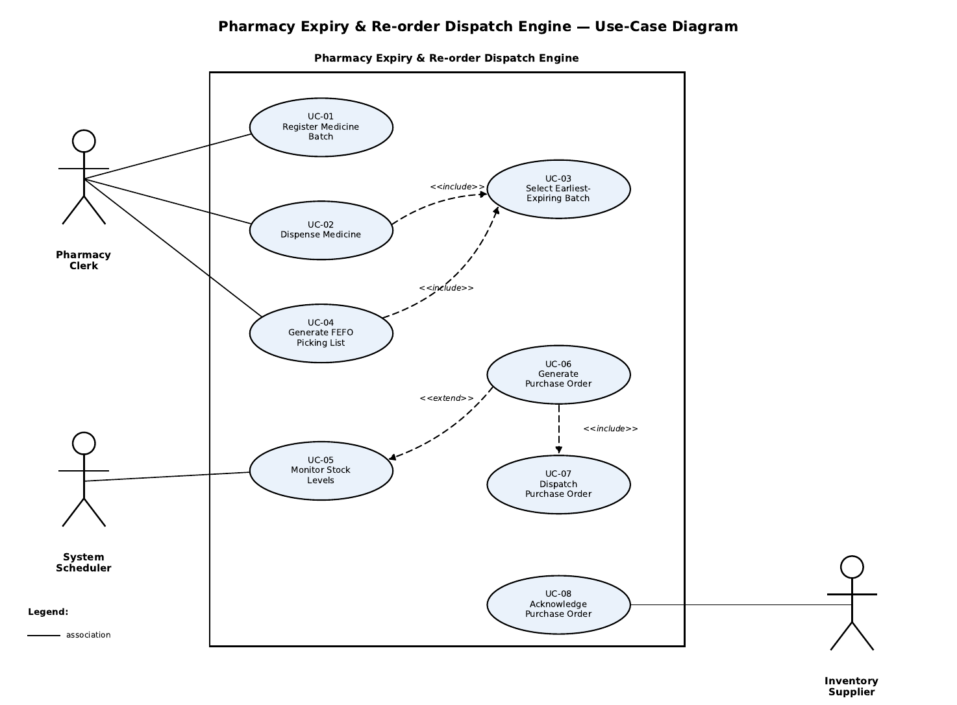

4.1 Use Cases
ID | Use Case | Actor
UC-01 | Register Medicine Batch | Pharmacy Clerk
UC-02 | Dispense Medicine | Pharmacy Clerk
UC-03 | Select Earliest-Expiring Batch | (included)
UC-04 | Generate FEFO Picking List | Pharmacy Clerk
UC-05 | Monitor Stock Levels | System Scheduler
UC-06 | Generate Purchase Order | (extends UC-05)
UC-07 | Dispatch Purchase Order | (included)
UC-08 | Acknowledge Purchase Order | Inventory Supplier

4.2 Relationships
- UC-02 «include» UC-03 and UC-04 «include» UC-03: both dispensing and the picking list always rank batches by expiry.
- UC-06 «include» UC-07: every generated purchase order is always dispatched.
- UC-06 «extend» UC-05: a purchase order is generated only when monitoring finds stock at or below the safety threshold.

4.3 Core Use-Case Flow: UC-02 Dispense Medicine
Primary actor: Pharmacy Clerk. Goal: dispense medicine from the oldest valid (unexpired) batch first.
Preconditions: the Clerk is logged in, and the medicine has at least one unexpired batch in stock.
Main success scenario:
- Clerk selects Dispense Medicine and enters the medicine name and quantity.
- System retrieves all in-stock batches and invokes UC-03 to rank them by ascending expiry date.
- System selects the oldest unexpired batch first (FEFO).
- System deducts the quantity, continuing to the next batch in FEFO order if needed.
- System logs the transaction (batch ID, quantity, clerk, timestamp).
- System shows a confirmation with the batch ID and expiry date used.
Alternate flows:
- 3a. No valid batch: all batches are expired or out of stock; the system shows "No valid batch available" and blocks the transaction.
- 4a. Insufficient stock: total unexpired stock is below the request; the system shows the maximum available, and the Clerk dispenses that amount or cancels.
Postconditions: stock is deducted, the transaction is logged to the audit trail, and the medicine is flagged for re-order if stock is now at or below its threshold.

5. System Architecture
The system uses a layered architecture: each layer calls only the layer below it.
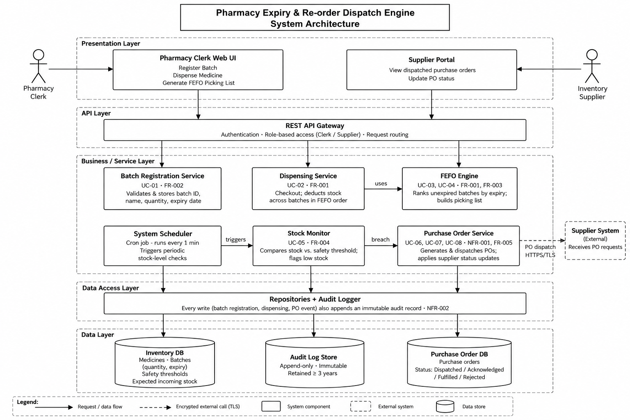
Layer | Components
Presentation | Pharmacy Clerk Web UI, Supplier Portal
API | REST API Gateway (authentication, role-based access, routing)
Business / Service | Batch Registration, Dispensing, FEFO Engine, System Scheduler, Stock Monitor, Purchase Order Service
Data Access | Repositories + Audit Logger
Data | Inventory DB, Audit Log Store, Purchase Order DB
The automated re-order path runs: System Scheduler → Stock Monitor → Purchase Order Service → Supplier System over HTTPS/TLS. Details are in folder 02.

6. Traceability
All 7 requirements trace to at least one use case and one test case; the full RTM is in folder 01.
Req ID | Use Case(s) | Test Case
FR-001 | UC-02, UC-03 | TC-01
FR-002 | UC-01 | TC-02
FR-003 | UC-04, UC-03 | TC-03
FR-004 | UC-05 | TC-04
FR-005 | UC-08 | TC-05
NFR-001 | UC-06, UC-07 | TC-06
NFR-002 | UC-01, UC-02, UC-06, UC-07, UC-08 | TC-07

