WBS (WORK BREAKDOWN STEPS)— Pharmacy Expiry & Re-order Dispatch Engine
The project breaks into 6 phases and 22 work packages, from requirements through deployment.

WBS Tree
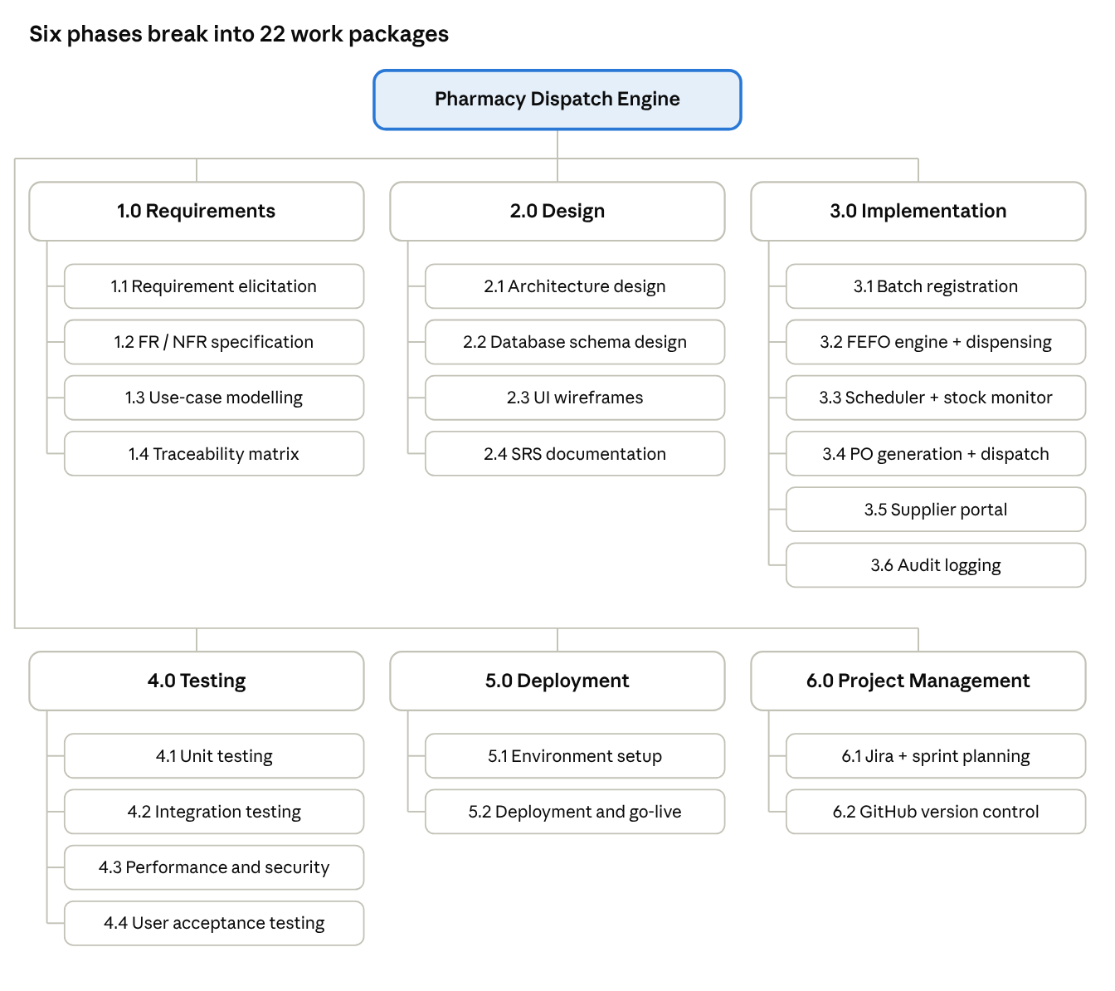
WBS · 6 phases, 22 work packages
Each phase is a level-1 deliverable; the boxes under it are the work packages that produce it.

Work Package Dictionary
ID | Work Package | Output | Requirement(s) | Depends on
1.1 | Requirement elicitation | Stakeholder needs, actor list | All | —
1.2 | FR / NFR specification | Requirements Table | FR-001 to NFR-002 | 1.1
1.3 | Use-case modelling | Use-case diagram, UC-02 flow | All FRs | 1.2
1.4 | Traceability matrix | RTM | All | 1.2, 1.3
2.1 | Architecture design | Layered architecture diagram | All | 1.3
2.2 | Database schema design | Tables for batches, POs, audit log | FR-002, FR-005, NFR-002 | 2.1
2.3 | UI wireframes | Clerk UI and Supplier Portal screens | FR-002, FR-003, FR-005 | 2.1
2.4 | SRS documentation | SRS document | All | 1.4, 2.1
3.1 | Batch registration module | Register Medicine Batch feature | FR-002 | 2.2
3.2 | FEFO engine and dispensing | Dispense + picking list features | FR-001, FR-003 | 3.1
3.3 | Scheduler and stock monitor | Low Stock detection job | FR-004 | 3.1
3.4 | PO generation and dispatch | Automated PO service | NFR-001 | 3.3
3.5 | Supplier portal | PO status update feature | FR-005 | 3.4
3.6 | Audit logging | Append-only audit log | NFR-002 | 2.2
4.1 | Unit testing | Unit tests per module | All FRs | 3.1 to 3.6
4.2 | Integration testing | End-to-end dispense and re-order tests | FR-001, FR-004 | 4.1
4.3 | Performance and security testing | 2-second PO dispatch and TLS checks | NFR-001 | 4.2
4.4 | User acceptance testing | TC-01 to TC-07 results | All | 4.3
5.1 | Environment setup | Server, database, TLS certificate | NFR-001 | 4.4
5.2 | Deployment and go-live | Live system | All | 5.1
6.1 | Jira setup and sprint planning | Scrum, Kanban, Bug Tracking projects | All | —
6.2 | GitHub repo and version control | MyProject_PharmacyDispatch repo | All | —

