**UML Diagrams**

-----------------------------------------------------------------------------------------------------------------------------------

**Activity Diagram**

-----------------------------------------------------------------------------------------------------------------------------------

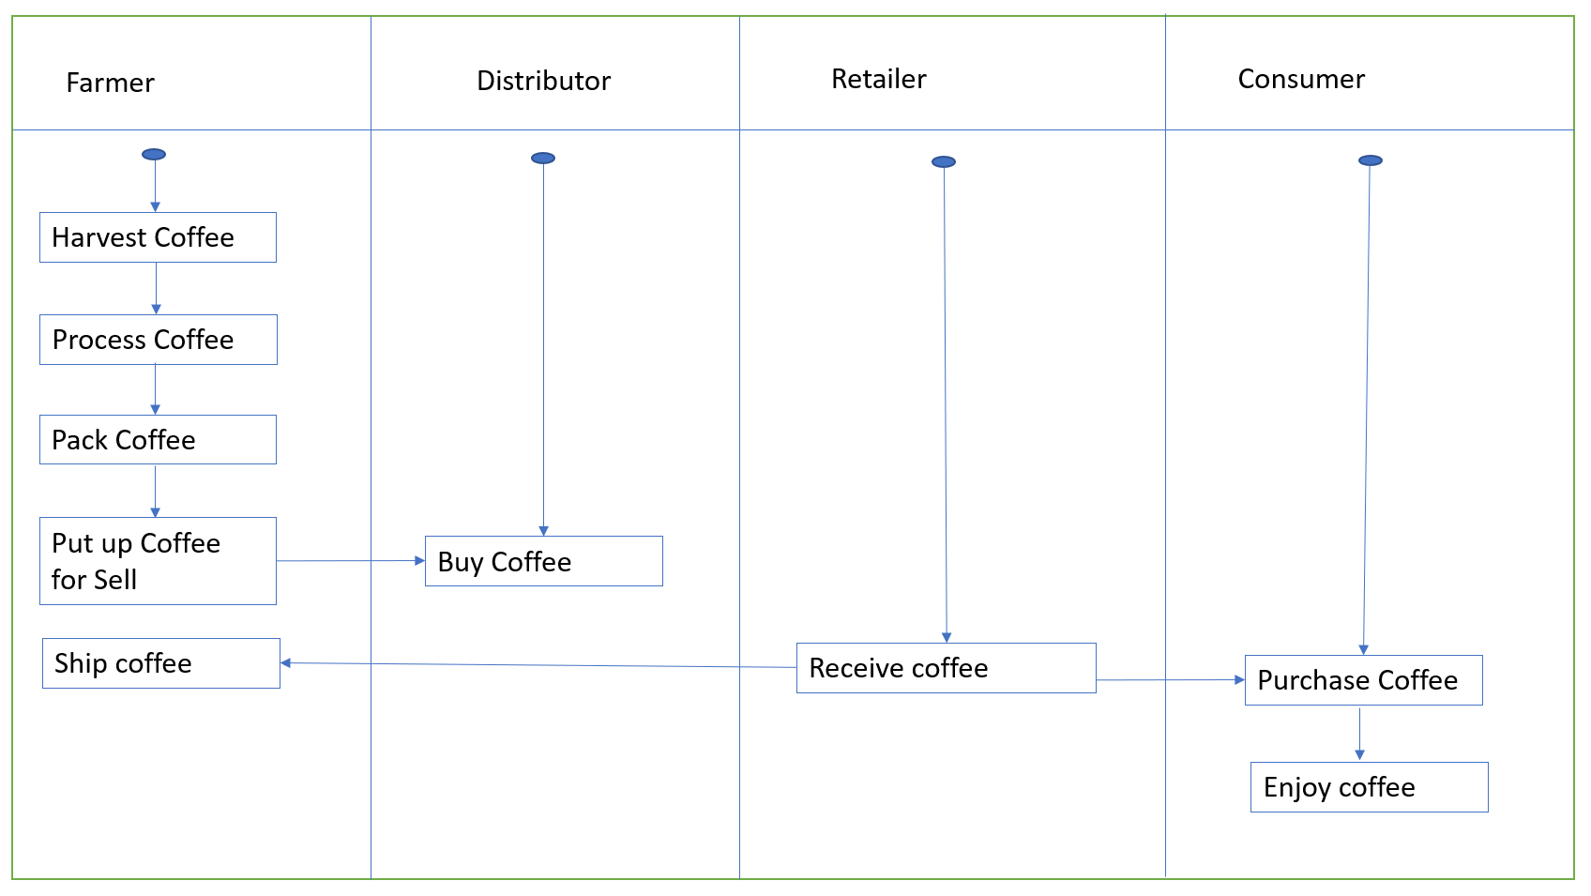

-----------------------------------------------------------------------------------------------------------------------------------

**Sequence Diagram**

-----------------------------------------------------------------------------------------------------------------------------------

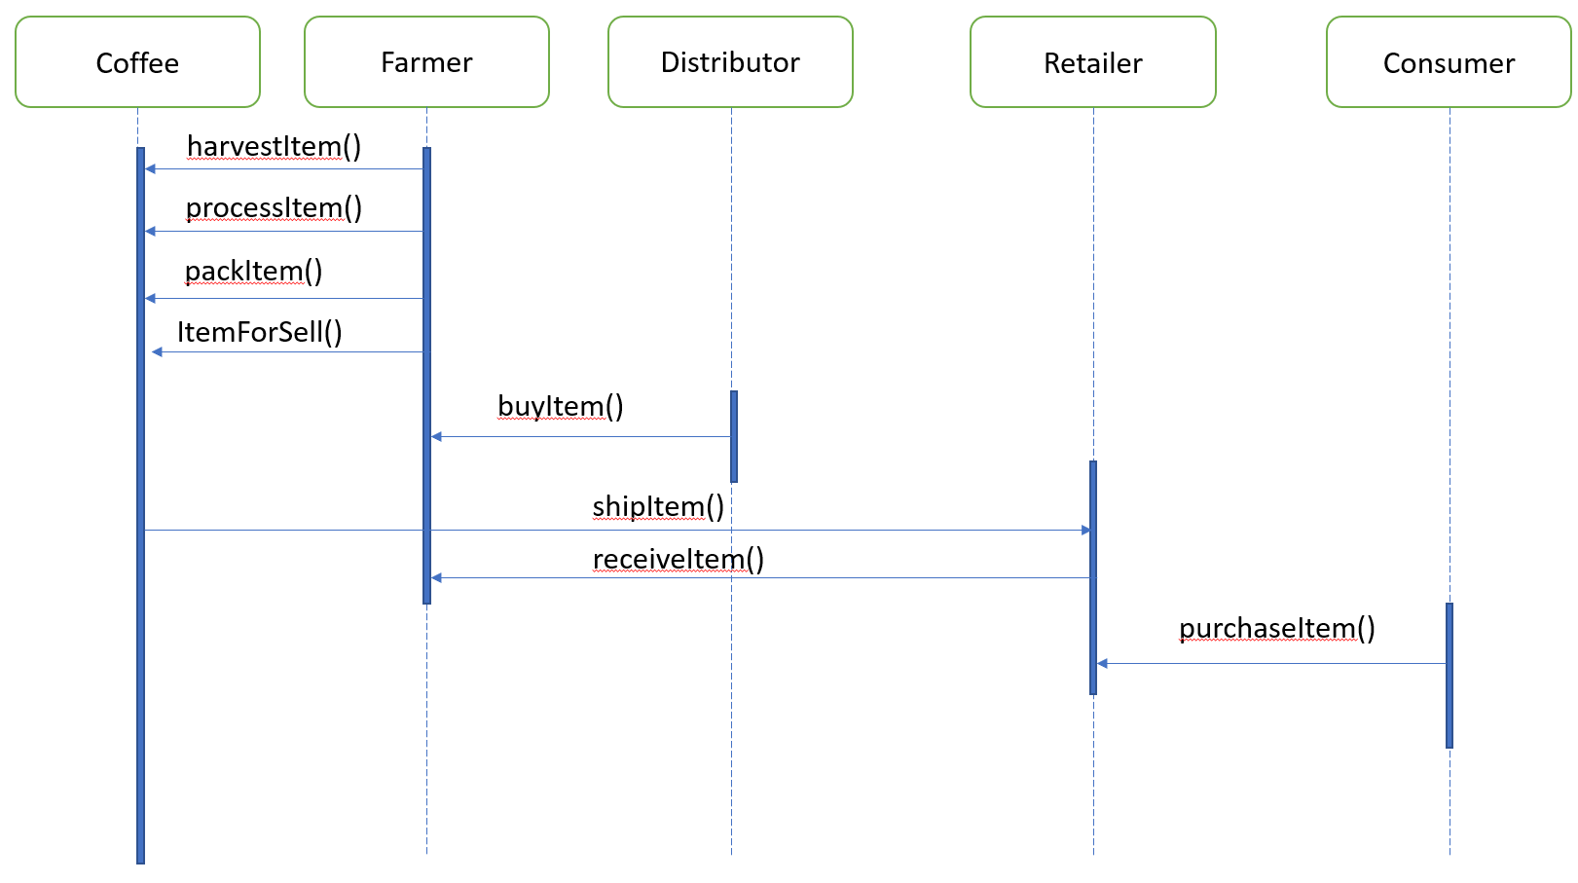

-----------------------------------------------------------------------------------------------------------------------------------

State Diagram

-----------------------------------------------------------------------------------------------------------------------------------

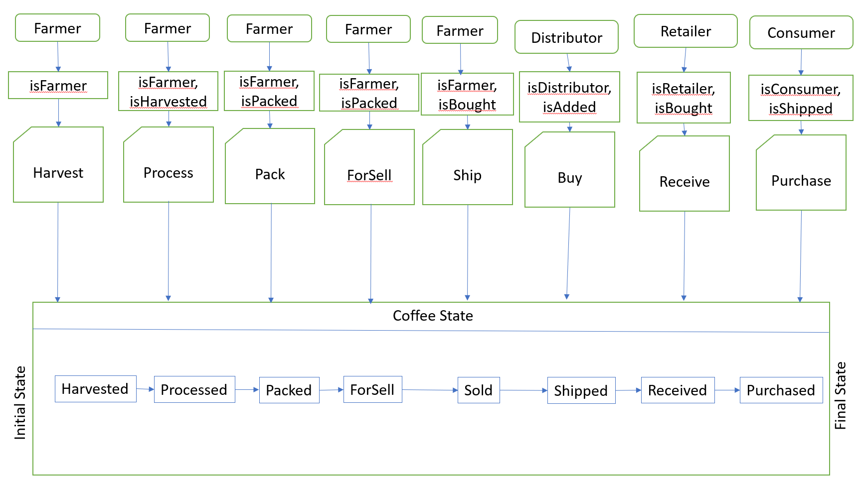

-----------------------------------------------------------------------------------------------------------------------------------

Class (Data Model) Diagram

-----------------------------------------------------------------------------------------------------------------------------------

