Insurance Portfolio Performance Analysis (2014-2019)

1. Objective of the Analysis
This report analyzes the performance of a motor insurance portfolio between 2014 and 2018 using interactive Power BI dashboards. Each dashboard represents data filtered by a year slicer. The objective is to evaluate financial performance, portfolio growth, claim behavior, and risk distribution across vehicle types, usage categories, and customer demographics.

2. Overall Portfolio Performance
Across the five‑year period, the organization issued approximately 57,000 policies and generated $384M in total premium revenue while paying $337M in claims. The premium‑to‑claim ratio of 114% indicates that the company collected about 14% more in premiums than it paid in claims. This results in an approximate surplus of $47M before operational costs.
Although the portfolio appears profitable at a high level, operational expenses such as administrative costs, commissions, and underwriting expenses can significantly reduce the final margin. Therefore, deeper analysis of vehicle categories, usage types, and claim behavior is necessary to understand true profitability.

3. Dashboard Visualizations

Dashboard View 1
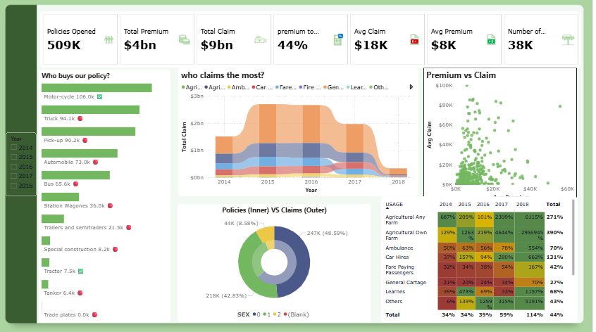

Dashboard View 2
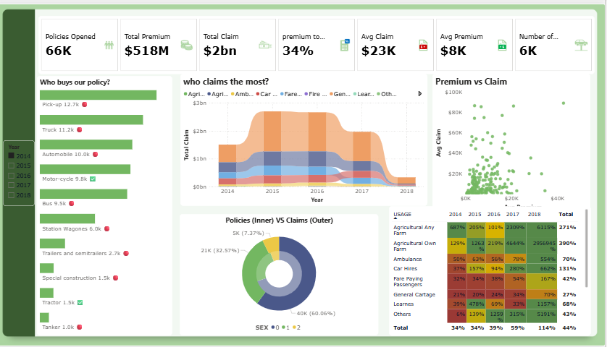

Dashboard View 3
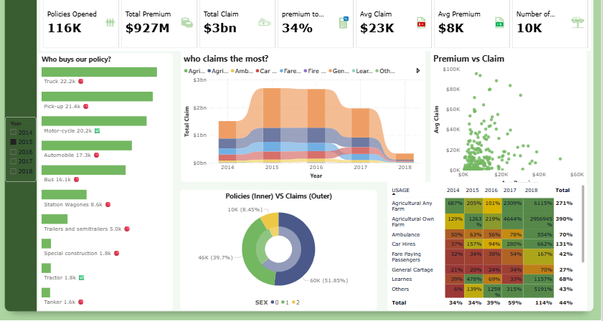

Dashboard View 4
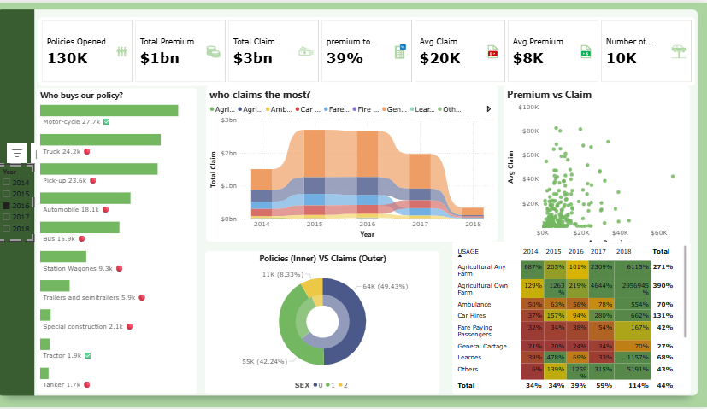

Dashboard View 5
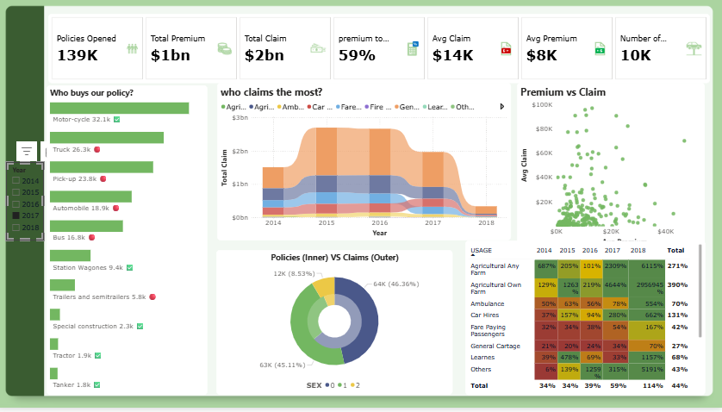

Dashboard View 6
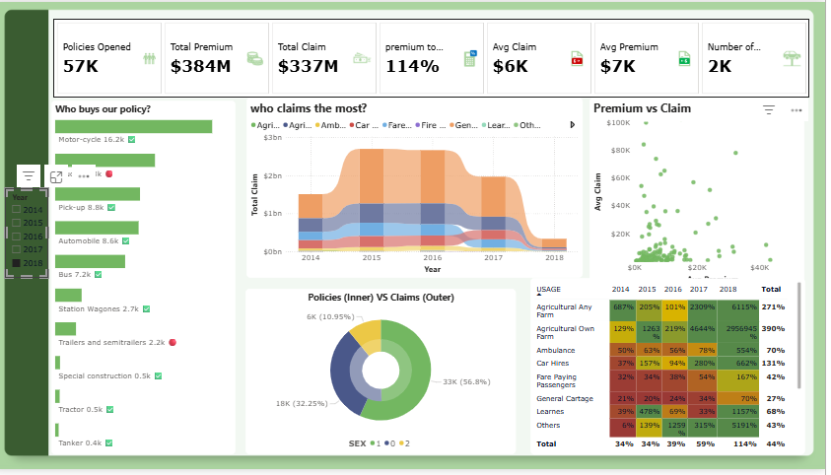

4. Vehicle Category Insights
The analysis of policy distribution shows that motorcycles represent the largest portion of policies issued. Trucks and pick‑up vehicles also form a significant portion of the portfolio. However, commercial vehicle segments such as trucks and trailers appear to show higher claim intensity, indicating potential risk exposure in commercial transport.

5. Usage Based Claim Analysis
The profitability heatmap reveals large differences between usage categories. Segments such as General Cartage and Fare Paying Passengers show relatively stable claim ratios and appear to be profitable. However, agricultural usage categories show extremely high claim ratios, particularly Agricultural Own Farm and Agricultural Any Farm.
In 2018, the agricultural segments show extreme spikes in claim ratios, suggesting either catastrophic losses or potential data anomalies. These segments represent significant financial risk to the insurance portfolio.

6. Customer Demographics
The policy distribution by sex shows that one demographic group represents more than half of the total policies issued. While claim distribution appears proportional to policy distribution, heavy reliance on a single demographic group increases systemic risk exposure.

7. Key Insights
• The portfolio generated a premium surplus but the margin remains relatively small.
• Commercial vehicle segments contribute significant policy volume but also introduce higher risk.
• Agricultural usage categories represent the highest claim risk in the dataset.
• Premium vs Claim scatter plots indicate a cluster of low‑premium policies with varying claim sizes.
• Demographic concentration suggests potential exposure to behavioral risk patterns.

8. Strategic Recommendations
1. Review and recalibrate pricing for high‑risk agricultural segments.
2. Conduct underwriting reviews for trucks and commercial transport vehicles.
3. Focus growth strategies on profitable usage segments such as General Cartage.
4. Improve risk diversification by expanding policy distribution across more demographic groups.
5. Implement advanced claim monitoring to identify abnormal loss events early.

9. Conclusion
The insurance portfolio appears financially stable but vulnerable to risk concentration in certain vehicle and usage categories. While premium revenue currently exceeds claim payments, extreme spikes in agricultural claim ratios highlight potential structural risk within the portfolio. By improving underwriting strategies, adjusting pricing models, and focusing on profitable segments, the organization can strengthen long‑term financial sustainability and risk resilience.

