Name: Manasi Jadhav

UID: 2018140025

Batch: B

TE-IT

**Web Crawler**

Link: [List of largest recorded music markets - Wikipedia](https://en.wikipedia.org/wiki/List_of_largest_recorded_music_markets)

Initially no entries in database

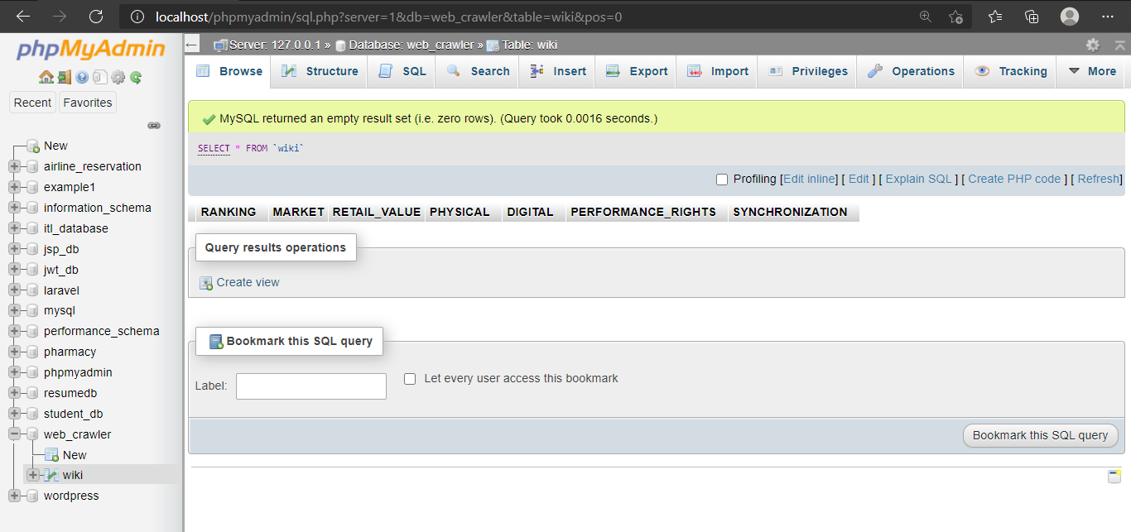

Fetching data of year 2017

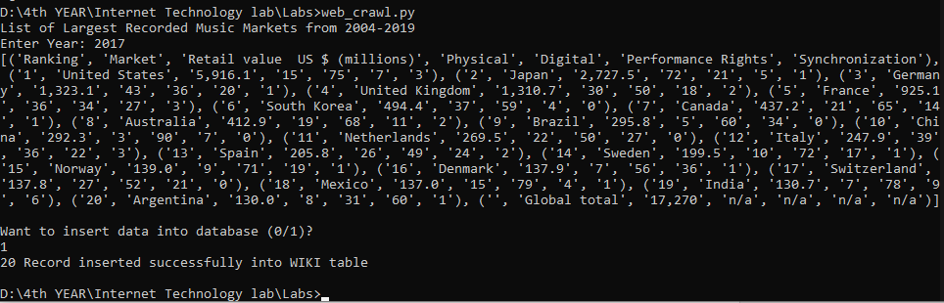

Data inserted in database

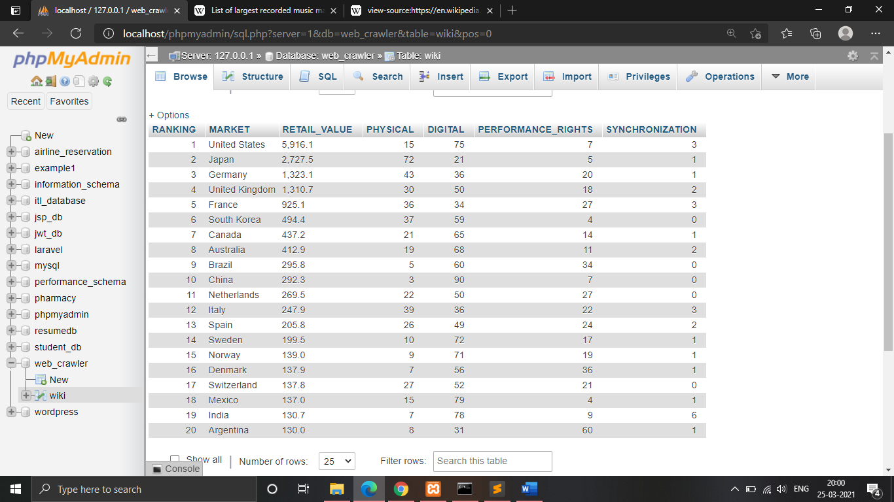

Fetching data of year 2016

