Name: Manasi Jadhav

UID: 2018140025

Batch: B

TE-IT

**Exp4: WEB MASHUP**

**API for location: ipinfo.io**

**API for weather: openweathermap**

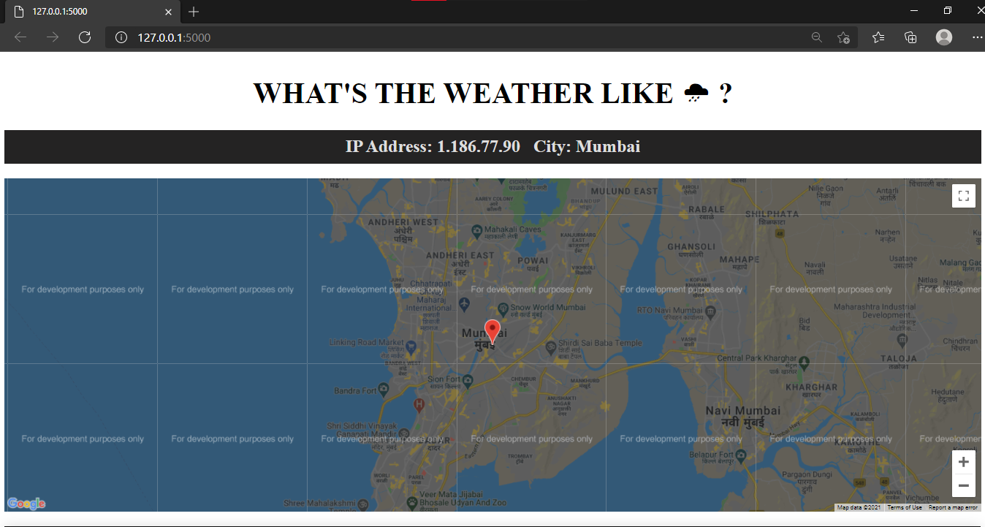

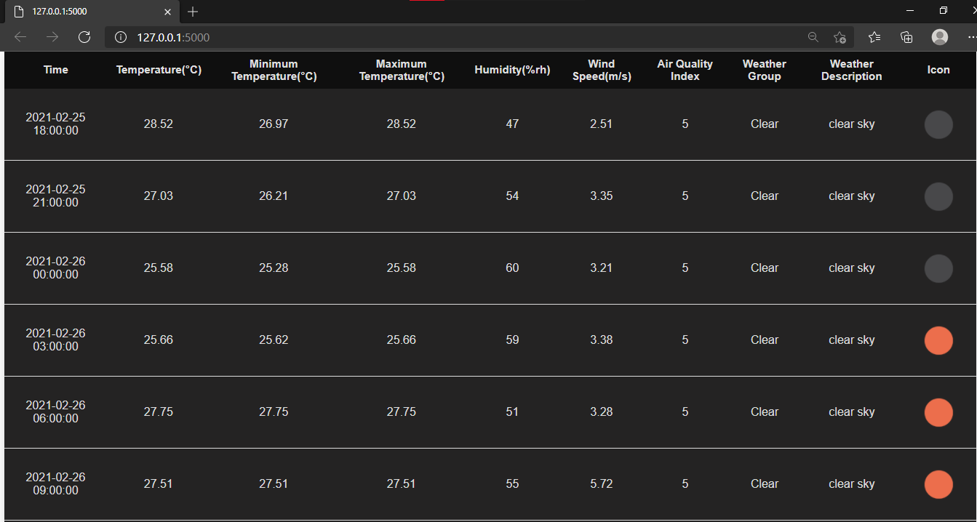

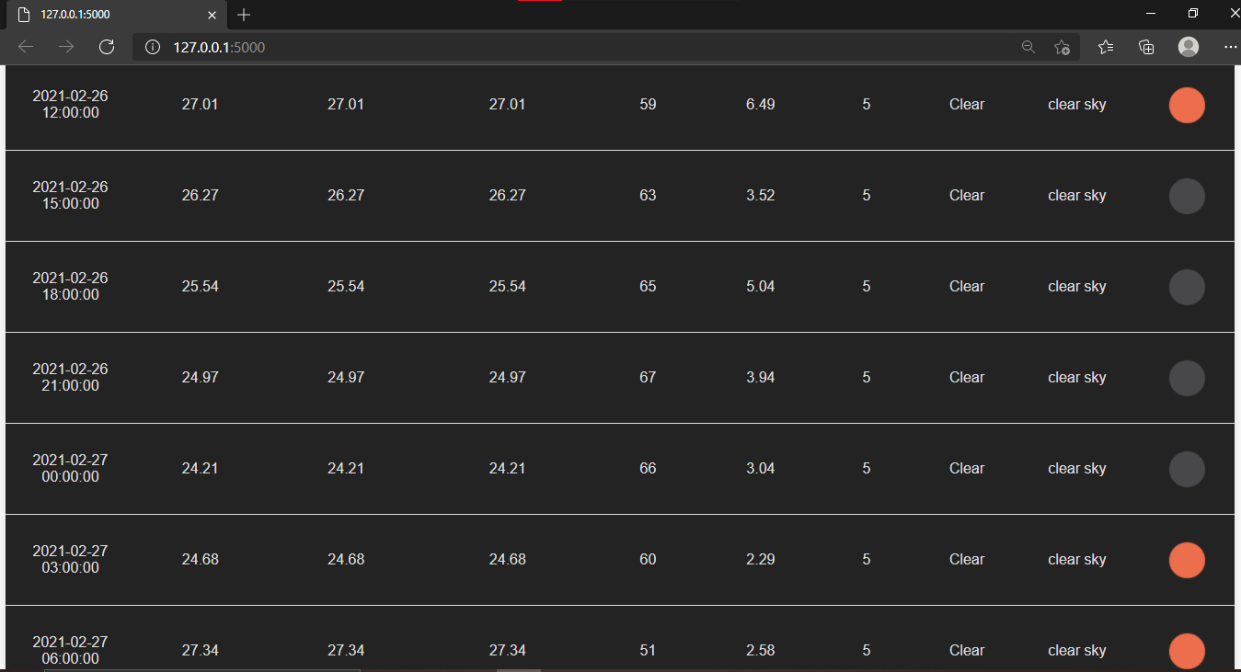

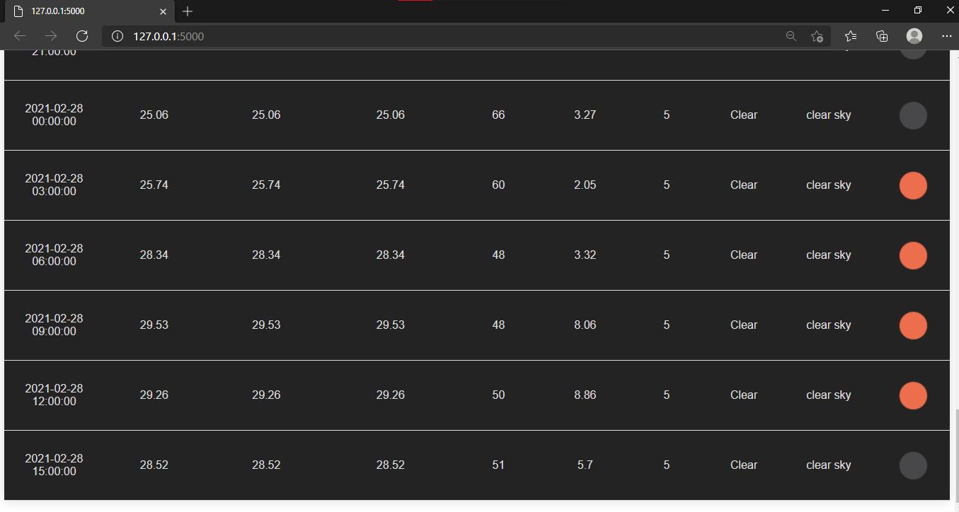

**Conclusion:**

Implemented a weather forecasting system using location and weather api