**Topics: Confidence Intervals**

1. For each of the following statements, indicate whether it is True/False. If false, explain why.
2. The sample size of the survey should at least be a fixed percentage of the population size in order to produce representative results.

Ans: False. Representative results do not depend on the % of population rather it depends on size of the sample. n>30 is sufficiently large amount.

1. The sampling frame is a list of every item that appears in a survey sample, including those that did not respond to questions.

Ans: True

1. Larger surveys convey a more accurate impression of the population than smaller surveys.

Ans: True

*2. PC Magazine* asked all of its readers to participate in a survey of their satisfaction with different brands of electronics. In the 2004 survey, which was included in an issue of the magazine that year, more than 9000 readers rated the products on a scale from 1 to 10. The magazine reported that the average rating assigned by 225 readers to a Kodak compact digital camera was 7.5. For this product, identify the following:

1. The population - All readers of magazine
2. The parameter of interest - satisfaction with different brand of electronics(ratings), average, population,sample size
3. The sampling frame - all readers who respond to surveys, approx. 9000
4. The sample size - 225
5. The sampling design - responses given by readers voluntarily.
6. Any potential sources of bias or other problems with the survey or sample - surveys conducted by the magazines often suffer from nonresponse bias and also the source of this data is from readers that read PC magazine vs the whole population that do not read PC magazine yet they use these different brands of electronics.

3. For each of the following statements, indicate whether it is True/False. If false, explain why.

1. If the 95% confidence interval for the average purchase of customers at a department store is $50 to $110, then $100 is a plausible value for the population mean at this level of confidence.

Ans: True

1. If the 95% confidence interval for the number of moviegoers who purchase concessions is 30% to 45%, this means that fewer than half of all moviegoers purchase concessions.

Ans: False. Above data only gives info about the confidence interval of 30-45% of moviegoers. We cannot confirm for the rest of the moviegoers.

1. The 95% Confidence-Interval for *μ* only applies if the sample data are nearly normally distributed.

Ans: False. It also holds true for data that are not nearly normally distributed but are little bit symmetric.

4. What are the chances that 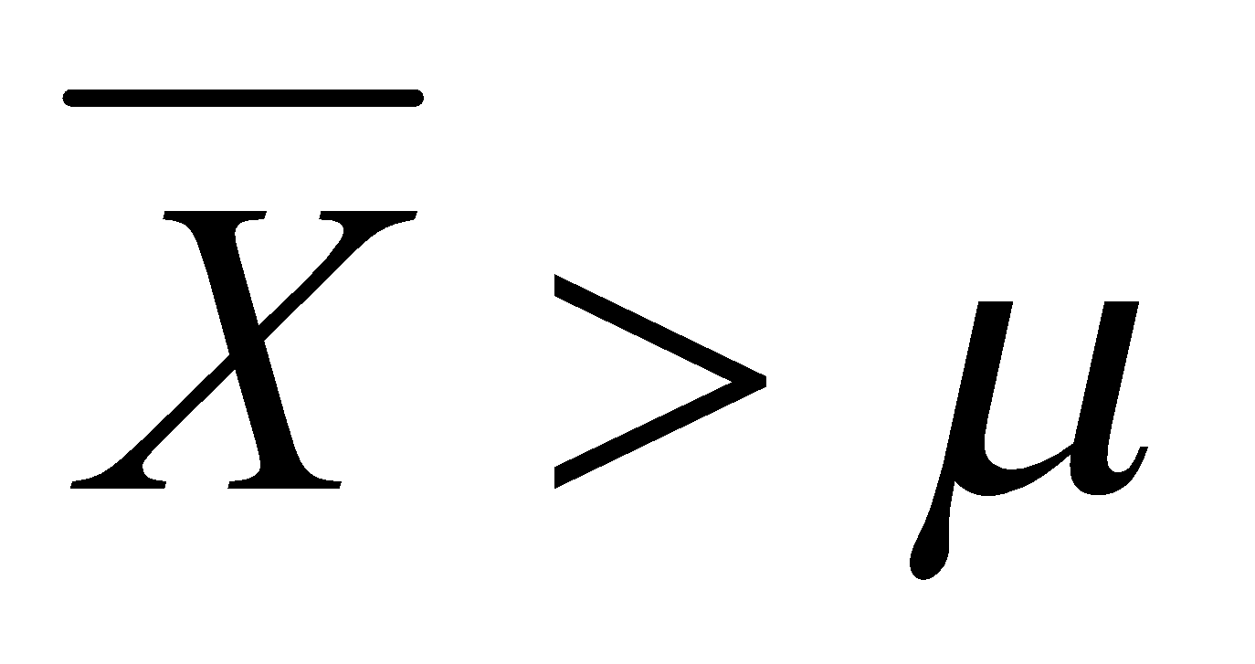?

1. ¼
2. ½
3. ¾
4. 1

Ans: (B), if half sample mean is > population mean then half sample mean will be < population mean and it can be balanced. Only an assumption.

5. In January 2005, a company that monitors Internet traffic (WebSideStory) reported that its sampling revealed that the Mozilla Firefox browser launched in 2004 had grabbed a 4.6% share of the market.

1. If the sample were based on 2,000 users, could Microsoft conclude that Mozilla has a less than 5% share of the market?

Ans: n =2000,*, H0 - >5% Ha - <5%, z = (0.046-0.05)/np.sqrt(0.005(1-0.05)/2000)*

*No. p_value>alpha(0.05) fail to reject H0*

*Microsoft could not conclude that Mozilla has a less than 5% share of the market*

1. WebSideStory claims that its sample includes all the daily Internet users. If that’s the case, then can Microsoft conclude that Mozilla has a less than 5% share of the market?

Ans: Yes.

6. A book publisher monitors the size of shipments of its textbooks to university bookstores. For a sample of texts used at various schools, the 95% confidence interval for the size of the shipment was 250 ± 45 books. Which, if any, of the following interpretations of this interval are correct?

A.All shipments are between 205 and 295 books. - Incorrect

B. 95% of shipments are between 205 and 295 books. - Correct

C. The procedure that produced this interval generates ranges that hold the population mean for 95% of samples. - Correct

D. If we get another sample, then we can be 95% sure that the mean of this second sample is between 205 and 295. - Correct

E. We can be 95% confident that the range 160 to 340 holds the population mean. - Incorrect. As (160,340) is the case for ±2(45) which hold true for 97.5% confidence interval.

7. Which is shorter: a 95% *z*-interval or a 95% *t*-interval for *μ* if we know that σ =s?

A.The z-interval is shorter

B. The t-interval is shorter

C.Both are equal

D. We cannot say

Ans: A. The z-interval is shorter as in t interval degrees of freedom decrease hence t interval is wider than z interval.

Questions 8 and 9 are based on the following: To prepare a report on the economy, analysts need to estimate the percentage of businesses that plan to hire additional employees in the next 60 days.

8. How many randomly selected employers (minimum number) must we contact in order to guarantee a margin of error of no more than 4% (at 95% confidence)?

1. 600
2. 400
3. 550
4. 1000

Ans: ME = z*sqrt((p(1-p)/n)

→ Assume p = 0.5, for 95% CI, z=1.64, ME=0.04,

→ n = p(1-p)*z^2/ME^2

→ n = 420

Hence n = 452(B)

9. Suppose we want the above margin of error to be based on a 98% confidence level. What sample size (minimum) must we now use?

1. 1000
2. 757
3. 848
4. 543

Ans: ME = z*sqrt((p(1-p)/n)

→ Assume p = 0.5, for 98% CI, z=2.06, ME=0.04,

→ n = p(1-p)*z^2/ME^2

→ n = 663

Hence n = 757(B)