**AUTOMATED EXAMINATION SEATING ARRANGEMENT USING AI**

Kaviyapriya K   
Information Technology  
SSN College of Engineering   
Chennai,India  
[kaviyapriya2110735@ssn.edu.in](mailto:kaviyapriya2110735@ssn.edu.in)

Dr. N. Radha

Associate Professor,Department of Information Technology

Kayathri R  
 Information Technology  
SSN College of Engineering   
Chennai,India  
[@ssn.edu.in](mailto:manasi@ssn.edu.in)

Dr. N. Radha

Associate Professor, Department of Information Technology Konidala Manasi   
Information Technology   
SSN College of Engineering   
Chennai,India  
[manasi@ssn.edu.in](mailto:manasi@ssn.edu.in)

Dr. N. Radha

Associate Professor,Department of Information Technology

*Abstract*—   
In the realm of educational assessment, the allocation of students to examination rooms and benches while ensuring fairness, adherence to capacity constraints, and maximizing student satisfaction has remained a challenging problem. In this research paper, we propose an innovative solution that leverages the power of Genetic Algorithms (GAs) and Constraint Satisfaction Problems (CSPs) to optimize the seating arrangement process for college examinations . Our proposed system takes as input the classroom ID, the students to be accommodated, the number of benches in each classroom, and the capacity of each bench. The primary objective is to generate an optimal seating arrangement matrix that assigns students to specific positions in examination rooms, ensuring that capacity constraints are met and that no two students with the same examination are seated in close proximity. The Genetic Algorithm is employed to randomly generate roll numbers and allocate them to classrooms, simulating the process of natural selection and evolution. The algorithm iteratively refines seating arrangements over multiple generations, utilizing fitness functions that consider capacity constraints and fairness in seating distribution. To satisfy the constraint of maintaining a fair distance between students with the same examination, we employ Constraint techniques. A dedicated constraint mechanism is integrated into the genetic algorithm to ensure that students with identical exams are seated at an appropriate distance from each other, promoting an equitable examination environment. Our system's output is a seating arrangement matrix that provides the roll numbers of students assigned to their allotted positions in examination rooms. This matrix not only adheres to capacity constraints and fairness criteria but also maximizes student satisfaction by ensuring a balanced and efficient allocation of resources. Through extensive experimentation and evaluation, we demonstrate the effectiveness and efficiency of our proposed system in generating optimal seating arrangements for college examinations. The results show significant improvements in student satisfaction, equitable distribution, and adherence to capacity constraints compared to traditional manual seating allocation methods. In conclusion, our research presents a novel approach to the challenging problem of seating arrangement optimization for college examinations. By combining Genetic Algorithms and Constraint , we have developed an intelligent system that not only ensures fairness and capacity adherence but also maximizes student satisfaction, ultimately enhancing the overall examination experience.

Keywords— Seating Allotment , Examination Hall , Student, roll number, Class room, Genetic Algorithm

# Introduction

The allocation of students to examination rooms and seating benches is a critical administrative task in the realm of higher education. It is a multifaceted challenge that involves optimizing various factors, including classroom capacity, adherence to fairness principles, and student satisfaction. A well-designed seating arrangement system not only ensures a smooth and organized examination process but also contributes to a fair and equitable assessment environment, which is paramount for academic integrity.In this era of advanced technology and artificial intelligence, traditional manual methods of seating allocation have become outdated and inefficient. The increasing complexity of academic schedules, diverse student populations, and evolving examination formats demand innovative solutions that can efficiently and equitably assign students to their examination locations.

# RELATED WORK

The Examination Hall Seating Management System streamlines the process of hall allocation during college exams, providing an automated and efficient solution. The system facilitates easy access to examination information for students in specific departments, allowing for alphabetically sorted data provided by teachers. It also assists in determining the examination eligibility criteria for students within a particular department. The proposed system introduces a new sub-rule algorithm for arranging examination rooms, aiming to control the distribution of examinees and overall arrangement procedures. This algorithm prevents students from the same school being seated near each other, resulting in an ideal and uniform seating arrangement[1].

In the context of seating arrangements, the literature survey reveals various approaches and systems developed to optimize the allocation of seats in examination halls. Leveraging cloud computing technology, one system automatically assigns seats to students based on hall capacity and the number of students, providing an efficient and computerized approach to seating allocation. Additionally, supervisors can easily exchange duties using this system, enhancing flexibility during exam supervision[2]. Another study focuses on the impact of seating arrangements on student performance, showcasing a shift from traditional row setups to more student-centered seating arrangements. This evolution reflects a growing interest in understanding how seating configurations influence student success[4,5,6].

The proposed model and algorithm address the complexities of the exam seating problem within I-shaped seat allocation systems[7]. The system employs room and exam information, imposing a crucial constraint to ensure the total number of students aligns with available seating capacity. The algorithm meticulously computes seat and student totals, identifying vacant rooms if there is a surplus. The core of the approach involves distributing columns to subjects, considering row capacities and enforcing a minimum one-column distance to prevent academic dishonesty. The system determines maximum column sizes and capacities for each subject, assigning columns using diverse sizes and accommodating extra seats if needed. Subject diversity, room identities, and efficient column and room distribution collectively ensure a comprehensive solution to the exam seating problem within the I-shaped seat allocation context[7].

Furthermore, an Android application with a PHP backend is proposed to simplify the seating allocation process. This system receives PDFs from the university during exam periods, which undergo algorithmic verification. Once conditions are met, automatic seat allocation occurs using algorithms like natural selection. This project utilizes databases to efficiently store and manage information related to students, teachers, and classrooms, streamlining processes and reducing workloads for administrators[8]. Combining constraint programming and genetic algorithms, the proposed solution addresses the exam seating problem effectively. Genetic algorithms, known for their effectiveness in handling complex and highly constrained problems, are applied to create diverse populations of chromosomes through crossovers and mutations. The natural selection process guided by a fitness function ensures the transfer of the best individuals to subsequent generations, optimizing the search for optimal solutions[10].

# METHODOLOGY

Genetic algorithms, classified as evolutionary algorithms, operate on the principles of genetics and natural selection. They serve as efficient search-based optimization techniques, particularly valuable for addressing complex problems that would otherwise require prolonged computational efforts. These algorithms, characterized as population-based random search algorithms, fall under the broader category of evolutionary algorithms. Their primary focus is on mimicking biological evaluation processes within the numerical domain. Widely applicable, genetic algorithms excel in solving optimization problems, offering a versatile approach to finding optimal or nearly optimal solutions for challenging computational tasks.

**KEY FEATURES**

**Input Parameters:** The genetic algorithm takes several input parameters to customize its behavior. These include the classroom ID, specifying the examination room, and the department IDs for Department 1 and Department 2, indicating the student groups that need to be accommodated. These parameters guide the algorithm in tailoring seating arrangements for specific scenarios.

**Data Source:** Real-time data for the genetic algorithm is sourced from the university database. This database contains information about students, including their roll numbers, which encode details such as department affiliation. The department ID within a roll number determines the department to which a student belongs.

In the context of the genetic algorithm employed for optimizing the student seating arrangement in the university examination, each stage can be explained as follows:

**ALGORITHM**

**1. Initialization**:

The process begins with the creation of an initial population of potential seating arrangements. Each arrangement, represented as an individual, corresponds to a unique permutation of students from the specified departments. This population is randomly generated and serves as the starting point for the optimization process.

**2.Fitness Evaluation:**

The fitness of each seating arrangement is evaluated based on predefined criteria. In this scenario, the fitness function assesses the arrangement's quality by considering the proximity of students from the same department. The objective is to minimize the instances where students from the same department are seated close to each other, promoting a fair and equitable distribution. Assign a fitness score to each seating arrangement, where lower scores are better. Penalize arrangements where students from the same department are seated adjacent to each other to encourage a more balanced distribution.

**4. Crossover (Recombination):**

Crossover involves combining genetic material from two selected individuals to create new offspring. In the seating arrangement problem, this translates to merging the seating positions of students from two parent arrangements. The crossover point is chosen randomly, contributing to the diversity of the offspring and introducing new combinations that may exhibit improved fitness. select a crossover point from register number of student representing the department and create an offspring by combining the genetic material of the parents before and after the crossover point.

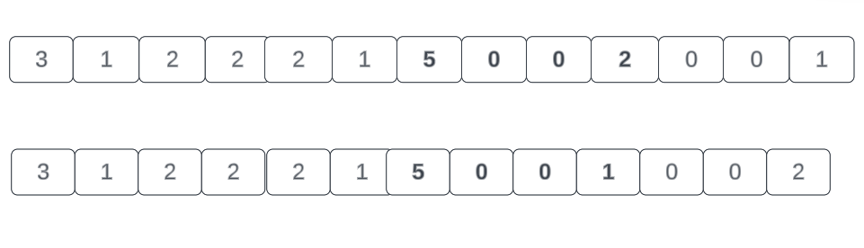

**FLOW DIAGRAM**

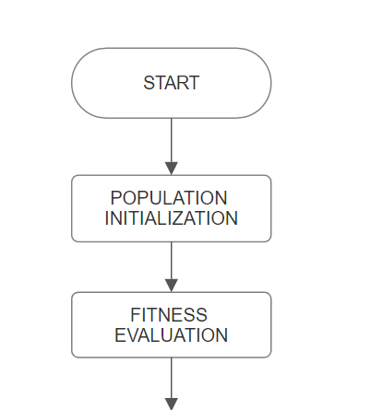

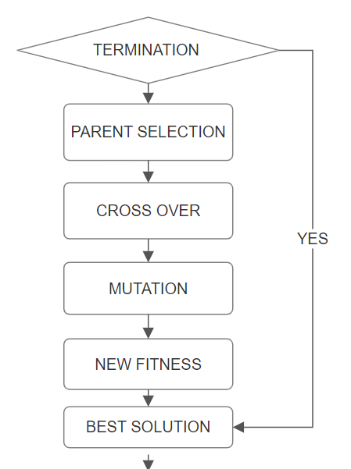

END

**5. Mutation:**

Mutation introduces small, random changes to individual arrangements. In the context of seating optimization, it entails swapping the positions of two students within an arrangement. This introduces diversity to the population, preventing premature convergence to suboptimal solutions and promoting exploration of the solution space.

**6. Population Update:**

The new offspring, generated through crossover and mutation, replace individuals in the existing population. The updated population represents a mixture of successful traits from previous generations, fostering an evolutionary process that converges towards improved seating arrangements.

**7. Termination Criteria:**

The algorithm iterates through these stages for multiple generations, continuously refining the seating arrangements. The process terminates based on predefined criteria, such as achieving a satisfactory fitness level or reaching a maximum number of generations. The resulting seating arrangement represents an optimized solution that satisfies the specified constraints and objectives.

Throughout these stages, the genetic algorithm harnesses evolutionary principles to iteratively enhance seating arrangements, ultimately providing an optimal or near-optimal solution for the university examination context.

##### References

,

1. PHP COOK BOOK, ODavid Sklar and Adam Trachtenberg,Reilly Publications, 2002 Edition
2. Ashti Fatima Alam , Seating Arrangemnet Tools for Examinations, International Journal Of engineering Applied science and technology
3. VOL:1 2016 Prof S.S.Aravinth, G. Pavithra, Exam Hall Seating Arrangement System Using PHP, Ap/Cse Knowledge Institute Of TechnologyVOL:1 2014
4. http://www.w3schools.com/php/default.asp
5. Algorithm for efficient seating plan for centralized exam system Prosanta Kumar Chaki ; Shikha Anirban 2016 International Conference on Computational Techniques in Information and Communication Technologies (ICCTICT)
6. Automatic Exam Seating & Teacher Duty Allocation System Apurva Inamdar ; Anand Gangar ; Arun Gupta ; Varsha Shrivastava 2018 Second International Conference on Inventive Communication and Computational Technologies(ICICCT)
7. Efficient Seat Allocation Process in College Exam System Muhammad Ramees C. K 1 , Sherin Eliyas2 1MCA, 2Assistant Professor Hindustan Institute of Technology and Science,Chennai.
8. Automatic and Efficient Allocation for Examination Seats using Android Application A.V.Allin Geo, R. Kavitha, R. Velvizhi, S. Sangeetha International Journal of Innovative Technology and Exploring Engineering (IJITEE) ISSN: 2278-3075, Volume-8 Issue-9S3, July 2019.
9. P. K. Chaki and S. Anirban, "Algorithm for efficient seating plan for centralized exam system," 2016 International Conference on Computational Techniques in Information and Communication Technologies (ICCTICT*)*, New Delhi, India, 2016, pp. 320-325, doi: 10.1109/ICCTICT.2016.7514601
10. F. Agalday and A. Nizam , "Performance Improvement of Genetic Algorithm Based Exam Seating Solution by Parameter Optimization", Journal of Innovative Science and Engineering, vol. 6, no. 2, pp. 220-232, Dec. 2022, doi:10.38088/jise.1006070