B)

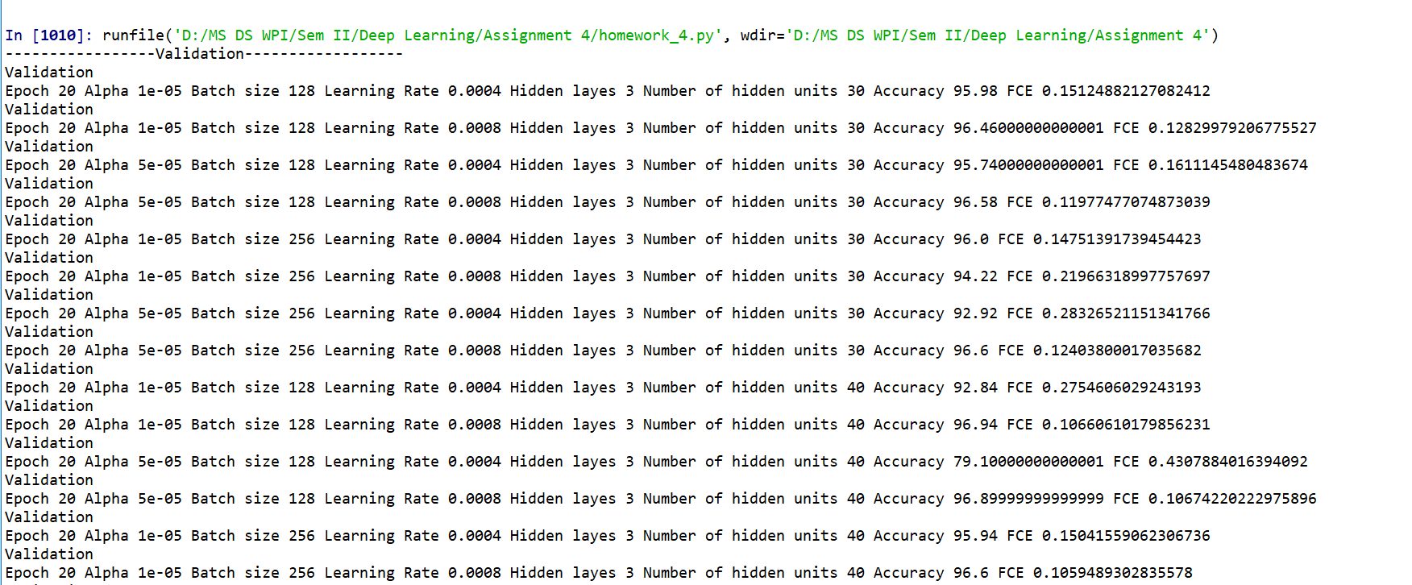

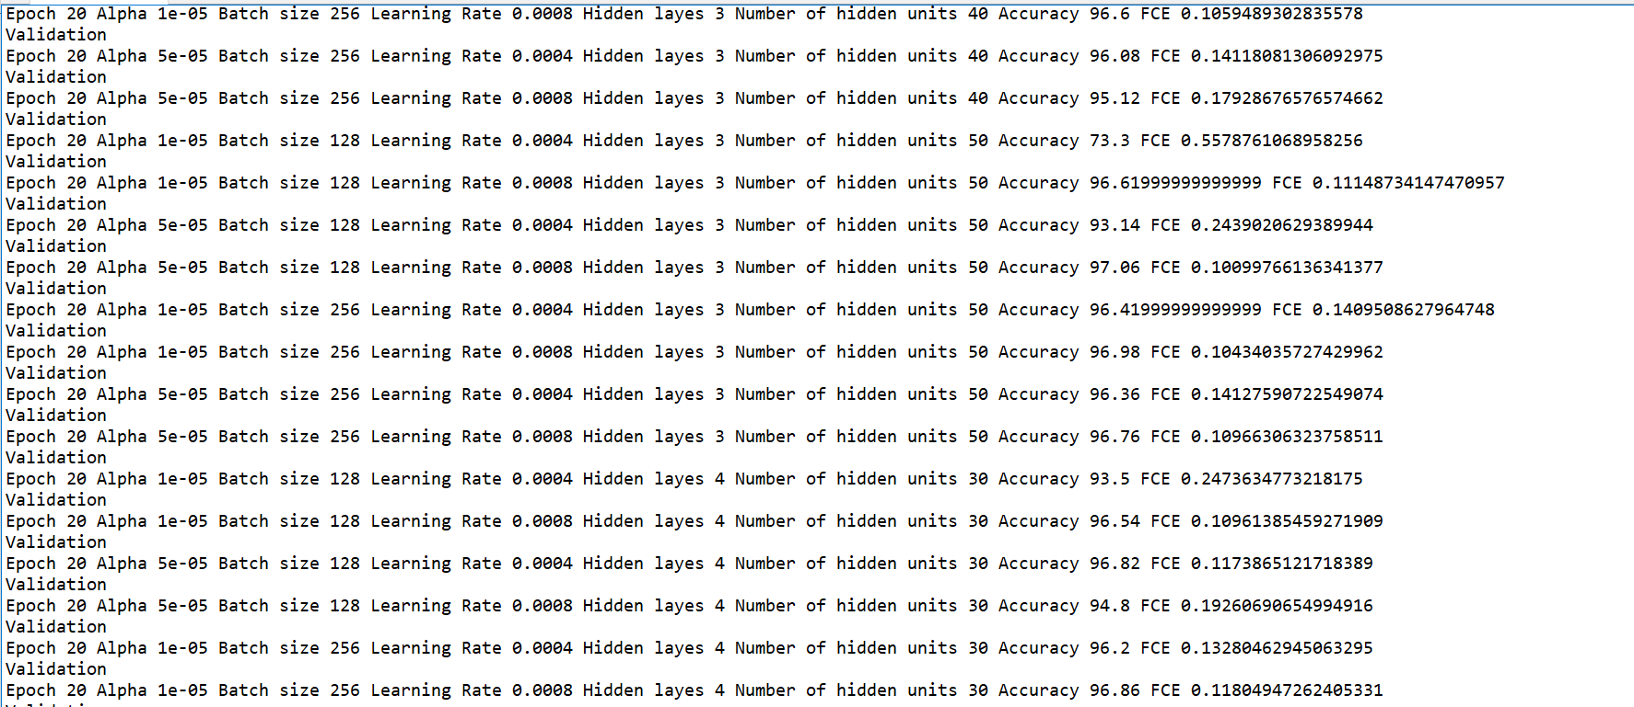

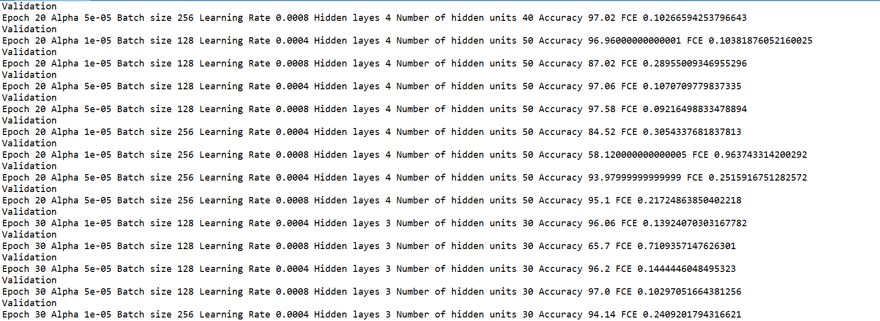

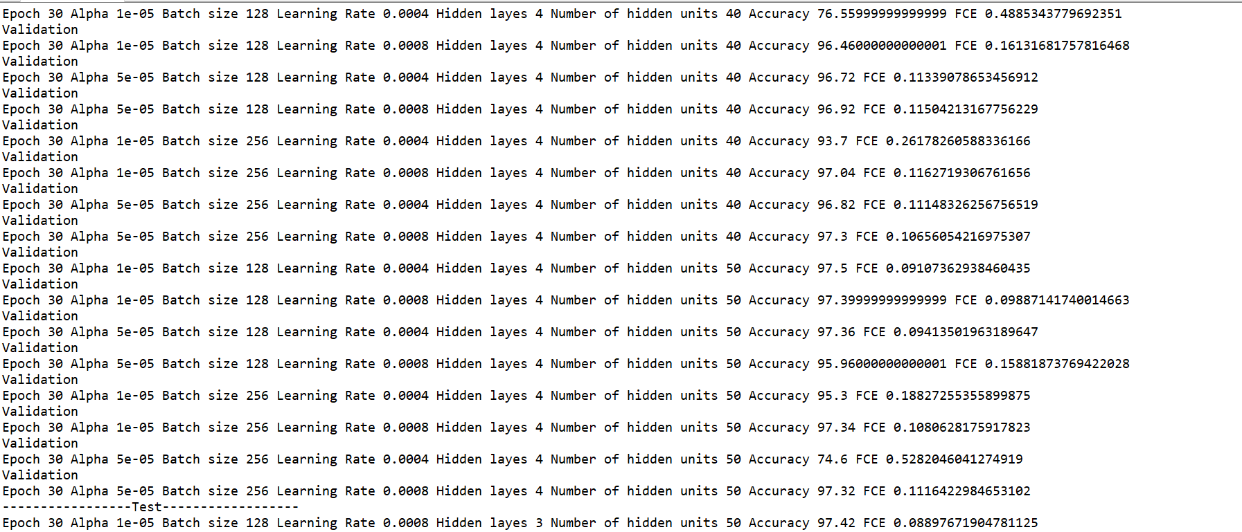

Test Accuracy: 97.42

**Best Hyperparameters**

Epoch 30

Alpha 1e-05

Batch 128

Learning rate 0.0008

Hidden Layer 3

Number of hidden units: 50

c)

