Aim: To set up a PostgreSQL database, create relational tables, and perform basic CRUD operations (Create, Read, Update, Delete) using SQL queries.

Theory:

Introduction to PostgreSQL:
PostgreSQL is a robust, open-source object-relational database system known for its reliability, feature richness, and high performance. Originally developed at the University of California, Berkeley, it is now maintained by a global community. PostgreSQL supports advanced features like user-defined types, table inheritance, views, foreign keys, transactions, and multi-version concurrency control (MVCC).

Relational Databases:
A relational database organizes information into structured tables, where each table (relation) consists of rows (records) and columns (attributes). Every row in a table represents a unique entry, typically identified by a primary key. Tables can relate to one another using foreign keys, enabling data normalization and integrity across the database.

SQL - Structured Query Language:
SQL is the standard language for managing and interacting with relational databases. PostgreSQL enhances SQL by adding advanced features and constructs. The major categories of SQL commands include:
- Data Definition Language (DDL): Defines and modifies database schema objects using CREATE, ALTER, and DROP.
- Data Manipulation Language (DML): Performs data operations using INSERT, UPDATE, DELETE, and SELECT.
- Data Control Language (DCL): Manages permissions using GRANT and REVOKE.
- Transaction Control Language (TCL): Controls transactions using BEGIN, COMMIT, and ROLLBACK.

CRUD Operations:
CRUD stands for the four basic operations used in database interaction:
- Create (INSERT): Adds new records to a table.
INSERT INTO students (name, age, email) VALUES ('Manas Mungekar', 22, 'manas@example.com');
- Read (SELECT): Retrieves data from a table.
SELECT * FROM students;
- Update (UPDATE): Modifies existing records.
UPDATE students SET age = 23 WHERE name = 'Manas Mungekar';
- Delete (DELETE): Removes records from a table.
DELETE FROM students WHERE name = 'Manas Mungekar';

Creating a Table in PostgreSQL:
To perform CRUD operations, you need to first define a table structure using DDL commands.
- CREATE TABLE students (
- id SERIAL PRIMARY KEY,
- name VARCHAR(100),
- age INT,
- email VARCHAR(100)
- );

- SERIAL: Automatically generates a unique ID.
- VARCHAR: Used for variable-length character strings.
- INT: Stores integer values.

Relationships and Foreign Keys:
In larger applications, multiple tables are used and linked together. For example, a students table may be linked with a courses table through an enrollments table using foreign keys to maintain referential integrity.

Normalization:
Normalization is a process used to reduce data redundancy and improve consistency by organizing data into separate, related tables. Common forms include:
- 1NF: Eliminates repeating groups.
- 2NF: Removes partial dependencies.
- 3NF: Eliminates transitive dependencies.

Indexes:
Indexes improve query performance by allowing faster data lookups. However, too many indexes can slow down insert/update operations and increase storage usage.

Constraints in PostgreSQL:
- NOT NULL: Prevents NULL values in a column.
- UNIQUE: Ensures that all values in a column are distinct.
- CHECK: Enforces specific conditions.
- DEFAULT: Assigns a default value to a column.

Transactions:
A transaction is a group of SQL operations executed as a single unit. PostgreSQL supports ACID properties (Atomicity, Consistency, Isolation, Durability) to ensure data reliability.
- BEGIN;
- UPDATE students SET age = 24 WHERE name = 'Manas Mungekar';
- COMMIT;

If something goes wrong during the transaction, you can use ROLLBACK to undo the changes.

Advantages of PostgreSQL:
- Completely free and open-source.
- ACID-compliant for reliable transaction processing.
- Compatible with major programming languages and platforms.
- Extensible through user-defined types, plugins, and functions.
- Native support for JSON, XML, full-text search, and GIS data (via PostGIS).
- Actively maintained by a global developer community.

Common PostgreSQL Tools:
- psql: Command-line tool for PostgreSQL.
- pgAdmin: Graphical user interface for managing databases.
- DBeaver / DataGrip: Powerful third-party database IDEs.

Security Features:
PostgreSQL includes strong access control systems using roles, passwords, and permissions. It also supports SSL for secure connections and row-level security for fine-grained access control.

Real-World Use Cases of PostgreSQL:
- Web application backends (e.g., Django, Express, Rails)
- Data warehousing and analytics
- Financial and banking systems
- Geographic Information Systems (PostGIS)
- ERP and CRM systems
- Internet of Things (IoT) platforms

CREATING A DATABASE

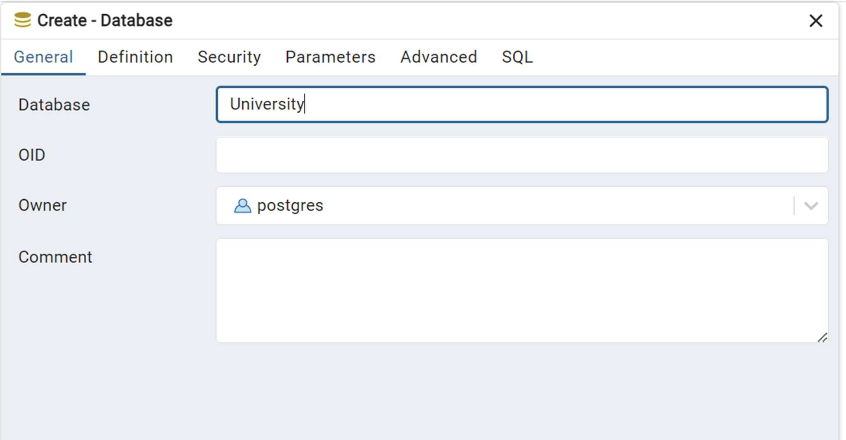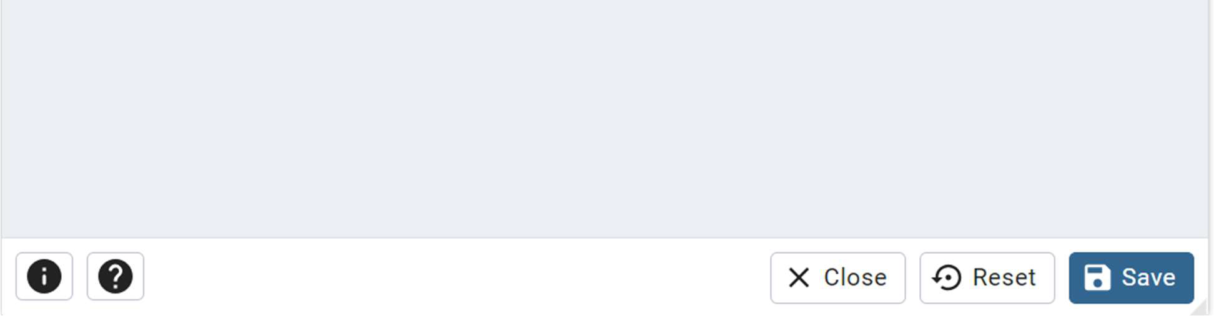

CREATING TABLE
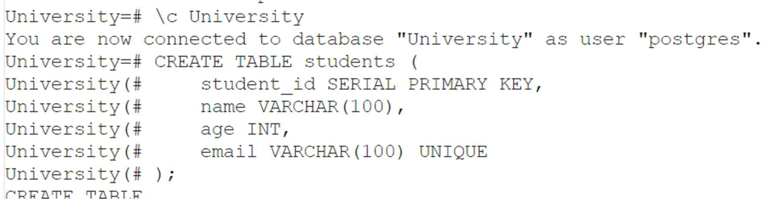

Table:
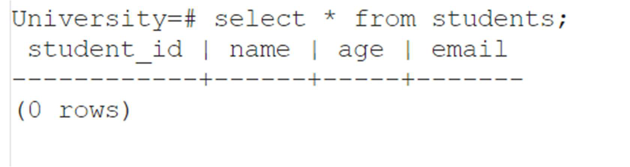

INSERTING VALUES IN TABLE
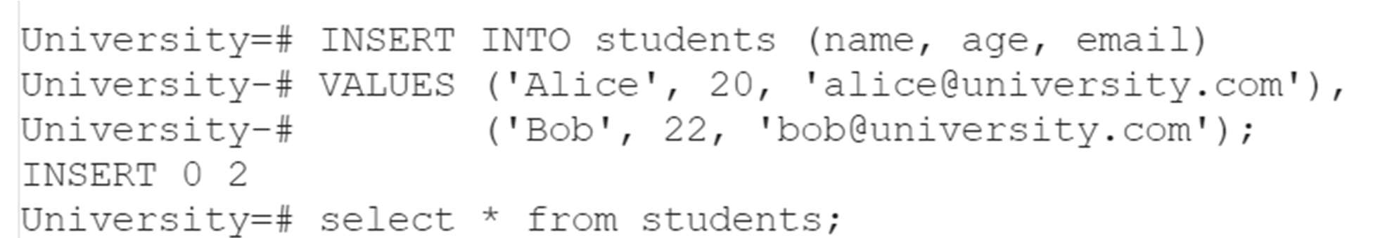

Tables:
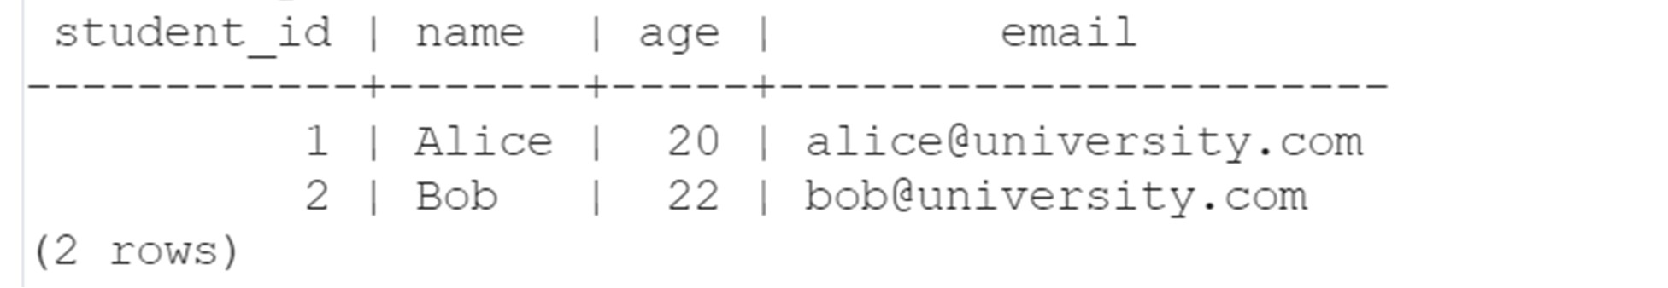

UPDATING VALUES IN TABLE
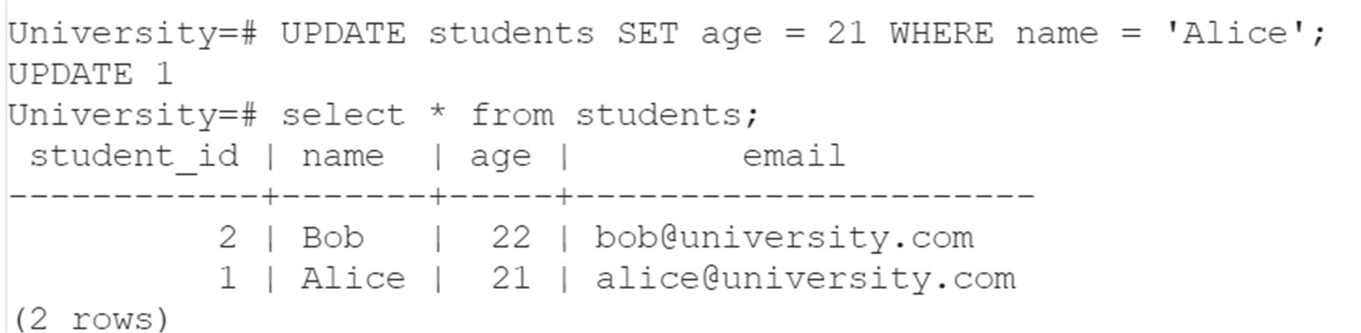
DELETING VALUES IN A TABLE
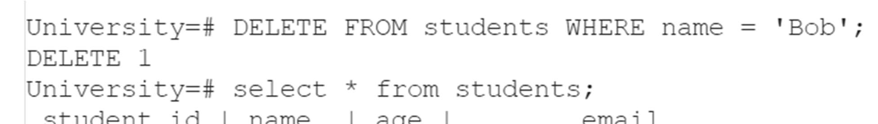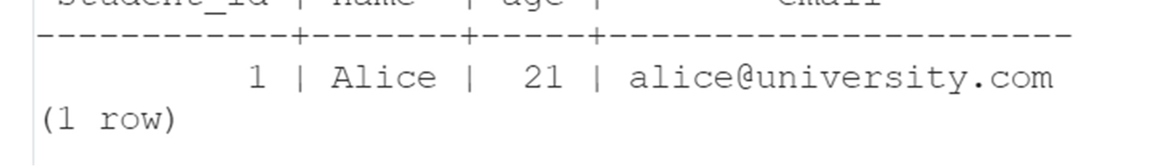

Conclusion:
In this experiment, we successfully learned the core concepts of setting up and interacting with a PostgreSQL database. We created relational tables to organize structured data efficiently and applied the four primary CRUD operations using SQL queries. These operations form the backbone of any application that requires data storage and management. Understanding CRUD in PostgreSQL lays the foundation for more advanced database concepts such as indexing, joins, transactions, triggers, and stored procedures.

By mastering PostgreSQL and SQL operations, students and developers are equipped with essential tools for building scalable and data-driven applications in real-world environments. This hands-on practice also strengthens the ability to design efficient schemas, enforce data integrity, and perform robust data manipulation tasks in production-level software systems.

