MODULE 3 QUES 5
https://leetcode.com/problems/sum-multiples/
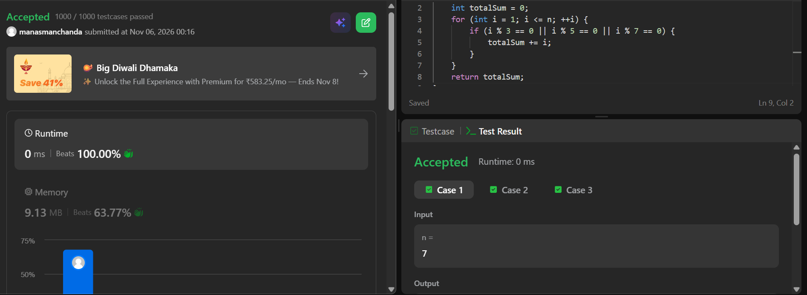
CODE
int sumOfMultiples(int n) {
int totalSum = 0;
for (int i = 1; i <= n; ++i) {
if (i % 3 == 0 || i % 5 == 0 || i % 7 == 0) {
totalSum += i;
}
}
return totalSum;
}

