MODULE 2 QUES4
https://www.hackerearth.com/practice/basic-programming/input-output/basics-of-input-output/practice-problems/algorithm/roy-and-profile-picture/

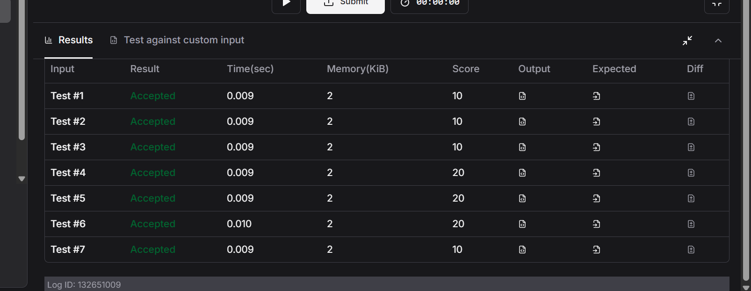
CODE
#include <stdio.h>

int main() {
int L;
scanf("%d", &L);

int N;
scanf("%d", &N);

while (N--) {
int W, H;
scanf("%d %d", &W, &H);

if (W < L || H < L) {
printf("UPLOAD ANOTHER\n");
} else {
if (W == H) {
printf("ACCEPTED\n");
} else {
printf("CROP IT\n");
}
}
}

return 0;
}

