MODULE 5 QUES 3
https://www.hackerearth.com/practice/basic-programming/input-output/basics-of-input-output/practice-problems/algorithm/find-factorial/
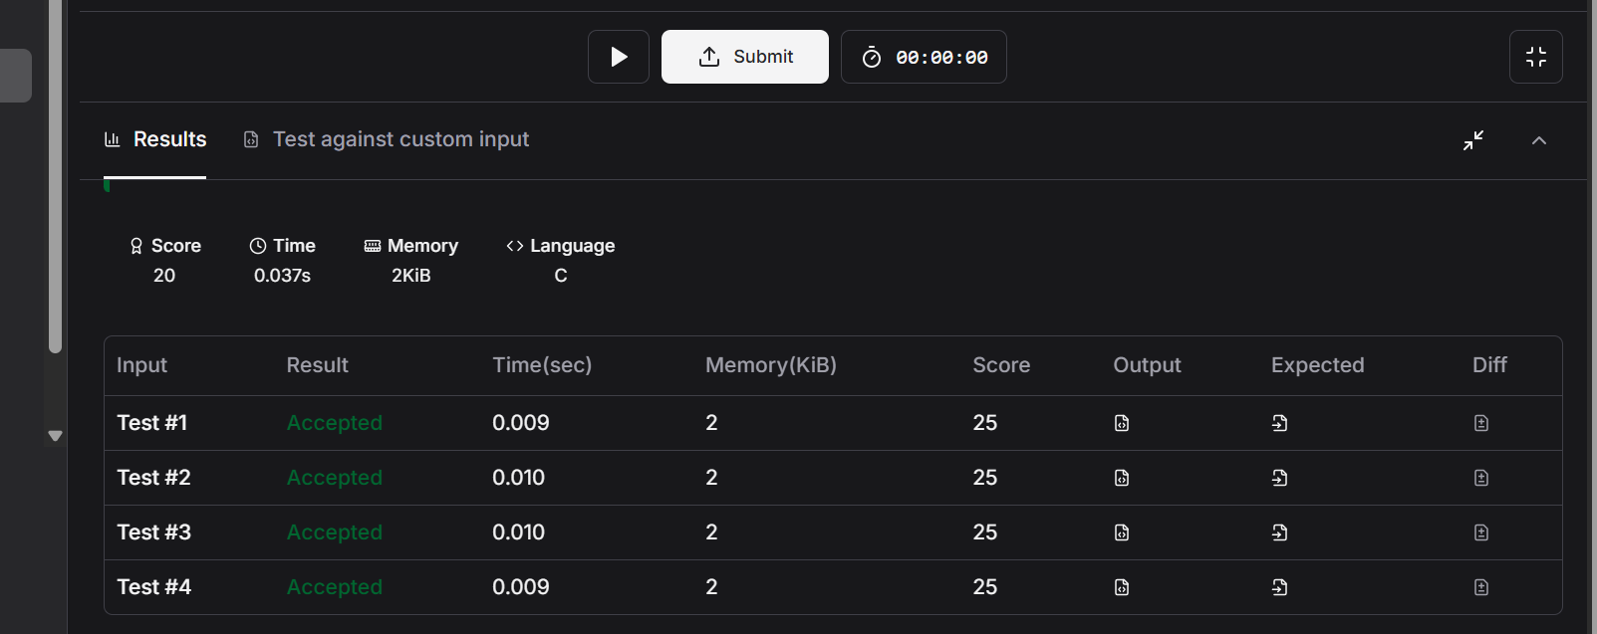
CODE
#include <stdio.h>

int main() {
int num;
// Reading input from STDIN
if (scanf("%d", &num) != 1) {
return 0;
}

// Use long long to prevent integer overflow for larger values of N
long long factorial = 1;

// Calculate factorial using a loop
for (int i = 1; i <= num; i++) {
factorial *= i;
}

// Writing output to STDOUT
printf("%lld\n", factorial);

return 0;
}

