MODULE 1 QUES 2
https://www.hackerrank.com/challenges/solve-me-first/problem
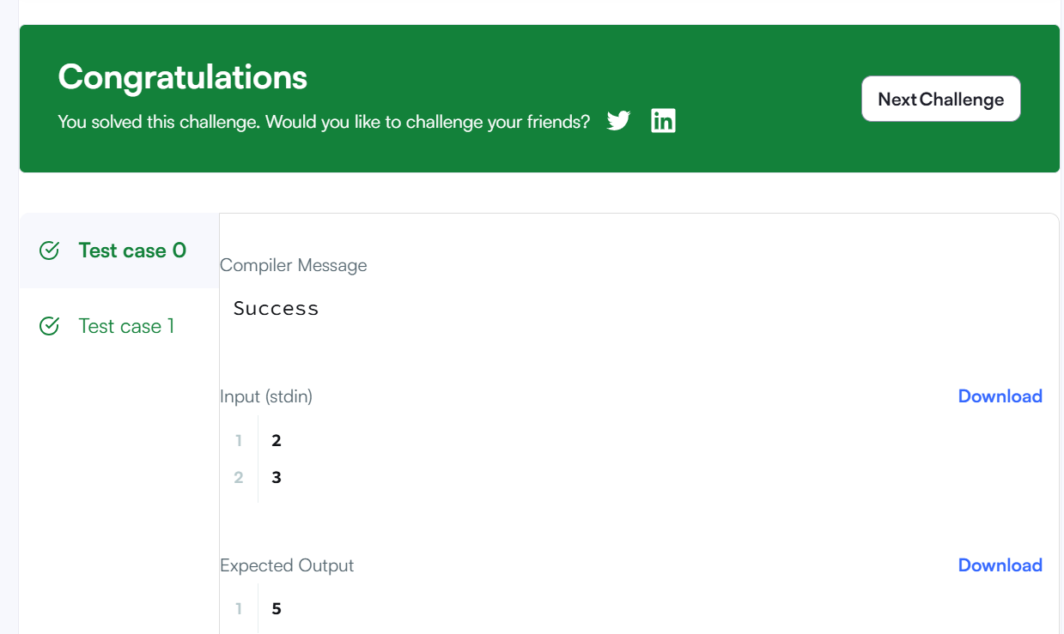
CODE
#include <stdio.h>
int solveMeFirst(int a, int b)
{
return a+b;
}
int main() {
int num1,num2;
scanf("%d %d",&num1,&num2);
int sum;
sum = solveMeFirst(num1,num2);
printf("%d",sum);
return 0;
}

