MODULE 2 QUES1
https://www.hackerrank.com/challenges/conditional-statements-in-c/problem
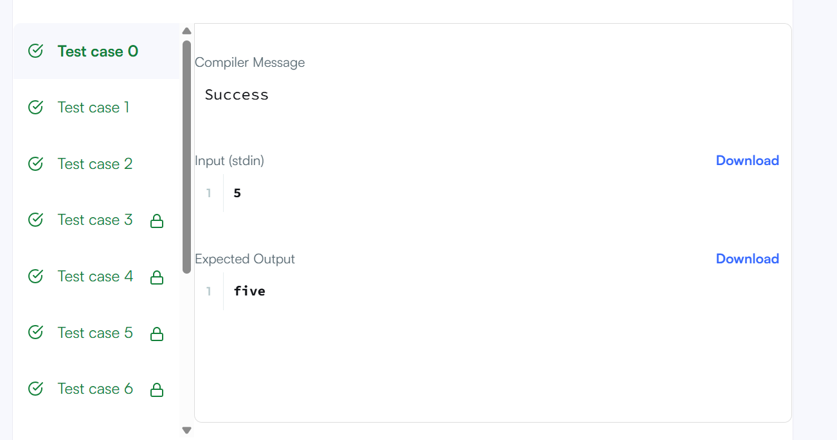
CODE
int main()
{
char* n_endptr;
char* n_str = readline();
int n = strtol(n_str, &n_endptr, 10);

if (n_endptr == n_str || *n_endptr != '\0') { exit(EXIT_FAILURE); }

if(n==1)
{
printf("one");
}
else if(n==2)
{
printf("two");
}
else if(n==3)
{
printf("three");
}
else if(n==4)
{
printf("four");
}
else if(n==5)
{
printf("five");
}
else if(n==6)
{
printf("six");
}
else if(n==7)
{
printf("seven");
}
else if(n==8)
{
printf("eight");
}
else if(n==9)
{
printf("nine");
}
else
{
printf("Greater than 9");
}

return 0;
}

