MODULE 3 QUES 1
https://www.hackerrank.com/challenges/for-loop-in-c/problem
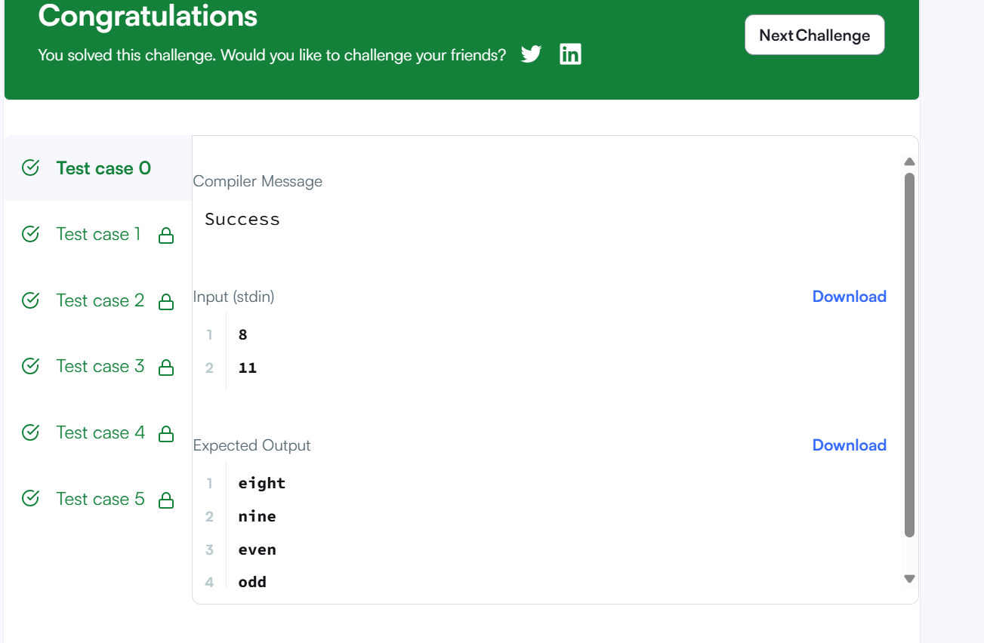
CODE
#include <stdio.h>
#include <string.h>
#include <math.h>
#include <stdlib.h>
int main() {
int a, b;
if (scanf("%d\n%d", &a, &b) != 2) return 0;
char *words[] = {"", "one", "two", "three", "four", "five", "six", "seven", "eight", "nine"};
for (int n = a; n <= b; n++) {
if (n >= 1 && n <= 9) {
printf("%s\n", words[n]);
} else if (n > 9) {
if (n % 2 == 0) {
printf("even\n");
} else {
printf("odd\n");
}
}
}

return 0;
}

