MODULE 2 QUES3
https://www.hackerrank.com/challenges/grading/problem
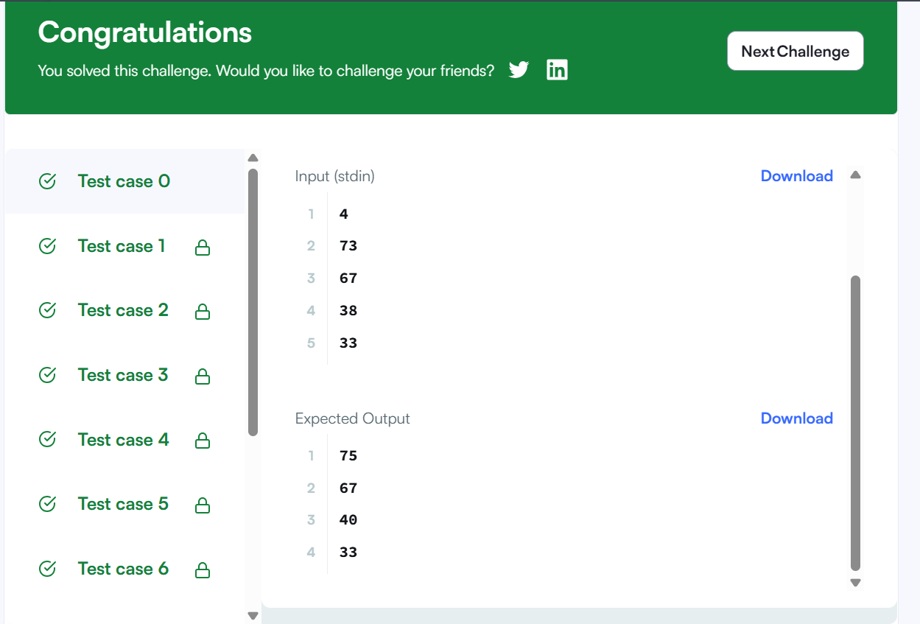
CODE
int* gradingStudents(int grades_count, int* grades, int* result_count) {
*result_count = grades_count;
int* result = (int*)malloc(grades_count * sizeof(int));

for (int i = 0; i < grades_count; i++) {
int grade = grades[i];
if (grade >= 38) {
int remainder = grade % 5;
if (remainder >= 3) {
grade += (5 - remainder);
}
}
result[i] = grade;
}

return result;
}

