MODULE 6 QUES 1
https://www.hackerrank.com/challenges/staircase/problem
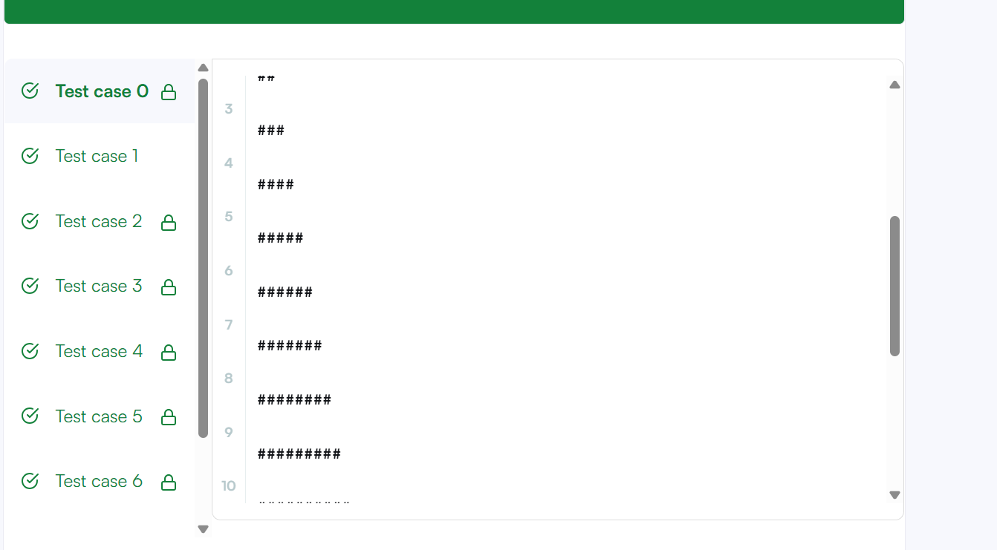
CODE
#include <stdio.h>
#include <stdlib.h>

void staircase(int n) {
for (int i = 1; i <= n; i++) {
// Print the leading spaces
for (int j = 0; j < n - i; j++) {
printf(" ");
}
// Print the '#' symbols
for (int j = 0; j < i; j++) {
printf("#");
}
// Move to the next line
printf("\n");
}
}

int main() {
int n;
// Read the input size provided by HackerRank
if (scanf("%d", &n) == 1) {
staircase(n);
}
return 0;
}

