MODULE 4 QUES 4
https://leetcode.com/problems/count-the-digits-that-divide-a-number/
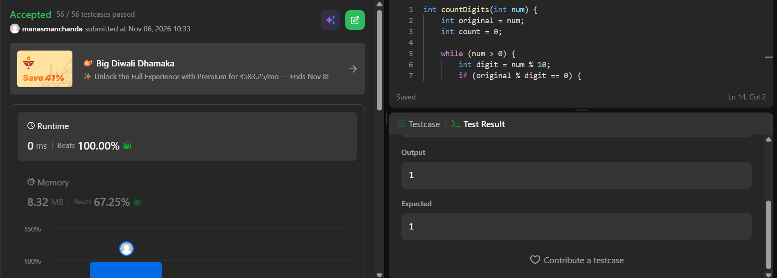
CODE
int countDigits(int num) {
int original = num;
int count = 0;

while (num > 0) {
int digit = num % 10;
if (original % digit == 0) {
count++;
}
num /= 10;
}

return count;
}

