MODULE 4 QUES 3
https://leetcode.com/problems/subtract-the-product-and-sum-of-digits-of-an-integer/
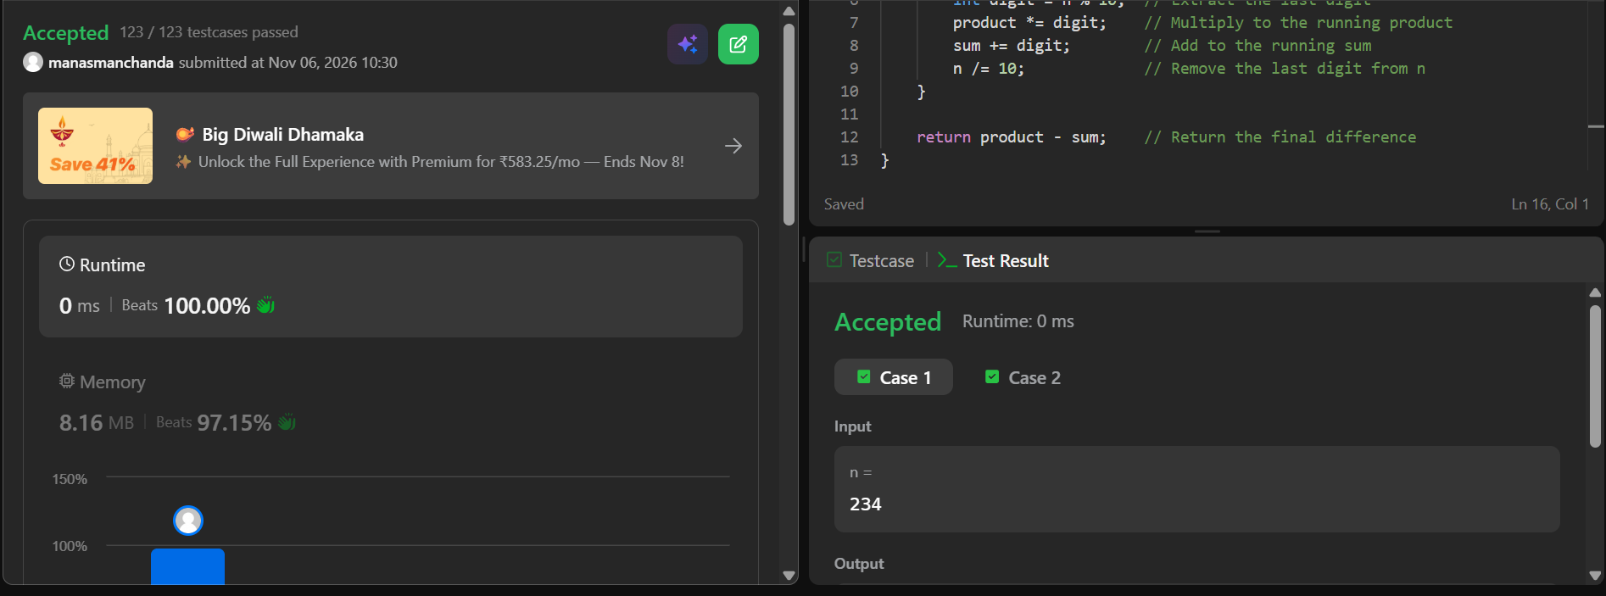
CODE
int subtractProductAndSum(int n){
int product = 1;
int sum = 0;

while (n > 0) {
int digit = n % 10; // Extract the last digit
product *= digit; // Multiply to the running product
sum += digit; // Add to the running sum
n /= 10; // Remove the last digit from n
}

return product - sum; // Return the final difference
}

