MODULE 1 QUES 4
https://leetcode.com/problems/calculate-delayed-arrival-time/
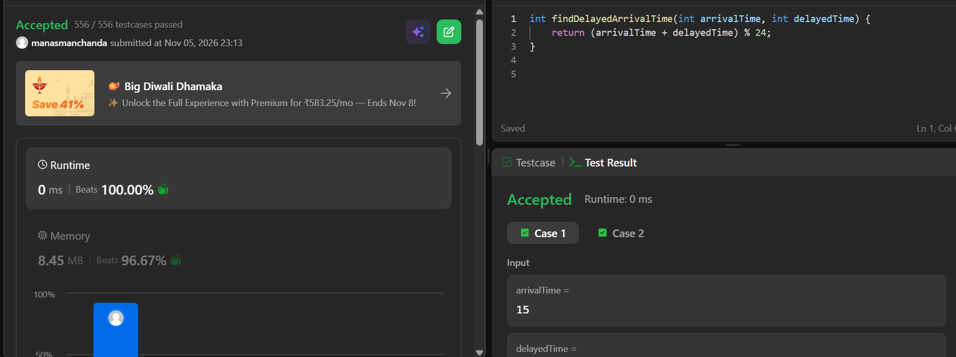
CODE
int findDelayedArrivalTime(int arrivalTime, int delayedTime) {
return (arrivalTime + delayedTime) % 24;
}

