MODULE 4 QUES 5
https://leetcode.com/problems/palindrome-number/
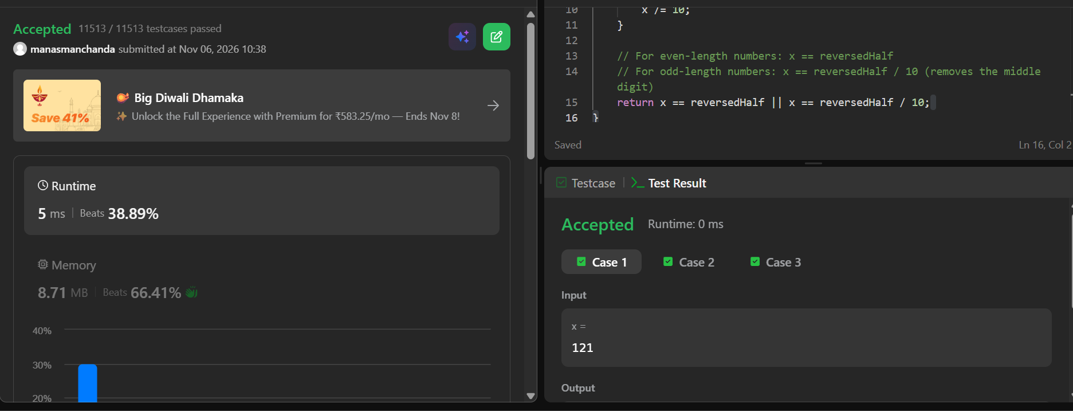
CODE
bool isPalindrome(int x) {
// Negative numbers and numbers ending in 0 (except 0 itself) cannot be palindromes
if (x < 0 || (x % 10 == 0 && x != 0)) {
return false;
}

int reversedHalf = 0;
while (x > reversedHalf) {
reversedHalf = reversedHalf * 10 + x % 10;
x /= 10;
}

// For even-length numbers: x == reversedHalf
// For odd-length numbers: x == reversedHalf / 10 (removes the middle digit)
return x == reversedHalf || x == reversedHalf / 10;
}

