MODULE 5 QUES 6

https://leetcode.com/problems/perfect-number/

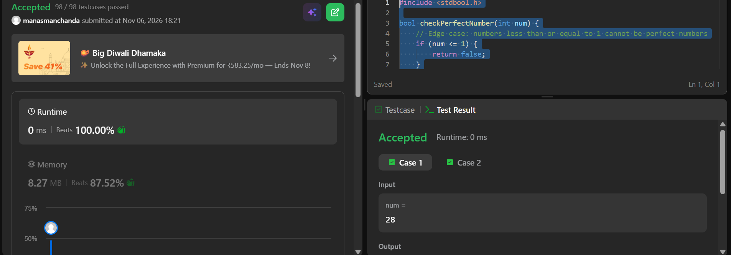
CODE

#include <stdbool.h>

bool checkPerfectNumber(int num) {
// Edge case: numbers less than or equal to 1 cannot be perfect numbers
if (num <= 1) {
return false;
}

int sum = 1; // 1 is a proper divisor for any number > 1

// Loop up to the square root of num to find pairs of divisors efficiently
for (int i = 2; i * i <= num; i++) {
if (num % i == 0) {
sum += i; // Add the divisor i
if (i * i != num) {
sum += num / i; // Add the matching divisor (num / i) if it's distinct
}
}
}

return sum == num;
}

