MODULE 5 QUES 1
https://leetcode.com/problems/power-of-two/https://leetcode.com/problems/power-of-two/
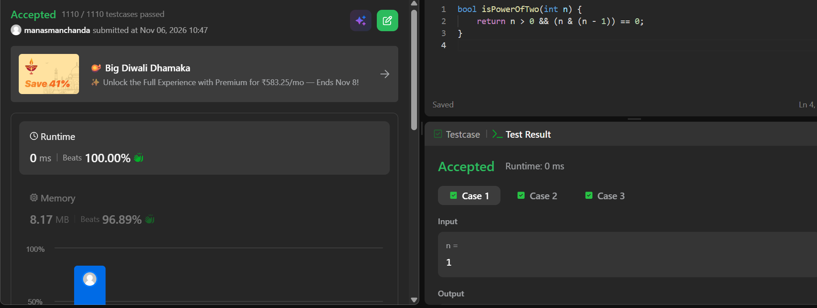
CODE
bool isPowerOfTwo(int n) {
return n > 0 && (n & (n - 1)) == 0;
}

