MODULE 4 QUES 6
https://leetcode.com/problems/reverse-integer/
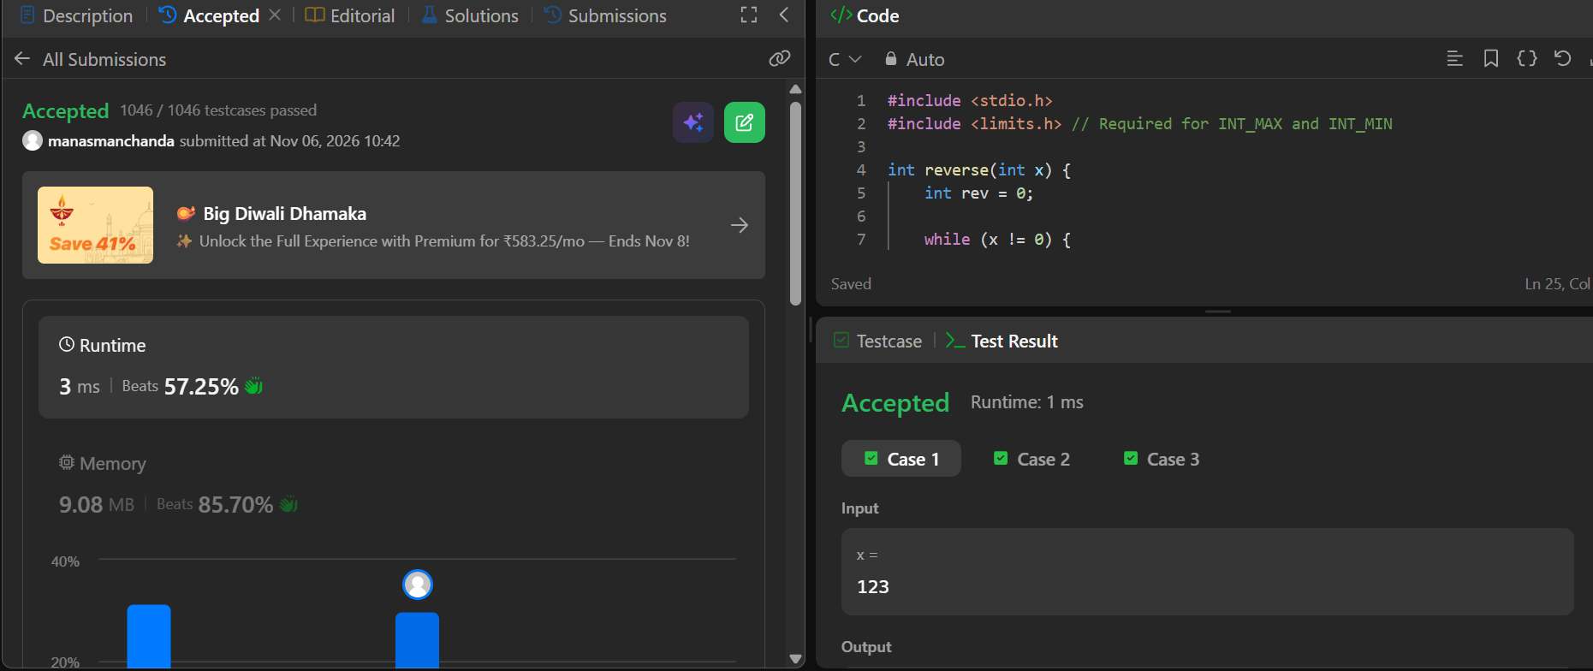
Code
#include <stdio.h>
#include <limits.h> // Required for INT_MAX and INT_MIN

int reverse(int x) {
int rev = 0;

while (x != 0) {
int pop = x % 10;
x /= 10;

// Check for positive overflow before multiplying by 10
if (rev > INT_MAX / 10 || (rev == INT_MAX / 10 && pop > 7)) {
return 0;
}

// Check for negative overflow before multiplying by 10
if (rev < INT_MIN / 10 || (rev == INT_MIN / 10 && pop < -8)) {
return 0;
}

rev = rev * 10 + pop;
} // Closes the while loop

return rev;
}

