MODULE QUES2
https://leetcode.com/problems/smallest-even-multiple/
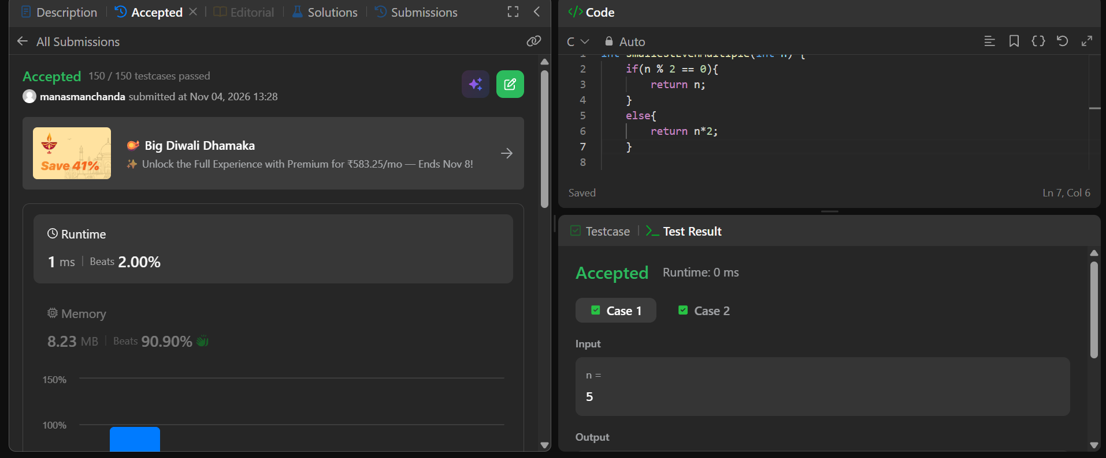
code
int smallestEvenMultiple(int n) {
if(n % 2 == 0){
return n;
}
else{
return n*2;
}

