MODULE 1 QUES 5
https://leetcode.com/problems/total-distance-traveled/
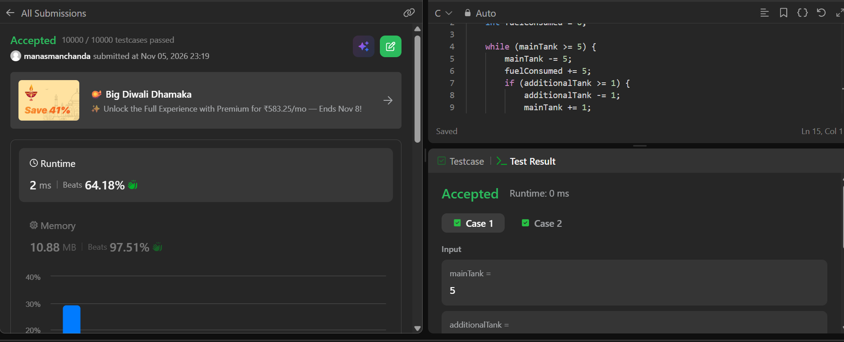
CODE
int distanceTraveled(int mainTank, int additionalTank) {
int fuelConsumed = 0;

while (mainTank >= 5) {
mainTank -= 5;
fuelConsumed += 5;
if (additionalTank >= 1) {
additionalTank -= 1;
mainTank += 1;
}
}
fuelConsumed += mainTank;
return fuelConsumed * 10;
}

