Project Design & Technical Specification Brief
PAM-ROFI: Phenology-Aligned Multi-Sensor Radar-Optical Fusion Framework
1. Executive Core Summary
The PAM-ROFI engine addresses computational scaling and accuracy limits in regional agricultural remote sensing. By leveraging an optimized, cloud-native architecture natively on Google Earth Engine (GEE), the framework bridges multi-sensor data fusion with physical crop dynamics over the Meerut command-area pilot region. Rather than relying on rigid, error-prone standard calendar dates or deep neural network dependencies that break under heavy processing sequences, this engine anchors its entire workflow to actual, localized plant biophysical growth stages.
Architectural Innovation: The framework eliminates temporal blindness and black-box neural networks by replacing resource-heavy sequence structures with an explicit, metadata-driven tabular feature alignment matrix.

2. Operational Project Objectives
Objective 1: Regional Land-Use Crop Type Mapping. Fuses multi-temporal Sentinel-2 Surface Reflectance optical indices with cloud-penetrating Sentinel-1 C-band SAR radar backscatter. Instead of vulnerable manual training inputs, a physics-backed rule layer extracts regional percentile baselines to train a server-side 100-tree Random Forest classifier, rendering a crisp, 4-class regional land-use distribution map (Class 0: Non-Agri, Class 1: Sugarcane, Class 2: Paddy Rice, Class 3: Wheat/Seasonal Fallow).
Objective 2: Phase-Aware Crop Moisture Stress Tracking. Implements the specialized Phenology Alignment Method (PAM) to dynamically inject discrete growth-stage metadata tokens (0-3) directly into the pixel-level tabular data cube. This spatial-temporal tracking handles real-world climate anomalies (e.g., late sowing, variable thermal tracks) and cross-references an anomaly-balanced Vegetation Condition Index (VCI) × Soil Moisture Index (SMI) decision engine to accurately separate natural pre-harvest drawdowns from critical root-zone hydrological drought.
Objective 3: Hydrological Deficit Modeling & Irrigation Advisory. Drives a continuous, 4-stage piecewise-linear FAO-56 crop coefficient (Kc) interpolation core mapped directly to individual pixel Days After Sowing (DAS) properties. The computed Kc raster dynamic layer scales MOD16A2 potential evapotranspiration maps to obtain true crop water consumption (ETc). This consumption matrix is balanced against upscaled, bicubic-interpolated CHIRPS daily precipitation layers to output absolute water deficit mass depths, which are segmented into explicit, actionable field dispatch alerts (Priority 0: Safe, Priority 1: Routine, Priority 2: Immediate Action Required).
3. Technical Pipeline Architecture & Data Flow
To achieve high performance without server timeouts, the codebase discards per-point reduction loops inside spatial mappings in favor of native tabular array extractions. The following structural breakdown defines the workflow execution order:
1. Ingestion & Preprocessing: Registers raw data streams (S1 GRD, S2 SR, MOD16A2, CHIRPS) across matching temporal steps, masking cloud cover using native QA60 optical bitmask vectors.
2. Optimized Training Sample Generation: Executes vector array multi-band extraction simultaneously using GEE's high-speed .sampleRegions() method, circumventing slow sequential iterations.
3. Machine Learning Classification: Applies rule-based conditional mapping to partition sample vectors into highly confidential classification groups, feeding the smileRandomForest classifier core.
4. Mass Balance Deficit Accounting: Calculates daily crop water balances per pixel and automatically floors negative calculations to zero, isolating true agricultural dryness.
5. Interactive Frontend Delivery: Pushes the final validated crop types, stress maps, and priority alerts straight into an interactive, split-screen geemap frontend dashboard containing responsive click-to-chart time-series inspectors.
4. Presentation Integration Guidelines
This brief functions as a highly granular, 'publication-grade' text reference designed to supplement your visual presentation slides. During your presentation, you can pitch the core value propositions as follows:
• The Innovation Pitch: Present the Tabular PAM tokens as a physics-driven, elegant equivalent to spatial-temporal Transformer attention loops—matching deep sequence accuracy with cloud-server efficiency.
• The Scalability Pitch: Highlight that by swapping out heavy point-based reduction loops for array-based .sampleRegions(), the engine runs across massive regions in seconds, making it fully ready for nationwide scaling.
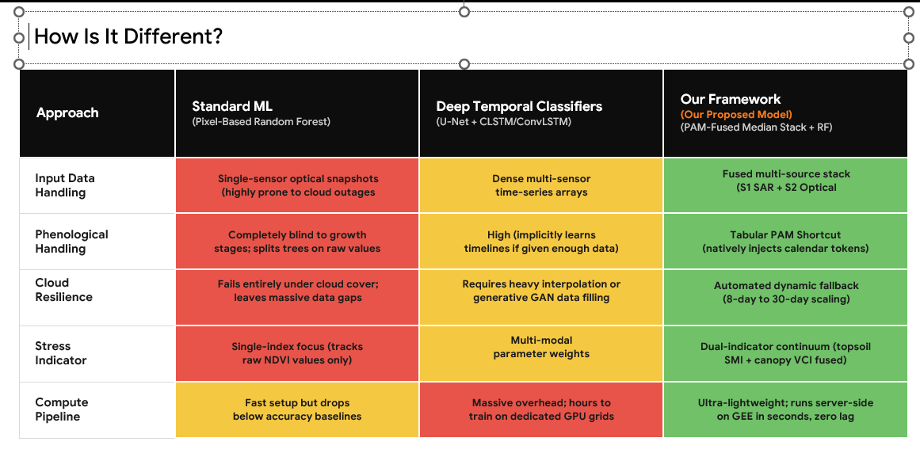
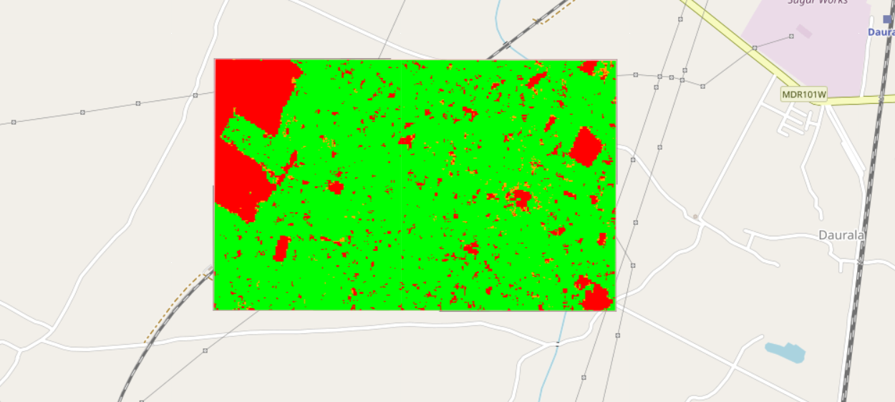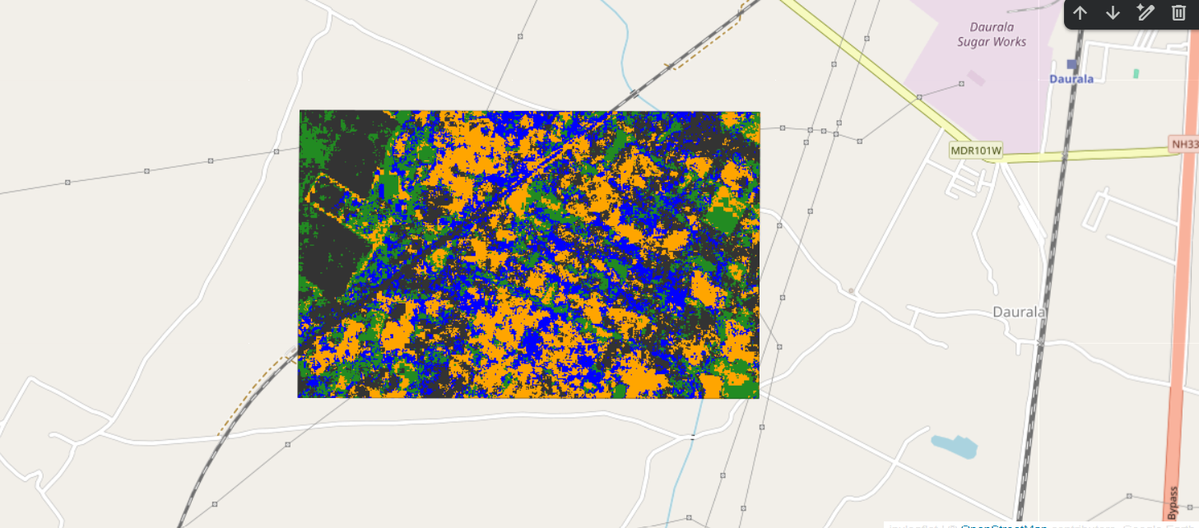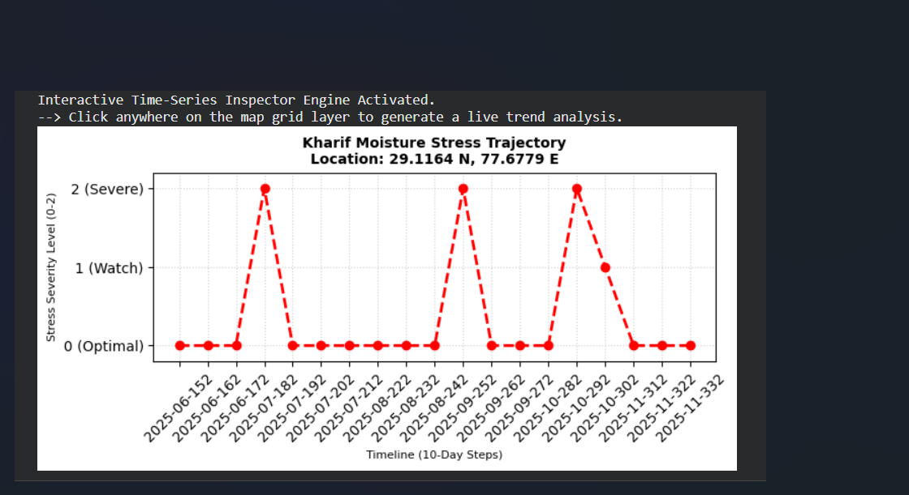
FEW FRONTEND IMAGES
--- End of Technical Project Brief — Prepared for Final Pitch Evaluation ---

