Hack2Skill Ideathon Submission: Personal Gemini Journal
Participant Name: Manas Musthafa A
Contact Email: manasmusthafa@gmail.com
Project ID: ⁠tensile-imprint-507111-j0⁠
Live Endpoint (Cloud Run): https://tensile-imprint-507111-j0.asia-southeast1.run.app

Executive Summary
Personal Gemini Journal is an enterprise-grade, privacy-first workspace designed for intelligent journaling, reflective goal setting, and strategic brainstorming. Developed as part of the Gen AI Academy APAC Edition Ideathon, the application leverages custom security directives in Google AI Studio, a containerized Cloud Run backend, server-side Gemini API execution via Secret Manager, and per-user database isolation in Cloud Firestore.

Security & Architecture Overview
The system architecture prioritizes zero-trust principles and robust multi-tenant data isolation:
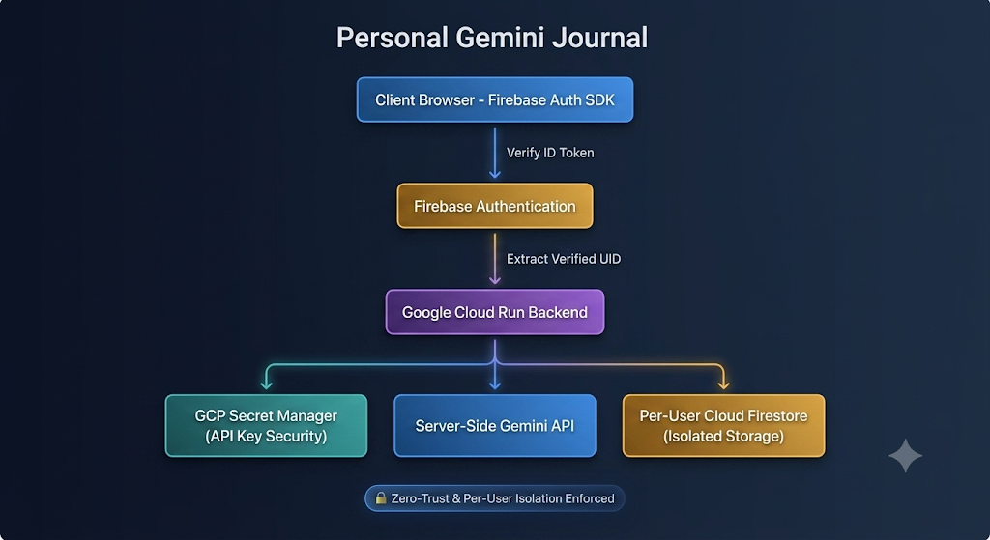

Core Security Pillars:
- Authentication: User identity is verified on every session using Firebase Authentication.
- Authorization: Backend endpoints extract and verify the ⁠UID⁠ directly from the session token rather than trusting front-end client payloads.
- Per-User Isolation: Cloud Firestore paths and rules restrict access so each user can only read and write their own documents
- Secret Management: The Gemini API key is fetched strictly on the server side via
- Google Cloud Secret Manager with least-privilege IAM permissions and is never exposed to the client browser.

Detailed Application Screen Guide

Screen 1: Authentication Gateway
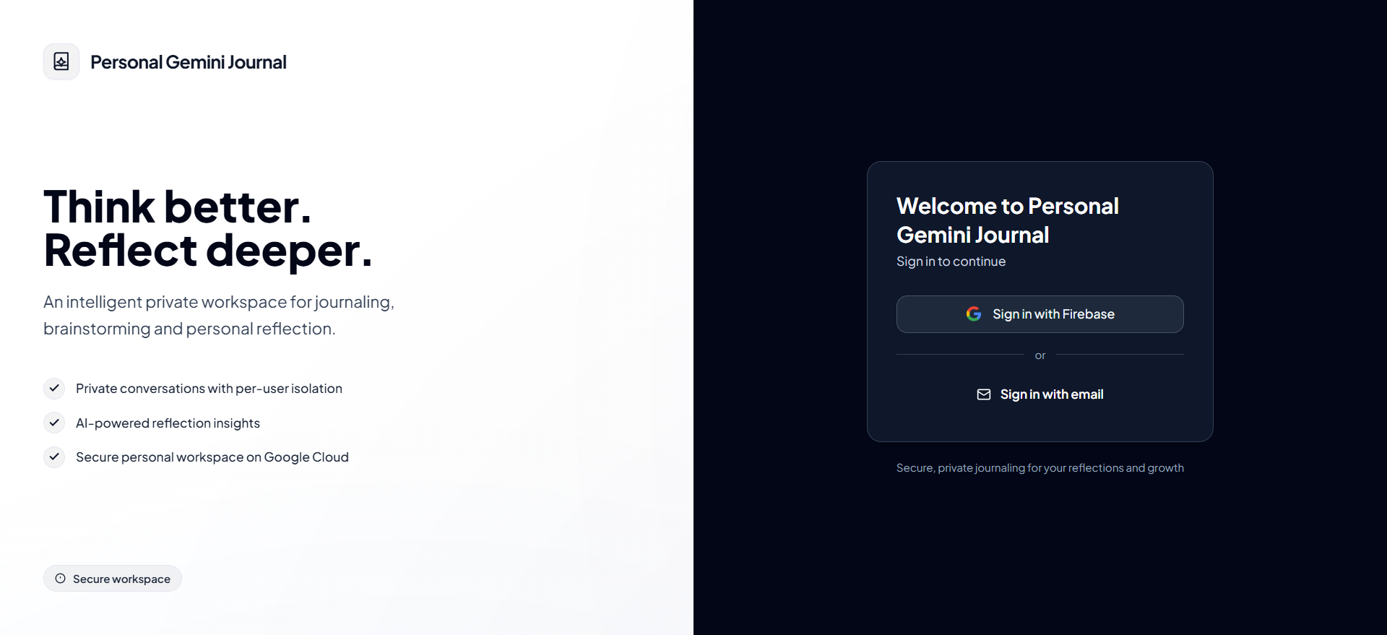
- Overview: Clean, secure landing page offering Single Sign-On (SSO) via Firebase Authentication and email/password sign-in.
- Key Functionality: Establishes the user identity boundary. Access to journal entries, AI generation, and database interactions is completely blocked until authentication succeeds.
- Value Add: Prevents unauthorized API usage and ensures all dynamic requests map directly to a verified user session.

Screen 2: Central Application Dashboard
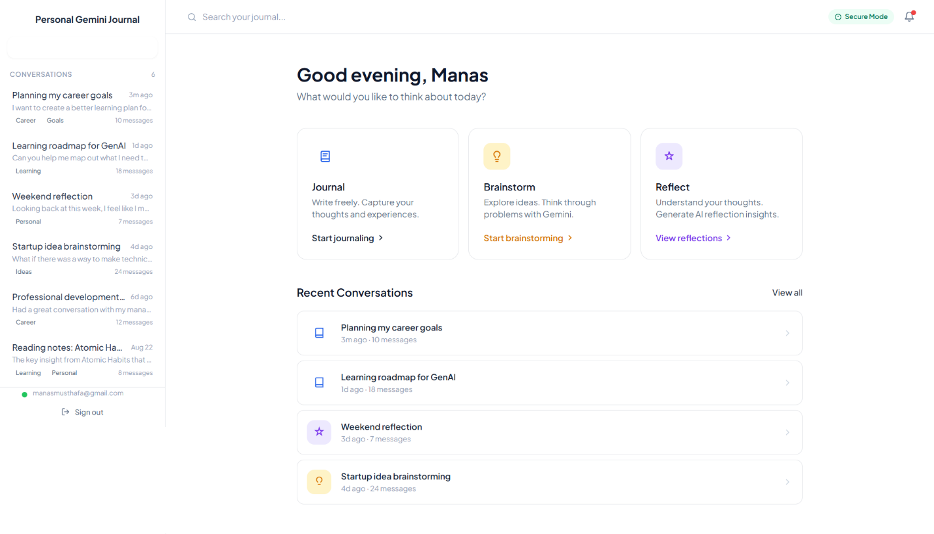
- Overview: The primary command center displaying recent conversations, conversation tagging, thread counts, and fast actions (Journal, Brainstorm, Reflect).
- Key Functionality: Allows users to initiate targeted multi-turn conversations with Gemini or review previous entries categorized by tags such as Career, Goals, Learning, Personal, and Ideas.
- Value Add: Features real-time session loading from Firestore, fetching only the records belonging to the authenticated user's scope.

Screen 3: AI-Generated Reflection Engine
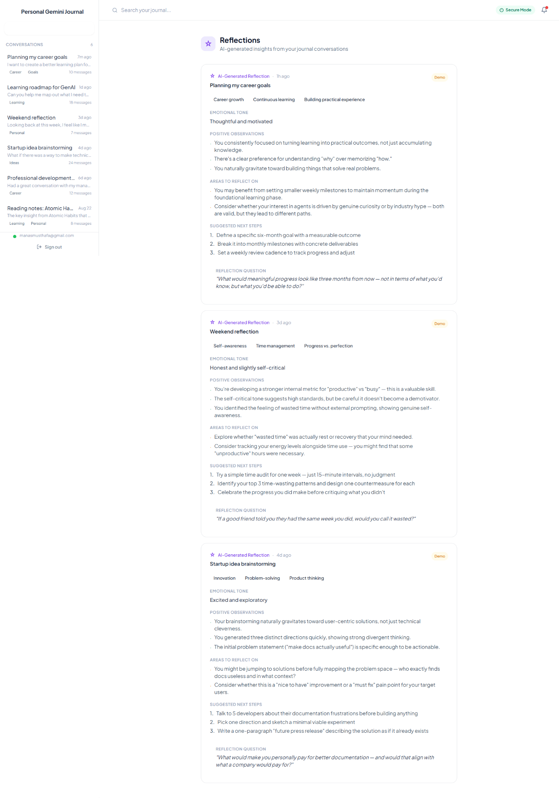
- Overview: A specialized metacognitive interface that processes journal threads into structured reflection outputs.
- Key Functionality: Automatically extracts key components from raw conversation history:
- Emotional Tone: Synthesizes the user's underlying sentiment (e.g., Thoughtful and motivated, Honest and slightly self-critical).
- Positive Observations & Areas to Reflect On: Identifies healthy habits and constructive improvement areas.
- Suggested Next Steps: Generates structured, actionable milestones.
- Reflection Question: Provides a tailored, open-ended question to encourage deeper thinking.
- Value Add: Built with Google AI Studio custom instructions to ensure insightful, empathetic, and production-safe formatting.

Screen 4: Personal Growth Dashboard (Original Enhancement)
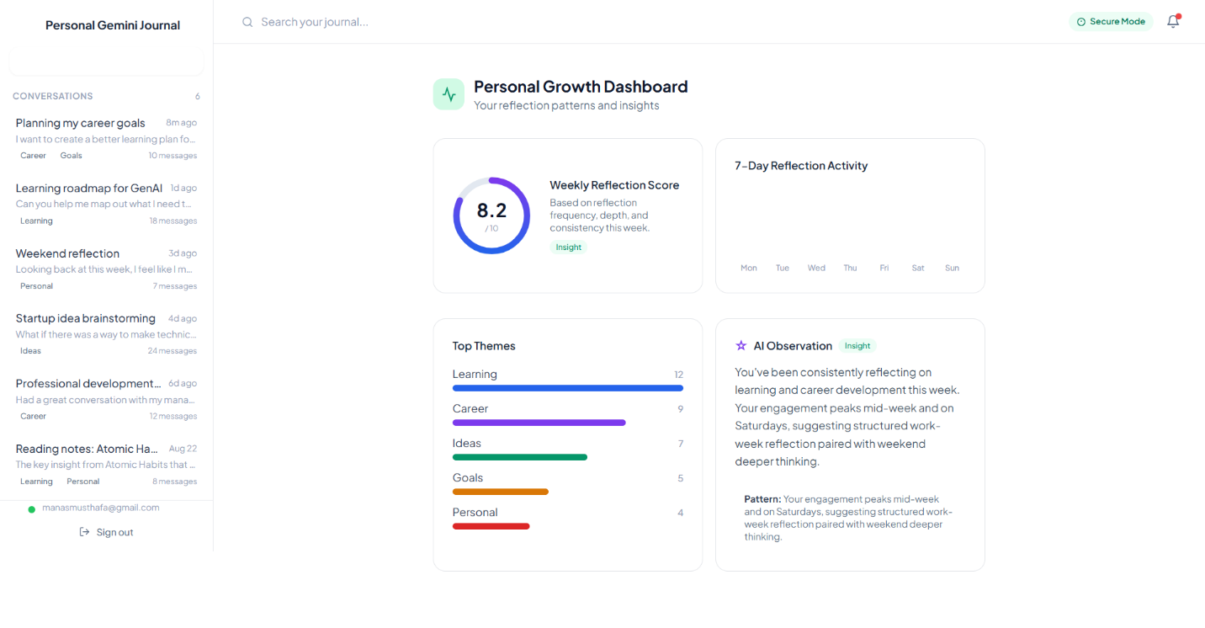
- Overview: An analytical view tracking user reflection patterns and consistency over time.
- Key Functionality: Displays quantitative and qualitative metrics including a Weekly Reflection Score (e.g., 8.2/10), a 7-Day Reflection Activity chart, a distribution of Top Themes (Learning, Career, Ideas, Goals), and synthesized AI Observations regarding thinking habits.
- Value Add: Goes beyond basic chatbot workflows by converting unstructured text logs into actionable productivity and self-growth metrics.

Screen 5: Privacy Center & Data Control

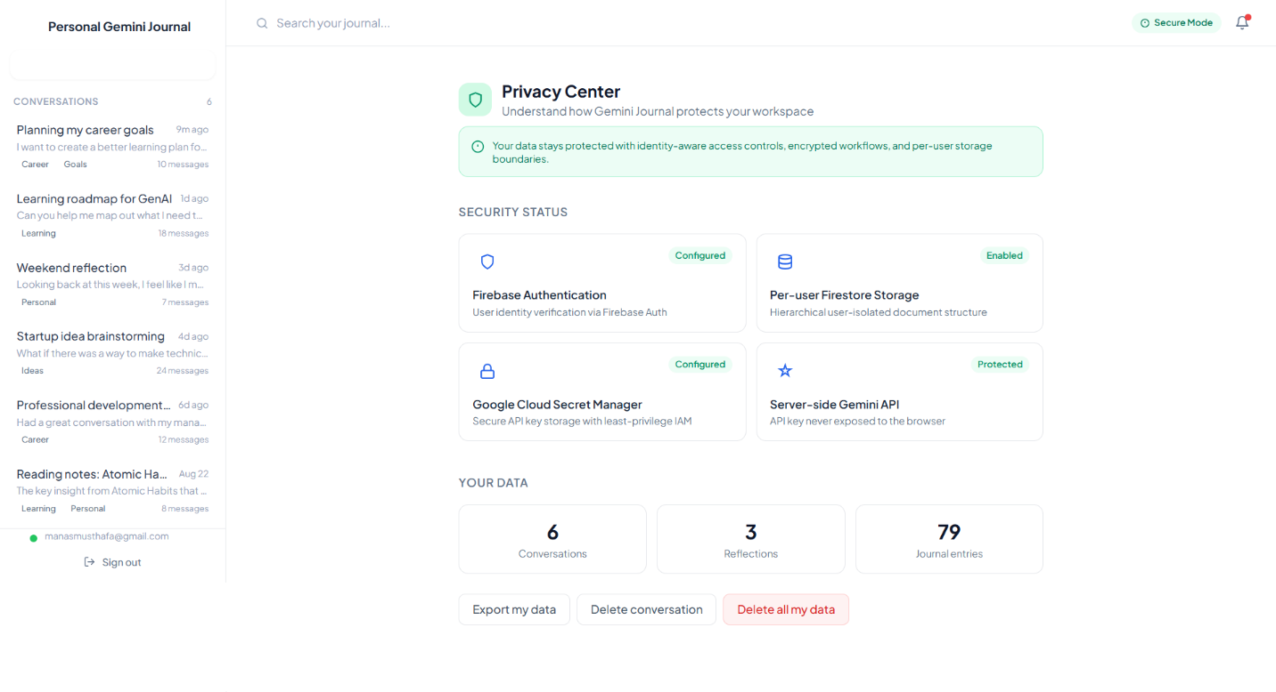
- Overview: A user-facing privacy management page showing live security statuses and data management controls.
- Key Functionality: Displays active safeguards (Firebase Auth, Isolated Firestore, Secret Manager, Server-side API execution) alongside total account usage stats (Conversations, Reflections, Journal Entries).
- Value Add: Empowers users with full data sovereignty through one-click Export My Data, Delete Conversation, and Delete All My Data actions.

Screen 6: System Security Architecture Diagnostic

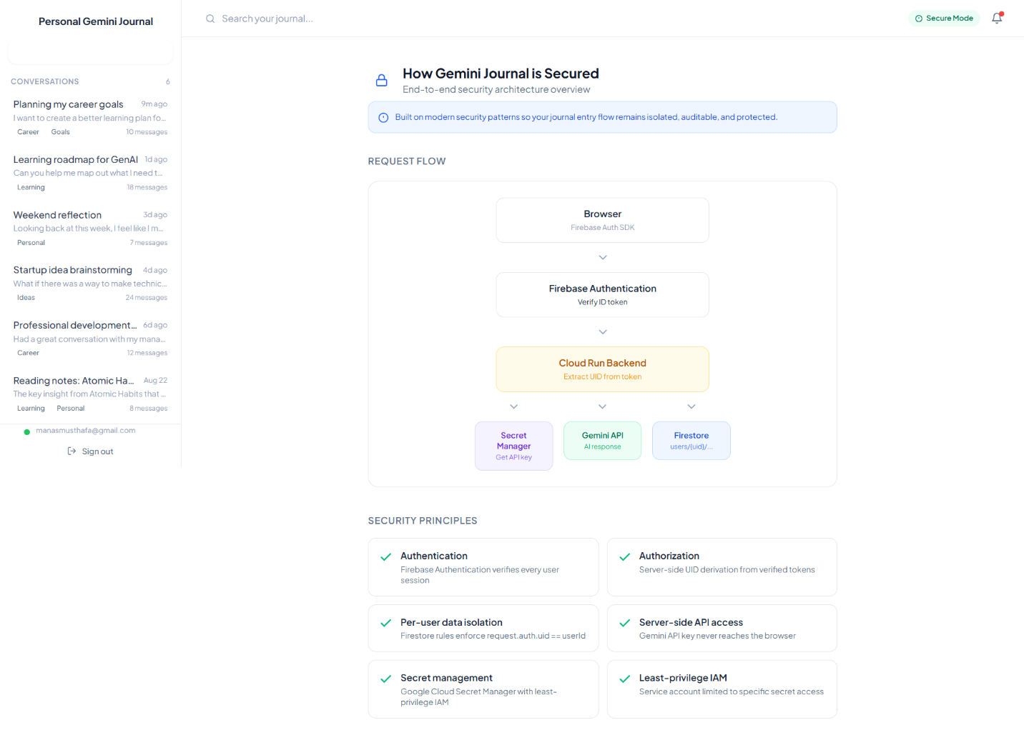

- Overview: An in-app architecture blueprint illustrating request lifecycle enforcement.
- Key Functionality: Details how requests pass through Firebase Auth ID token verification, server-side UID extraction on Cloud Run, Secret Manager retrieval, and isolated database queries.
- Value Add: Demonstrates total adherence to the Ideathon’s security requirements directly within the product.

Screen 7: User Preferences & Customization

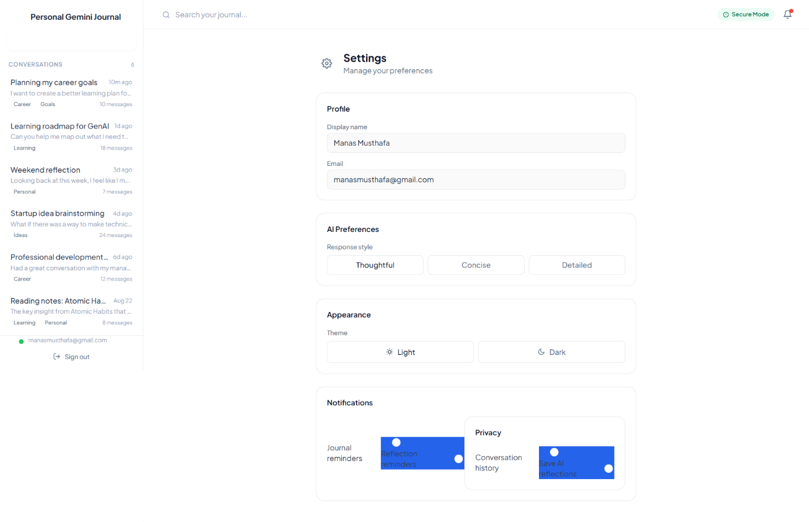
- Overview: User settings panel for managing user profile details, AI interaction styles, and theme settings.
- Key Functionality: Allows users to choose their preferred AI Response Style (Thoughtful, Concise, Detailed), toggle visual themes (Light / Dark), and configure privacy toggles like saving conversation histories or reflections.
- Value Add: Directly adjusts prompt constraints on the backend to customize the Gemini API behavior per user.

Screen 8: Identity & Deployment Verification Modal


- Overview: Modal detailing application metadata and cloud runtime environment status.
- Key Functionality: Confirms the active Google Cloud Project ID (⁠tensile-imprint-507111-j0⁠) and the regional Cloud Run URL endpoint.
- Value Add: Provides evaluation judges with immediate confirmation of live, verified deployment details.
