CSE 563: Software Requirements and Specifications
Project Report
Business Understanding
Fall 2015

Report By:
Manas Sharma
ASU ID: 1207686736
Contents:

- Introduction………………………………………………………………………………3
- Phase -1 Business and data understanding…………………………..4
- Phase -2 Data preparation…………………………………………………….18
- Phase -3 modeling……………………………………………………………………..26
- Phase -4 Evaluation and deployment………………………………….…40
Acknowledgement……………………………………………………………………….…52
References………………………………………………………………………………….…..52

Introduction:

‘In 2012, Google received over 2 million search queries per minute. Fast forward to 2014 and that number has more than doubled. Today, Google receives over 4 million search queries per minute from the 2.4 billion strong global internet population’ [1].
‘Every second, on average, around 6,000 tweets are tweeted on Twitter, which corresponds to over 350,000 tweets sent per minute, 500 million tweets per day and around 200 billion tweets per year.’ [2].
‘90% of world's data has been generated in the last two years’ [3].
A useful application of data science in practice can be that it ‘allows companies to utilize that information to recommend further purchases that might interest the individual’ [4] a technique that has been harnessed by firms like Amazon and Netflix.
These stats point us in a pretty straight forward direction, data is being generated at an exponential rate and this phenomenon in general has the potential to be leveraged in lot of productive areas. Large organizations are utilizing data science to increase productivity, sales and giving better service in general to the consumers. Applications like social closeness models, recommendation engines, co-occurrence grouping all have their roots in the fundamentals of data science.
Data science leverages the power of both mathematics and computation to build probabilistic machine learning models that are capable of making mission critical predictions. The curriculum of the subject provides an amazing opportunity to explore the spectrum of data science and use it in a productive project.

Understanding the business problem

This section is written to answer the textbook question ‘What exactly is the business problem to be solved’?
The intent of my project is to solve an ever trending problem in the automobile safety sphere while latently solving the problems faced by big automotive insurance firms and state DMVs.
The data has been collected from a test conducted by the Ford motor company and publically available over kaggle which aims to predict the alertness of a driver while he is on the road.
‘Driving while distracted, fatigued or drowsy may lead to accidents. Activities that divert the driver's attention from the road ahead, such as engaging in a conversation with other passengers in the car, making or receiving phone calls, sending or receiving text messages, eating while driving or events outside the car may cause driver distraction. Fatigue and drowsiness can result from driving long hours or from lack of sleep’ [5].
The main aim of the project focuses to build a detector/classifier that would detect whether the driver of the vehicle is alert or not. This can have many opportunistic applications like a device that kills the engine if the alertness of the driver waivers preventing fatalities, this can aid insurance agencies in turn who may choose to provide insurance at discounted rates for vehicles which are fitted with such systems. Local DMV offices can also leverage this device to assess the driver during license testing to ensure that only alert and cautious drivers pass the test.
I have a strong feeling that in near future such devices would be available in cars manufactured by big automotive companies as an added security measure in the vehicle. A model built on a preexisting dataset can prove to be beneficial as the AI aid to a device like that, a lot of accidents can be prevented by this mechanism which would save the lives of both the driver and the co-passengers. The insurance agents would be willing to offer insurance at discounted rates to owners of such vehicles because of the reduced risk of accidents moreover local DMVs would could also take in the reading of the device as an additional parameter to judge the net score of the driver while he/she undertakes a test.
In a nutshell, the automotive safety industry and insurance agencies can largely benefit from a device like this trained under the hood of a supervised learning algorithm.

Data science solution and its efficacy

This section is written to answer the textbook question ‘is the data science solution formulated appropriately to solve this business problem’?
The data science solution I propose for this problem statement is a supervised learning algorithm that would intuitively predict a binary target variable, in our case the variable being the alertness factor of a driver which can take only two values 0 or 1. The independent variables in the dataset directly influence the target variable therefore a classifier can be run upon the dataset to predict the target variable. The independent variables quantify to three categories namely vehicular data, environmental data and personal data which can all influence the target variable, I intend to scrutinize the dataset with the summary function available in R applied upon it to figure the rate of change in the values of the feature set to figure which items change values and influence the target variable.
Techniques that I would employ for classification are decision trees, support vector machines and random forest (depends upon time constraints), all these models would be tested independent of each other and the one giving highest precision and better performance would be used for construction of the model. I have left a window to do a proof of concept on all the aforementioned techniques.
In a nutshell to answer the textbook question, I can say that the data science solution is formulated appropriately to solve this particular problem in particular a supervised learning algorithm using classification techniques.
Business entity the example corresponds to

This section is written to answer the textbook question ‘what business entity does an instance/example correspond to’?
The business entity this project targets is the automotive industry, in particular the safety division of the automotive industry. The training data set for this project has been taken from the Ford motor company’s kaggle competition over where they have mentioned the stringent focus on safety which they try to adhere to. From United States government’s prospective the automotive industry is categorized under the ‘corporate sector with companies traded publically or otherwise (private)’ [6]. The dataset corresponds to a publically traded corporation (NYSE: F).
The problem statement can further be extended to adhere to the needs of the big insurance firms providing automotive insurance coverage like Geiko and State Farm (both classified under the insurance sector), however I would like to mention that the primary aim is the construction of a device that can override a car’s engine kill switch if the driver is not alert which would be built on based upon the model similar to the one being undertaken in this project, the second industry targeted was opportunistically determined.

Attributes of the supervised learning approach

This module is written to answer the textbook question ‘Is the problem supervised or unsupervised’
This is indeed a supervised learning problem with a target variable to be determined from a set of independent or information variables which directly or coherently influence the target variable.

Is a Target Variable Defined?

The target variable in this problem statement is well defined, the attribute ‘IsAlert’ of the data-set is the target variable in this problem statement which can take binary values, where 0 denotes that the driver is not alert while he is driving the automobile and a value of 1 denotes that the driver is alert while he is driving the automobile.

Snapshot of the testing dataset with the target variable attribute highlighted in red:
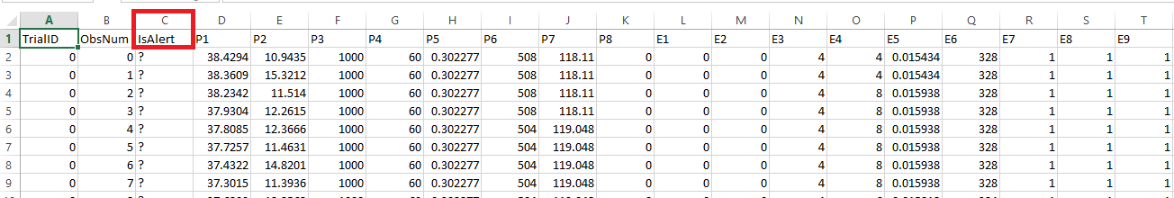

If so, is it defined precisely?

The target variable is vivid and defined precisely in the problem set. It is self-explanatory about the alertness state of the driver who is driving the car. With the target variable alone an intuition can be made about a possible anomaly in the personal state or environmental state or vehicular state under consideration of the subject.

Think about the values it can take

Summary snapshot of the training dataset taken from R studio:
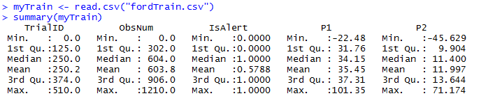

The target variable can take binary values which is evident from the sample method call on the training data set.

ARE THE ATTRIBUTES DEFINED PRECISELY

The attributes of the data are well defined, the dataset providers have precisely illustrated the presence and use of each of the attributes present in the dataset, I was further able to take a subset of the data for better analysis, the detailed information about the attributes is explained as below:
Trial ID - each period of around 2 minutes of sequential data has a unique trial ID [7], for predicting the target variable this would not be treated as an information variable.
The second column is the observation number - this is a sequentially increasing number within one trial ID [7], this variable again would not be treated as an information variable.
The third column is the target variable itself which can take up binary variables where a 0 indicates that the driver is not alert while he is driving the automobile while a value of 1 indicates that he is alert.
The next 8 columns with headers P1, P2 , …….., P8 represent physiological data [7], this set includes information variables, the values which they can take would be illustrated in the following section.
Next 11 columns with headers E1, E2, …….., E11 represent environmental data [7], this set would again influence the target variable and therefore is a set of information variables.
Next 11 columns with headers V1, V2, …….., V11 represent vehicular data [7], this set also has an effect on the target variable and therefore constitute a set of information variables.

VALUES THE ATTRIBUTES IN THE DATASET CAN TAKE

Following is a summary of the training dataset, taken by the use of the summary method invoked in R studio.
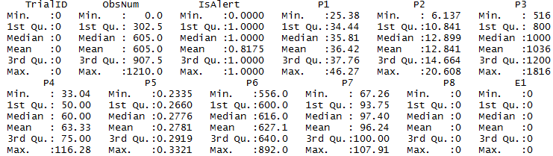
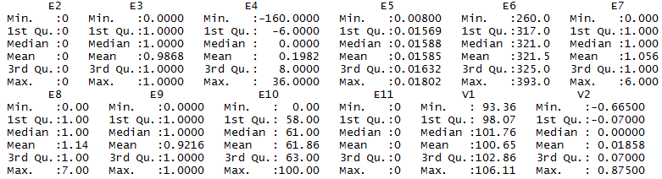
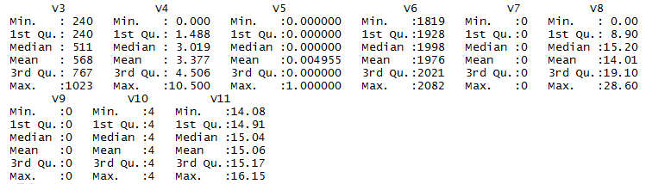

Analyzing the report of the summary function fired upon a subset of data helped me in analyzing the values the attributes can take, the findings are listed below:

TrailID – Holds an integer value and is reserved for a trial ID that spans across 2 minutes.
ObsNum – Can take integer values and is unique per row for a set of TrialID.
IsAlert – Target variable which takes up binary values
P1, P2, P4, P5, P7 – Can take up real numbers as values.
P3, P6 - Can take up integer values.
P8 – Remained constant for the entire length of the experiment taking up a value of 0, therefore this would not be used as an information variable while construction of the model is under way.
E1, E2 – Are constants and did not change for the entire length of a trial under scrutiny, they both took up a value of 0.
E3 – Took up binary values, this may prove to be of valuable importance when the model construction is under way.
E4 and E5 – Take up real numbers as values.
E6 – Can have integer values
E7 – Holds integer values in the range 1 through 6
E8 – Holds integer values in the range 1 through 7
E9 – Takes up binary values
E10 – Takes up integer values in the range 1 through 100
E11 – Takes up a constant value of 0 and therefore will not be used in the model construction.
V1 and V2 – Take up real numbers as values.
V3 – Takes up integer values.
V4 – Takes up real number values.
V5 – Holds binary values
V6 – Can take up integer values
V7 – Is a constant holding a value of 0 at all times, would not be used in model construction.
V8 – Can take up real numbers as values.
V9 and V10 – These are constants and therefore would not be used in model construction.
V11 – Can take up real values.

will modeling this target variable improve the stated
business problem? An important subproblem? If the latter, is the rest of the business
problem addressed?

Modeling the target variable would go a great deal in making driver and passenger safety much better. If a device gets built in the future that uses this model to override the kill switch of an automobile’s engine if a driver is not alert or brings down the vehicle’s speed a lot of catastrophes can be prevented. This would encourage insurance firms to give discounted rates to owners of such automobiles because of the reduced liability upon them in turn promoting people to buy automobiles with these systems installed. This can be proprietary module in ford cars as they have come with an approach to record passenger, vehicular and environmental data to build such a model which can predict the alertness of a driver.
The subproblem has been found opportunistically which deals with a different business entity, insurance firms can benefit drastically from such a device if installed as this would help them in identifying potential customers and offer them discounted rates for insurance because of the reduced liability. I would consider this as a subproblem because vehicular safety and the insurance rates levied upon them go pretty much hand in hand. Furthermore this model can be extended to be used by local DMV offices in assessing a driver while he/she takes a driving test to see if their alertness waivers.
This model inherently solves the aforementioned business problems and the subproblems.

Note*: Since this is a problem which follows a supervised learning approach the answer to the textbook question ‘If unsupervised, is there an “exploratory data analysis” path well defined? (That is,where is the analysis going?)’ was not provided.

USE CASE DIAGRAMS

Scenario: This use case demonstrates the process by which the datascience model acts upon the input dataset and predicts the target variable.

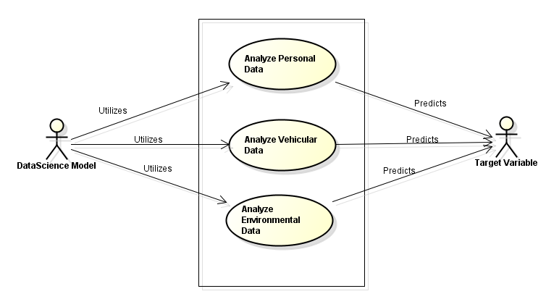

Use Case Specifications:
Use Case <<01>>: <<Working of the model>>
Objective: Demonstrates the functioning of the model on a given dataset and target variable prediction.
Primary Actor: The Data Science model
Dependencies: The data science model utilizes the vehicular, personal and environmental data to predict the target variable therefore in a way the model is dependent upon the dataset to predict the target variable.
Trigger: Test dataset is input into the model.
Secondary Actors: Target variable.
Preconditions: Target variable is not populated.
Post Condition(s): The model populates the target variable.

MAIN SUCCESS SCENARIO
- The model analyzes the vehicular data
- The model analyzes the personal data of the driver
- The model analyzes the environment data
- The model works by building a supervised machine learning classifier (would be tested by both a decision tree and a support vector machine)
- The model predicts the target variable based upon the value computed by the classification algorithm.

VARIATIONS
Variation ID: <<UC01VAR01>>
- The data science model is not able to gain enough information from the feature set to compute the target variable.
- Preconditions: The feature set for a particular trial id is incomplete or has vague value set.
Postconditions: The target variable remains undefined.

FAILURE VARIATIONS
Variation ID: <<UC01VAR01F>>
- There is a margin of error in the model being constructed which gives rise to failure variations.
- Precondition: The model computes the target variable incorrectly.
Postcondition: An action item is performed incorrectly (example engine is killed even though the driver is alert).

BUSINESS RULES
- It must be ensured that the feature set is well populated.
- The device that calibrates the environmental, personal and vehicular data is free from error.

Scenario: This use case denotes a case wherein the system built using the data science model computes the alertness factor to a 0 and overrides the kill switch of the vehicle’s engine to shut the vehicle down:

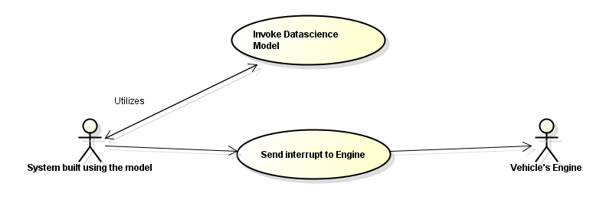
Use Case Specification:
Use Case <<02>>: <<Interaction of the model based System with the vehicle’s engine>>
Objective: To ensure that the vehicle’s engine is killed if the driver is not alert.
Primary Actor: System built using the data Science model.
Dependencies: The System utilizes the data science model to process the conditional interrupt generation clause and therefore is dependent upon the model.
Trigger: The target variable is computed to 0 from the data science model (negative value).
Secondary Actors: The engine of the vehicle
Preconditions: The driver is driving the car and is not alert.
Post Condition(s): The system overrides the engine’s kill switch and shuts off the engine.

MAIN SUCCESS SCENARIO
- The safety system that is built using the data science model iteratively calls the model
- The model returns a value for 0 for the alertness factor of the driver.
- The System responds to the negative case by sending an interrupt to the vehicle’s engine.
- The engine gets turned off preventing a catastrophe and an alertness message is issues to the driver.

VARIATIONS
Variation ID: <<UC02VAR01>>
- The Data Science model continues to give a positive feedback for the driver’s alertness.
- No interrupts are sent to the vehicle’s engine
- Preconditions: The Data Science model sends across a value for 1 for the alertness factor of the driver.
Postconditions: The vehicle continues in running mode.

FAILURE VARIATIONS
Variation ID: <<UC02VAR01F>>
- There is a margin of error in the model being constructed which gives rise to failure variations.
- The Data Science model may fail to capture the alertness factor for certain test cases
- Precondition: The model computes the target variable incorrectly.
Postcondition: An action item is performed incorrectly (example engine is killed even though the driver is alert).

BUSINESS RULES
- The system installed on the vehicle that uses the Data Science model is fully functional and error free.
- The device that calibrates the environmental, personal and vehicular data is free from error.
- The integration between the system and the onboard computer that hosts the model is well established and tested.

Scenario: This use case shows how the insurance agent would assess if a vehicle has the security system installed and offers a discount on the insurance price to the customer.

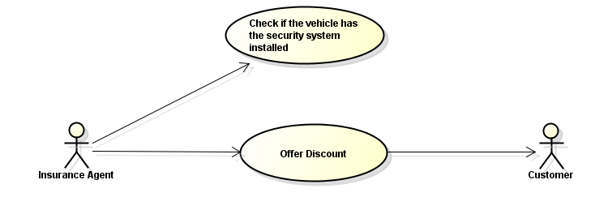

Use Case <<03>>: <<Scenario wherein an insurance agents offers discount on insurance rates to owners of vehicle’s who have the security system installed>>
Objective: Depicts the scenario wherein an insurance agent decides to offer a discount on the insurance for owners who have the aforementioned security system installed in their vehicels
Primary Actor: Insurance Brokers.
Dependencies: The use case is directly dependent upon the presence of a working security system in the customer’s car.
Trigger: If the security system is detected the agent may choose to offer a discount.
Secondary Actors: Customer who receives the discount.
Preconditions: The customer approaches the insurance agent for a discount.
Post Condition(s): The agent gives a discount if the security system is detected.

MAIN SUCCESS SCENARIO
- The insurance agent detects the presence of a security system built using our Data Science model in a customer’s car.
- If an installation is detected the owner of the vehicle receives a discount on the insurance rate.

VARIATIONS
There are no probable variations in this use case scenario is it is undertaken by an actor who takes a decision by physically assessing an entity.

FAILURE VARIATIONS
None, for the reasons mentioned in the Variations section.

BUSINESS RULES
- The insurance agent physically assesses the documents of a car for the presence of installation of the security system.
- A discounted rate is applied accordingly if an installation is detected.

Project Report: Phase 2
Data preparation

Will it be practical to get values for attributes and create feature vectors, and put them into a single table?

The training data that I am using has been taken from a Kaggle competition hosted by the Ford motor company, this dataset has the information attributes and target variable populated in a single file (I import into a single table) for the data set. This is indeed desired to start with the data analysis phase because the information attributes directly influence the target variable, therefore yes it is practical in this scenario to obtain values for attributes and create feature vectors (the feature vector in my case would be for the state of the vehicle during observation).

Dataset Description (Contained in a single table):

Column 1 – Trial ID
Column 2 – Observation Number
Column 3 – Target Variable (IsAlert)
Column 4 to 12 – P1 through P8 (Physiological Data)
Column 13 to 24 – E1 through E11 (Environmental Data)
Column 25 to 36 – V1 through V11 (Vehicular Data)

Furthermore, I intend to study the data and variance in the trend of feature element to discard those values that are giving negligible or zero information gain and also the correlated variables. From the first hand notion I noticed the following trends in the dataset:

- P7 and P6 have an inverse correlation
- P4 and P3 have an inverse correlation
- P8, E1, E2, E11, V7, V9, V10 were studied to remain constant for a particular observation.

Snapshots:

- Summary of data set:
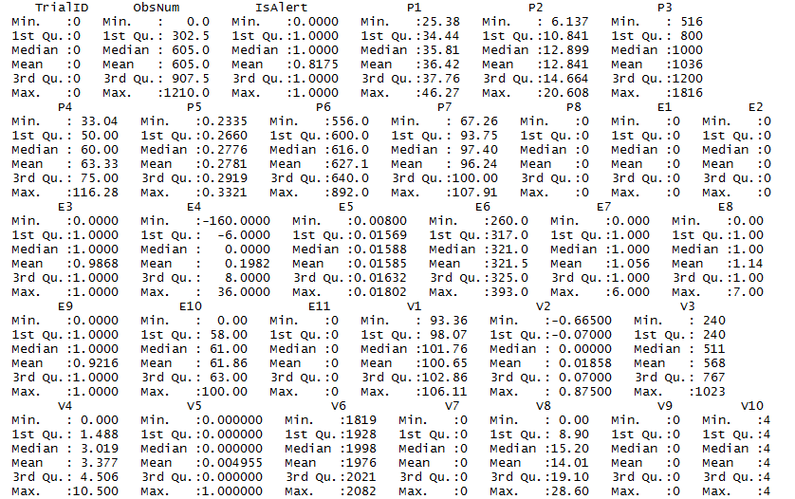

- Initial observations:

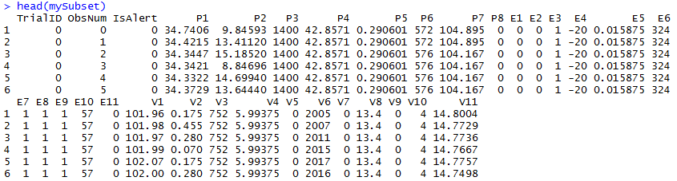

These attributes can eventually be removed from the data set and a new data frame can be constructed for model construction.

If not, is an alternative data format defined clearly and precisely? Is this taken into account in the later stages of the project? (Many of the later methods/techniques
assume the dataset is in feature vector format.)

An alternate approach would not be applicable for my scenario as I am using a singular table with the values of information attributes provided by the Ford motor company itself. The data has been meticulously noted via an electronic device calibrated for extreme precision (courtesy Ford).

If the modeling will be supervised, is the target variable well defined? Is it clear how to get values for the target variable (for training and testing) and put them into the table?

The data science model that would be used to predict the target variable would be based on a supervised machine learning algorithm as based upon information attributes a target variable has to be predicted, the target variable is well defined and it can take binary values which would denote a positive or a negative case (1 denoting a positive case wherein the driver of the vehicle is alert and 0 denoting a negative case wherein the driver is not alert). The target variable has been labelled as ‘IsAlert’ in the dataset provided by Ford.

The training set has already been provided by Ford motor company which has the target variable populated, the testing set can be derived by taking a subset of the observations in the training data set itself with the target variable values left unassigned for the model to predict, however Ford has also provided an explicit testing dataset, I intend to use both Ford’s data and a subset of the training dataset to better analyze the precision and performance of my supervised learning model.

Values for the information variable set that would be used to predict the target variable come from a test conducted by the Ford motor company that had a device installed in the vehicles of the test subjects that records vehicular, psychological and environmental data during the course of usage of the vehicle. The values obtained were subsequently labelled and these set of information attributes influence the target variable.

How exactly will the values for the target variable be acquired? Are there any costs
involved? If so, are the costs taken into account in the proposal?

The values for the target variable in the data set are provided by the Ford motor company itself through a competition hosted on Kaggle therefore the initial cost to obtain the values for target variable in the training data set is negligible, however I estimate that understanding the trend in which the information attributes influence the target variable would take a significant amount of time (5 man days). The training data set makes it evident that the target variable can only take up binary values. As the values for the target variable in the training set were obtained directly via the Kaggle competition the cost for acquiring has not been included in the proposal.

Histogram of mean alertness per trial taken from the test data-set (Shows that the distribution is mostly non homogeneous, driver is either alert(1) or not alert(0) [8]:
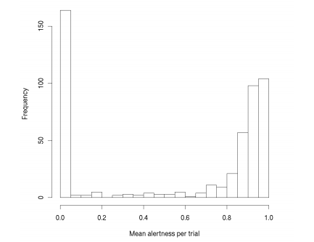

Are the data being drawn from the similar population to which the model will be
applied? If there are discrepancies, are the selection biases noted clearly? Is there a
plan for how to compensate for them?

The information attributes recorded in the training data set are taken from a homogeneous population, this is noted by the similar trends recorded in the changes their values show.

Samples (taken from the summary of top 5 and bottom 5 feature sets):

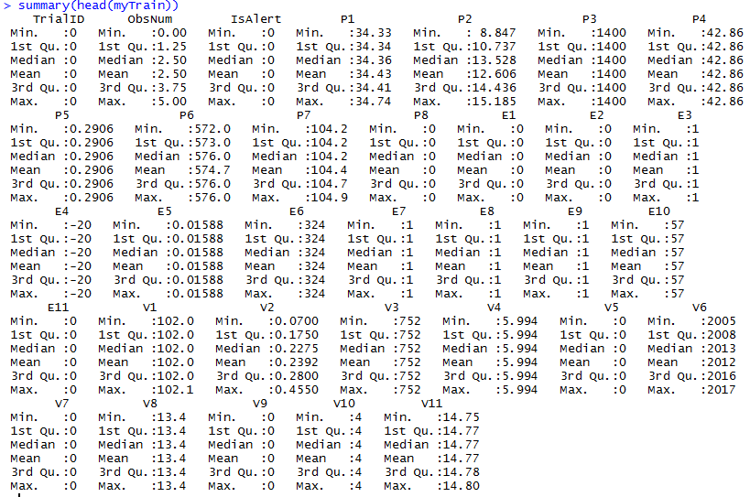

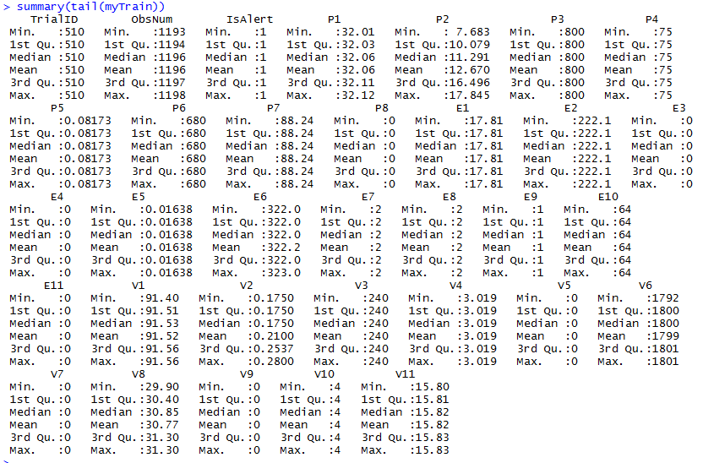

It is noteworthy that even though the observations seen are from totally different TrialIds (information attribute) the constants observed and the set of correlated features remain the same in the two scenarios, this trend was observed by large in the entire training dataset. I would however like to mention the fact that discrepancies in the real world application of the model could certainly arise because these observations were made in a controlled environment, in a real world scenarios natural and mechanical phenomenon could influence the information attributes. Possible instances to support this clause are that minor variances in the vehicular attributes could denote that the person driving the car is either drowsy (not alert) or cruising on a freeway (alert), another instance can be that major fluctuations in the vehicular information attributes could denote that the person is nervous (not alert) or driving against a rough terrain (possibly alert). The model should take care of these nuances and make powerful prediction.

To compensate these practical discrepancies by performing logistic regression of the target variable as a linear function of the entire feature set and based on the results select strong feature from each of the three categories that influence the target variable as they seldom interfere with each other, this would free the model of the mentioned intricacies and produce powerful predictions.

Project Report: Phase 3
Modeling

Auxiliary: feature selection

I would like to spend some time talking about the feature selection methodology employed by me. As rightly told in class the key to success of any machine learning model is good feature selection, it can distinguish between a model that takes lesser time to execute and produces accurate results as opposed to a one which runs for much longer lengths of time and produces unsatisfactory results. I used the fscaret library in R for feature selection running against an ensemble of two models to predict the importance of feature and their trends. An example of one such scripts used by me is as follows

> splitIndex <- createDataPartition(myTestFrame$IsAlert, p = .25, list=FALSE, times=1)
myFinalTrain <- myTrainFrame[-splitIndex]
> myFinalTest <- myTrainFrame[splitIndex]
functionsToApply <- c("rpart", "glm")
myFS<-fscaret(myFinalTrain, myFinalTest, myTimeLimit = 40, preprocessData=TRUE, Used.funcRegPred = functionsToApply, with.labels=TRUE,supress.output=FALSE, no.cores=4)

Here,

myFS – Is the data frame the result of the script gets returned into.
myFinalTrain, myFinalTest – Are the training and testing data frames respectively (taking a subset of training data for feature selection for quicker results).
myTimeLimit –A parameter that specifies the cutoff running time for the script
preprocessData – Flag to initiate preprocessing stage.
Used.funcRegPred – Takes in an ensemble of models as parameters and runs analysis against them (here myMethods is a vector of strings passed to it which has the aforementioned values from the script, for the respective models.
Number of cores are specified for parallelism (4 logical cores in this case).

Result of rpart’s analysis:

myFS$VarImp

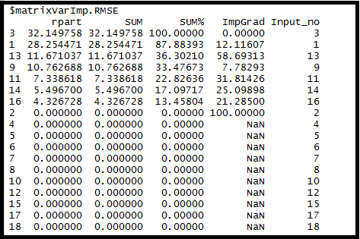

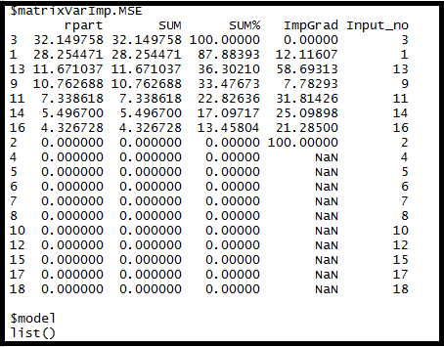

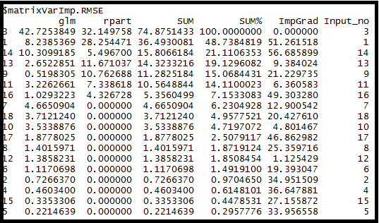

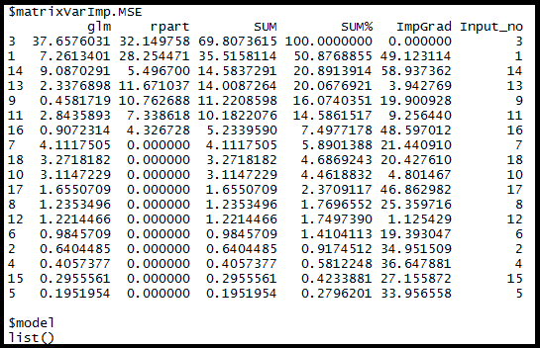

Furthermore diagnostics of the logical regression showed particularly strong features like V11 and E9, their plots against the IsAlert index is as follows (using the available ggplot package).

This was a necessary step because of the large number of features in the training data set that I used, selecting features that gave maximum information gain insured that correlated features were not used during training of the models this resulted in faster training times and efficient output of prediction on the testing data set.

Plot of V11 v/s alertness index
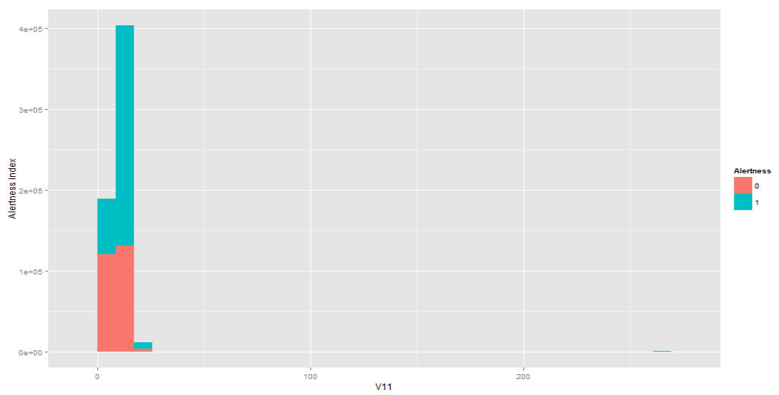

Plot of e9 vs alertness index
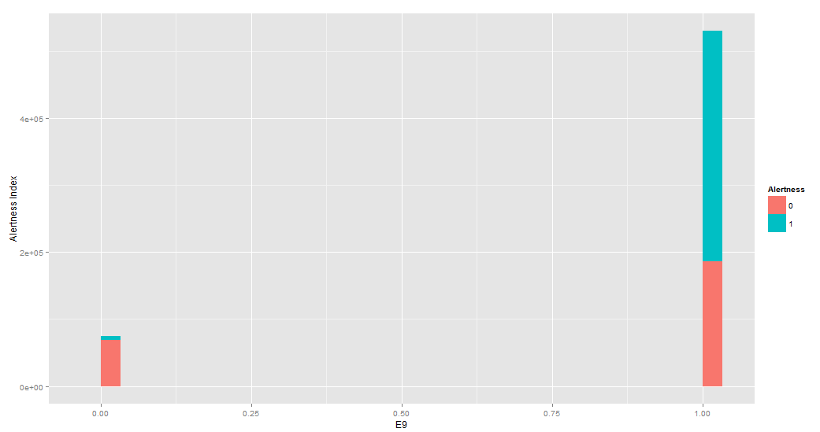
Plot of sd e5 vs alertness index
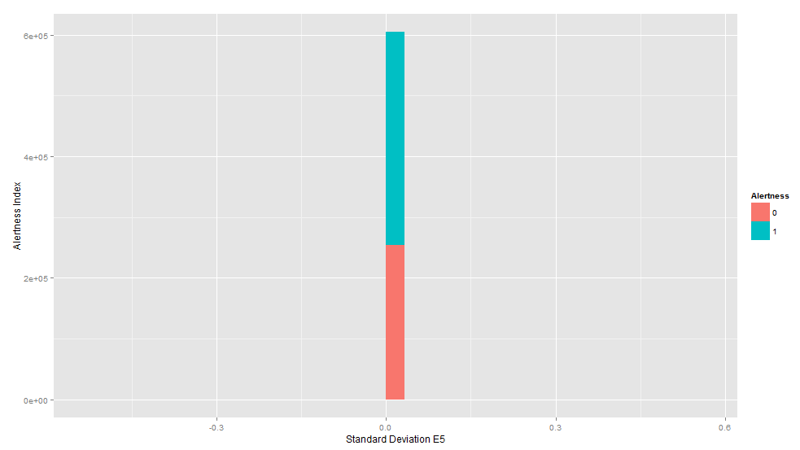
Note – Impurity in the group is observed
SD – Standard Deviation

Is the choice of the model appropriate for the target variable

Model selected for the project – Random Forest (Ensemble)

Since the training data I obtained from the Ford motor company for analysis was labelled and the features in the training set were many (32 excluding the target variable) I figured that the best learning model for prediction in my case would be the Random Forest model. There were significant advantages of this model that I observed and inferred. The biggest advantage being significantly accurate results over the other models that I tested and faster training and running times. Since the target variable in my case can only take up binary values I employed a ‘forest of classification trees’ to predict the target variable.

Following results were obtained with a model built on 100 trees and 50% of the data set (on all features):

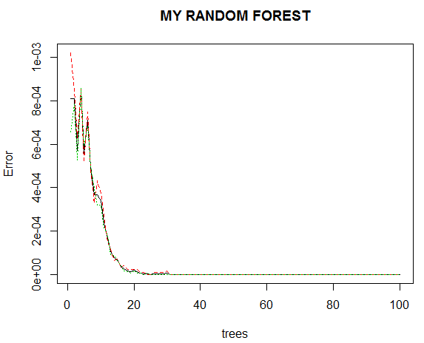

It is noteworthy that the mean error stables out at the 40 tree bench mark. Precision metrics of this model are as follows:

randomForest(x = myTrainSet, y = myTrainSet$IsAlert, ntree = 100, importance = TRUE, do.trace = TRUE, method = "class", forest = TRUE)
Type of random forest: classification
Number of trees: 100
No. of variables tried at each split: 5

OOB estimate of error rate: 12%

Note* The target variable was casted as a factor prior to running the random forest algorithm because it can take only binary values. This improves the precision percentage.

Feature importance as observed from the random Forest model (50% data set):
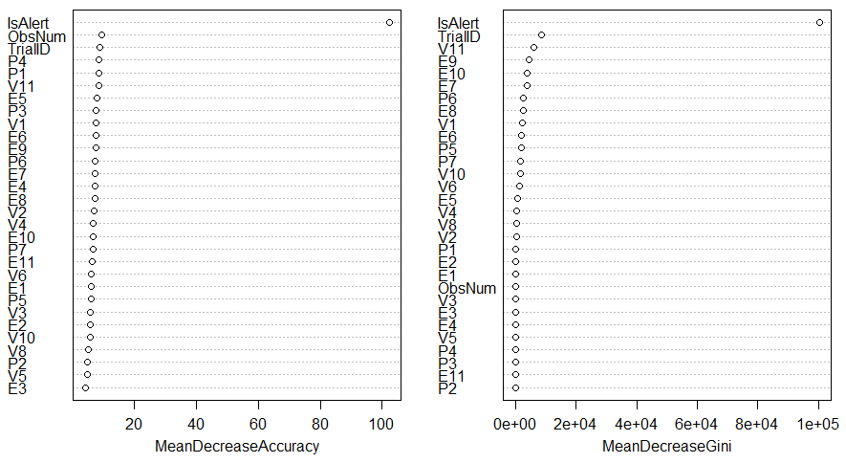

Post this I tried generating a random forest model on the features selected during the analysis of the fscaret log (V11, E5, E9)

Being an ensemble model the prediction via random forest model are generally impressive primarily because it holistically evaluates the results produced by the conjunction of all decision trees, reducing the overall mean error.
Does the model/modeling technique meet the other requirements of the task?

The results observed post execution of the ensemble random forest model were impressive and its ability to ‘fit’ the data was very strong. First hand impression of the data showed that many of the training cases were similar therefore the random forest performed well even on being trained upon 50% of the training data.

- Generalization performance

When run on an unseen dataset having 2000 rows a precision value of 81% was obtained with the model which was by far the highest among all the models I executed. This is made possible because of the fact the model is an ensemble, performance is significantly boosted when the forest is grown beyond 40 nodes.

- Comprehensibility

The model is easy to comprehend, it can be viewed with an analogy that each tree performs a prediction and the end result is collated holistically with the value towards which the majority of the decisions are skewed. Just like a musical ensemble wherein a wrong note played by a musician dies out amidst everyone playing the right note in an ensemble model like random forest the result is generally better because of the mushroom effect of several trees.

- Speed of Learning

The model was trained in under 5 minutes on a training data set having 302164 rows and 33 features. The total nodes grown in the forest were 100. I however felt that the nodes can be reduced to 40 as the error curve stabilizes beyond that point. This would ensure even faster training times.

- Amount of Data Required
Because many of the training cases were similar the model performed better with a fraction of data set as well. I could evaluate the results with only 20% of the overall training data which showed good results (mean square error was under 10%), however I evaluated the results with training the model with 50% of the data as well.

- Is the choice of modeling technique compatible with prior knowledge of problem

During the Data Analysis phase a few strong features were analyzed, however a model built only upon these features generally produced poor results. It was therefore taken into consideration that an ensemble random forest model would perform better than linear models and noteworthy enough this observation was made in the modelling phase as well. It was clear in the data preparation phase that the target variable can only take up binary values therefore classification algorithms will be apt for this scenario, the results were however enhanced by an ensemble random forest model.

Should various models be tried and compared (In evaluation)

Trying various models was not only essential to compare and contrast their precision and performance metrics to come up with the best model but also necessary as this was the first time I got exposed to machine learning fundamentals. I started off model performance metric via classification tree and Multiple logistic regression with the latter completely outplaying the first in terms of precision and performance indexes. Classification trees usually tend to overfit and hence perform poorly on generic data. Overall the best precision was obtained using an ensemble model with the random forest algorithm. This model as the name suggest grows out multiple classification trees and the end result of a target variable is measured with the output generated by the majority of the trees. The mean squared error for the random forest model was under 1%.
Trying various model was essential in the sense that it allowed me to gauge the feasibility of a model in the parameters of both speed of development/deployment and precision percentage.

I would however try to assess a few more models in the evaluation phase, particularly using SVM and measure its performance over the current model that I have used (due to time constraints training the SVM model was not completed). This would ensure that the current model in use is optimal and additionally strengthen my basics in machine learning.

Following are my inferences post evaluating the different models in my project

Initial attempt with a classification tree:

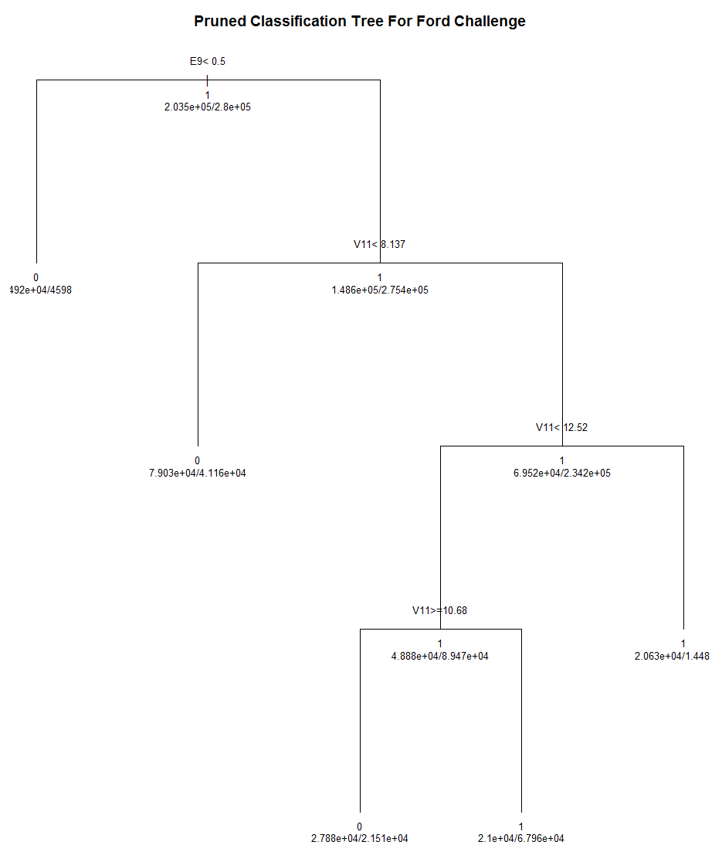
I tried predicting the target variable with three machine learning models. The findings were interesting and the amount of knowledge I gained while executing this phase of the project was also a lot. I give my findings and the description of the models I executed as follows, I also state the reasons why I selected one of the models after carrying out the initial proof of concept:

1) Model 1: Classification Tree using the rpart library:

Classification trees are a popular means of solving supervised machine learning problems, they were covered thoroughly in class with the R Kyphosis example so this was my first choice in starting with the model evaluation. It was well established in the class that decision trees usually tend to overfit, they perform well on the training set and perform badly when they are applied on generic data. The classification tree I used for the project gave an accuracy of about 41% when trained on 80% of the given data and tested upon the remainder 20%. It was certainly easy to implement and I used the top strong features returned during the feature selection phase via the fscaret library to train this model, although the sheer error rate makes it an unsuitable candidate to be used as the de facto model for my project.
Notable observations (disadvantages)

- Instability – The reliability of the information that a decision tree produces depends largely on feeding the precise information during the training phase. Even a small variance in the input data may lead to inconsistent results and may need reconstructing the model
- Complexity – Running a decision tree model can be a time consuming task when the branches grow out. This was observed even though my tree branched out to only four levels.
- Overfits – Decision trees perform well on the training dataset but poorly on unseen data. Thus they did not quite satisfy the criterion of generalized performance needed by a data science model.

2) Multiple Generalized linear model (GLM):

While modeling with GLM the dependent variable was set to the target variable and the explanatory variables (independent variables) were the remainder of the features in the training set). Probabilities of the inclination of the target variable to a value was noted, if the probability recorded was greater than 0.5 then it was rounded off to a positive scenario (value 1) and otherwise was rounded off to a negative case (value 0)
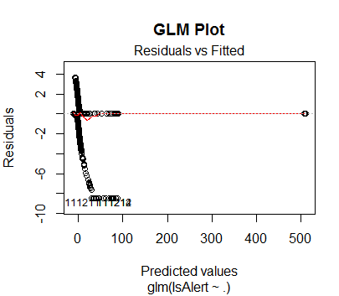

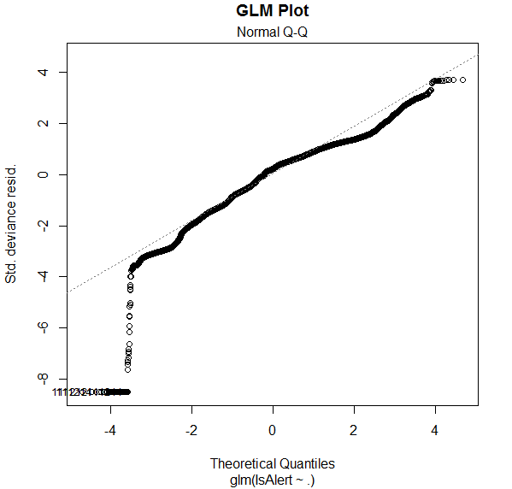
Although the model was easy to train and gave an accuracy of around 74%, I choose not to go forward with this model as it is a linear regression model and hence assigns probabilities to the occurrence of each event. There is an additional overhead of interpreting and normalizing the acquired data.

Original Data:
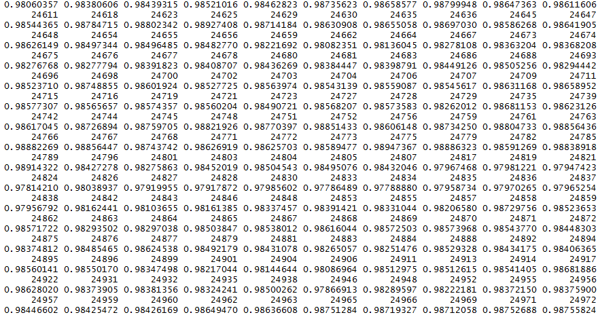

GLM Normalized Output:
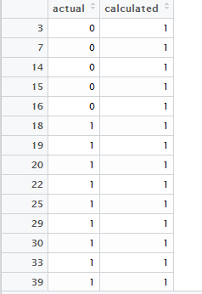

For clustering, is there a similarity metric defined? Does it make sense for the business
problem?

Clustering techniques were not used for model construction in my project. Since the target variable was a factor of only 2 values and this represents a supervised learning problem I preferred not to use clustering models. Classification models would prove to be better in this scenario. Not using classification therefore gets justified in this scenario, primarily because this is a supervised learning problem.

Project report: Phase 4
Evaluation and Deployment

Is there a plan for domain knowledge validation

The supervised learning models used in my project rely heavily on rich features extracted from the datasets. These have been selected based on first hand analysis and the ranking metric produced by the fscaret package that computes the information gain index per feature. Since the feature set is abstractly labelled and gives out few details about the scenario under scrutiny it is a mandate to cross-validate the model and its construction from somebody in the industry. For the purpose of my project I validated my model against the top finishers of the Ford Kaggle competition:
https://www.kaggle.com/c/stayalert/forums/t/328/methods-tips-from-non-top-3-participants

I could relate to the findings of the top finishers in the competition with my inferences and features who noted similar observations some of whom are expert data scientist and domain knowledge experts. Although the trends noticed by several other competitors does run in parallel to the model’s success in a real world situation pertaining to the domain I intend to submit my model to the Kaggle archive and request feedback from Ford engineers themselves.

-Will domain experts or stakeholders want to vet the model before deployment?
If so, will the model be in a form they can understand?

Certainly the stakeholders would vet the model and carry out multiple beta tests to ensure its real time success because this is expected to serve as a mission critical system which would change the road safety strategies used by current safety systems, it is essential for the system to perform optimally under all circumstances.

I have tried to construct the model in a way that most of the data processing steps are quite self explanatory. I intend to focus more on the feature selection strategies because the original data set had around 33 features many of which were correlated and during model construction I was able to bottle down to 3-4 rich features which affect the values taken by the target variable to a major extent, these have been shown graphically in the report with histograms on the basis of the way they divide data into pure and impute groups and also the way popular models rank them individually. The confusion matrix produced by the classification model would be quite a section of interest for the stakeholders because this inherently explains the precision index of the model and its accuracy over unseen data. I intend to showcase the result of the model’s action on unseen data as a confusion matrix to the stakeholders and document my model to a large extent to ensure that its working and action are relayed to a large audience.

Error rate stabilizes if trees in the random forest reach the threshold value 40
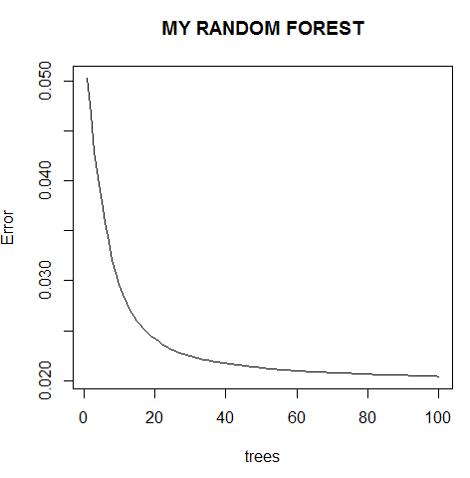

ROC computation:

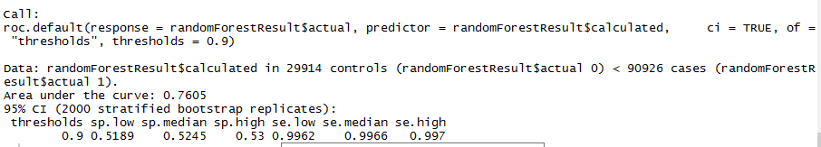

Is the evaluation setup and metric appropriate for the business task? Recall the
original formulation

I have relied on the RMSE and confusion matrix factor to showcase the accuracy and cost for deployment of my models.

—Are business costs and benefits taken into account?
The model would certainly benefit the automobile safety and insurance firms as was mentioned during the business understanding phase. The insurance agents can target the customers who have the system that uses this machine learning safety model as potentially low risk candidates and offer a discounted price on the regular insurance to these customers, this would serve as an auxiliary added benefit. The prime objective of the system that would use this model is to ensure driver safety which majorly benefits the customers. I hope that in the due course of time if such a system enters the market the government can almost certainly provide tax rebate to such vehicles because these are less prone to cause road accidents and fatalities.

Costs – False positive + False Negatives:

Random Forest – 14,533 (cost), 87% (Accuracy)
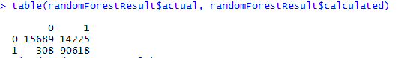

GLM – 16,096 (cost), 86% (Accuracy)
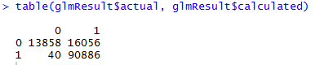

Classification Tree – 27,130 (cost), 77% (Accuracy)
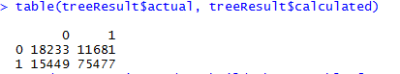

The above snapshot illustrates that the selected random forest model has the best accuracy with the least cost.

—For classification, how is a classification threshold chosen?
The model based on classification was initially trained on all the features to see the accuracy it returned, the AUC achieved by this was fairly low. I later used the fscaret library to rank the features in the dataset. Post this operation the model was trained on the top 3 rich features, this yielded an AUC of 71%. Further training sets on varied features showed no significant improvement in the accuracy ration, therefore the threshold was set to this value.

—Are probability estimates used directly?
From the models that I submitted one is based upon pure classification (classification tree) which is directly computing the value of the target variable. However one of the models that I submitted is based upon a linear model (glm) in whose scenario I have casted the value of the target variable to whole numbers on the basis of probability. For instance if the value of the target variable is predicted to be 1 above 50% (0.5 probability) then I have casted it to 1 else kept it as 0. The output of the ensemble random forest has also been rounded off to find get a whole number.

—Is ranking more appropriate (e.g., for a fixed budget)?

According to me each prediction has the same weightage because each scenario would be unique on per individual basis. Once the model is installed on a vehicle it would predict the alertness of a driver in every plausible situation. Therefore ranking does not quite seem appropriate to me for this particular problem. For every vehicle the model would predict unbiased target variable at all times.
Due to the fact that my dataset contains a large amount of features I have given weightage to features which give more information gain and influence the target variable directly. From the set of correlated features I have tried to take only one of each pair. I ran the fscaret function to rank the features in order of the information gain they provided and took only the top 5 non correlated features. This ensured that the models were trained faster and gave better results on a per trial basis. For the classification tree training with the top 3 strongest features gave an AUC of around 71% and on the entire dataset the AUC was around 56%.

—For regression, how will you evaluate the quality of numeric predictions? Why
is this the right way in the context of the problem?

For the linear regression model that I tried (GLM) I casted the probabilistic results to whole numbers if the probability of the driver being alert is calculated to be more than 50%. The casted results were then checked against the original datasets value for precision. I feel this is the right technique as the target variable in my case could take up binary values and therefore there is a 50% probability of either scenario. The data in general was well distributed with cases of drivers being both alert and not alert and therefore the round off threshold of 50% was used (from a total of 6,00,000 observations around 2,50,000 were 0s and the remainder were 1s therefore the data was in general uniformly distributed).
In the case of random forest prediction the results were merely rounded off as well because the results were heterogeneous.

Does the evaluation use holdout data?

The model (random forest) was trained by using 50% of the given dataset and tested against the remainder of the dataset. The createDataPartition() method was used for splitting the dataset into training and testing data. This method has the property of selecting a chunk of random data. The testing dataset created in this manner serves as the holdout data for cross validation. However on request Ford also provided an additional test set with solution to test the model for precision, I was able to run the model against this and following are the precision parameters noted (In this scenario I trained the random forest model with only 20% of the training data because a trend was noted in the dataset which showed a lot of similar cases under observation). For the other models I resorted to using the dataset provided by Ford itself and trained them on the entire training dataset and then tested against the exclusive testing dataset, the exclusive data for testing and its solution set provided served for cross validation.

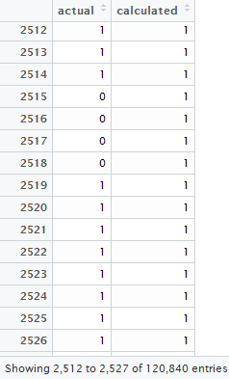
Test conducted on the holdout data for cross validation

Against what baselines will the results be compared?

The models would be matched for precision against the RMS (root mean square) error values produced by them individually over the exclusive dataset and its solution provided by Ford. Apart from this I intend to use the confusion matrix generated by the ensemble random forest model as another baseline as well when tested against the exclusive test set. I have selected the ensemble Random Forest model because it has the highest precision among all the models analyzed and is easy to train. In general out of the models I trained I selected the one which performed the best on the exclusive dataset provided by Ford for testing (cross-validation data set).

Classification Tree Confusion Matrix:

Classification Tree RMSE:
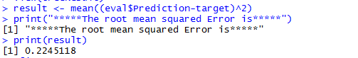

Accuracy – 77%

GLM Error %age and confusion matrix:
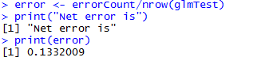

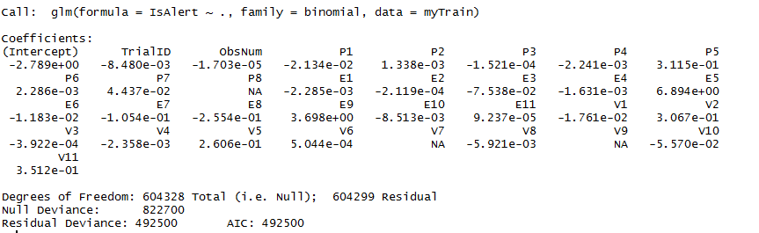
Accuracy – 86%

Random forest confusion matrix:

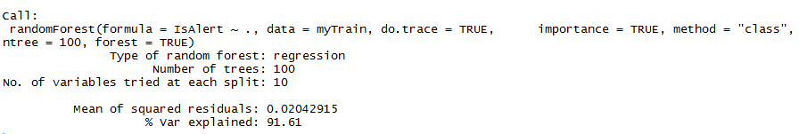

Approximate computed accuracy from confusion Matrix – 87%
(Note from confusion matrix – Accuracy = (TP+TN)/P+N)

—Why do these make sense in the context of the actual problem to be solved?

Since the model would be used in mission critical systems it is essential for it to be accurate in most situations. Since the root mean square error is used frequently to measure the differences between values (sample and population values) predicted by a model or an estimator and the values actually observed, in turn depicting the accuracy of the model in the real world. I have chosen the model that had the least root mean square error out of the set of 3 models that I trained. The confusion matrix clearly depicts the variance between the actual and the predicted values and hence has been included as well. The validation data provided by Ford are instances from real world scenario so the model that performs best on this dataset would certainly be applicable in a real time scenario as well.

From the confusion matrices illustrated in the above section it is clear that net accuracy over cost is the best for the ensemble random forest model.

—Is there a plan to evaluate the baseline methods objectively as well?

On request Ford provided real time data for evaluating the test results with the driver details hidden. I was able to run the model against this data set and check for the precision the model provides. I think this test closely mimics a real world objective test and is a testimony to the model’s success in real world application. I have included this dataset in the project package as a final deliverable. If the precision of the model that has been constructed meets the threshold decided upon by the stakeholders then this can test its applicability objectively.
ROC for Random Forest (exclusive test data provided by Ford):

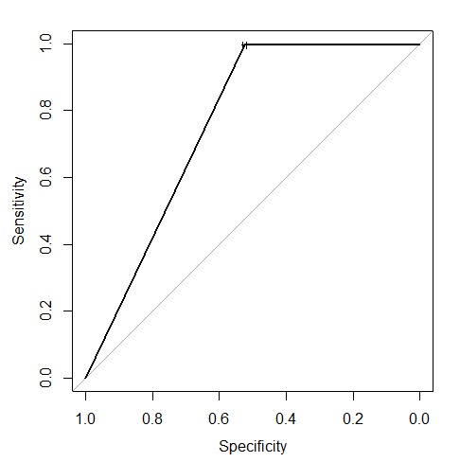

For clustering, how will the clustering be understood?

Since my project is centered on supervised machine learning models with labelled datasets I have not used clustering for this particular project.

Will deployment as planned actually (best) address the stated business problem?

I certainly foresee the trained model being deployed in safety systems to ensure passenger safety on roads. This would be the most optimal deployment sector for the model. I am excited about the fact that if in production systems built using such models can potentially save a lot of lives by preventing road accidents. The auxiliary business model listed in phase 1 would also be significantly benefited with the model’s deployment. Since the model has been tested on real time data provided by Ford it is quite certain for it to perform well in real world situations and hence prevent road fatalities.

If the project expense has to be justified to stakeholders, what is the plan to measure
the final (deployed) business impact?

I think that the best way to assess the model’s success would be to articulate the reduction in the percentage of road accidents post deployment of the system built using the model and the subsequent increase in the car sales for Ford who took the initiative to have the system installed in the vehicles manufactured by them. For the auxiliary business model that I had proposed in phase one I feel it would be best if the profit/loss percentages are analyzed for insurance firms who are targeting the customers who own vehicles which have this system installed onboard. The strongpoint of the system is the fact that it can certainly go a long way in saving many lives by preventing road accidents. From the confusion matrix of the final selected model:
From the confusion matrix above it is evident that the net cost over accuracy for the model is an acceptable ration, therefore if deployed the model would certainly be beneficial to the organization.

Acknowledgement

I would like to acknowledge the efforts of Professor Arbi Ghazarian for structuring the course in a way that focuses on the core Data Science concepts, the project which is included in the curriculum is a great way to understand the application of the concepts in Data Science. The lecture material covered in class goes in sync with what we are trying to implement in our graduate project. I learnt a lot in the subject, I was completely oblivious to data science and machine learning techniques prior to taking the course and over the course of this fall I have developed a keen interest in the domain, I would certainly like to learn more about data science.

References

[1]. http://aci.info/2014/07/12/the-data-explosion-in-2014-minute-by-minute-infographic/
[2]. http://www.internetlivestats.com/twitter-statistics/
[3]. http://www.sciencedaily.com/releases/2013/05/130522085217.htm
[4]. https://en.wikipedia.org/wiki/Data_science
[5]. https://www.kaggle.com/c/stayalert
[6]. https://en.wikipedia.org/wiki/Types_of_business_entity#United_States
[7]. https://www.kaggle.com/c/stayalert/data
[8]. http://blog.kaggle.com/wp-content/uploads/2011/03/ford.pdf

