Geolocation of microblogging users

Team Members: Manas Sharma, Tarun Gangwani, Agalya Loganathan, Shwetha Narayanan, Aarti Rao M, Divyesh Dnyanmothe, Gautham Atluri
CSE 591: Semantic Web Mining
Dr. Paulo Shakarian

Abstract — Terabytes of data is being user-generated every day and it is useful to identify users' geolocations for an array real-time applications. However, the instance of geo-tagged tweets in comparison to the total tweets generated is less than 1%. Also, observations show that about 95% of the Twitter users never use the geo-tag feature. Therefore, there is a strong need to formulate an effective method to predict the location of a Twitter user from the profile information and the posted content. In this project, we analyze various techniques to predict the location and evaluate their impact on accuracy. Further, we propose a clustering based model to efficiently determine the user’s location.

Keywords—Micro-Blogging, Geo-Location, Social Media, Classification, Clustering

Introduction
With millions of tweets posted every day, Twitter has easily become one of the most popular social media platforms across the globe. Users post tweets, restricted to 140 characters in length and also retweet to spread the information deeper into the social network.
Superior to plain text, tweets are enriched with useful features like (1) Geolocation information - owing to GPS-enabled devices (2) Hashtags - a tag used to identify labels on a specific theme.
In this paper, we analyze the shortcomings of classification techniques for this application and propose a clustering based model to determine a user's location from the posted tweets.
There are previous works related to mining the location information from tweets based on different approaches such as (1) Tweet based clustering using similarity measurements (2) Burst keyword based clustering which identifies keywords and uses those words instead of the whole tweets (3) Hash tag based predictions [1]. Research has been done on clustering hash tags of tweets to analyze event exploration in different time intervals [1].
In our work, we propose a technique based on [1] to build a model which trains based on the hashtag occurrence trends in tweets, classified based on location. It identifies and eliminates hashtags which trend across different locations and clusters only the hashtags which trend in the locations of interest.
Based on the hierarchical clustering model, the given user’s tweets are clustered to appropriate locations depending on the hashtag trends in his tweets. The clustering is further analyzed to identify similarities in hashtag trends in different locations.

Initial Approach
As a first step, we started with a supervised learning model - Naïve Bayesian. Based on Bayes Theorem, this classification model is known for its simplicity. The training set was based on our filtered data corpus of tweet documents labelled under one of the states of USA. A large volume of tweets (around 4 million) was classified. Each user’s tweets were collected in a tweet document and labelled to a class depending on their geo-location information (extracted from the user profile). These documents were then converted to bag of words after preprocessing, stemming and identification of named entities using n-gram Stanford NER. This was used to build the Naïve Bayes Classification model.

An accuracy of 38% was achieved for states with sufficiently high volume of tweet documents based on k-fold cross validation. However, the performance degraded considerably for states with comparatively smaller volumes of data. It was observed that this was due to --------

At the second attempt, city-wise classification was carried out. <Observations here>

Since our trained classification model was not able to perform based on the nature of our data instances, we explored an unsupervised model to cluster the tweet documents based on the hashtags occurrence.

Framework

Data Collection and Processing
Data was collected by crawling Twitter for geo-tag enabled users. With an initial seed set, we performed a breadth-first search crawl of each user’s network under the assumption that most friends would be co-located. Next, the data was standardized by state and city names, meaningless locations were eliminated and non-USA locations were pruned off.
Further, each user’s tweet document content was preprocessed to remove stop words, emoticons, URLS and correct spelling errors by fuzzy matching.
Bot detection and removal was done based on heuristics. Factors like low followers count, majority of URL and spam words containing tweets, retweet frequency were considered.
Finally, the tweet corpus is normalized using TF/IDF.

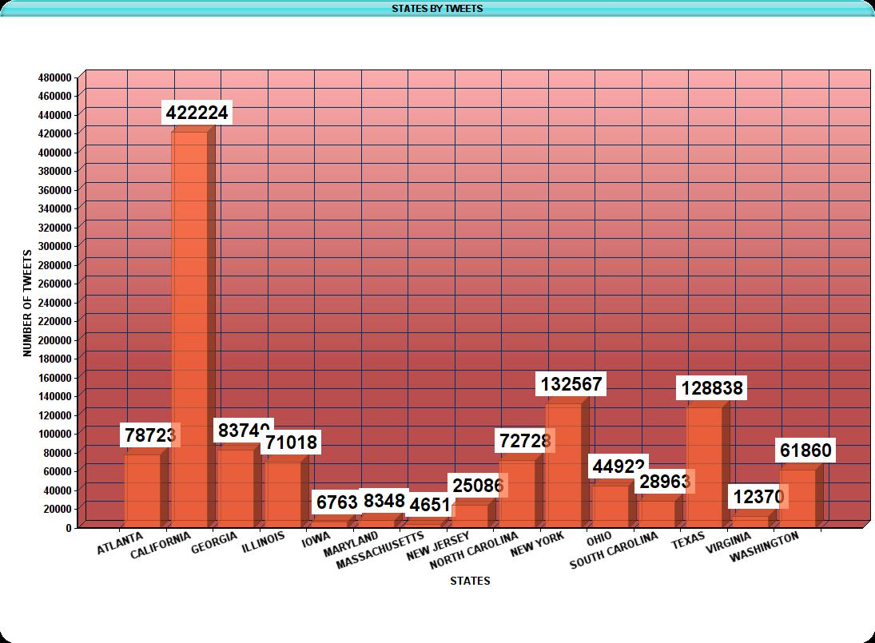

Feature Selection
With high dimensionality of data, a learning model tends to overfit and the results might be inaccurate (skewed?). Feature selection is one of the most used techniques to reduce data dimensionality. We pick a small subset of the relevant features from the original ones in order to improve performance.

In our case, we have chosen
- Hashtags – primarily because it represents the current trending topics, although temporal. Non-hashtag words are not suitable because they are likely to create unnecessary clusters which are not location-relevant. In order to implement words, topic models may be used but even then there is no guarantee of local words being identified.

- Mentions – Twitter allows users to target their tweets to others by mentioning them using the “@” symbol. We evaluate the relationship (friend/follower) between users and their frequency of communication to determine their location proximity.

Hashtag Clustering
Clustering may be carried out based on tweets or burst <indent>keywords. The drawback of these approaches is that the results are not easily comprehendible. On the other hand, clustering hashtags can be well depicted to make location inferences. Hashtags play a vital role in our evaluation and they have since they are user-generated and thus less noisy. Only user consented hashtags can become popular though retweeting.
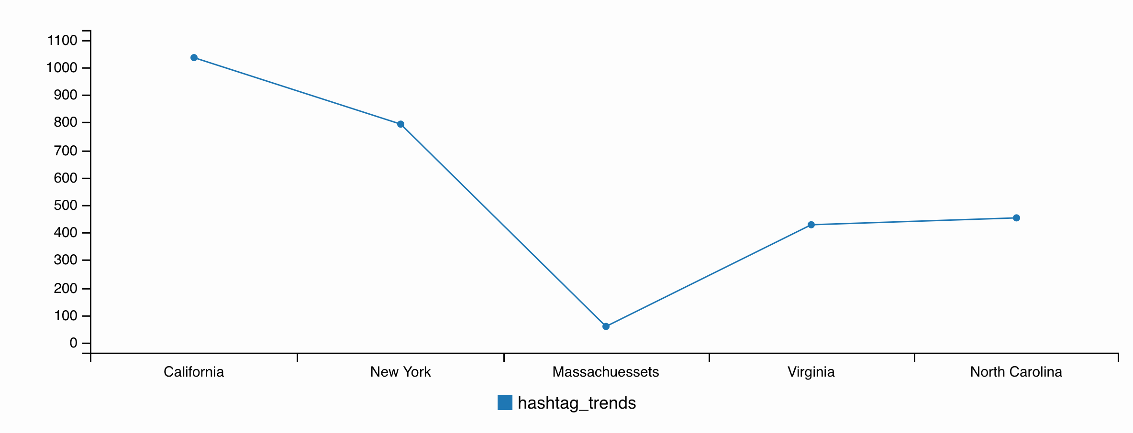
We employ agglomerative hierarchical clustering of hashtags extracted from a user’s tweet document. This bottom-up approach clusters similar labels together, progressively combining them further at each level up. It is represented in the form of a tree structure – dendrogram.
Hashtags are extracted from the tweet corpus and labelled based on known locations. A new user’s hashtag set is given as input along with the extracted corpus to observe which cluster its gets mapped to. We eliminate hashtags which are popular and common across states to ensure that we use only state-specific labels. <same time period>
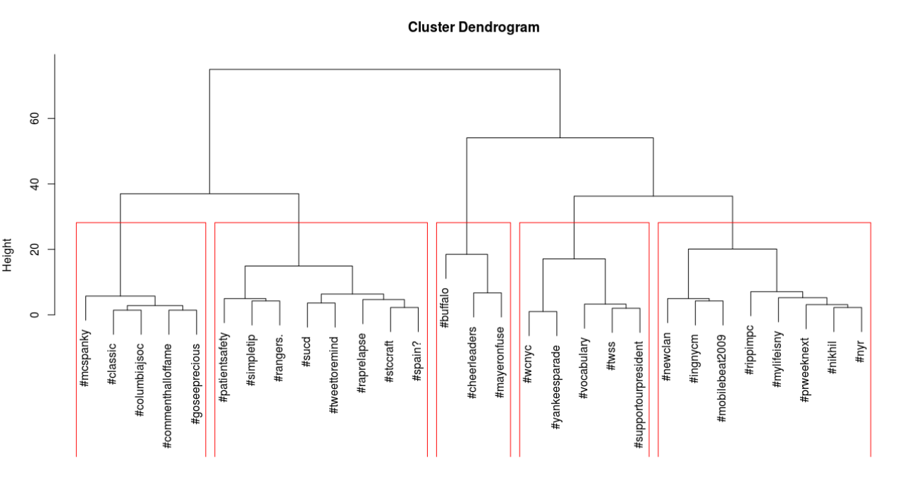

<formula + algo>

The Mentions-oriented approach
For users whose tweet documents do not contain enough hashtags, we attempt to determine their location using mentions. It is observed that if two users who follow each other mention one another frequently, their probability of being co-located is high. Conversely, when an ordinary user mentions someone they follow, who does not follow them (say a celebrity), and we filter out its influence on the location results to improve the results of clustering.
<output-table>

Document Similarity
As a final technique, we apply document similarity to tweet sets which do not fall into the hashtag or mentions categories.

The main focus of the model is content-driven location prediction. Hashtags are of primary importance because they directly represent the content of the user tweet. Next, we consider the user’s social interaction in the form of mentions in the case where hashtags cannot be analyzed. As a final resort, if both of the aforementioned cannot be used, we implement the technique of document similarity.

Experimental Study

Dataset
We crawled 4 million tweets with 62 thousand unique hashtags using Twitter’s API for Python. The data was preprocessed using (1) Stopword removal (2) Bot filtering. The user specific hashtags were then given as input to the hierarchical clustering model along with the all-state hashtag corpus.

Evaluation Methodology
Headings, or heads, are organizational devices that guide the reader through your paper. There are two types: component heads and text heads.
Component heads identify the different components of your paper and are not topically subordinate to each other. Examples include ACKNOWLEDGMENTS and REFERENCES, and for these, the correct style to use is “Heading 5.” Use “figure caption” for your Figure captions, and “table head” for your table title. Run-in heads, such as “Abstract,” will require you to apply a style (in this case, italic) in addition to the style provided by the drop down menu to differentiate the head from the text.
Text heads organize the topics on a relational, hierarchical basis. For example, the paper title is the primary text head because all subsequent material relates and elaborates on this one topic. If there are two or more sub-topics, the next level head (uppercase Roman numerals) should be used and, conversely, if there are not at least two sub-topics, then no subheads should be introduced. Styles named “Heading 1,” “Heading 2,” “Heading 3,” and “Heading 4” are prescribed.

Baselines

Positioning Figures and Tables: Place figures and tables at the top and bottom of columns. Avoid placing them in the middle of columns. Large figures and tables may span across both columns. Figure captions should be below the figures; table heads should appear above the tables. Insert figures and tables after they are cited in the text. Use the abbreviation “Fig. 1,” even at the beginning of a sentence.
- Table Styles
Table Head | Table Column Head
Table Head | Table column subhead | Subhead | Subhead
copy | More table copyª
- Sample of a Table footnote. (Table footnote)

- Example of a figure caption. (figure caption)
Figure Labels: Use 8 point Times New Roman for Figure labels. Use words rather than symbols or abbreviations when writing Figure axis labels to avoid confusing the reader. As an example, write the quantity “Magnetization,” or “Magnetization, M,” not just “M.” If including units in the label, present them within parentheses. Do not label axes only with units. In the example, write “Magnetization (A/m)” or “Magnetization (A ( m(1),” not just “A/m.” Do not label axes with a ratio of quantities and units. For example, write “Temperature (K),” not “Temperature/K.”

Future Work
The preferred spelling of the word “acknowledgment” in America is without an “e” after the “g.” Avoid the stilted expression “one of us (R. B. G.) thanks ...”. Instead, try “R. B. G. thanks...”. Put sponsor acknowledgments in the unnumbered footnote on the first page.

References
The template will number citations consecutively within brackets [1]. The sentence punctuation follows the bracket [2]. Refer simply to the reference number, as in [3]—do not use “Ref. [3]” or “reference [3]” except at the beginning of a sentence: “Reference [3] was the first ...”
Number footnotes separately in superscripts. Place the actual footnote at the bottom of the column in which it was cited. Do not put footnotes in the reference list. Use letters for table footnotes.
Unless there are six authors or more give all authors’ names; do not use “et al.”. Papers that have not been published, even if they have been submitted for publication, should be cited as “unpublished” [4]. Papers that have been accepted for publication should be cited as “in press” [5]. Capitalize only the first word in a paper title, except for proper nouns and element symbols.
For papers published in translation journals, please give the English citation first, followed by the original foreign-language citation [6].

- G. Eason, B. Noble, and I.N. Sneddon, “On certain integrals of Lipschitz-Hankel type involving products of Bessel functions,” Phil. Trans. Roy. Soc. London, vol. A247, pp. 529-551, April 1955. (references)
- J. Clerk Maxwell, A Treatise on Electricity and Magnetism, 3rd ed., vol. 2. Oxford: Clarendon, 1892, pp.68-73.
- I.S. Jacobs and C.P. Bean, “Fine particles, thin films and exchange anisotropy,” in Magnetism, vol. III, G.T. Rado and H. Suhl, Eds. New York: Academic, 1963, pp. 271-350.
- K. Elissa, “Title of paper if known,” unpublished.
- R. Nicole, “Title of paper with only first word capitalized,” J. Name Stand. Abbrev., in press.
- Y. Yorozu, M. Hirano, K. Oka, and Y. Tagawa, “Electron spectroscopy studies on magneto-optical media and plastic substrate interface,” IEEE Transl. J. Magn. Japan, vol. 2, pp. 740-741, August 1987 [Digests 9th Annual Conf. Magnetics Japan, p. 301, 1982].
- M. Young, The Technical Writer’s Handbook. Mill Valley, CA: University Science, 1989.

