Author Guidelines for Preparing 8.5 x 11-inch Conference Manuscripts

Jane Doe, responsible for the topic: Service brokers and their contributions in the service-oriented software development
Arthur Lee, responsible for the topic: Application development environments and platforms
Class Name
Instructor Name

Abstract

This page should follow the title page and table of contents. The abstract is to be in fully-justified italicized text, at the top of the left-hand column as it is here, below the author information. Use the word “Abstract” as the title, in 12-point Times, boldface type, centered relative to the column, initially capitalized. The abstract is to be in 10-point, single-spaced type, and up to 350 words in length. Leave two blank lines after the abstract, then begin the main text.

Keywords: Service-oriented computing, …

1. Introduction

All manuscripts must be in English. These guidelines include complete descriptions of the fonts, spacing, and related information for producing your proceedings manuscripts. Please follow them and if you have any questions, please check with your TA and instructor.

2. Formatting your paper

All printed material, including text, illustrations, and charts, must be kept within a print area of 6-1/2 inches (16.51 cm) wide by 8-7/8 inches (22.51 cm) high. Do not write or print anything outside the print area. All text must be in a two-column format. Columns are to be 3-1/16 inches (7.85 cm) wide, with a 3/8 inch (0.81 cm) space between them. Text must be fully justified. If you use LaTex, you can find the template for the IEEE conference proceedings format at
www.ieee.org/web/publications/authors/index.html

3. Main title

The main title (on the first page) should begin 1-3/8 inches (3.49 cm) from the top edge of the page, centered, and in Times 14-point, boldface type. Capitalize the first letter of nouns, pronouns, verbs, adjectives, and adverbs; do not capitalize articles, coordinate conjunctions, or prepositions (unless the title begins with such a word). Leave two 12-point blank lines after the title.

4. Author name(s) and affiliation(s)

Author names and affiliations are to be centered beneath the title and printed in Times 12-point, non-boldface type. Multiple authors may be shown in a two- or three-column format, with their affiliations italicized and centered below their respective names. Include e-mail addresses if possible. Author information should be followed by two 12-point blank lines. The order of the author's names can either be based on the contribution of simply in alphabetic order.

5. Second and following pages

The second and following pages should begin 1.0 inch (2.54 cm) from the top edge. On all pages, the bottom margin should be 1-1/8 inches (2.86 cm) from the bottom edge of the page for 8.5 x 11-inch paper; for A4 paper, approximately 1-5/8 inches (4.13 cm) from the bottom edge of the page.

6. Type-style and fonts

Wherever Times is specified, Times Roman or Times New Roman may be used. If neither is available on your word processor, please use the font closest in appearance to Times. Avoid using bit-mapped fonts if possible. True-Type 1 fonts are preferred.

7. Main text

Type your main text in 10-point Times, single-spaced. Do not use double-spacing. All paragraphs should be indented 1/4 inch (approximately 0.5 cm). Be sure your text is fully justified—that is, flush left and flush right. Please do not place any additional blank lines between paragraphs.
Figure and table captions should be 10-point boldface Helvetica (or a similar sans-serif font). Callouts should be 9-point non-boldface Helvetica. Initially capitalize only the first word of each figure caption and table title. Figures and tables must be numbered separately. For example: “Figure 1. Design space”, “Table 1. Gantt chart”. Figure captions are to be centered below the figures. Table titles are to be centered above the tables. The text in figures and in tables should have similar size as the main text.

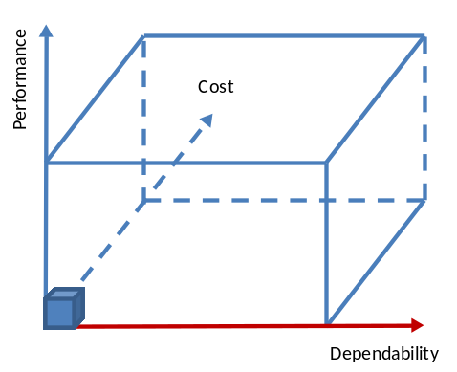
Figure 1. Design Space

Oversized figures and table can be expanded into two columns, as shown in Figure 1 and Table 1.
Considering that the report will be printed in black/white, cautious use of color in the report is suggested.

8. First-order headings

For example, “1. Introduction”, should be Times 12-point boldface, initially capitalized, flush left, with one blank line before, and one blank line after. Use a period (“.”) after the heading number, not a colon.

8.1. Second-order headings

As in this heading, they should be Times 11-point boldface, initially capitalized, flush left, with one blank line before, and one after.

8.1.1. Third-order headings.
Third-order headings, as in this paragraph, are discouraged. However, if you must use them, use 10-point Times, boldface, initially capitalized, flush left, preceded by one blank line, followed by a period and your text on the same line.
Table 1 shows an example how you create and cite the table. The table caption must be on top of the table, instead of below the table.
Table 1. List of classes
Class | Title | Cap
CSE240 | Introduction to Programming Languages | 82
CSE360 | Introduction Software Engineering | 65
CSE445 | Distributed Software Development | 45
CSE598 | Distributed Software Development | 26

When using headings, headings defined in the styles should be used, so that the table of contents can be automatically generated.

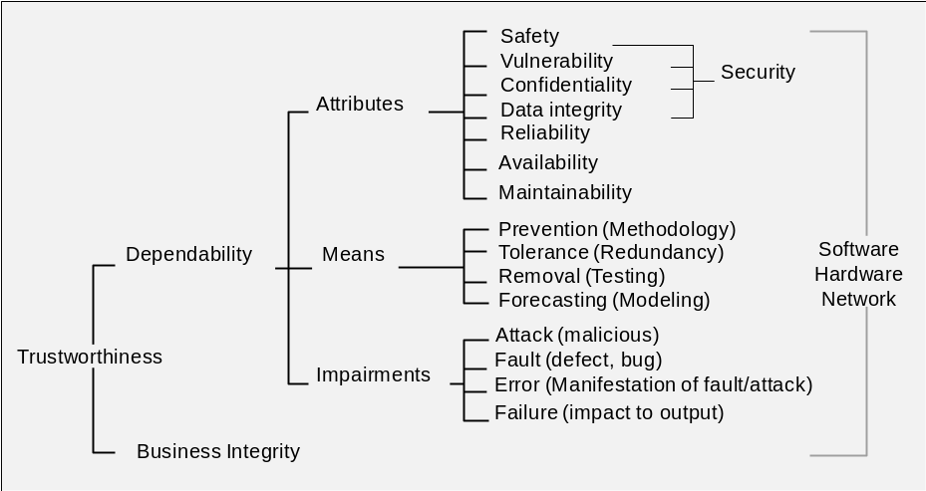
Figure 2. Dependability and related terminology

9. Footnotes

Use footnotes sparingly (or not at all) and place them at the bottom of the column on the page on which they are referenced. Use Times 9-point type, single-spaced. To help your readers, avoid using footnotes altogether and include necessary peripheral observations in the text (within parentheses, if you prefer, as in this sentence).
Use "References" and "Footnote" insertion functions to help you maintain the footnotes in your report.

10. Acknowledgement

This document is based on IEEE proceedings manuscript formatting document, and it is customized for CSE graduate research project.

11. Using References

List and number all bibliographical references in 9-point Times, single-spaced, at the end of your paper. When referenced in the text, enclose the citation number in square brackets, for example [1]. Where appropriate, include the name(s) of editors of referenced books.
The citation and the reference must be linked by "Cross-reference", so that the link can be automatically maintained when references are added and removed. The references should be ordered in their first appearances in the report, or in alphabetical order of the first author's last name.

12. References

- Y. Chen, W.T. Tsai, Service-Oriented Computing and Web Software Integration, 3rd edition, Kendall Hunt Publishing, 2011.
- Jones, C.D., A.B. Smith, and E.F. Roberts, Book Title, Publisher, Location, Date.
- Smith, A.B., C.D. Jones, and E.F. Roberts, “Article Title”, Journal, Publisher, Location, Date, pp. 1-10.
- Michael Stevens, Service-Oriented Architecture Introduction, retrieved on September 4, 2012 from: http://www.developer.com/design/article.php/1010451

13. About the Authors

A brief bio of each author should be listed here, with two to four lines for each author.

