List of Publications
Manas Sharma
1. Y. J. Franzke†, M. Sharma†, P. Bhasin, F. Bruder, U. Huniar, P. Komonvasee, M. Krstić, A. Nejad, A. Pausch, K. Sorathia, N. Sülzner, Ö. F. C. Tiska, A. Zhu, R. Zielke, C. Hättig*, C. Holzer*, M. Sierka*, D. P. Tew*, F. Weigend (2026), Recent Developments in TURBOMOLE, In review at The Journal of Chemical Physics (2026).
• Authorship note: Co-first author († equal contribution with Y. J. Franzke, whose name appears first alphabetically).

2. M. Sharma*, S. Punnathanam, A. G. Rajan* (2026), MLIP Studio: An Open Platform for Interactive Benchmarking and Atomistic Simulations Using Machine Learning Interatomic Potentials, arXiv:2607.07606 (2026).
• Special note: Co-corresponding author.

3. C. Sahoo*, S. K. Chakraborty, A. Kousika, A. J. H. Jones, M. Sharma, T. S. Nielsen, Z. Jiang, I. A. Kolasseri, S. Das, M. D. Watson, C. Cacho, K. Watanabe, T. Taniguchi, Y. P. Chen, T. F. Heinz, A. G. Rajan, P. K. Sahoo, S. Ulstrup* (2026), Direct Nanoscale Mapping of Band Alignment in Single-Layer Semiconducting Lateral Heterojunctions, Nano Letters 26:15:5178–5186, DOI: 10.1021/acs.nanolett.6c00590.

4. V. Kumar, A. Jangid^{T}, M. Sharma^{T}, M. Verma, J. Pasyanthi, K. S. Kumar, P. Sharma, E. O. Chiglintsev, M. I. Panin, S. N. Punnathanam, A. I. Chernov, A. G. Rajan, A. Singh (2026), Tailored Vapor Deposition Unlocks Large-Grain, Wafer-Scale Epitaxial Growth of 2D Magnetic CrCl₃, Advanced Materials 38:34:e14405 (2026), DOI: 10.1002/adma.202514405.
• Special note: Equal second authorship (denoted by ‘^{T}’).
• Featured on IISc News

5. M. Sharma*, M. Sierka* (2026), PyFock: A Just-In-Time Compiled Gaussian Basis DFT Python Code for CPU and GPU Architectures, The Journal of Physical Chemistry A (2026), DOI: 10.1021/acs.jpca.6c03727.
• Special note: Co-corresponding author.
• Project: https://github.com/manassharma07/PyFock (alternatively: https://pyfock.bragitoff.com).

6. M. Sharma, Y. J. Franzke, C. Holzer, F. Pauly, M. Sierka* (2025), Density Functional Theory for Molecular and Periodic Systems in TURBOMOLE: Theory, Implementation, and Applications, Journal of Physical Chemistry A 129:39:9062–9083, DOI: 10.1021/acs.jpca.5c02937.
• Special note: In the list of 20 most read articles in the last 12 months of JPC A.

7. M. Sharma, M. Sierka (2024), Optical Gaps of Ionic Materials from GW/BSE-in-DFT and CC2-in-DFT, Journal of Chemical Theory and Computation 20:21:9592–9605, DOI: 10.1021/acs.jctc.4c00819.
• Special note: In the list of 20 most read articles for the months of November and December (2024).

8. Y. J. Franzke, C. Holzer, J. H. Andersen, T. Begušić, F. Bruder, S. Coriani, F. Della Sala, E. Fabiano, D. A. Fedotov, S. Fürst, S. Gillhuber, R. Grotjahn, M. Kaupp, M. Kehry, M. Krstić, F. Mack, S. Majumdar, B. D. Nguyen, A. Pausch, E. Perlt, G. S. Phun, A. Rajabi, D. Rappoport, B. Samal, T. Schrader, M. Sharma, E. Tapavicza, R. S. Treß, V. Voora, A. Wodyński, J. M. Yu, B. Zerulla, F. Furche*, C. Hättig*, M. Sierka*, D. P. Tew*, F. Weigend* (2023), TURBOMOLE: Today and Tomorrow, Journal of Chemical Theory and Computation 19:20:6859–6890, DOI: 10.1021/acs.jctc.3c00347.
• Special note: Highly Cited and Read Paper.
• Authorship note: Except for the first two and the last five authors, author ordering was determined alphabetically, so equal third authorship.

9. W. Li, A. Saleh, M. Sharma, C. Hünecke, M. Sierka, M. Neuhaus, L. Hedewig, B. Bergues, M. Alharbi, H. ALQahtani, A. M. Azeer, S. Graefe, M. F. Kling, A. F. Alharbi, Z. Wang* (2023), Resonance Effect in Brunel Harmonic Generation in Thin Film Organic Semiconductors, Advanced Optical Materials 11:16:2203070, DOI: 10.1002/adom.202203070.
• Special note: On Journal Cover (see Figure 1).

10. M. Sharma, M. Sierka* (2022), Efficient Implementation of Density Functional Theory based Embedding for Molecular and Periodic Systems using Gaussian Basis Functions, Journal of Chemical Theory and Computation 18:11:6892–6904, DOI: 10.1021/acs.jctc.2c00380.
• Special note: On Supplementary Journal Cover (see Figure 1).

11. C. Müller, M. Sharma, M. Sierka* (2020), Real-Time Time-Dependent Density Functional Theory using Density Fitting and the Continuous Fast Multipole Method, Journal of Computational Chemistry 41:30:2573–2582, DOI: 10.1002/jcc.26412.

12. M. Sharma, D. Mishra* (2019), CrysX: Crystallographic Tools for the Android Platform, Journal of Applied Crystallography 52:6:1449–1454, DOI: 10.1107/S1600576719013682.
• Special note: Highly Downloaded Paper.
• Journal cover: Featured on the journal cover (see Figure 1).

13. M. Sharma, D. Mishra*, J. Kumar (2019), First-principles Study of the Structural and Electronic Properties of Bulk ZnS and Small Zn_{n}S_{n} Nanoclusters in the Framework of the DFT+U Method, Physical Review B 100:045151, DOI: 10.1103/PhysRevB.100.045151.

14. M. Sharma, D. Mishra* (2019), DFT+U Study of Small ZnO Nanoclusters, AIP Conference Proceedings 2142:110025, DOI: 10.1063/1.5122485.
• Special note: Conference publication.

Journal Covers & Google Scholar Link
Google Scholar profile: https://scholar.google.com/citations?user=WYOEL94AAAAJ
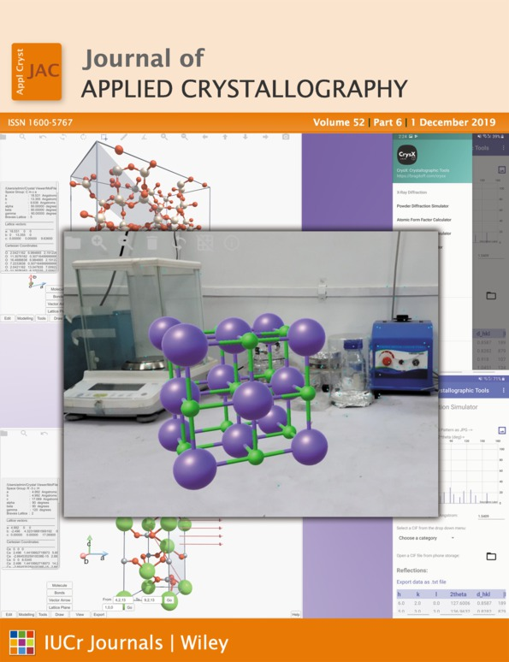 | 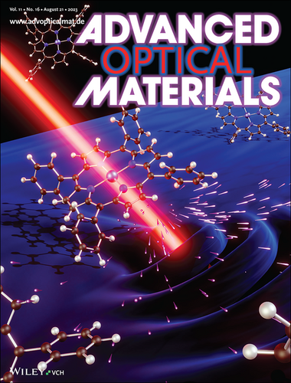 | 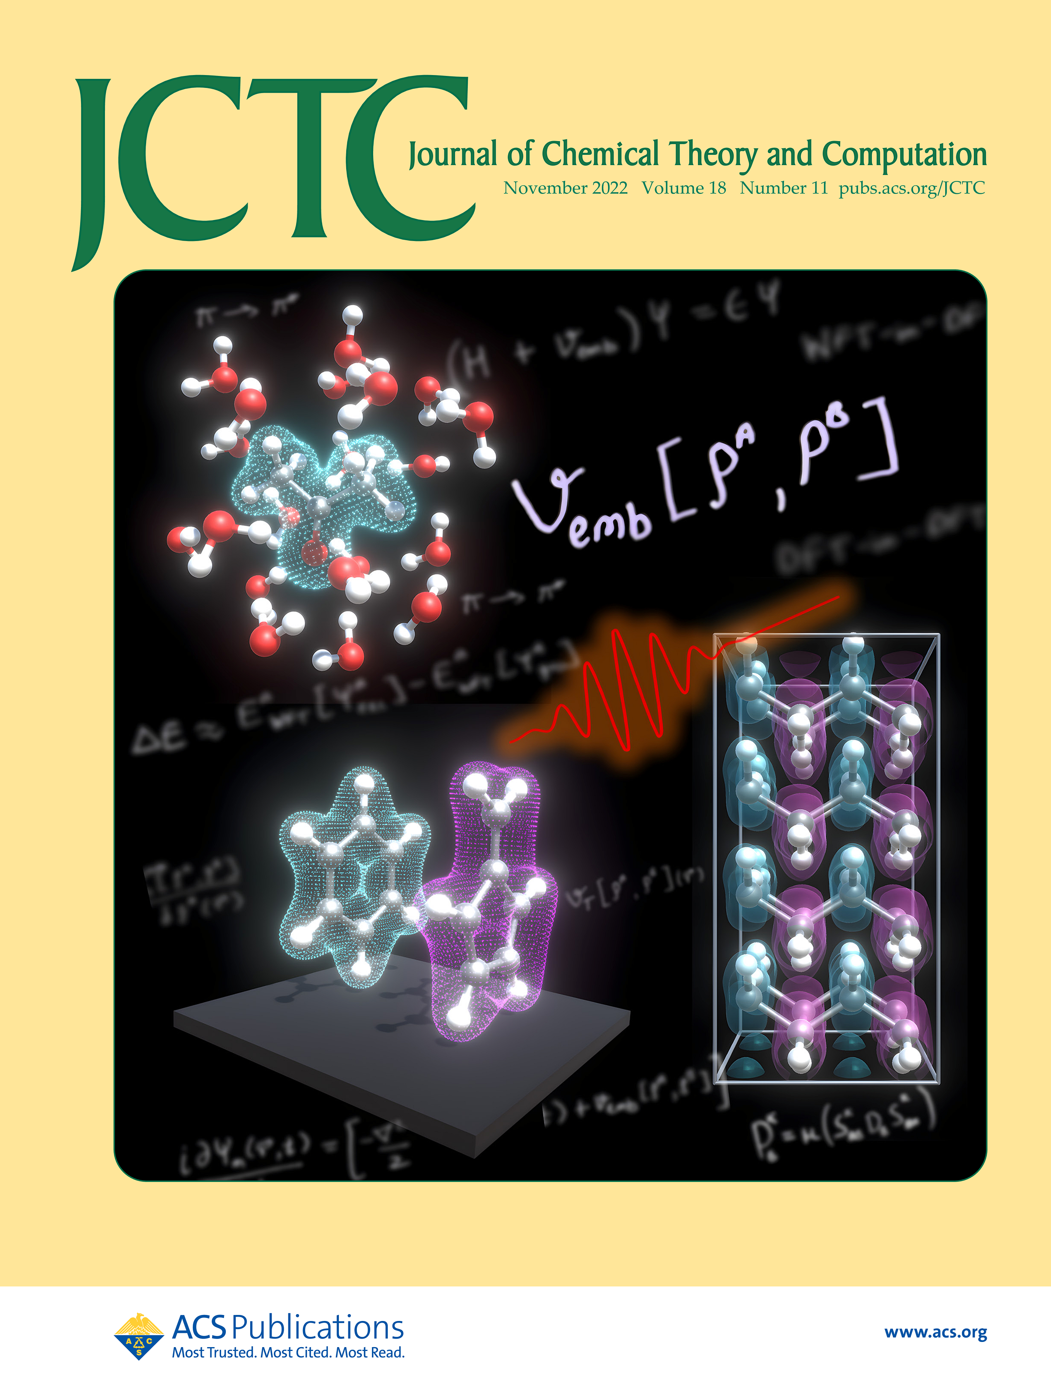
Publication #12 (2019) | Publication #9 (2023) | Publication #10 (2022)
Figure 1: Journal cover images for publication #12 (2019), publication #9 (2023), and publication #10 (2022).
Google Scholar Citation Metrics
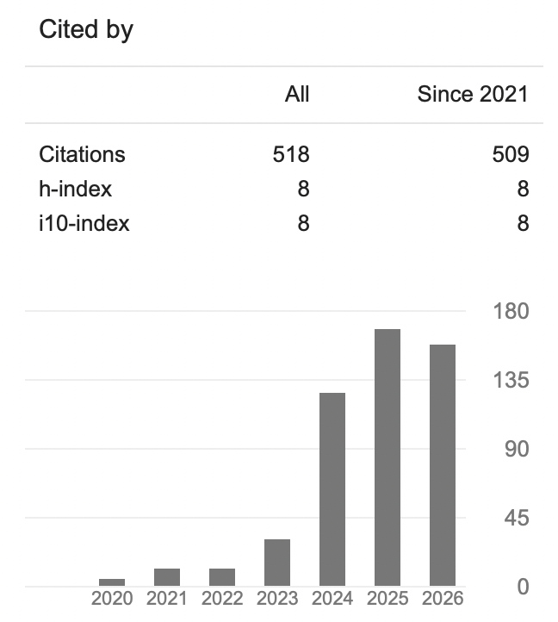
Citation metrics from Google Scholar.

