http://www.johncorser.com/princeton-algorithms-part-1-week-1/
http://indefiniteseven.wordpress.com/tag/quick-union/
Height of a Tree: https://www.cs.auckland.ac.nz/~jmor159/PLDS210/trees.html

Size of a Tree = Total number of nodes in it. [http://www.youtube.com/watch?v=sqVefIEttT0]

Forest = Union of all connected nodes in a set of trees, i.e., union of all trees.

[http://indefiniteseven.wordpress.com/tag/quick-union/]
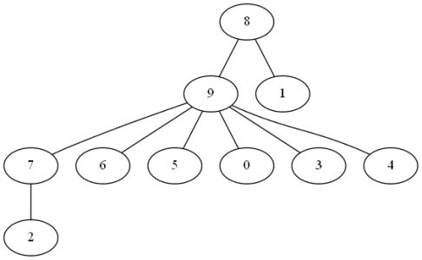

Criteria for failure:
- Height of forest = 4 > lg N = lg(10)
- Size of tree rooted at parent of a node < twice the size of tree rooted at that node. In figure above, this translates to: Size of tree rooted at parent of 9 < 2 * size of tree rooted at 9, i.e., 10 < 2 * 9, i.e., 10 < 18.
- The id[] array contains a cycle. Eg.: 9->0->6->4->9 for array [6 4 6 4 9 4 4 4 4 0].

