Experiment 5: End-to-End MLOps Pipeline
Name: Manas Tawde Roll No: E019 Subject: MLOps
Repository: https://github.com/manastawde/MANAS_E019_MLOPS (branch feature/exp5-end-to-end-mlops, PR #1)

1. Aim
To build, test, containerise, automatically publish and deploy a machine-learning service on Kubernetes, and monitor it with Prometheus and Grafana.

2. Architecture
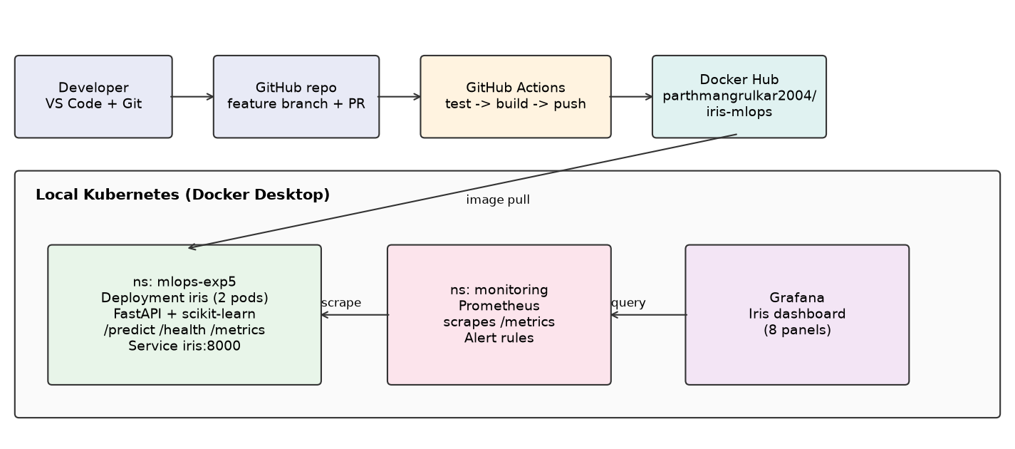

3. Application
A RandomForest classifier trained on the Iris dataset at start-up is served by FastAPI. Endpoints: POST /predict (validated input), GET /health, GET /metrics (Prometheus) and GET /boom (deliberate HTTP 500 used only for the alert test). Custom metrics: iris_predictions_total{species}, http_requests_total{method,path,status}, http_request_duration_seconds{path}.

4. Testing
Five pytest tests cover model accuracy, health, a setosa prediction, input validation (422) and metrics exposure. They run locally and in CI.
$ gh run list
completed success Experiment 5: End-to-End MLOps pipeline Exp5 MLOps CI/CD feature/exp5-end-to-end-mlops pull_request 41611171386 59s 2026-11-03T09:27:27Z
completed success Use parthmangrulkar2004 Docker Hub image in k8s manifest Exp5 MLOps CI/CD feature/exp5-end-to-end-mlops push 41611164747 1m12s 2026-11-03T09:27:24Z
completed success Experiment 5: End-to-End MLOps pipeline Exp5 MLOps CI/CD feature/exp5-end-to-end-mlops pull_request 41609152994 1m7s 2026-11-03T09:12:37Z
completed success Add Experiment 5: end-to-end MLOps (FastAPI Iris, Docker, CI/CD, k8s,… Exp5 MLOps CI/CD feature/exp5-end-to-end-mlops push 41609150944 1m15s 2026-11-03T09:25:36Z
$ pytest
5 passed, 1 warning in 2.45s

5. Docker and CI/CD
The Dockerfile uses python:3.11-slim and a non-root user. The workflow .github/workflows/exp5-mlops.yml runs on push and pull request: job 'test' runs pytest; job 'docker' builds the image and, on push events only, logs in to Docker Hub using repository secrets DOCKERHUB_USERNAME and DOCKERHUB_TOKEN and pushes :latest and :<commit sha>. The first push run failed at the Docker Hub login because the secrets had not yet been added; after adding them, all runs succeeded. The image was then pulled from Docker Hub and run locally (/health and /predict answered correctly).

6. Kubernetes deployment
The published image was deployed to namespace mlops-exp5 (2 replicas, readiness/liveness probes on /health, CPU/memory requests and limits, ClusterIP service).
$ kubectl get nodes
NAME STATUS ROLES AGE VERSION
desktop-control-plane Ready control-plane 28m v1.36.1
$ kubectl -n mlops-exp5 get deploy,pods,svc -o wide
NAME READY UP-TO-DATE AVAILABLE AGE CONTAINERS IMAGES SELECTOR
deployment.apps/iris 2/2 2 2 28m iris parthmangrulkar2004/iris-mlops:latest app=iris
NAME READY STATUS RESTARTS AGE IP NODE NOMINATED NODE READINESS GATES
pod/iris-6b9db9f858-82bk6 1/1 Running 0 2m49s 10.244.0.17 desktop-control-plane <none> <none>
pod/iris-6b9db9f858-hqjl7 1/1 Running 0 2m49s 10.244.0.18 desktop-control-plane <none> <none>
NAME TYPE CLUSTER-IP EXTERNAL-IP PORT(S) AGE SELECTOR
service/iris ClusterIP 10.96.178.206 <none> 8000/TCP 28m app=iris
$ kubectl -n monitoring get pods
NAME READY STATUS RESTARTS AGE
alertmanager-monitoring-kube-prometheus-alertmanager-0 2/2 Running 0 25m
monitoring-grafana-6ccb6c56f7-cgtzk 3/3 Running 0 26m
monitoring-kube-prometheus-operator-d94b4f4b6-597dv 1/1 Running 0 26m
monitoring-kube-state-metrics-764584797b-v9k5c 1/1 Running 0 26m
monitoring-prometheus-node-exporter-hw8mf 1/1 Running 0 26m
prometheus-monitoring-kube-prometheus-prometheus-0 2/2 Running 0 25m
$ kubectl -n mlops-exp5 describe deploy iris | image
parthmangrulkar2004/iris-mlops:latest

7. Monitoring
kube-prometheus-stack was installed with Helm into namespace 'monitoring'. An extra scrape job discovers the iris service endpoints and scrapes /metrics/. A Grafana dashboard (provisioned from a ConfigMap) shows prediction requests, p95 latency, error rate, application health, CPU, memory, replicas and restarts. Local access used kubectl port-forward on ports 19090 (Prometheus), 13000 (Grafana) and 18080 (app), chosen to avoid the existing Devops project.
target iris-6b9db9f858-82bk6 up http://10.244.0.17:8000/metrics/
target iris-6b9db9f858-hqjl7 up http://10.244.0.18:8000/metrics/
sum(iris_predictions_total) by (species)
{'species': 'virginica'} 226
{'species': 'versicolor'} 255
{'species': 'setosa'} 251
sum(http_requests_total) by (status)
{'status': '200'} 794
histogram_quantile(0.95, sum(rate(http_request_duration_seconds_bucket{path="/predict"}[5m])) by (le))
{} 0.00487657981089132
rule IrisDown inactive
rule IrisHighErrorRate inactive

8. Alert and recovery tests
Test 1: sustained /boom requests drove the 5xx ratio above 20% and IrisHighErrorRate fired, then cleared when the load stopped. Test 2: scaling the deployment to 0 should fire IrisDown. The first attempt did NOT fire: with no targets, sum(up) returns no series rather than 0. The rule was corrected to (sum(up{job="iris"}) or vector(0)) < 1, and the repeated test fired IrisDown and cleared after scaling back to 2 replicas. Deleting one pod showed Kubernetes self-healing (a replacement started automatically).

9. Screenshots
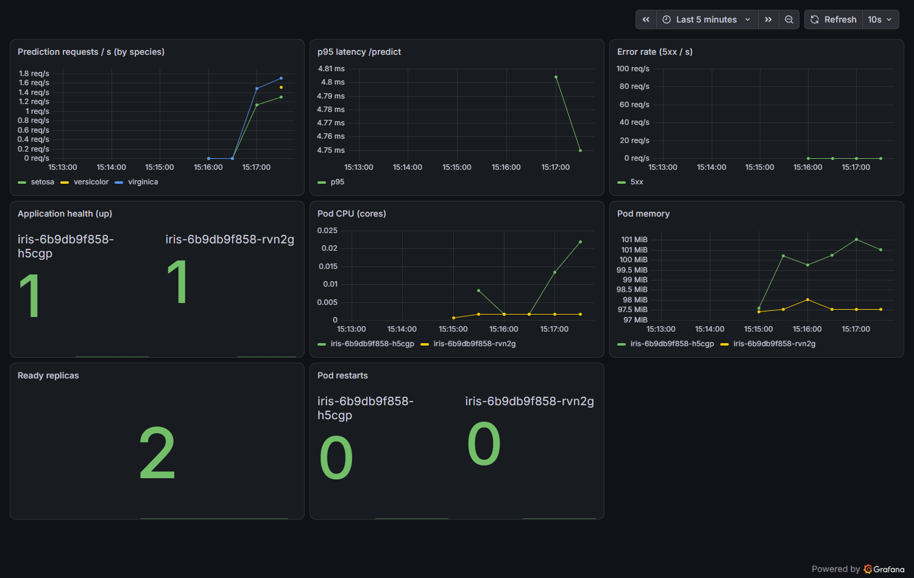
Figure: Grafana dashboard under live traffic (requests by species, p95 latency, errors, health, CPU, memory, replicas, restarts).
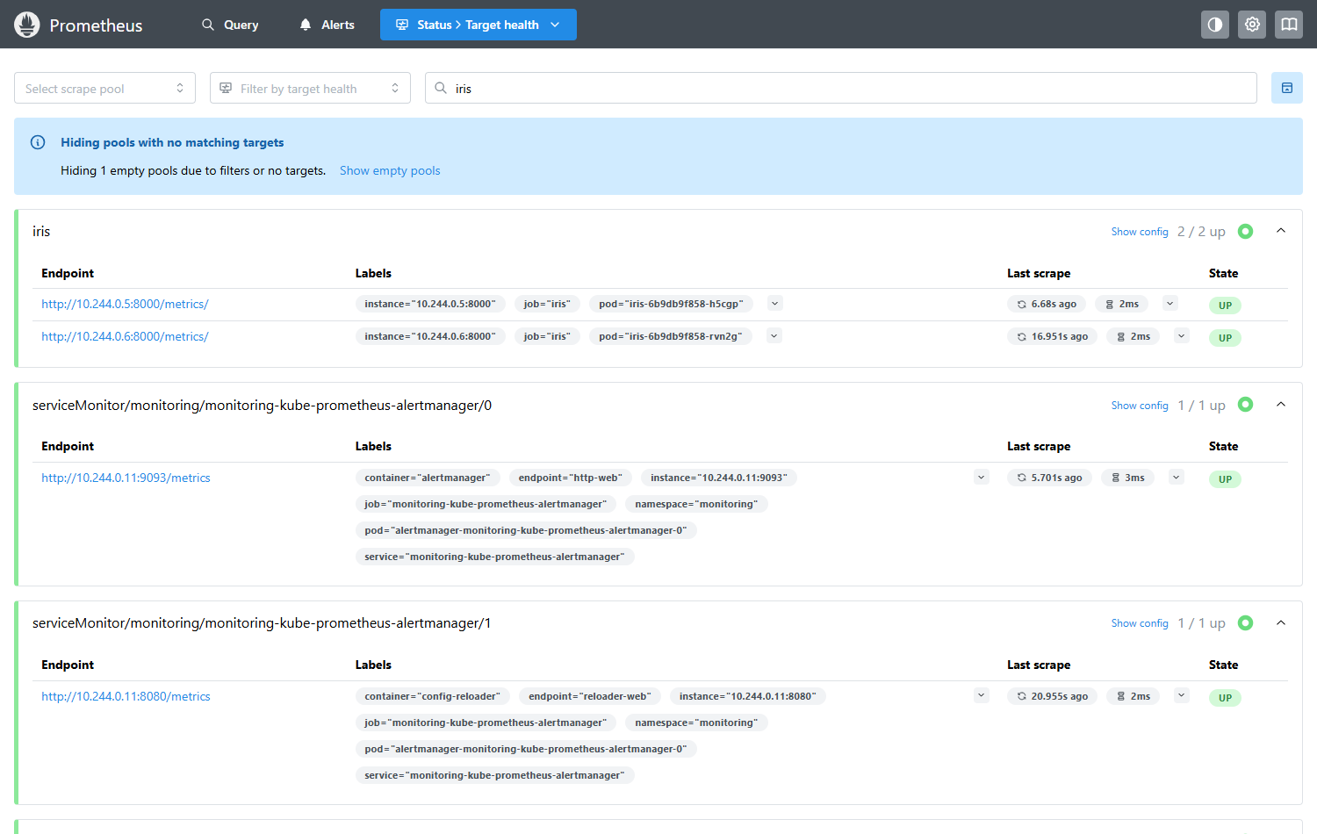
Figure: Prometheus 'iris' scrape job: both pods UP.
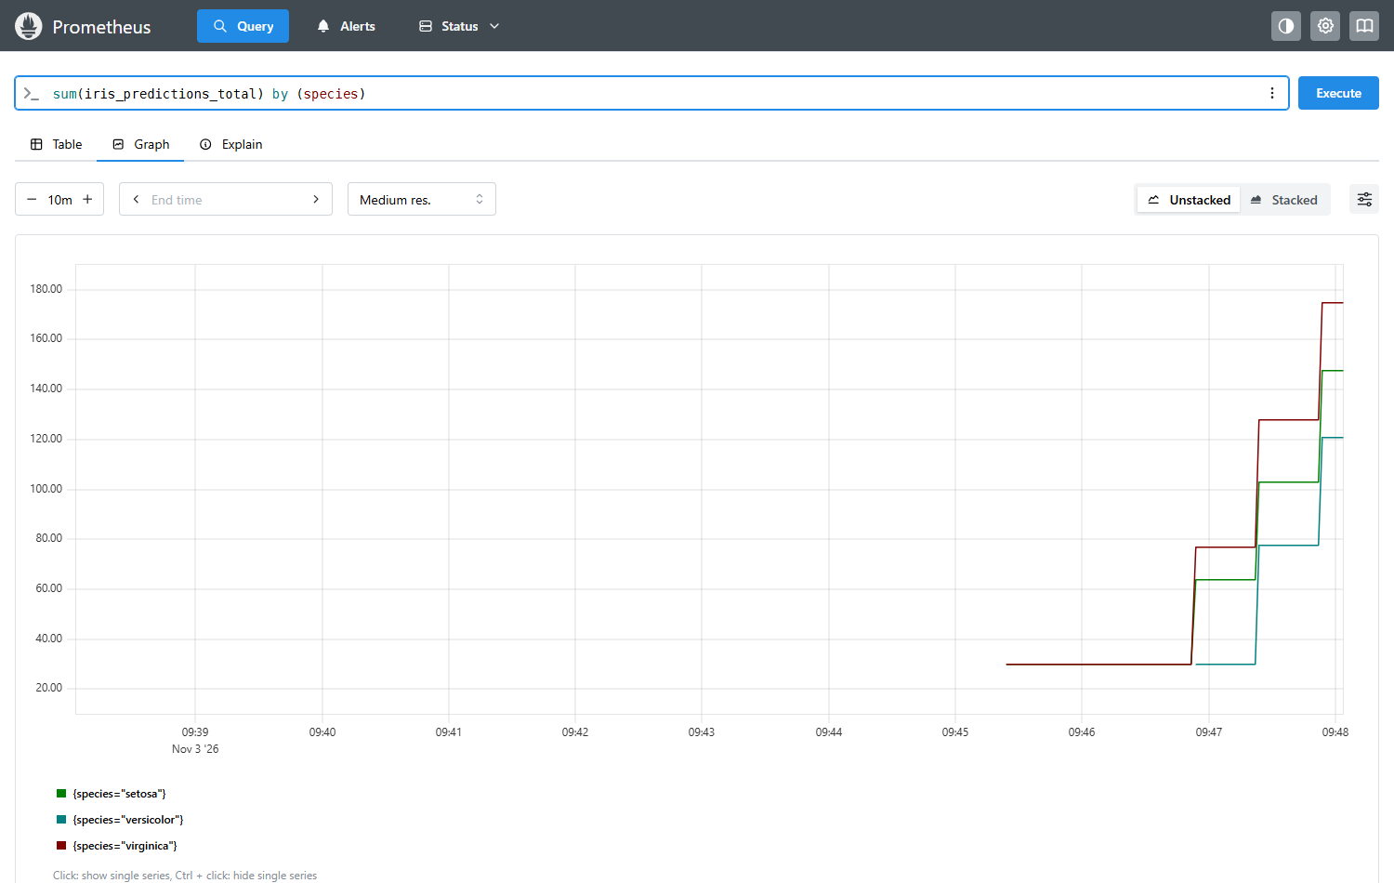
Figure: Prometheus query of iris_predictions_total by species.
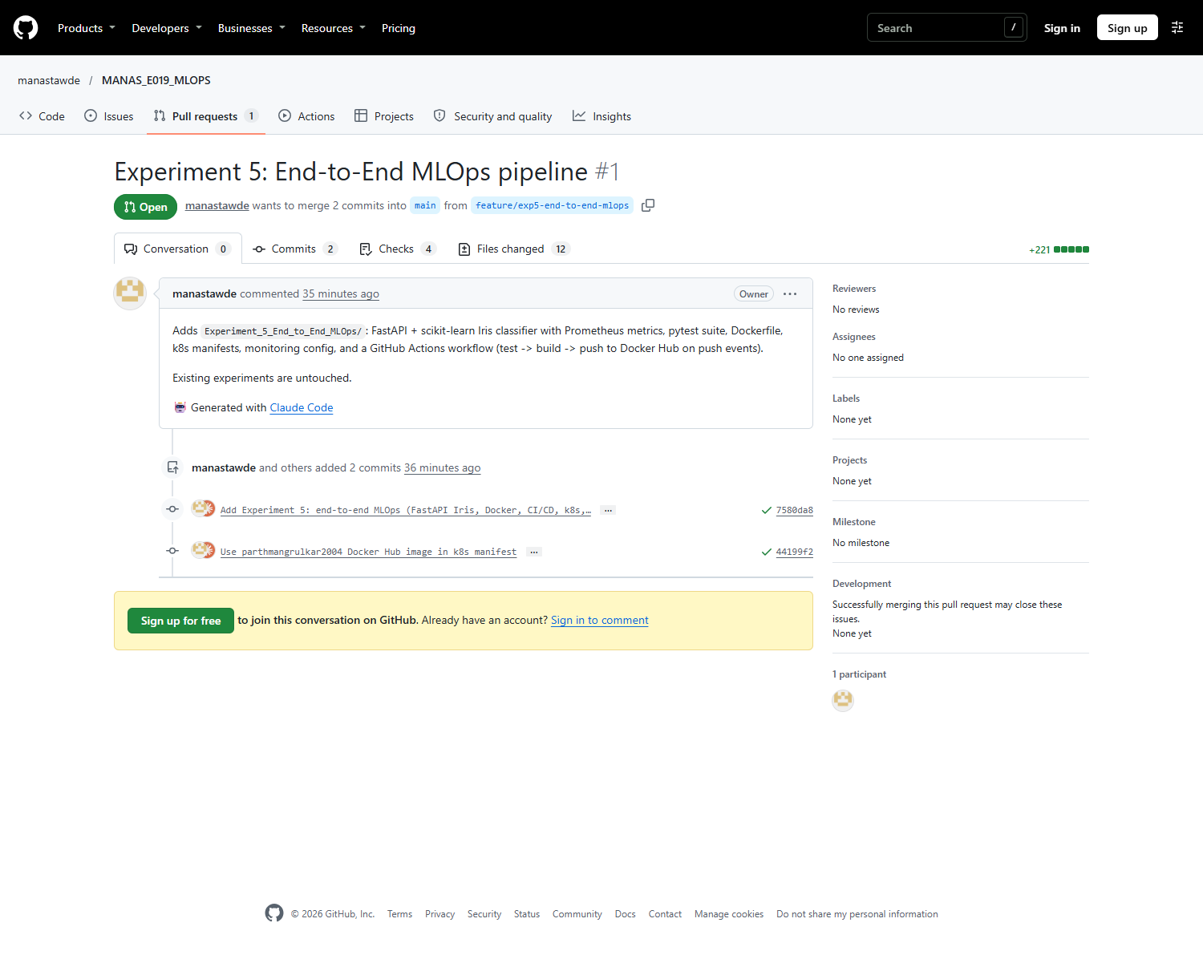
Figure: Pull request #1 into main.
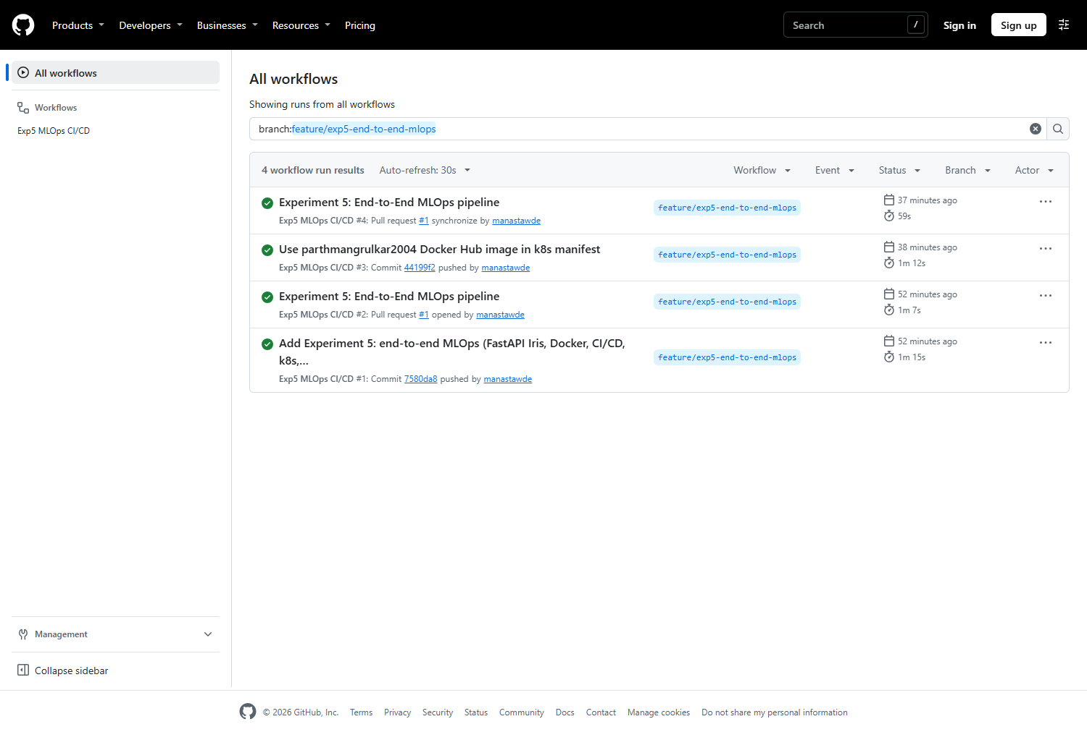
Figure: GitHub Actions runs for the feature branch.
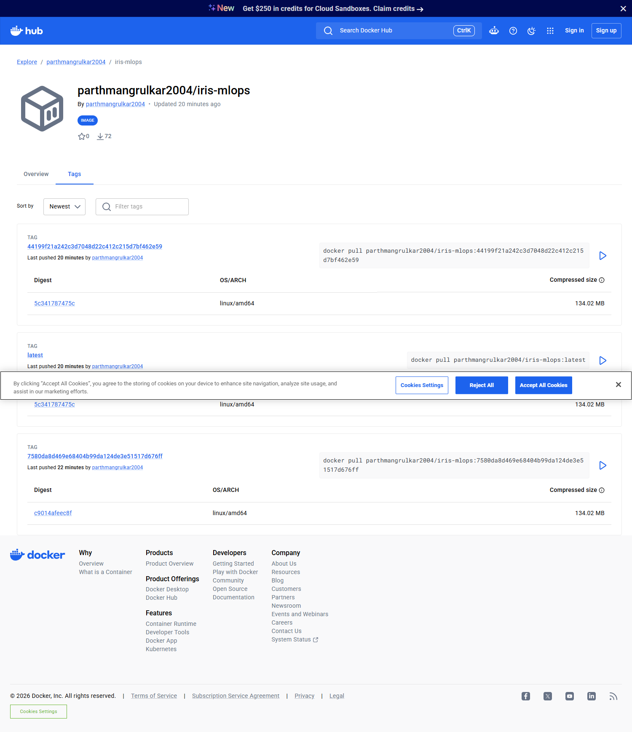
Figure: Docker Hub repository parthmangrulkar2004/iris-mlops with tags (a cookie banner partly covers the 'latest' row).
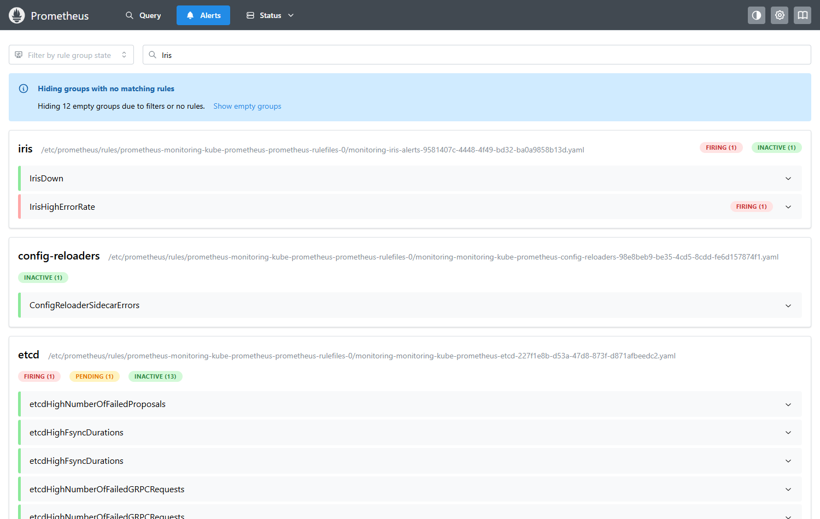
Figure: Alert test 1: IrisHighErrorRate FIRING after sustained requests to /boom.
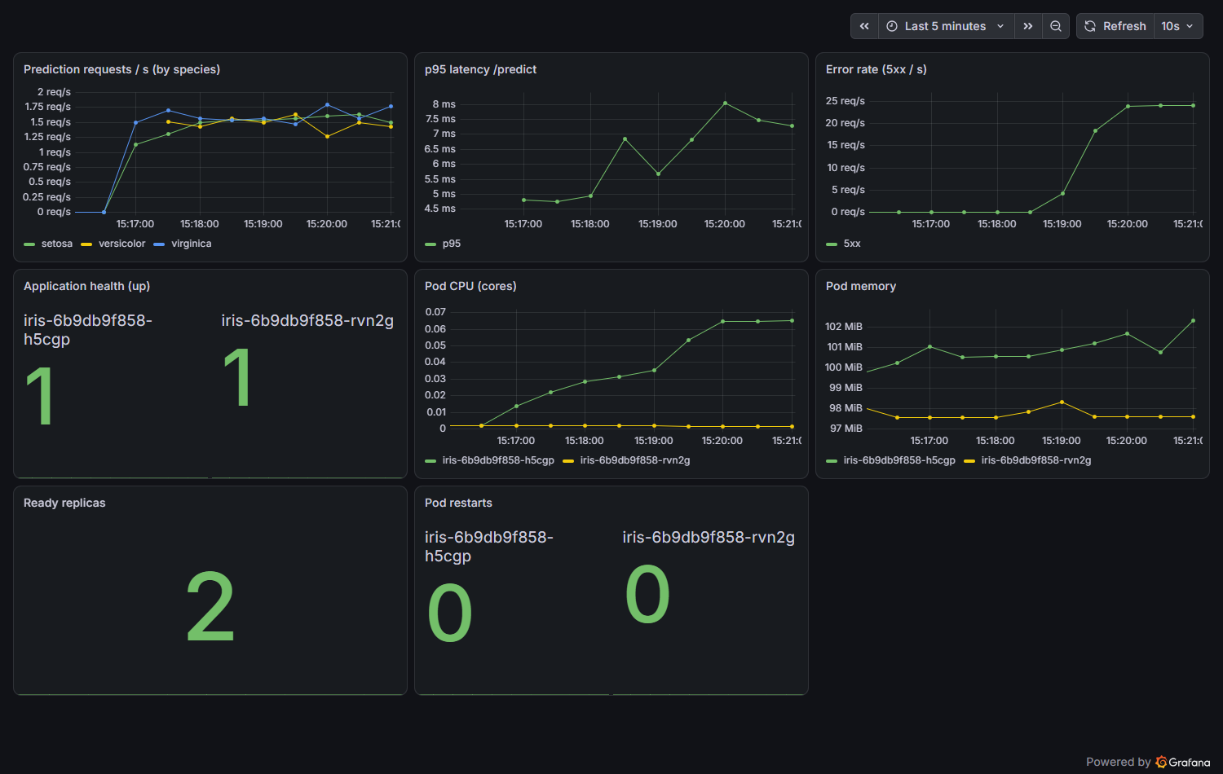
Figure: Grafana error-rate panel during the error test.
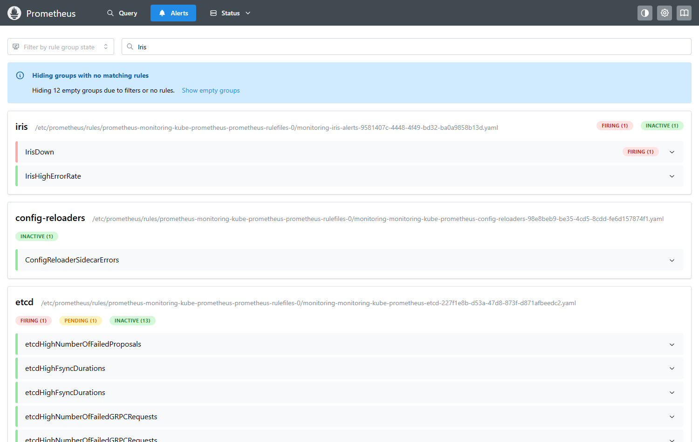
Figure: Alert test 2: IrisDown FIRING with the deployment scaled to 0 replicas.
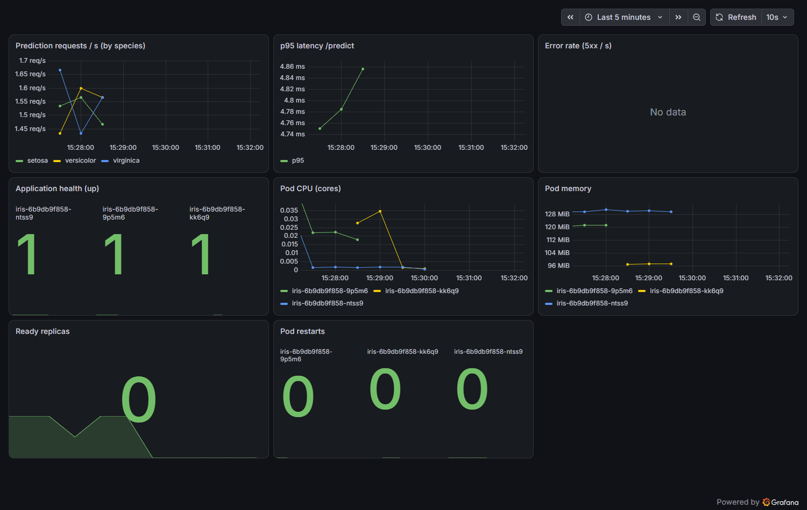
Figure: Grafana during the outage (health and replica panels).
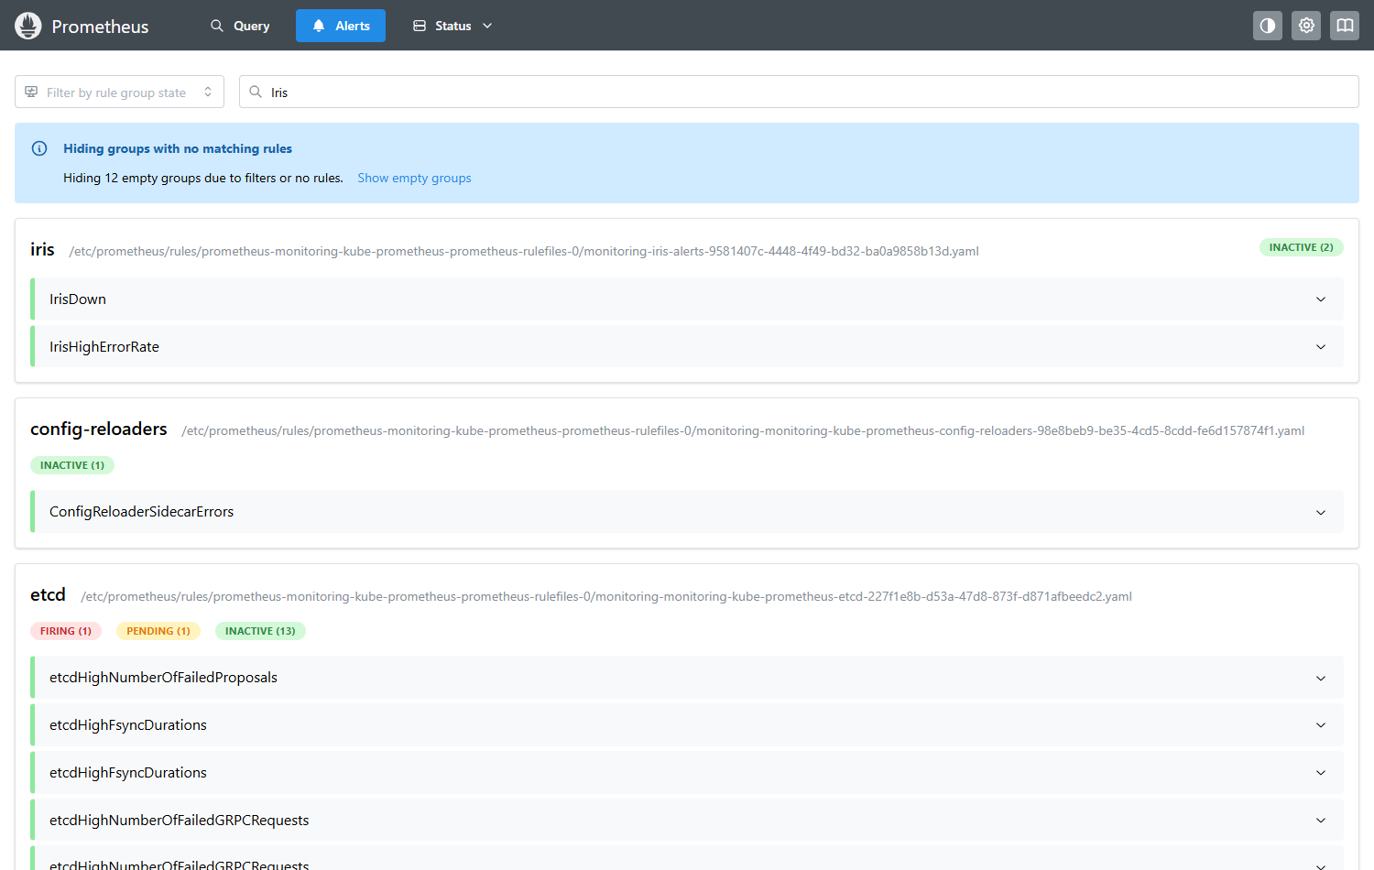
Figure: Recovery: both alerts inactive after scaling back to 2 replicas.
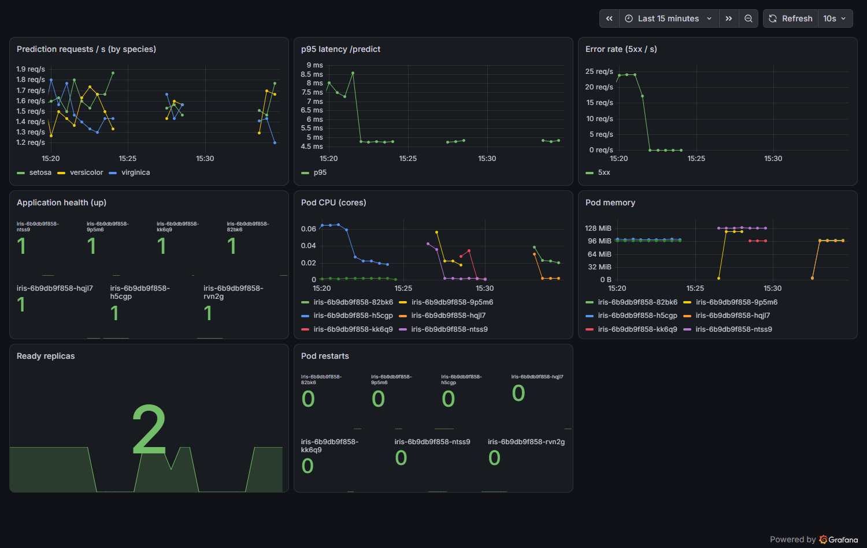
Figure: Grafana after recovery.

10. Limitations
The cluster is a single-node local Docker Desktop cluster; Grafana uses a demo password and is reachable only through localhost port-forwards; Alertmanager has no receiver configured, so alerts are visible in Prometheus rather than sent as notifications; GitHub Actions cannot reach the laptop cluster, so deployment is a manual kubectl step from the published image.

11. Conclusion
A change committed to a feature branch is tested and built by GitHub Actions, published to Docker Hub, deployed to Kubernetes and observed with Prometheus and Grafana, with alerting and recovery verified.

